 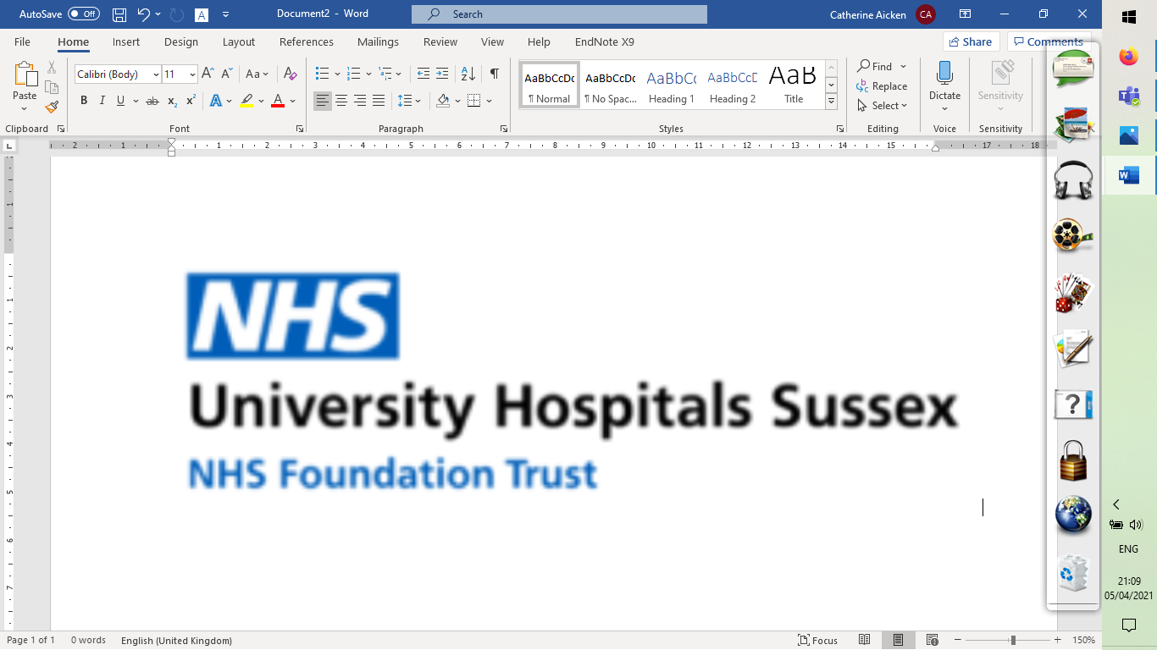 



**PARTICIPANT INFORMATION SHEET – CLIENT IN-DEPTH INTERVIEW**

**Research Study:** Health systems analysis and evaluations of the barriers to availability, utilisation, and readiness of selected sexual and reproductive health services in COVID-19 affected areas

|  |
| --- |
| **Would you like to take part in a research interview about access to sexual and reproductive health services during the COVID-19 pandemic?**  To take part, or to find out more about the study, please contact:  Dr Alexandra Sawyer (lead researcher)  Tel: 07929 671026, Email: [WHOcovid@brighton.ac.uk](mailto:WHOcovid@brighton.ac.uk) / [A.Sawyer@brighton.ac.uk](mailto:A.Sawyer@brighton.ac.uk) |

**Invitation**

You are being invited to take part in an interview, for a research study about the impacts of COVID-19 on the health system’s capacity to provide sexual and reproductive health services. Before you decide if you would like to take part, it is important for you to understand why this study is being done and what participation will involve. Please take time to read the following information carefully and discuss it with others if you wish. If there is anything that is not clear, or if you would like more information, please ask the research team. Thank you for reading this.

**What is the purpose of this study?**

The aim of this research is to identify the key gaps and barriers to the delivery of Sexual and Reproductive Health Services during the COVID-19 pandemic.

**Why have I been invited to take part in this research study?**

You have been invited to take part because you are:

* Aged 18 or over;
* Have accessed a BPAS clinic;

**Do I have to take part in the study?**

No. It is entirely up to you whether or not to take part. If you are not sure, please feel free to discuss it with someone else. If you want to find out more, the research team’s contact details are provided above, and at the end of this leaflet. Even if you say you would like to be involved, you can withdraw from the study at any time without stating a reason. If you decide to withdraw before or during the interview, or before your interview has been included in the analysis (up to four weeks after the interview has taken place) we will not keep any of the information you have provided. If you decide to withdraw after the interview has been included in the analysis, any anonymised data you have already given us will be kept. We need to manage your records in specific ways for the research to be reliable. This means that we won’t be able to let you see or change the data we hold about you. Taking part in the study, or deciding not to take part, will not affect the care you receive at the clinic.

**What will taking part in the research involve?**

This study involves being interviewed by a researcher for approximately 60 minutes. The interview can be done by telephone or online and will be arranged at a time that is convenient for you. If an online or telephone interview would be problematic for you, please discuss with the researcher as it may be possible to conduct the interview face-to-face. The interview will be an informal conversation about your knowledge of COVID-19, your experiences of accessing BPAS in the context of COVID-19, your experiences of the services provided during COVID-19, and the impacts of COVID-19 on your emotional wellbeing. We will *not* be asking you about the circumstances that led to you needing an abortion – because this is not the focus of our study.

**What are the possible disadvantages or risks of taking part?**

There are no foreseeable risks of taking part in this study. However, you may find speaking about some of your experiences difficult or upsetting. You can choose not to answer any questions that you find difficult or uncomfortable. You can also take a break, or stop the interview at any time. At the end of this leaflet, we have given you some details of organisations where you can get further information and support, if you need it.

**What are the benefits of taking part?**

Although there are no immediate benefits of taking part in this study, the findings will help us understand the impact of COVID-19 on sexual and reproductive health services during the COVID-19 pandemic. The research will also identify the key gaps and barriers to the delivery of important aspects of sexual and reproductive health services in health emergencies. The findings will also be used to inform current and future sexual and reproductive health services in this country, and in other countries.

At the end of the interview, you will be offered a £10 Amazon voucher (which can be used online) to say ‘thank you’ for your contribution.

**What will happen to the results of the study?**

The anonymous research findings will be written up into a report for the World Health Organization (WHO). Results may also be presented at academic conferences and published in academic peer-reviewed journals. You will not be personally identified in any research presentations, reports or publications. A summary of the results can be sent to you if you wish to see them.

**Who has funded this research? Who is running the study?**

The World Health Organization (WHO) has funded the study. The study is being run by the University of Brighton and University Hospitals Sussex NHS Foundation Trust. Similar studies are being run in several other countries.

**How will you keep my personal details safe?**

Anything you say to the research team will remain strictly confidential. However, if we hear anything during our conversation which makes us worried that you or others may be at risk of serious harm, we might have to inform relevant agencies of this. This would usually be discussed with you first.

We will keep information about you safe and secure. All data will be stored securely using locked filing cabinets and password and network protected computers. If you have any further questions about your privacy you can see the University of Brighton’s Research Privacy Notice here:

<https://www.brighton.ac.uk/about-us/statistics-and-legal/privacy/index.aspx>

If you would like a printed copy of this information, please contact the research team on the details below.

With your permission, we will audio record the interview using a digital recorder to allow us to capture accurately the information you give us. After the interview, the recording will be typed up (transcribed) by an external transcribing service, which is approved by the University of Brighton and are experienced in dealing with sensitive and confidential information. The research team will delete any names or personally-identifiable details from the transcripts.

**How will my data be used?**

The University of Brighton is the sponsor for this study based in the United Kingdom. We will be using information from you in order to undertake this study. This information will include your name and contact details in order to arrange the interview, and to provide you with a summary of our research findings (if you would like this). People who do not need to know who you are will not be able to see your name or contact details. Your data will have a code number instead. The University of Brighton will act as the data controller for this study. This means that we are responsible for looking after your information and using it properly. In keeping with the WHO’s standard procedures for study archives, data from the study will be kept, de-identified, and secured, for 15 years after the end of the study and may then be destroyed or kept for a limited time period (only) in electronic format.

If you have any further questions about how we use your information you can ask one of the research study team or contact the University’s Data Protection Officer (Rachel Page, Head of Data Compliance and Records Management, 01273 642010, [dataprotection@brighton.ac.uk](mailto:dataprotection@brighton.ac.uk)).

**Who has reviewed this study?**

All research is looked at by an independent group of people, called a Research Ethics Committee, to protect participants’ interests. This study has been reviewed and given a favourable opinion by London - Fulham Research Ethics Committee (09 August 2021, REC reference: 21/LO/0528) and the BPAS Research Ethics Committee (12 July 2021).

|  |
| --- |
| **What happens next?**  If you would like to take part in the interview please contact the lead researcher, Dr Alexandra Sawyer (07929 671026, Email: [WHOcovid@brighton.ac.uk](mailto:WHOcovid@brighton.ac.uk) / [A.Sawyer@brighton.ac.uk](mailto:A.Sawyer@brighton.ac.uk))*.* She will be able to answer any questions you might have before you decide to take part. If you agree, she will arrange a convenient time for the interview. |

**What if I have further questions? What if there is a problem?**

You can contact one of the research team who will be able to help (details below). If you have any complaints or concerns about any part of the study, you can contact **Lucy Redhead**, Chair of the University of Brighton’s Life, Health and Physical Sciences Cross-School Research Ethics Committee, **Email**: [L.Redhead@brighton.ac.uk](mailto:L.Redhead@brighton.ac.uk); **Tel**: 01273 643650.

**Further information and contact details**

You may contact any of the research team if you have questions about the research. Outside of working hours, all the research team’s phone lines have answering machines to allow you to leave a message.

***Contact details of research team***

* Dr Alexandra Sawyer (Co-Investigator and lead researcher): Tel: 07929 671026,

Email: [WHOcovid@brighton.ac.uk](mailto:WHOcovid@brighton.ac.uk) / [A.Sawyer@brighton.ac.uk](mailto:A.Sawyer@brighton.ac.uk)

* Dr Catherine Aicken (researcher): Tel: 07929 671024, Email: [WHOcovid@brighton.ac.uk](mailto:WHOcovid@brighton.ac.uk)
* Professor Nigel Sherriff (Chief Investigator): Tel: 01273 644539 (direct), Email: [N.S.Sherriff@brighton.ac.uk](mailto:N.S.Sherriff@brighton.ac.uk)
* Professor Jörg Huber (Co-Investigator): Email: [J.Huber@brighton.ac.uk](mailto:J.Huber@brighton.ac.uk)
* Dr Jaime Vera (Co-Investigator): Email: [J.Vera@bsms.ac.uk](mailto:J.Vera@bsms.ac.uk)
* Dr Debbie Williams (Co-Investigator): Email: [deborah.williams46@nhs.net](mailto:deborah.williams46@nhs.net)

***Contact details of local research collaborators***

* Matthew Richards (Treatment Unit Manager, BPAS Richmond): Clinic telephone number: 020 88913173,

Email: [Matthew.Richards@bpas.org](mailto:Matthew.Richards@bpas.org)

* Patricia Lohr (BPAS Medical Director and Director, Centre for Reproductive Research Communication):

Email: [patricia.lohr@bpas.org](mailto:patricia.lohr@bpas.org)

**Thank you for considering taking part in this study and taking time to read this information sheet.**

**Further support available to everyone:**

For confidential emotional support on any issue, you can contact SupportLine:

Phone: 01708 765200

Email: info@supportline.org.uk

[www.supportline.org.uk](http://www.supportline.org.uk)

If you have a concern about a sexual health issue, you can contact the sexual health service that you used, your GP, or you can phone the confidential National Sexual Health Helpline 0300 123 7123 (free to call, open 9am to 8pm, Monday to Friday). You can also find information about a range of sexual health issues from the FPA’s Sexwise website: [www.sexwise.org.uk](http://www.sexwise.org.uk)

For urgent healthcare, contact NHS 111, either online on [111.nhs.uk](http://111.nhs.uk), or by phone (call 111).