To _______ students
The recent strike action has been successful in forcing progress in the negotiations. But the employers have not given enough concrete assurances about how they will solve the issues of casualisation, excessive workloads and inequalities in higher education. So next week's planned strike action is set to go ahead. You can check with individual lecturers, but you should expect that no classes will take place on strike days.
We have seen fantastic student support for these strikes, including sit-ins, protests, students joining the picket lines and even organising fundraiser events (more below).
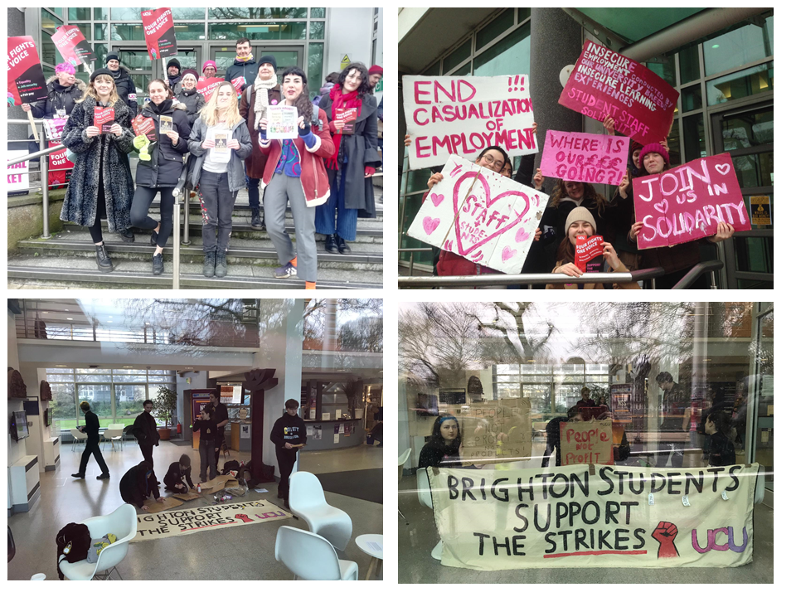
Let's not forget why staff are striking. It is because we refuse to accept the current state of higher education in the UK, in which:
- women are paid on average 15.1% less than men
- the disability pay gap is 8.7%
- black academic staff earn 12-13% less than white colleagues of the same gender and experience
- salaries have fallen against inflation by over 20% since 2009.
- academic staff work over 50 hours during a typical week.
- Over 100,000 staff are employed on fixed-term contracts, and a further 70,000 are employed on other casual contracts.
In short: the system is not working for staff or students.

Teachouts
Every day of the strike action, there are teachouts. We love to teach. You love to learn. Teachouts are a way to keep education going even during the strikes. Join us every day of strikes from 1pm for lunch, then 2pm for teachouts at the King & Queen pub. For the latest info, see: http://blogs.brighton.ac.uk/ucu/2019/11/07/industrial-action-at-the-university-of-brighton/

Student ​Fundraiser
A group of students have organised a solidarity fundraiser for the current UCU strikes on Monday 9 March.
What's happening:
- A raffle
- Art display put on by students
- Speakers including those particularly hard hit by casualisation
- Gallery of testimonials from staff about their treatment by the University.
King & Queen pub. Marlborough Place, BN1 1BU. Monday 9 March. 7:30pm. Details here https://www.facebook.com/events/1259942374214619

More info
blogs.brighton.ac.uk/ucu
twitter.com/BrightonUCU
instagram.com/brightonucu
facebook.com/BrightonUCU
