University of Brighton

How to check your workload allocation

Introduction
Different schools across the university have had different methods for allocating and recording workloads. This is being standardised by the introduction of workload allocation software being rolled out to all schools for the 2017/18 session. All lecturing staff workloads will be recorded and open to scrutiny via this software system by September 2017. Whether it is via the software system or more traditional means, all lecturing staff should be issued with a workload allocation statement for the 2017-18 session by July 2017.

For the workload allocation to be compliant with the HEFCE Transparent Approach to Costing (TRAC) guidance, staff will be required to ‘accept’ their workload. This means that you will need to confirm the accuracy of your workload allocation. In a context of reduction in staffing and consequent increased pressure on the workloads of remaining staff, it is important that we all understand the principles of workload allocation agreed in the recent Workload Agreement between the University and the UCU.

Basic principles of academic workload allocation
The full-time total workload which can be allocated is 1,600 hours per year.
Of this, 500 hours are allocated to Research and Scholarly Activity and General Administration (320 and 180 hours respectively). This leaves 1,100 Teaching hours which can be allocated to contact and teaching-related activity (TRA). What is counted as contact and teaching-related activity is outlined in appendix 1 and 2 of the workload agreement (available on the UCU website http://ucu.brighton.ac.uk )

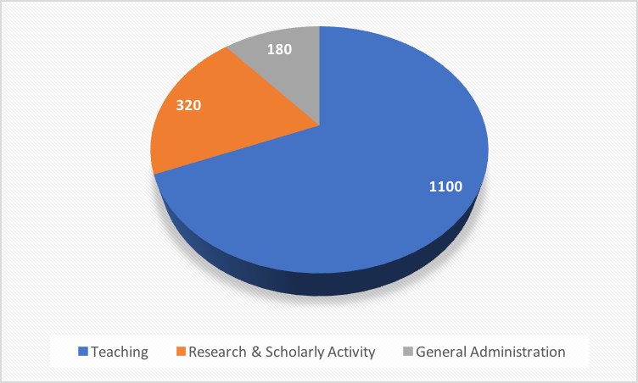

The average ratio of contact to TRA across schools must be a minimum of 1 hour of teaching contact to 1.3 hours of TRA. Across schools, for every hour of teaching allocated there should be a minimum of 1.3 hours of teaching-related activity allocated. While, in some cases the ratio may be higher, for any individual lecturer the ratio should never fall below 1 teaching contact hour to 1 hour of TRA (and this would only apply to exceptional circumstances where the amounts of TRA are demonstrably lower than the norm).

This means that your teaching contact hours should never exceed 550 hours and only approach this figure if your contact hours require minimal or no preparation and marking. Your teaching hours (contact and TRA combined) must not exceed 1100 hours. If your workload conforms with the minimum school average, your teaching contact hours should not exceed 478 hours and could be lower if higher ratios are used.

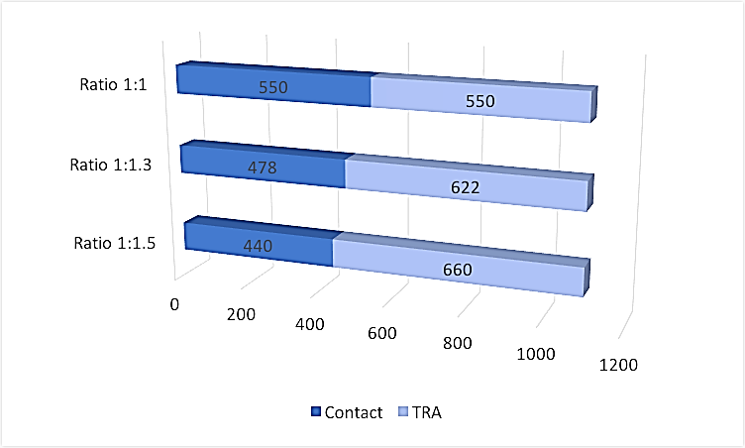

Remission from teaching time for other activities
Any additional non-teaching activities must necessarily be allocated time against the 1100 hours available for teaching, i.e. these duties must be accommodated by remission from teaching.
- Additional research: You may, for example, be allocated 200 hours of research time in addition to the 320 hours Research and Scholarly Activity (RSA) time which is in the contract for lecturing staff at the university. This will reduce the hours available for the allocation of teaching from 1100 to 900.

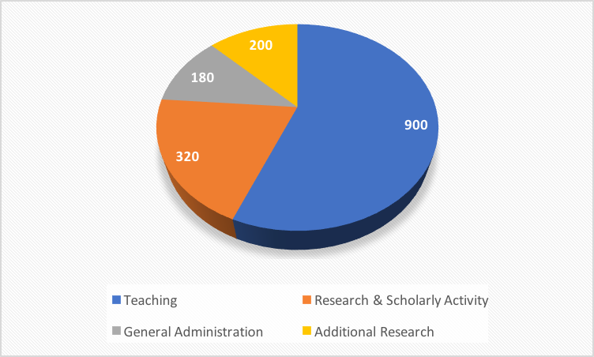

- Course leadership: The workload agreement specifies that the allocation of hours for managerial and administrative roles should be based on a time allocation split of 90:10 between the 1100 hours available for teaching and the 180 hours allocated for general administrative duties. This means that if you have 320 hours for course leadership, 32 hours (10%) will come from your 180 hours general admin allocation and 288 will come from the time available for teaching. In this example, this would mean that the time available for teaching would further reduce to 612 (900-288=612).
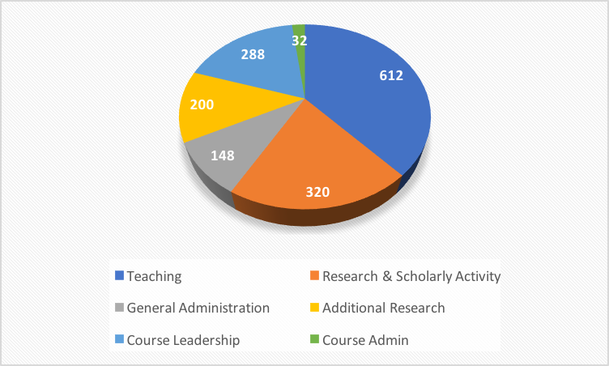

- Module leadership: A 10 credit module taken by a small cohort (less than 20 students) requires a minimum of 10 hours remission with higher rates of remission required for larger modules and larger cohorts. In this example, a module leader for two 20 credit modules with over 30 students and several tutors gets 30 hours remission for the leadership of each module further reducing the time available for teaching to 552.

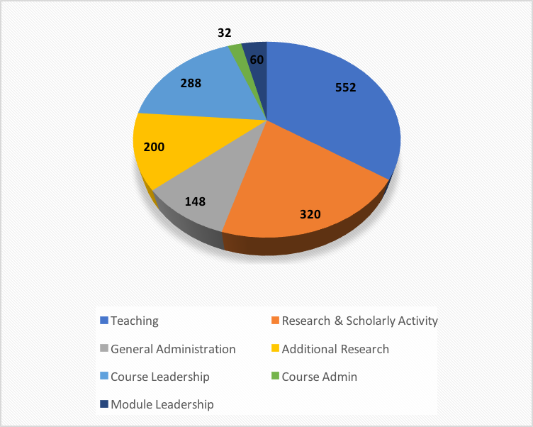

- Necessary travel time: this needs to be included in the workload allocation on a 1:1 basis – i.e. if you need to travel 1 hour each way to teach a module of 12 sessions or to travel on 12 occasions to supervise 12 students on placement at a site other than your usual workplace this should be shown as 12x2 hours of travel time. In our example, this reduces the total left available for teaching to 528 hours.

- Contingency time: An allocation of a minimum of 30 ‘contingency’ hours also needs to be made to allow for in-year response to unexpected change in patterns of work (eg covering for staff illness). The 30 hours would normally represent 13 hours of teaching and 17 hours of TRA. In our example the inclusion of these contingency hours brings the total left available for teaching down to 498 hours.

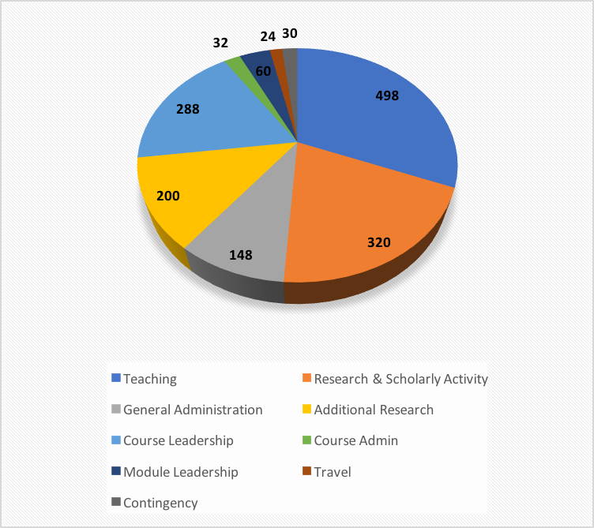

- Saturday/open days: where attendance of these is required, an allowance of 8 hours for a full day and 4 hours for a half day will be allocated from the teaching time. In our example this means that if you are down to do two half day open days the total remaining to be allocated to teaching reduces to 490 hours.

Counted against that 490 hours should be all the teaching contact activity and the associated TRA I undertake. This includes:
- Lectures
- Seminars
- Tutorials dissertation or project supervision on taught undergraduate and post-graduate programmes
- Supervision and observation eg in studios, workshops and laboratories or in clinical practice settings
- Mandatory study visits or field trips (for which a maximum of 18 hours per week contact hours should be allocated, with TRA allocated at a minimum ratio of 1:1 to make up the duration in hours of the work associated with the study visit or field trip)
- E-learning, distance learning or other asynchronous blended learning which forms part of an agreed course or module delivery. This should be recognised by incorporating a minimum expectation of direct student contact time per module and an appropriate allocation of TRA for other teaching activities. In consequence, such module teaching should have TRA well in excess of the 1:1.3 average ratio of contact to TRA. For example, a 20 credit module may involve 50 hours of direct contact (see Curriculum Framework Guidelines) and 65 hours of TRA. A 20 credit module with significant online/asynchronous blended learning may involve only 20 hours of direct contact but 100 hours of TRA. This would represent a 1:5 contact to TRA ratio.
- Research Degree supervision. A full-time research student is entitled to 90 hours of supervisors’ time. This is typically 45 hours each for a team of two supervisors (see appendix 3 of the WLA). This can either be represented as a global figure added to research and scholarly activity time or as 15 hours of contact with TRA in the ratio of 1:2 (ie 15 hours of contact and 30 hours of TRA).

In our example, the workload allocation may look like this:
Teaching | Contact | TRA | Total  Teaching
Doctoral supervision x2 | 15x2=30 | 30x2=60 | 90
MA dissertation supervision x4 | 5x4=20 | 6.5 x4 =26 | 46
Module 1 | 12x2=24 | 12x2.6=31.2 | 55.2
Module 2 | 12x4=48 | 12x5.2=62.4 | 110.4
Module 3 | 12x2=24 | 12x2.6=31.2 | 55.2
Tutorials | 20 | 26 | 46
Teaching observations (not including travel time already taken into account) | 12 | 12 | 24
Total | 178 | 235.8 | 426.8

The teaching load as a proportion of the absolute maximum I can be allocated= 87.1% (426.8/490x100)

You will need to check that that your workload is accurately represented on your workload allocation. The software organises workload allocation under four headings:
- Modular Teaching. This should show all your actual contact hours and TRA.
- Non Modular Activities. This should show any time which is not contact or research and scholarly activity or admin Leadership and Management. It would include contingency hours, travel time, open days and any remission for TU activities.
- Research and Scholarly Activity. This should show your contractual 320 hours (or pro-rate) of research and scholarly activity time and any additional research activity time you are awarded. (Doctoral student supervision may also be shown under this heading if it is not shown under A).
- Admin Leadership and Management. This should show hours allocated for course leadership and module leadership, admissions and any other administrative and management roles.

If you have any questions, please contact members of you branch committee.

UCU co-com 2/6/17

