School of Sport and Health Sciences Practice Learning Newsletter – Edition 1: Summer 2021

Welcome to the first School of Sport and Health Sciences Practice Learning Newsletter. As the new Head of Practice Learning and Development for the School I wanted to introduce myself to those of you who don’t know me. I would also like to update you on all the fantastic work that is happening here in the School and in practice and to send the biggest thank you to everyone that has supported us and our students with practice learning, in what has been the most challenging year for everyone. We really could not have enabled our students to progress and graduate without you and we are all truly grateful.
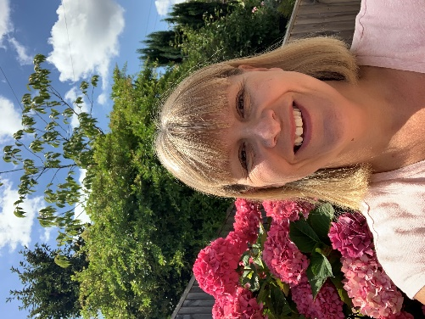
My name is Channine Clarke and I have worked at the University since 2007 and am an occupational therapists by profession. I was the placement tutor for the occupational therapy courses for 10 years before becoming the Academic lead for the last 5 years. Practice learning has always been my passion and when I was offered this new post, supporting the great placement teams across the new School, I felt like I ‘had come home’. My PhD was on the development of professional identity for students undertaking role-emerging placements and I have also been part of the teams delivering the post graduate modules and PG Certs in Practice learning.
I have met many partners in my previous role and am really enjoying getting to know new partners. Please do contact me if you would like to arrange time to meet me or if I can offer any support at all to you or your teams in enhancing practice learning. C.clarke@brighton.ac.uk

Practice Learning Edublog
I hope that you are aware that in January we launched a new website dedicated to supporting practice educators for Sport and Health students. This was developed by two occupational therapy students, Shauna Rouse and Megan Dudziak, who were with me on a leadership placement. They developed this from an original Edublog site created by Theresa Corkill and Erika Thorne that encompassed all NMC registered courses, guidance and advice on practice assessment documents, support with diverse learners and much more. This site has subsequently been linked to the new one so all information can be accessed in one place.
It provides lots of really useful and important information about supporting students, educator courses, placement dates, new modules of practice learning, resources to support Black, Asian and Minority Ethnic students, top tips for educators. The site is being updated regularly and we are working on areas that have yet to be completed. If you have resources that you are willing to share please do send them me c.clarke@brighton.ac.uk and I will upload them. Feel free to download posters and resources and to share in your departments.
About Us | University of Brighton Supporting Health and Sport Students in Practice

Practice Learning Awards
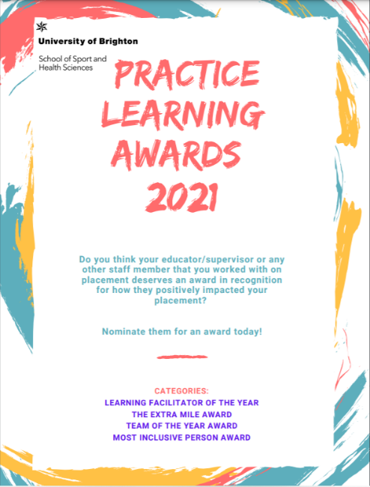
We have recently launched our new Practice Learning Awards 2021, an initiative led by two occupational therapy students on a leadership placement with Channine; Sinead Aksoy and Harry Covill. It has been wonderful reading all the fantastic nominations that are coming in and as I write this we have over 100 educators / teams nominated. This shows the gratitude that the students have for the support you have provided them during this last year. Reading the quotes it is evident that the practice teams have all gone above and beyond in providing meaningful learning opportunities for students- thank you!
All those nominated will be sent a CPD certificate and invited to attend the award event on July 14th at 3pm when the winners will be announced. S I hope to see many of your there.

Growing the workforce
We are very aware of the demands facing practice with staffing, recruitment, retention, workforce supply and demand issues. We are working with the Integrated Care System to understand your needs so that we can respond with increasing student cohort sizes that enable you to grow the workforce. Growing our courses is obviously dependent on practice learning opportunities and the teams here, together with the Practice Educator factors (PEF’s), are working hard to help teams think about different ways of delivering these opportunities. You will find lots of ideas and examples on the Edublog site (Models of Placements Delivery | University of Brighton Supporting Health and Sport Students in Practice)
We know many of you are being creative and trying new approaches but we would ask everyone to discuss in your teams how you may be able to optimise placement capacity through, for example:
- 2:1 model : If all offers became 2:1 as the norm we would double our capacity. Evidence for the value of peer learning and benefits for educator and students is strong
- Team approaches
- Leadership, research and project placements
- Technology enhanced placements
- CLIP models
- Role-emerging / diverse placements

I have certainly seen the value of facilitating leadership placements myself where the outputs by students to enhance practice learning have been really high quality. The growth in their confidence and development of their leadership skills has been evident to see and stands them all in really good stead as graduates. I would encourage all teams to think about quality enhancement projects that you have always wanted to do and never had the time for, and which could support students to achieve whilst facilitating their leadership skills. It’s a win win for the students and your teams.

HEE have just released this short video about practice-based learning : A new world of Practice-Based Learning for Allied Health Professions - YouTube
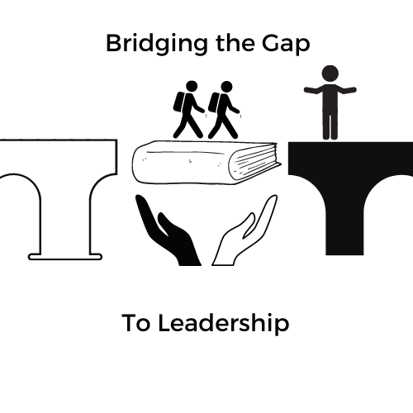  Bridging the Gap to Leadership  Health Education England are currently funding a collaborative placement between the University of Brighton and Canterbury Christ Church University, providing a leadership placement for Black, Asian and Minority Ethnic students. Focus groups have highlighted that some B.A.M.E students have negative placement experiences and poorer achievements than their white counterparts due to issues of racism, microaggression and unconscious bias. The aim of the placement was to provide leadership experience and create resources for educators that help them support BAME students on placement.  The students have co-created this project from the start, sharing their experiences and identifying resources that they feel would be of value for practice educators supporting BAME students in practice learning. The first two students created the name of the project: Bridging the Gap to Leadership and developed a timeline for the project that has been shared with subsequent students. 12 students have undertaken the placement so far.  The resources that have been created to date are:  - A webinar attended by over 80 people, including managers, educators, HEI representatives - a feedback tool given to all attendees and the session was evaluated extremely highly. Attendees felt their understanding of issues such as microagressions, the attainment gap, allyship, and research increased as did their confidence to support BAME students in practice, through the practical advice provided by the students.  - Creation of a leadership placement logo  - A resource and poster promoting allyship  - Posters on ‘respecting names’ ‘race and ethnicity’ and ‘microaggression’  - Three podcasts were recorded that promote the project, share experiences, provide an empathy walk  - Placement blogs and reflections of doing a leadership placement  - Two focus groups with students were carried out (one each at CCCU and UoB) with BAME students to understand further the support they feel is needed in practice learning.  A great animated video has been created by Kai Yan Chu Spirini as part of his placements and highlights important messages for educators: https://app.animaker.com/video/4IKQG4VIBAX1U8R1  These resources have been disseminated in a variety of ways including the HEI practice learning sites (Resources for educators | University of Brighton Supporting Health and Sport Students in Practice), Closing Our Gap (canterbury.ac.uk), CCCU Bridging the Gap to Leadership and social media.  Please take a look and share and discuss these in your teams. Please also let us know if this is having an impact on the teams supporting BAME students. |  | Inclusive practice  I encourage everyone to watch this powerful and informative webinar that highlights the lived experiences of AHP students from ethnically diverse, LGBTGIA+ and disability backgrounds. AHP Student Experience Discussion - YouTube  The students in the webinar are really open and honest about the challenges they face and offer very useful suggestions for educators. It is a 2 hour webinar but we encourage you to spare the time to watch this as it is so important to raise awareness about the experiences of students and the necessity of creating an inclusive learning environment and reflecting on our practice. Please share with all staff in your teams. Thank you.  Occupational Therapy students Codie Franklin, Chloe Godden have also created some posters to offer useful tips for educators when supporting students. These include:  - Dyslexia  - Dyspraxia  - Dyscalculia  These can be downloaded Equality, Diversity & Inclusion | University of Brighton Supporting Health and Sport Students in Practice  They have also, along with fellow students Harry Covill and Sinead Aksoy, created some top tip posters on:  - Providing supervision  - Creating a sense of belonging  - Encouraging reflective  - Supporting students  These can be downloaded Top Tips for Educators | University of Brighton Supporting Health and Sport Students in Practice

Admissions 2021-22
We have had an excellent year for recruitment on our health courses, with all courses seeing a high increase in the number of applicants. This shows the level of interest in careers in health and social care which is great news for the future workforce. We have met our target numbers for all courses, except podiatry, and both physiotherapy and midwifery have exceeded the target. All courses, except podiatry, are now closed, including adult nursing for both the Sept 2021 and Feb 2022 cohorts which the team say is the first time in recent memory.

We will need to ensure continued placement capacity for these students and all the work that is happening in practice and here in the School will hopefully enable us to grow numbers for the 2022 intakes to meet the workforce demands.

Practice Facilitators
Thank you to all our practice education facilitators (PEF’s), we know how hard you are working to enable student practice learning to continue and develop. It has been great having the new AHP PEF’s and Faculty’s in place across Sussex, Surrey, Kent & Medway for the last few months and they are certainly helping us to develop more links with practice and look at ways of increasing capacity in the organisations. We have been lucky to have PEF’s for nursing and midwifery for a number of years but the AHP role is new and much valued. If you haven’t yet met them and would like to discuss anything related to enhancing AHP practice learning then please do contact:
Jess Poulton (East) jessica.poulton@nhs.net
Amelia Palmer (West) a.palmer@nhs.net
Emma Merrell (Pan sussex) Emma.Merrell@nhs.net
Camille Devaux (Surrey and Heartlands) camille.devaux2@nhs.net
Nicki McRae (Kent and Medway) nicki.mcrae@nhs.net
Iain Spink (Kent and Medway) iain.spink@nhs.net

We are also pleased that Liz Johnson, who was an experienced PEF in Brighton, is currently working with us 2 days a week to help us with HEE’s nursing expansion project. If you have ideas or new placement sites that you would like to talk to us about please contact Liz or Theresa:
E.Johnson3@brighton
T.K.Corkill@brighton.ac.uk

Digital Hub

As part of the Sussex placement expansion bid, we are developing a ‘digital hub’ at the Eastbourne campus so that students have a confidential space to be able to do remote / technology enabled placements if they cannot do these from home. We know that organisations have been purchasing laptops that they will be able to loan to students so that they can access the systems they need and the hub will provide a place where they can work, if they do not have a quiet alternative place. This will be ready for students to use in September.

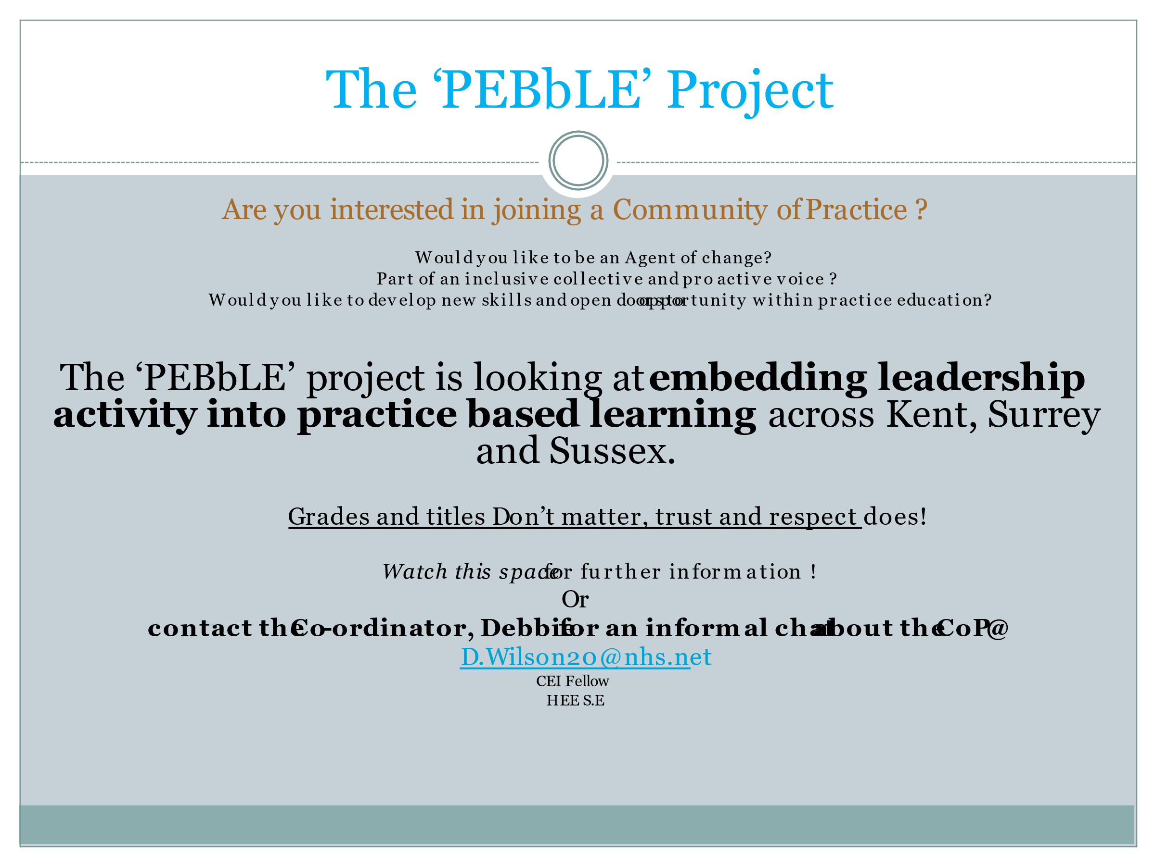

News from the teams

OCCUPATIONAL THERAPY
Firstly, as we reach the end of this academic year, we would like to say a huge thank you to everyone who has supported our students in practice in what has been a very challenging year. We have managed to secure placements for all our students and this is down to all your efforts in offering placements. We are also grateful that so many of you have considered new and creative ways of offering placements using different models and approaches. This has helped placement capacity immensely and will hopefully become more of the norm as we look forward into the future years. Please pass on our thanks to all educators and coordinators.

The practice learning leaders (Tara and Audrey) have two MSc occupational therapy students, Codie and Chloe, on placement with them. Chloe and Codie have been working hard to help develop the Peer Enhanced E-learning Programme (PEEP, which is a simulated placement programme). They have been working on the simulated case studies, the teaching and learning website and the PEEP handbook. They have also been involved in further developing the school website for practice educators, which includes all our placement documentation as well as placement and workshop dates for your easy access. It also includes a whole host of information and resources to support practice learning such as: ‘equality, diversity and inclusion’, different approaches/models to placement provision and supporting students with disabilities. This is still work in progress and also constantly updated. The link to it is here: UoBSupportingStudentsinPractice

We are now looking towards the next academic year. Our pressures for placements are usually in the new calendar year from January to June with a particular pinch point around May to June when both our BSc (novice) and MSc (intermediate) students overlap. Please contact us on Occupational-Therapy-Placements@brighton.ac.uk to find out more about our placements or practice educator training courses, or to make a placement offer.

DIVERSE PLACEMENTS
We continue to have many interesting offers for diverse placements for our students. Our diverse placement offers more flexibility to practice learning for our students in that they can be in the form of role-emerging (no OT on site), non-traditional (within an NHS or social care site looking to promote the role of OT); or take the form of a project, research or leadership placement. We have had a few AHP leaders offering our students the opportunity of a leadership placement this year and we hope for this to continue.
- If you or anyone within your team or service have an idea for a project or research that will promote occupational therapy; or if you are a leader and would like to offer a placement, please do get in touch so that we can discuss your ideas and hopefully bring it to life, whilst ensuring that our student learning outcomes are met.
- We are always in need of long arm, experienced clinical practice educators to support our students in their diverse placements. If you are interested in this role, do please contact Audrey. We offer a half day training session online via MS Teams – see dates below.
- Finally, if you know of or work with other organisations, social enterprises or settings whom you feel may benefit from an occupational perspective or occupational therapy input and who may be interested in offering a diverse placement, please put them in touch with us too.

For any of the above or if you would like any further information, please email Audrey Yong: A.Yong@brighton.ac.uk

We wish you all a good, healthy and warm summer.
The occupational therapy placement team:
Audrey, Tara and Sara.

Midwifery
Thank you to all our Practice Supervisors and Practice Assessors for all you support for the new Midwifery Ongoing Record of Achievements ( MORA), which is our new practice assessment documentation. This has been a big change in our assessment process and we are really grateful for all you support in implementing this.
Many of our students have been working in the new continuity models and have found this such a rewarding experience. We hope to continue to expand this opportunity for all of the students over the coming year- if you have any feedback from these experiences, please do let the link tutor know. Thank you.

Paramedics
Thank you to all our Practice Educators support over the last year. Our paramedic students have continued to undertake both SECAmb and interprofessional placements all year and have fed back how supported they have been in all areas. Community services have played an important part in the development of skills for our year 3 students, and this will be embedded in the placement opportunities moving forward. The widening of placements has enabled the student to see the varied opportunities for these skills in the future and this will no doubt improve the longevity of the role of the paramedic. A very big thank you to you all.

