Assessment Submission Guidance During Covid-19 –

SB506B Feb19 cohort
The following guidance will support you to meet the following assessment requirements for SB506B:
- Complete learning agreements in all healthcare settings.
- Achievement of NMC Professional Values in all healthcare settings (NMC, 2018)
- Demonstration of competency in the level 5 procedural skills as defined by the NMC standards of proficiency (2018)
- Declaration of achievement by TNA & Mentor
Submission of the AoPD and Additional Evidence Portfolio will be undertaken electronically. You will need to scan all the document pages the correct way up and sequentially as indicated in the list on P.2 and upload them as one file to student central (using the link that will be posted under the Assessments area).
You can use the ONEDRIVE app on an android mobile or iPhone to take a picture of all the required pages of your AoPD and Additional Evidence Portfolio and this will be converted to a single PDF file that can be submitted to student central.
Full instructions on using this app will be provided on P.3 - 7
Trainee Nursing Associates:

The summative submission date for your AoPD is the 21st January 2021 by 4pm
or 4th February 2021 by 4pm (LSP).
100% achievement of SafeMedicate drug calculation exam
- 2nd Attempt SafeMedicate exam will be undertaken remotely on 28th January 2021 for those that need to re-sit.
- We will set up the summative assessment so that those of you that need to complete the exam will be able to access the exam online between 09.00-16.00.
- A password will be issued to you no later than the 26th January 2021 by 4pm for you to enter this self- directed exam.

Pages to be submitted:
Page number | Title/description of page
1 | Cover page completed with apprentice details
2 | Employer details and mentor signature log
11 | 5th meeting with mentor in Homebase – end of semester 2 report.  This must be completed in full by TNA and Mentor, and confirmation that the TNA has achieved the 3 negotiated learning outcomes circled YES.
16 | End of External Placement 1 – Review  This must be completed in full by TNA and mentor.
20 | End of External Placement 2 – Review  This must be completed in full by TNA and mentor.
22 – 26 | Nursing Associate Apprenticeship Competency Domains  All 8 pages must be completed in full; with signatures, dates and ticks for each clinical area assessed in by mentor.  Homebase mentor to complete confirmation of achievement on P. 26.
28 – 29 | Assessment of 10 practice skills  All pages must be completed in full; with the summative assessment for each skill having a date, tick for achieved and signature of assessor. In addition, the confirmation of achievement needs to be completed at the bottom of P.29 by your mentor in your homebase.
30 | Mentor Declaration and Trainee Nursing Associate Declaration completed in full (Please ensure your mentor adds your name to the Mentor declaration).
Additional Evidence for the NMC portfolio
You must submit the pages that demonstrate achievement of all the NMC skills listed in the additional evidence for the NMC portfolio.
Please ensure that all NMC proficiencies have been assessed in either: SB401 (as optional skill) / SB506 (as optional skill) or within the additional evidence portfolio.
If a skill was achieved in SB401, you must include the pages ‘List of optional skills achieved’ from within the SB401 AoPD in your submission document.
eLearning Certificates:
- Spotting the Sick Child
- Maternity Insights
- Learning Disabilities Workbook – Page 7 only to be submitted titled ‘Personal Reflection’ as this demonstrates your learning and development achieved through completion of this workbook.
- For all eLearning modules completed via National Skills Academy (NSA eLearning) you do not need to include the certificates of completion (I have a log of what has been completed by each learner)
- If you have completed eLearning from the list in your homebase, in place of via the NSA website, you must in addition provide a screenshot of your eLearning record to demonstrate achieving these modules.

Scanning Documents with the OneDrive App Guidance

Using the OneDrive app on one’s mobile device goes beyond file-storage. There is also a handy scanning function that works especially well if you are working out at placement, and need to scan in a signed document for many uses, such as portfolios, assessment, etc.
First make sure you’ve installed the Microsoft OneDrive app to your device. Sign in to the app, and it will remember your details.

Make a Folder to store your scans
Click on the app in your mobile device to launch it. (The first time you do this, you’ll need to log in, use your normal university username and password. It will remember your details moving forward.)
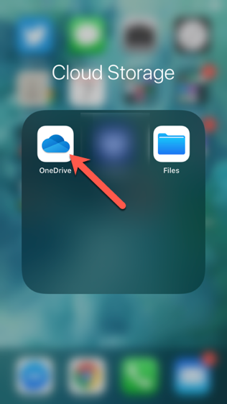

The first time you wish to scan a document, you should probably create a new folder in your OneDrive, so that scans will all live in the same place, and be easy to find later. Click on the plus-symbol in the top right-hand side of the app to add a new file.
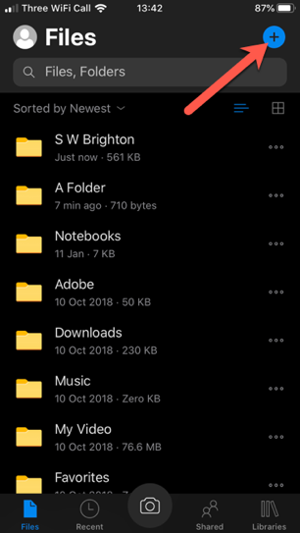

Choose ‘Create a folder’ to make a new folder in your OneDrive
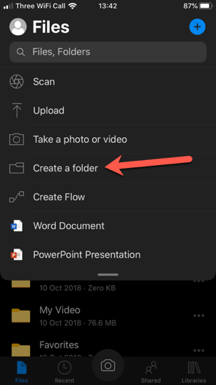
Name the folder something that makes sense to you, and then click ‘done’.
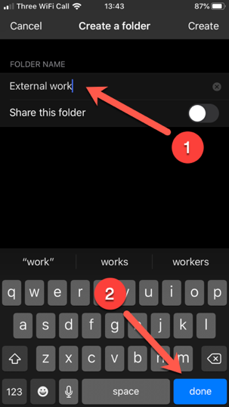
Now you’re ready to start scanning documents into a folder.

Scanning a Single-page document
Make sure you’re in your folder, and then click on the Camera-button on the bottom of the screen.
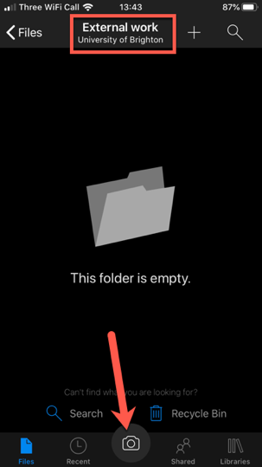

You will be using your device’s camera to do the scanning. A Blue-guide should show up around your document that you’re scanning (1). You may need to move things about a bit, for the app to locate the edges properly. The app will default to ‘Document’ (2) but there are other options, depending on what you’re doing. Finally, press the round button to scan (3).
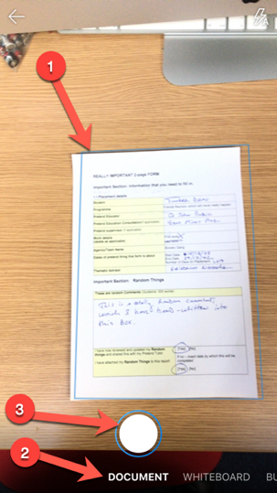
If you only need the one page document for your purposes, then press the done button.
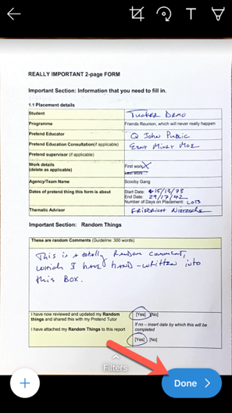
Name the scan something that works for you, and that will allow you to find it later, and then click on the tick-mark in the upper right side of the app, to save this to your OneDrive in the folder you’ve chosen.
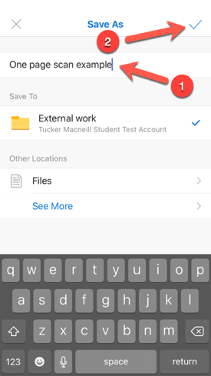
Here’s the file living in my OneDrive on my device (in its folder ‘External Work’)
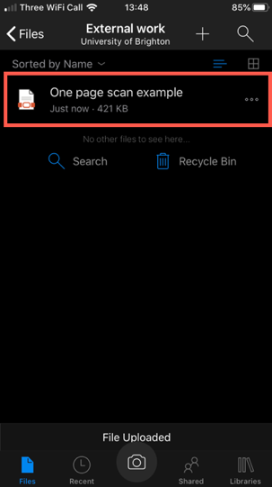

Scanning a multiple page document
Do the exact same work-flow as written above. Scan the first page of the document, but instead of clicking ‘done’ rather click on the plus-symbol button on the lower left.
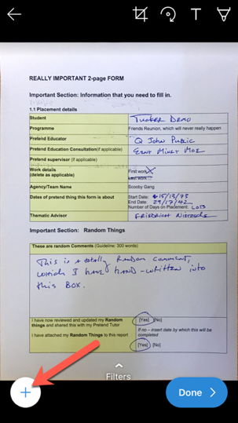
Scan the next page, and the next, and the next in the same manner, adding each page by clicking the plus-symbol button, until you’re done.
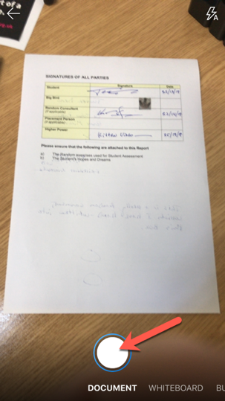
Once you’ve scanned all of your pages for the multi-paged document, then you can click ‘done’.
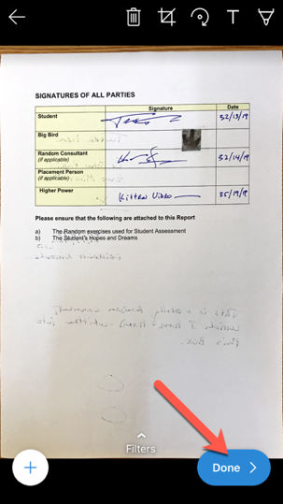
Save as before, by naming the file something useful to you, and clicking on the tick-mark in the upper right side.
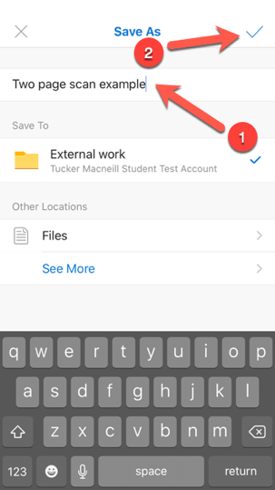
Now your documents are saved into your OneDrive, and you can access these documents from any device on campus or at home, by logging into your OneDrive through a browser.
