Assessment Submission Guidance During Covid-19 –

SB401 F20 cohort TNA
The following guidance will support you to meet the following assessment requirements for SB401:
- Complete learning agreements in all healthcare settings.
- Achievement of NMC Professional Values in all healthcare settings (NMC, 2018)
- Demonstration of competency in the level 4 proficiencies as defined by the NMC standards of proficiency (2018)
- Declaration of achievement by TNA & PA
Submission of PAD 1 will be undertaken electronically. You will need to scan all the document pages the correct way up and sequentially as indicated in the list on P.2 and upload them as one file to student central (using the link that will be posted under the Assessments area).
You can use the ONEDRIVE app on an android mobile or iPhone to take a picture of all the required pages of your PAD and this will be converted to a single PDF file that can be submitted to student central.
Full instructions on using this app will be provided on P.3 - 7
Trainee Nursing Associates:

The summative submission date for your PAD 1 is the 14th January 2021 by 4pm
Or 4th February 2021 by 4pm if you have an LSP

Please note:
We have selected the minimal number of pages for submission to minimise the challenge of online submission whilst demonstrating the requirements to achieve this module.

*For quality assurance reasons you could be asked at any time to demonstrate completion of other pages, such as interviews, so these must be completed *

Pages to be submitted:
Page number | Title/description of page
PAD 1
Cover Page | Cover page completed with apprentice details
13 - 14 | Signature log pages:  If signature for AP/PS/AA is not available, please enter an e-mail address so they can be contacted if required.
15 | Home Base Details
25 - 26 | Semester 2: Final Interview  These pages must be completed in full by TNA and PA/PS.
36 | PAD 1 – External Placement Experience 1 Details
41 - 42 | PAD 1 – External Placement Experience 1: Final Interview
43 | PAD 1 - External Placement Experience 2 Details
48 – 49 | PAD 1: External Placement Experience 2: Final Interview
66 - 68 | PAD 1 – Assessment of Professional Values  All pages must be completed in full; with signatures, dates and ticks for each clinical area assessed in by PA/PS, and TNA reflections completed in full on P.68
70 - 76 | PAD 1 – Assessment of Proficiencies  All 7 pages must be completed to demonstrate achievement of each proficiency in either your Home Base, External Placement 1 or External Placement 2.
81 – 82 | PAD 1 – Episode of Care: Summative
84 – 85 | PAD 1 – Medicines Management Assessment
OAR
171 | End of PAD 1 – Declaration  AA section to be left blank, the AA will agree progression to PAD 2 at moderation of submission if all elements are achieved.
187 | Mandatory Training and DBS Declaration Year 1

Scanning Documents with the OneDrive App Guidance

Using the OneDrive app on one’s mobile device goes beyond file-storage. There is also a handy scanning function that works especially well if you are working out at placement, and need to scan in a signed document for many uses, such as portfolios, assessment, etc.
First make sure you’ve installed the Microsoft OneDrive app to your device. Sign in to the app, and it will remember your details.

Make a Folder to store your scans
Click on the app in your mobile device to launch it. (The first time you do this, you’ll need to log in, use your normal university username and password. It will remember your details moving forward.)
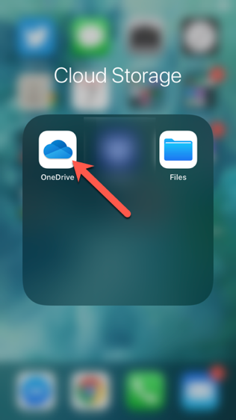

The first time you wish to scan a document, you should probably create a new folder in your OneDrive, so that scans will all live in the same place, and be easy to find later. Click on the plus-symbol in the top right-hand side of the app to add a new file.
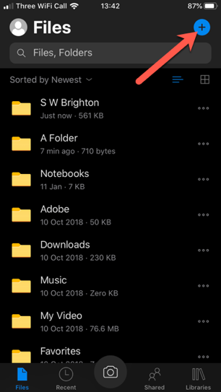

Choose ‘Create a folder’ to make a new folder in your OneDrive
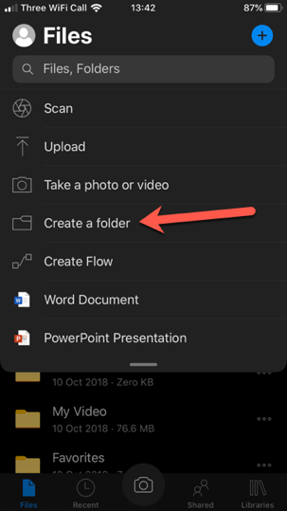
Name the folder something that makes sense to you, and then click ‘done’.
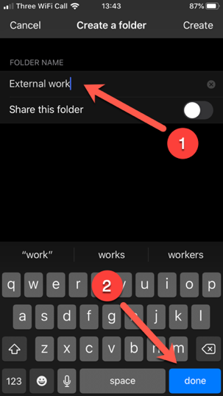
Now you’re ready to start scanning documents into a folder.

Scanning a Single-page document
Make sure you’re in your folder, and then click on the Camera-button on the bottom of the screen.
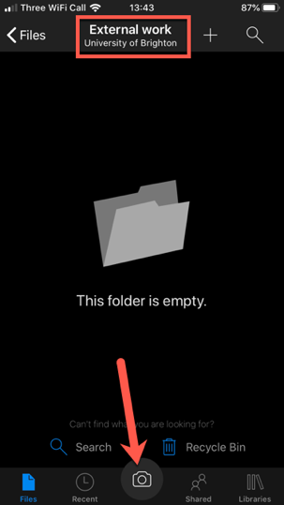

You will be using your device’s camera to do the scanning. A Blue-guide should show up around your document that you’re scanning (1). You may need to move things about a bit, for the app to locate the edges properly. The app will default to ‘Document’ (2) but there are other options, depending on what you’re doing. Finally, press the round button to scan (3).
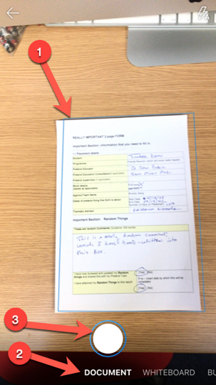
If you only need the one page document for your purposes, then press the done button.
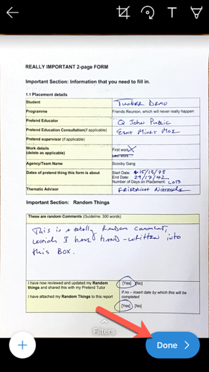
Name the scan something that works for you, and that will allow you to find it later, and then click on the tick-mark in the upper right side of the app, to save this to your OneDrive in the folder you’ve chosen.
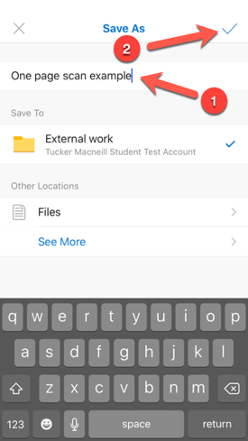
Here’s the file living in my OneDrive on my device (in its folder ‘External Work’)
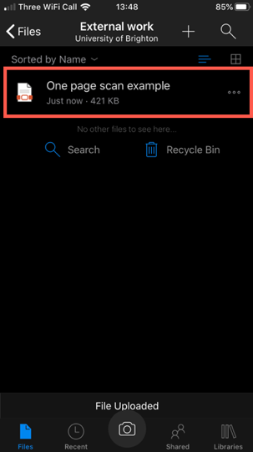

Scanning a multiple page document
Do the exact same work-flow as written above. Scan the first page of the document, but instead of clicking ‘done’ rather click on the plus-symbol button on the lower left.
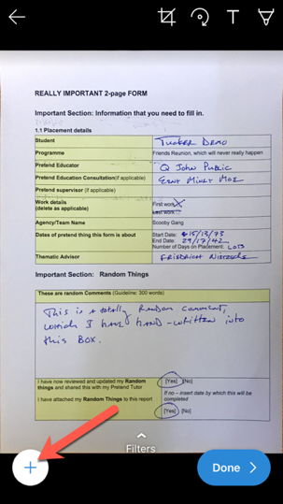
Scan the next page, and the next, and the next in the same manner, adding each page by clicking the plus-symbol button, until you’re done.
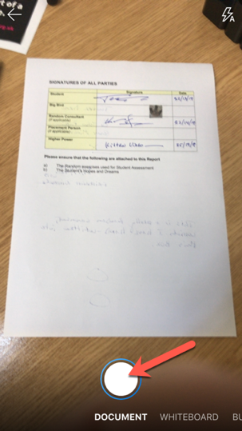
Once you’ve scanned all of your pages for the multi-paged document, then you can click ‘done’.
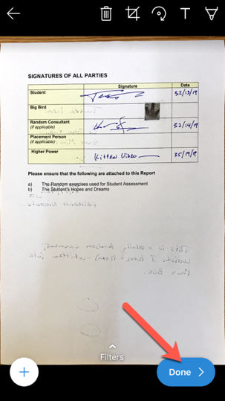
Save as before, by naming the file something useful to you, and clicking on the tick-mark in the upper right side.
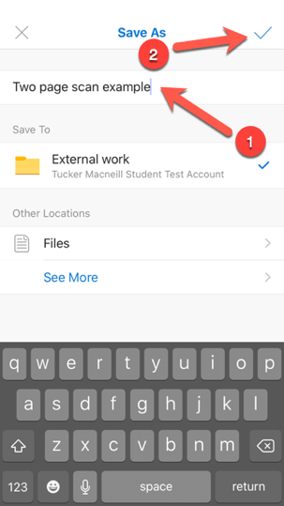
Now your documents are saved into your OneDrive, and you can access these documents from any device on campus or at home, by logging into your OneDrive through a browser.
