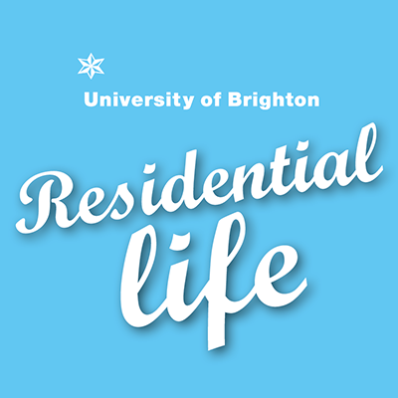

Student Residential Advisor 2021/2022 - Application form and process

Application process

Thank you for showing an interest in the Student Residential Advisor (SRA) role.

- Please begin by reading the Volunteer Agreement and understanding what is required of SRAs.

- Please complete the application form below and send it as an attachment in an email to resilife@brighton.ac.uk. The deadline for submission is Wednesday 10th February 2021. We will not accept any applications after this date.

- It is important that your supporting statement demonstrates how you meet the essential and desirable criteria set out in the Volunteer Agreement. You must demonstrate how your skills and experience are relevant to the role, and how you are able to support students living in university accommodation.

- Interviews for shortlisted candidates will take place between Monday 01st March and Friday 05th March 2021. We will contact you using the email you provide in the application form.

- Please note successful applicants are required to attend mandatory training sessions. Please do not apply if you are unable to make these mandatory training sessions:

- There will be an initial one day introduction and team-building session on Friday 28th May 2021.
- There is a further one week training induction from: Monday 20th September to Friday 24th September 2021 just before residents move into the halls. You will also be required to assist with the move in weekend (Saturday 25th and Sunday 26th September 2021).

We are looking forward to receiving your applications. If you have any queries about the role or the application process, please feel free to contact us.

Residential Life Team
Resilife@brighton.ac.uk

Application Form

PERSONAL DETAILS:
Surname: | Preferred title:
First names: | Home or International student:
Gender: | Address for correspondence:
Date of birth:
Student number:
Telephone: | E-mail:
Please provide full details of your University of Brighton course of study:

Course title:

Current year of study (e.g. 2nd year):

Graduation date:

Full time? Yes No

Have you previously lived in university accommodation? Please provide details of your current/previous stay in university accommodation: (Halls / Unihome or Unilet, Year of Stay):

PREVIOUS EDUCATION:
Dates: | College/University: | Qualifications Obtained:
PREVIOUS EMPLOYMENT: (Most recent first; please include voluntary work and work experience)
Dates: | Place of Employment: | Title of Appointment:

EXPERIENCE/KNOWLEDGE:
Create and submit a video that ‘tells us about yourself and what motivates you’.
Be as creative as you like and submit a video that tells us about yourself and what motivates you. Please keep your video under 1 minute.

Use University of Brighton MediaStream to share the video with us. Instructions on how to upload your video and obtain the link are at the back of this application.

Insert the link to your video here:

Based on your experience living in university accommodation, what types of issues do you think new residents need support with?
Beyond providing a comfortable and secure home, please suggest three ways in which you think we can enhance students’ experience living in halls or university-managed housing.

Do you have any other commitments that might impact on the SRA role? For example another job, sports, volunteer work, academic duties. Please tell us what methods you would use to manage your time.
Part the SRA role is to organise and deliver social events for students. What types of events would you host and why? How would you advertise and promote these events considering the diverse student community?

SUPPORTING STATEMENT:
Please use this page to write a personal statement including:
- Why you are applying for the role.
- Evidence of what you can bring to the role. This is your opportunity to demonstrate how your qualifications, skills, knowledge and experience are relevant to the role.
- Examples/evidence to support your application.

Please ensure that your supporting statement demonstrates how you meet the essential and / or desirable criteria listed in the Volunteer Agreement.

ACCOMMODATION PREFERENCE & SPECIAL REQUIREMENTS:
Successful applicants will be provided with a room in halls or university-managed housing. We will try to allocate you a room based on your preference but we cannot guarantee you will be based on a specific site.
Do you prefer a room in halls or a university-managed house?

If you want a room in halls, do you have a preference for Phoenix, Varley, Moulscoomb, Great Wilkins, Paddock Fields, Welkin Halls or Mithras Halls (new accommodation complex on Lewes Rd)?

Please let us know if you have any special accommodation requirements due to a disability or medical condition. We may ask you to provide supporting evidence of any particular needs.

REFEREES:
Please give the names and contact details of two referees below. If you have not been in paid employment, we will accept a reference based on any voluntary work you have undertaken. One of your references must be from your academic school.
1 | Name:  Address:  Postcode: | Position held/capacity known:  e-mail address:  Telephone:  May we contact the referee prior to interview?  Yes / No
2 | Name  Address:  Postcode: | Position held/capacity known:  e-mail address:  Telephone:  May we contact the referee prior to interview?  Yes / No

DECLARATION:

I declare that the information given in this application is to the best of my knowledge complete and correct.

Signed:

Date:

Using UOB MediaStream to Share video

Record your video
Using the built-in camera on your mobile device to record your short video.
- Record your video with your chosen device
- Using the web browser on your device access the following site: https://mediastream.brighton.ac.uk/
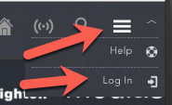
- Login with your user ID and password - use the same user ID and password you use to access StudentCentral
- After login, Click the Upload option (shown left)
- Browse to the video on your mobile device
- Select Choose/Record the video to be uploaded
A progress bar will appear showing progress of the upload (and compression)
- Once uploaded Click Next
- Enter a Title (please use your full name as the title)
- Enter a short description (e.g. SRA application)
- Ensure the Category is set as Personal
- Scroll to the bottom of the page
- Tick box to indicate you agree to the Terms of Use
This is easily forgotten so please remember to scroll down
- Click Next
- Click the Finish button

The video will now be processed, this can take a few minutes or several hours depending on the video file size and queue on the MediaStream server. You will receive an email when the video is processed – this can take time
The video is currently private (Personal) and only available to you for viewing. You must now follow the steps below so we can view your video application.

Making the video viewable by those with the URL
We recommend you perform the next steps on a desktop computer as you are able to work more easily.
Your video is currently private (Personal) and viewable only by you. To ensure others, with a link/URL can view your video, please do the following:
- Wait for the email to arrive to inform you that your video is processed and ready for use. The notification email will come from: Central Media Services Notifications
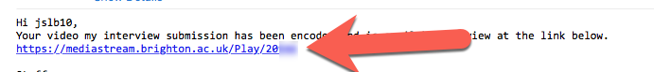
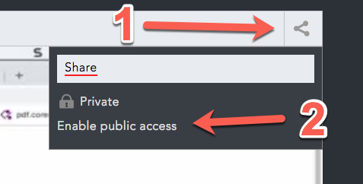
- Click on the first link within the email
You may need to login, if you have moved to another computer.
- In the top-right of the video, click the share button (1)
- Click the Enable public access option (2)
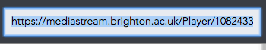
- A new link/URL will be revealed and you should copy this link and use it to share your video with others.
You should only send the link/URL to people that you wish to give access to view your video.

Troubleshooting
We recommend that you test that the URL/Link works correctly by logging-off from MediaStream and using the link to access the video. If you are able to view the video when not logged in to MediaStream then it is suitable for sharing.
Note that the link is not available via a search using google and only those with the link can view your video.

