Setting up randomisation in your online surveys
This guide will show you how to randomise the order in which elements of your survey, such as questions or blocks of questions, are presented to the participants.

Randomising answer choices
While you wouldn’t normally randomise choices on Likert scale questions, this option can be useful if, for example, you want participants to pick from a list of items but you want to counterbalance for the fact that people might be biased to pick items closer to the top of the list.
- Locate the question in the survey editing mode and click on the "settings" symbol on the left:
- Select "Randomisation". You can choose between "No Randomisation", "Randomise the order of all choices" or "Present only X of total choices" - this option allows you to present a random subset of all the choices.
- Click "Save".

Randomising questions within blocks
- Locate the block in the survey editing mode and clock on "Block Options" above the block
- Select "Question Randomisation". You can chose between "No Randomisation", "Randomise the order of all questions" or "Present only X of total questions" - this option allows you to present a random subset of all the questions.
- Click "Save"

Advanced randomization
If you need to randomise the answer choices or questions within blocks in a more complex way e.g. if you’d like to have some items in a fixed order and some randomised, click on "Block Options" > "Question randomisation" > "Set Up Advanced Randomisation"
- Fixed Display Order - allows you to change order in which the choices are displayed. You can also do this in the main editing window.
- Randomise Choices - move the choices you want to randomise from the list on the left to the box on the right. Choices that stay in the "Fixed Display Order" will not be randomised.
- Random Subset - this option will present a subset of choices in the blue box based on the number you define. The participants will then see X choices subsetted from the list, plus whatever is left in the "Fixed Display Order"
- Undisplayed Items - if you have items that you don’t want to be displayed, move them to this box. This option is useful if you want to remove items but your questionnaire has been live and collecting responses for a while. Removing items this way prevents data corruption.

Randomising whole blocks
- If you feel like you could use some extra help setting up your survey, get in touch with Joe or Click on "Survey Flow" on the bar above your survey title. The survey flow shows you exactly how blocks of questions will be presented to the participant. If you have a block in the survey editing mode but it’s not shown in the survey flow, the participants won’t be able to see it.
- Click on "Add a New Element Here" at the end of the Survey Flow. Select "Randomiser"
- Click on "Move" in the bottom right part of the Randomiser box, and drag and drop the Randomiser above the first block that you want to randomise.
- Click on "Move" in the one of the blocks that you want to randomise. Drag and drop it either on the purple Randomiser box or on "Add a New Element Here". Repeat this step until all of your blocks are attached to the randomiser.
- In the randomiser box, define the value for "Randomly present X of the following elements". If you want all of your blocks randomised, this value needs to be the same as the number of blocks you have. If you want only one of your blocks presented, set this value to be 1.
- Tick "Evenly Present Elements" if you want your blocks to be presented roughly equal number of times. This option is only relevant if you’re not presenting all the blocks all the time (e.g. if you have three blocks attached to the randomiser, but you only want the participant to see randomly picked one or two).
Qualtrics will keep count on how many times each block has been presented. If you click on "Edit Count", you’ll see that the values for these blocks are set to 0 and will start going up every time a block is presented. This includes presentations in Preview. To get the best balance, select "Reset all Counts" when you’re ready to launch the survey.
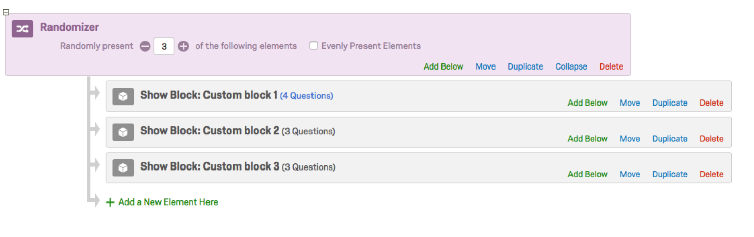

Need some help?
If you’ve got any questions or need additional guidance, e-mail Joe and Martina or stop by at the psychology lab for a chat. Visit the lab’s website for more Qualtrics guides.

