Online survey guide: Question types

STATIC CONTENT
- Descriptive text - present participants with a text to read or give them instructions
- Graphic - present images, videos, or audio files

standard Questions
- Multiple choice - enables single or multiple answer. Can be presented as a standard multiple-choice question, dropdown list, or a select box.
- Matrix table - allows you to ask multiple questions in a more compact space
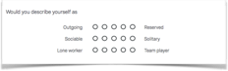
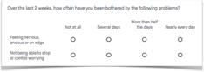

Example of a matrix question Example of a bipolar matrix
- Text entry - participants can enter text into a single line, multi-line or an essay sized text box. You can set requirements for a minimum amount of characters or set a maximum limit.
- Slider - asks participants to position themselves on a continuous scale.
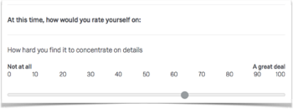

Example of a slider question
- Rank order - asks participants to rank items in a preferred order.
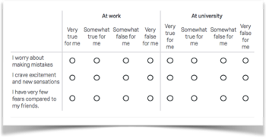
- Side by side - allows you to enquire about multiple dimensions of an item in a convenient way.

Example of a side by side question

Specialty questions
- Constant sum - asks participants to allocate a set amount of resources to different options (e.g. "How many hours a day do you spend doing the following activities…")
- Pick, group and rank - allows participants to sort items into groups and then assign ranks.
- Hot spot - You can define clickable areas on an image and ask participants to select one of the areas.
- Heat maps - Participants are able to click anywhere on an image. You can then analyse which parts of the image were most frequently clicked.
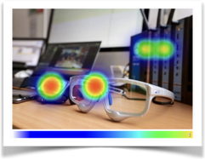
Example of a heat map
- Graphic sliders - combines regular slider questions with more engaging graphics
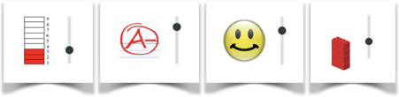
Examples of graphic sliders
- Gap analysis - ask follow-up questions if participants score too low or too high on one of the questionnaire items.
- Drill down - Participants first pick from a general drop-down list and from their answers are presented with specific follow-up lists to “drill down” to their answer.

ADVANCED
- Meta info questions - records information about the participant’s browser such as browser type, browser version, operating system and screen resolution. This question runs in the background and is not displayed to the participant.
- Timing question - records the time between the loading of the page and the first click, last click and the page submission as well as the number of clicks. You can set a limit for how minimum or maximum time spent on the page.

