QUANTITATIVE

How the lab can support students doing quantitative dissertations

Why should I read this?

As a psychology dissertation student your UniCard now gives you unlimited access to the lab in WB138 (first door on the left as you enter Watson Building from campus). This guide is for quantitative research. There is another for qualitative research. Click the blue links for further information where available.

Face-to-face studies
SONA enables you to manage recruitment of participants and book the experimental booths.

Online surveys
To run online surveys you must use Qualtrics because it is ethically compliant unlike online other providers. It is easy to create surveys such as Likert questionnaires as well as present images, video & audio. We also have a regularly updated database of over 90 freely available psychometric questionnaires with journal articles, as well as paper surveys. We can also lend you iPads for data collection if your supervisor agrees to you collecting data in this way.

Computer experiments
We offer 20 “off the shelf” experiments on a PsyCog CD and Cyberball. We can help you program your own experiment on SuperLab, such as an IAT or Stroop task. Response pads allow responses by pressing coloured keys or speaking aloud.

Measuring biometrics
We offer research grade equipment to explore unconscious processes.
You can use a bench mounted eye tracker or eye tracking glasses to measure where a participant is looking on a screen or in real life, and measure fixations and saccades.
NEW! We have a new wireless Epoc EEG headset to easily measure brain activity in response to anything, obtain graphs of: stress; engagement; interest; focus; excitement; relaxation.
You can use BioPac to measure subconscious psychophysiology such as skin conductance, heart rate and respiration rate, or create a lie detector.
We also offer a body analyser to measure body weight, body fat percentage, heart rate and air quality, finger pulse oximeter to measure pulse, a blood pressure cuff a simple EEG headset to detect a range of emotions..

New this year! Virtual Reality
We have 2 Oculus Go headsets to immerse people in virtual worlds, and funding to purchase apps from the Oculus store, if you and your supervisor agree to use it in your dissertation.

Other equipment
Wearable cameras, disguised camera glasses, stopwatches, hand tallies to count large numbers of people, ‘drunk buster’ goggles to simulate drunkness and cannabis intoxication, robot docks to observe rooms remotely, and a fake hand to create the rubber arm illusion.

Help with data analysis & design
All lab computers have SPSS, you can purchase SPSS for your own computer for £6 through the Computer Store. The lab and the psychology technicians provide a range of SPSS and data analysis help.
We can help you come up with ideas for your dissertation and experimental design even before you discuss your ideas with your supervisor - please pop into the lab and ask for Joe or Martina - your psychology technicians.

Lab spaces

Visit the website for virtual lab tour.

- 2-person soundproofed booths - Ideal computer presented experiments. Each has two seats and a computer.
- 3-4-person soundproofed booths - ideal for computer experiments.
- Teaching area - 8 computers with SPSS for use at any time. You can book the teaching area to run an experiment on 8 people at a time. And use smart whiteboard for group work.
- Creative methods lab – 15-person multifunctional space with Mac pro, 42” 3D HDTV and Nintendo Wii. Book via psychology technicians (agreement of your supervisor needed).Visit the website for virtual lab tour.

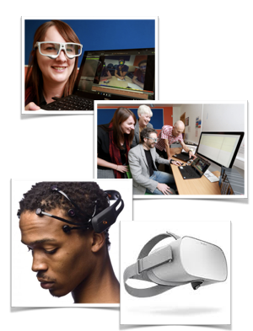

Want to know more?
Please speak to the Psychology Technicians if you have any questions about lab equipment, or you want any advice or technical help with anything the lab offers. They are in the office at the back of the lab, WB139 Watson Building, and would be delighted to help!

