QUALITATIVE

How the lab can support students doing qualitative dissertations

Why should I read this?

As a psychology dissertation student your UniCard now gives you unlimited access to the lab in WB138 (first door on the left as you enter Watson Building from campus). This guide is for qualitative research. There is another for quantitative research. Click the blue links for further information where available.

Help with recruiting participants
SONA enables you to manage recruitment of participants and book the interview booths.

Interviews and focus groups
We offer voice recorders to record interviews, and can back up your recordings and put them on a USB for you. We also have a windshield for recording outside.
The biggest chore is transcribing interviews and NEW FOR THIS YEAR we now offer headphones, transcription pedals and transcription software on all the teaching area computers to make transcription as easy as possible.

Social media analysis
Nvivo software now has an excellent ability to mine Twitter and Facebook data, and helps with visualising and analysing the data for content analysis. We offer the software in the lab and full training - please ask for a demo and help!

Online surveys
Although primarily used for surveys, Qualtrics is also excellent for qualitative research as it allows people to respond with large text answers. You can present images, video and audio. You must use Qualtrics for online research because it is ethically compliant unlike online other providers. We can also lend you iPads for data collection if your supervisor agrees to you collecting data in this way.

Qualitative data analysis
We offer NVivo on all the lab’s computers if you need to analyse qualitative data but don't like working with pen and paper. You can book the Smart whiteboard to help you organise and record your thoughts and themes. We offer Transana software to help you code and analyse video data.

Creative methods
We offer creative methods resources like Lego, plasticine, and craft materials. We have the original Rorschach (inkblot) Test for elicitation. We offer a graphics tablet to draw on a computer and create animations.
The creative methods lab offers a Mac Pro with iMovie, Final Cut Pro, Photoshop for video, audio, and image editing and production. The creative methods lab can be configured flexibly and includes a studio quality microphone.

Visual methods

We offer wearable cameras and spy glasses for covert recording, digital cameras, camcorders and tripods to facilitate higher quality video and audio. We offer robot docks to remotely control iPhone or camera and automatically follow somebody’s movement.

Consider eye tracking

You can use an eye tracker to record a participant looking at an image, video or website, and play it back to them and ask them questions about where they were looking.

We can help with ideas for your dissertation even before you discuss your ideas with your supervisor - please pop into the lab and ask for Joe or Martina - your psychology technicians.

Lab spaces

Visit the website for virtual lab tour.

- 2-person soundproofed booths - Ideal for one-to-one interviews or transcription. Each has two seats and a computer.
- 3-4-person soundproofed booths - Ideal for interviews and small focus groups.
- Teaching area - 8 computers with transcription pedals and software for use at any time. You can also book it to use the smart whiteboard for group work.
- Creative methods lab - 15-person multifunctional space with Mac pro, 42” 3D HDTV and Nintendo Wii. Ideal for focus groups. Book via psychology technicians (agreement of your supervisor needed)

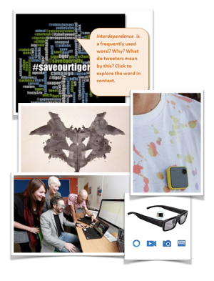

Want to know more?
Please speak to the Psychology Technicians if you have any questions about lab equipment, or you want any advice or technical help with anything the lab offers. They are in the office at the back of the lab, WB139 Watson Building, and would be delighted to help!

