Recording Sound/Mp3’s

- Ensure you have a microphone plugged into your computer.

- On your PC, click the start menu (windows logo bottom left) and search for ‘Sound’
Open the Sound Recorder program

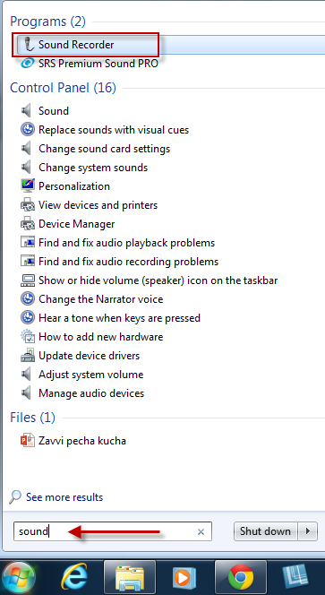

- You should see the sound recorder program on your screen. You can drag it around to a more suitable possible if needed (so you can see your powerpoint).

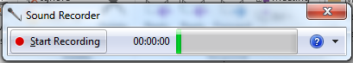

- You can test your microphone by talking – you should see the green bar move

- When ready, click ‘Start Recording’. When you’ve finished, click ‘Stop Recording’. You’ll be asked to save the file (e.g. Slide 1)

- You can then repeat the process for each slide of your powerpoint.

TIPS:
- To pause, click ‘Stop Recording’ and close the save menu that appears. You can then ‘Resume Recording’.
- If you need to restart, you can always close the software and reopen it.

