Your Blog Posts for Semester 1
As part of the formative tasks on this module we would like you to write 2 blog posts on the topic of cognitive psychology. To do this, we’d like you to use the University’s blogging network ‘Edublogs’ (http://blogs.brighton.ac.uk/). We’ve created blog classes for seminar tutors, and you should post to your seminar tutor’s class blog.
What should you blog about?
We’d like you to write 2 blog posts. To help with this, we’ve set some deadlines for when we’d like you to write your blog posts by, and what we’d like you to cover in each post. Your blog posts will be visible to your seminar tutor and students in your seminar tutor’s classes (each seminar tutor has 2 seminar groups for this module). There are no strict word count limits for your blog posts, but try to set yourself a limit of 400 words.
Blog post 1 - “The fun one” (posted by Friday 8th November): Tell us something interesting you’ve found out about cognitive psychology. Try to pitch your blog post as if you’re writing to an audience who don’t have a psychology background (i.e. a lay audience). Your post could be based on something you’ve read in a book, journal article, cognitive psychology website, or something you’ve seen posted in a psychology blog (e.g., http://web.colby.edu/cogblog/). You could include a study, a theory, a research technique, an aspect of cognitive neuropsychology, or cognitive neuroscience. You can use links and relevant images in your blog post.
Blog post 2 – “The academic one” (posted by Friday 6th December): Choose a concept/topic in cognitive psychology and summarise a research study you have found that examines this. Your post should describe the key concept and the research study (e.g., what was the aim of the study, how was the study carried out, what were the key findings, what conclusions were drawn). Remember you can use links and images in your blog post. Make sure you include the reference(s) for the research.
Feedback: Your seminar tutor will provide comments on your 2nd blog post, but ONLY if you’ve completed the 1st blog post. Remember you can read other students’ blog posts in your blog class and leave a nice/encouraging comment!
Why are we asking you to write a blog?
Blogging is great way to enhance your own understanding of a topic area, as you have to get to grips with the material you are writing about in order to tell others about it. There are lots of good examples of psychology blog posts (see: https://mindhacks.com/, https://digest.bps.org.uk/), and these blogs help to communicate research in an accessible way to a wider audience. Your blog posts are a “formative” task on this module. This means that you will not be assessed on your posts. The aim of writing the blogs is to: 1) help you gather research studies that you could potentially use in your essay assignment, 2) help to create a learning community with others on your course, and 3) give you experience of writing about psychology using a less formal but accessible way of writing, something you might not often be asked to do in your time at university.

How do I go about creating my blog?
- Go to a link below based on the seminar group your belong to:
  - Julie Morgan’s Seminar Groups C & F:
https://blogs.brighton.ac.uk/?join-invite-code=5908-juliecf
  - Charlie Lea’s Seminar Groups A & E:
https://blogs.brighton.ac.uk/?join-invite-code=5911-charlieae
  - Mark Wright’s Seminar Groups B & H:
https://blogs.brighton.ac.uk/?join-invite-code=5913-markbh
  - Becky Grists Seminar Groups D & G:
https://blogs.brighton.ac.uk/?join-invite-code=5915-beckydg
- You will be shown a page that prompts you to login, as shown in the screenshot below.
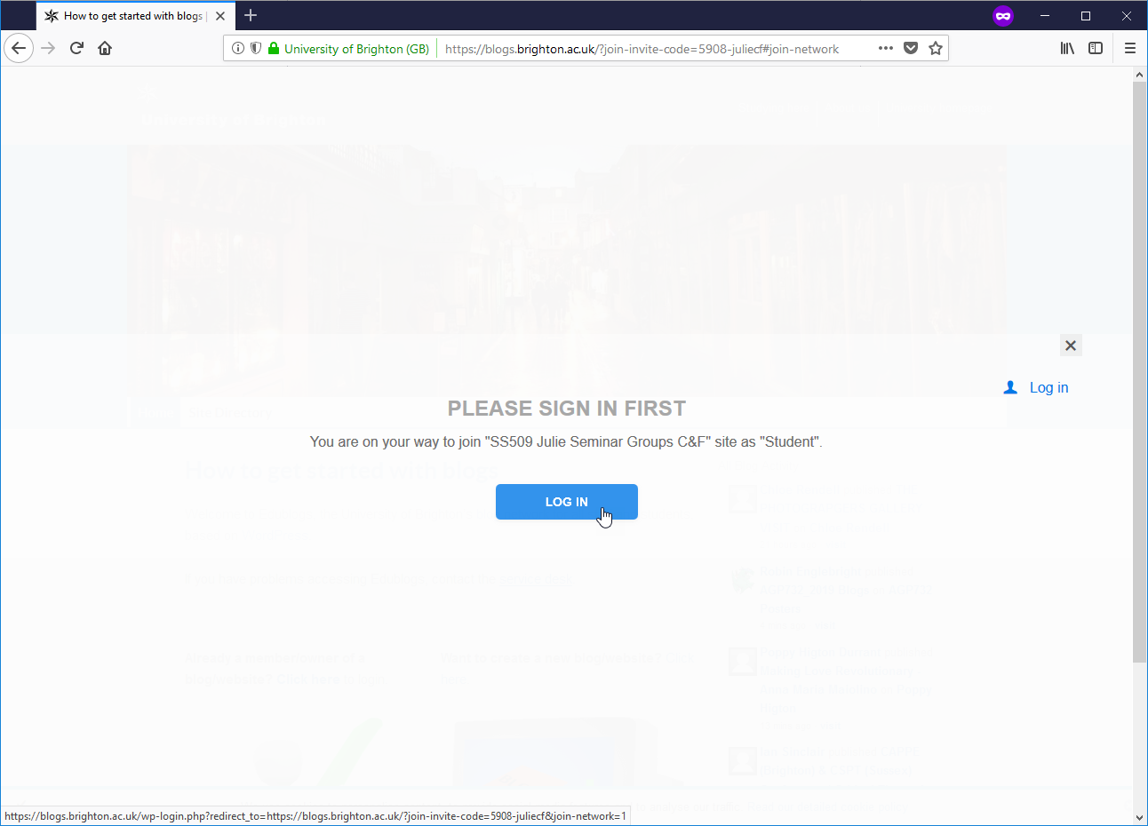
- Login in with the same credentials that you use for studentcentral (so username e.g. abc12 and password – example shown below).
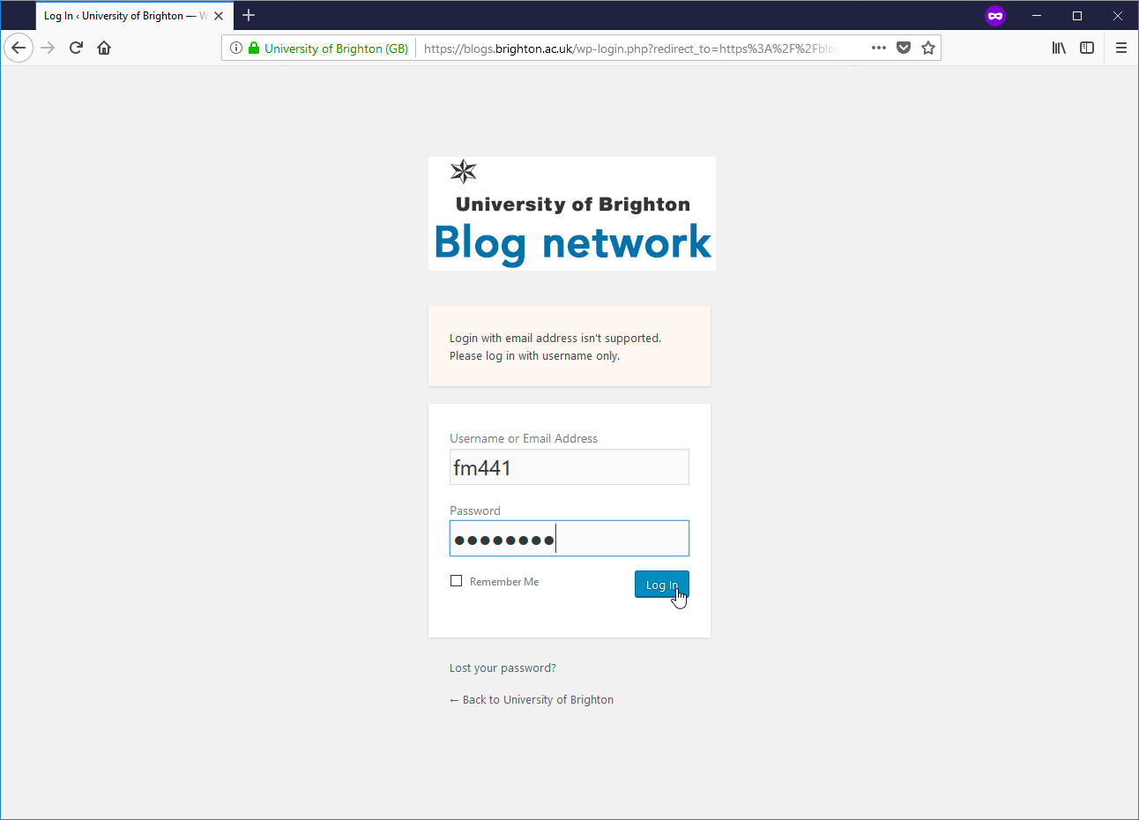
- On the next page write in the following information (see screenshot on next page):
  - Give your blog a title
  - Create a unique web address for your blog. It is helpful, but not essential for you to include ss509. What is important is that your web address is all lowercase and not too long (ideally under 10 character in the entry box). It must also be only alphanumeric – so no punctuation characters (e.g. &*$%)(_-+? ).
  - Agree to the terms of service for the University blogging service. If you click on the link you can read these in the same window.
  - Prove that you are not a robot by completing the reCAPTCHA challenge.
  - Click on the Create a blog button to confirm your changes.
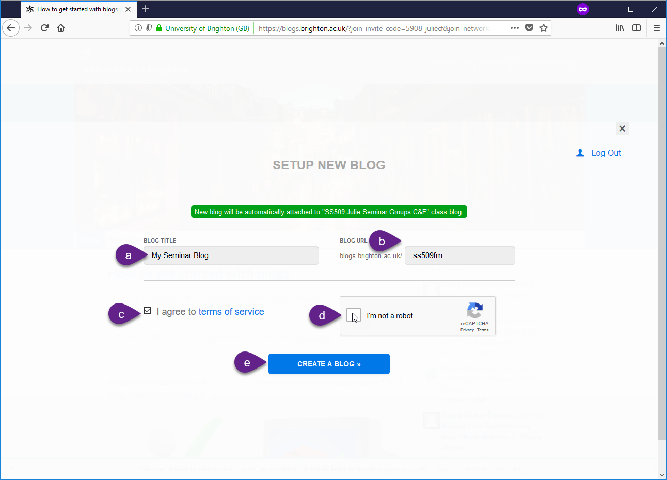
- After this screen, your new blog site will be automatically joined up to the class blogging site.
- To view other students’ blogs. Click on the view class blog button: 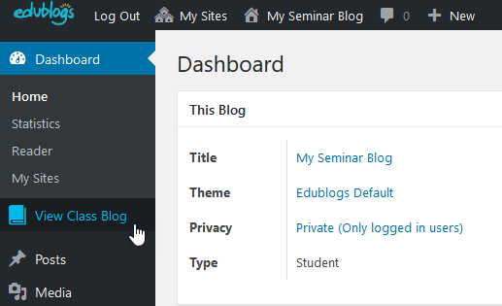
- The class blog features a list of students who are also blogging in your seminar group (see yellow area on the right in the screenshot below).
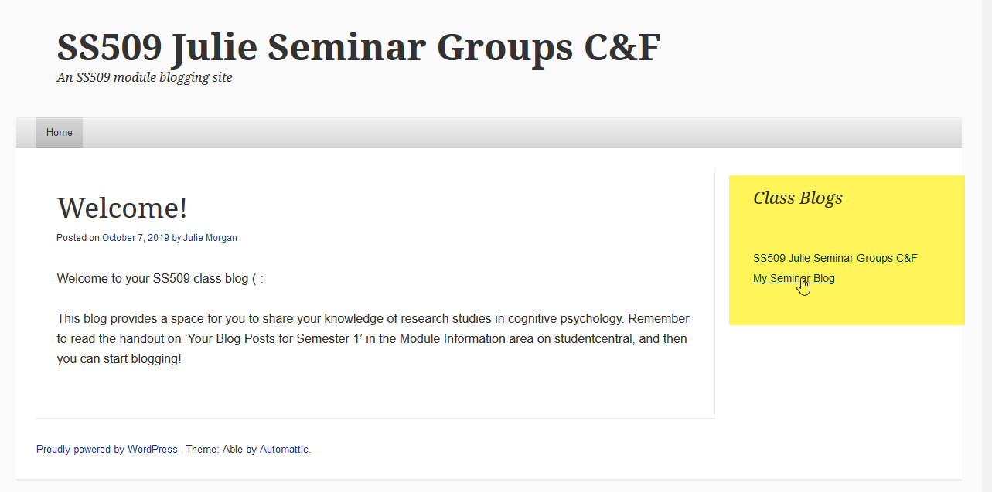

- You can also see a quick digest of blog posts from your seminar group in the reader area of your blog.
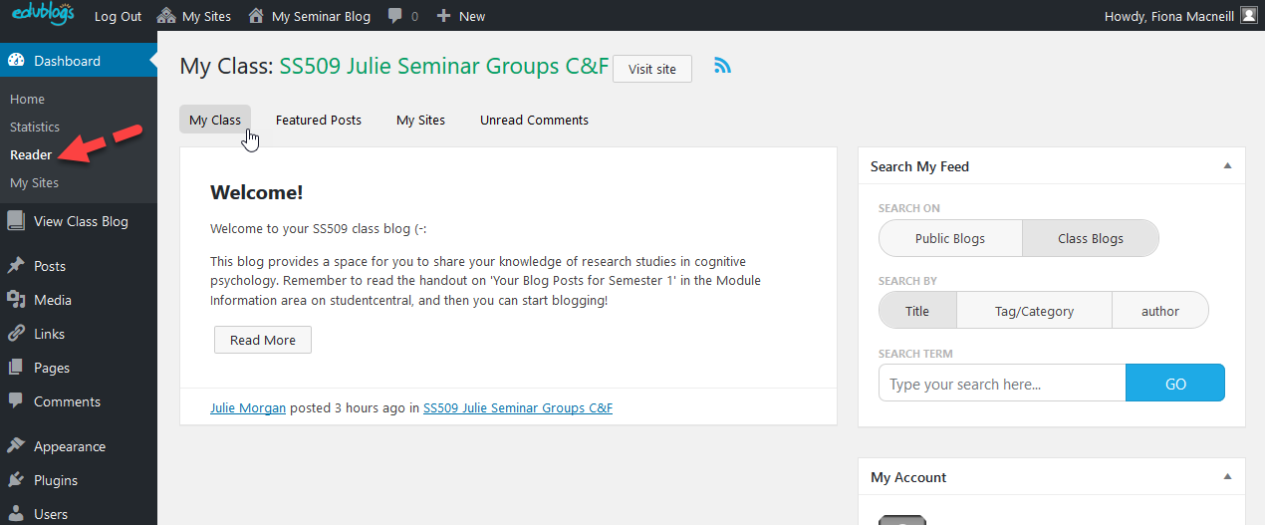

- Your new blog site is all yours and can persist after this module if you wish to continue with it.

  - To return to your blog in future, login to edublogs by going to https://blogs.brighton.ac.uk and clicking on the returning user link as shown in the screenshot below.
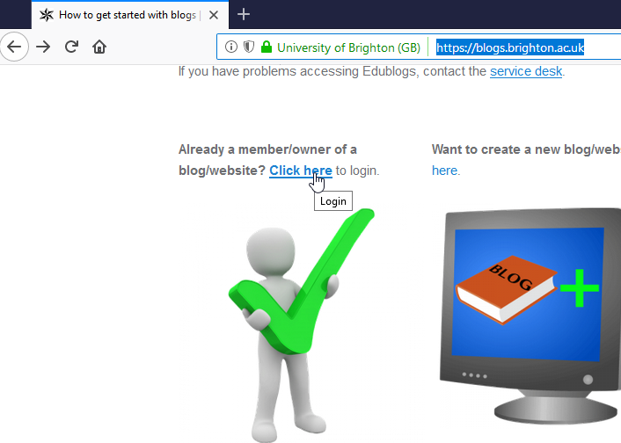
  - To start writing posts use the ‘+’ sign at the top of your blog dashboard. As shown in the screenshot below.
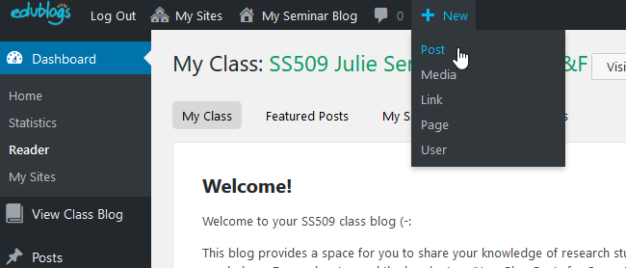
  - If you need help, video guides and resources are available at the Edublogs support site.
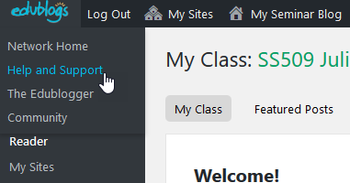
  - To personalise your blog and to add functionality please take a look at the following tutorial from Edublogs:
- Choosing a theme - http://help.edublogs.org/choosing-your-theme/

