How to find out your personal tutor
Finding out your allocated personal tutor
  - Login to studentcentral at: https://studentcentral.brighton.ac.uk
  - Go to the Personal Tab.
  - Scroll down the page and click on Details on the right-hand side of the title of your course.
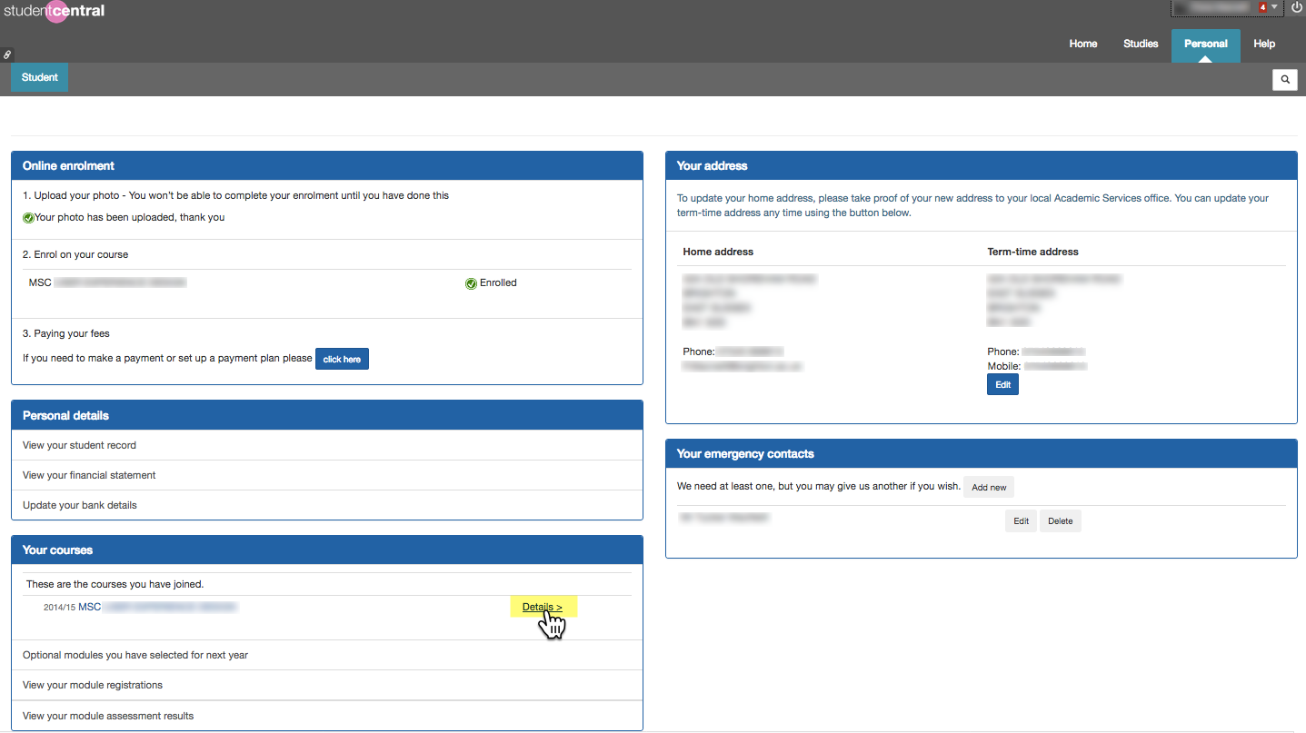
Close-up view of the Details link.
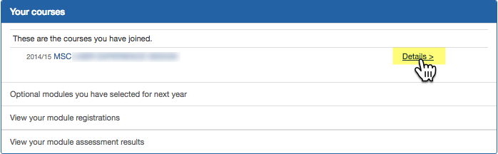

  - On the next page you will see the name of your person tutor.
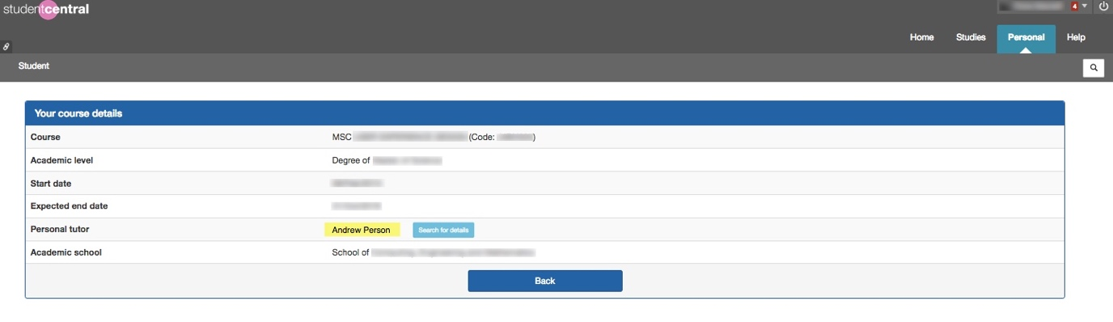
Close-up view of the Personal Tutor Name area.
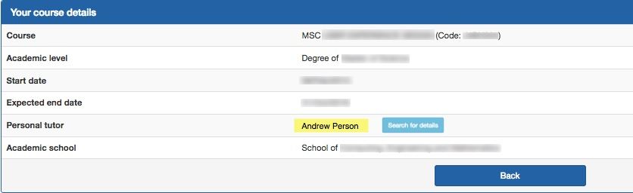
Please note: if your personal tutor is not shown here, please contact the school office.
  - You can use the Search for details button next to your personal tutor’s name to look-up their staff profile on the university website.
  - To contact your personal tutor:
In your student email, you can type your personal tutor’s name into the “To” field in order to find their contact details and send them an email.
