A quick start guide for workplace supervisors - email
Accessing your Brighton email account
Please note: it is not possible to setup an automatic forward from our email server to another work account. If you have a smartphone or tablet, it is advised that you add your Brighton account, so that it is easier to pick up your notifications. Instructions are included below.
This document explains how to access and manage your Exchange account using a web browser. To access staffmail via the web you should use one of the following recommended browsers:
- For PC’s, Internet Explorer 7 and later versions is recommended
- For Mac OS X, use either Safari 3.1 and later versions, or Firefox 3.0.1 and later versions.
- For computers with Linux, you can use Firefox 3.0.1 and later versions.
You may be able to use other browsers, but you will be restricted to the ‘Light’ client with fewer features.
*Note that only the Light client can be used with Internet Explorer 11

Connecting to staffmail (Brighton email account)
You can access the staffmail service by following the link on staffcentral, or going by directly to https://staffmail.brighton.ac.uk
We recommend bookmarking this in your web browser for ease of access.
To log on, enter your university username and password:
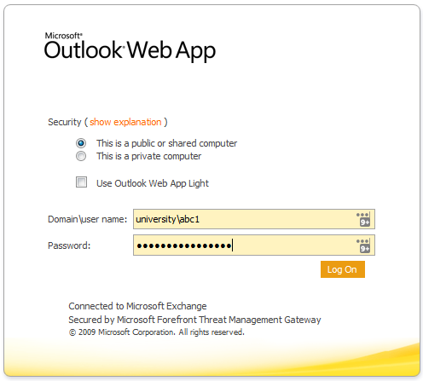
Outlook Web App Light is designed for people with slow internet connections or unsupported web browsers. It is faster but has less features than the full Outlook Web App.
If you select Public you will be logged out after 10 minutes.
If you select Private you will be logged out after 36 hours.

Add Staffmail to your mobile device (iPhone/iPad)
  - Tap the Settings icon on your device
  - Scroll down and tap Mail, Contacts, Calendars
  - Tap Add Account...
  - Tap Exchange
  - In the Email field, type in your university email address in full
  - Type in your password
  - Add a name for the account in Description (eg University mail)
  - Click Next
  - If you see a message saying Unable to verify certificate, just click the Accept button
  - At the next screen type staffmail.brighton.ac.uk into the Server field
  - Enter your university username and password
  - Click Next
  - If you want to sync Mail Contacts and Calendars, just tap Save. Otherwise, tap to deselect the services you don't need, then tap Save

Add Staffmail to your mobile device (Android)
  - Go to Email
  - Tap “Add Account”
  - Enter your full university email address and your usual university password
  - Tap Manual Setup then choose Microsoft Exchange Activesync
  - Change Domain:User name to your university username
  - Leave the Password field unchanged
  - Enter staffmail.brighton.ac.uk as the Exchange server
  - Tick “Use secure connection (SSL)”
  - Tap Next
  - There will be a pause while the phone checks the server details
  - Tap Yes when you see the Remote security administration prompt
  - Choose what you would like to sync and when, and how many days worth of email and appointments you’d like to sync and tap next
  - Give the account a name, and tap Done

Add Staffmail to your mobile device (Windows phone)
  - Swipe to the left to view the Apps list, then tap Settings:
  - Tap email+accounts
  - Tap add an account
  - Tap Outlook
  - Enter your full email address (usually initial(s).surname@brighton.ac.uk) and usual university password, then tap sign in
  - Ensure that your email address is correct, and enter your usual university username in the username box. If you’re unable to proceed without entering a domain, enter university. When you’re done, tap sign in again.
  - There will be a delay while your phone synchronises, when it’s done you should see your account listed.

