Using the SET CE standard Rubric

How to access the Rubric
NOTE – To access the rubric ad adapt it for your own use you need to have either:
- Already have a Turnitin Submission point set up on the module or
- Use an old module on which a Turnitin submission point already exists

- Open the module and go to the Control Panel>Course Tools>Turnitin Assignments
- Click on the title of the Turnitin Submission point. This give you access to a Turnitin inbox and also your Turnitin Libraries where you Rubrics are located.
NOTE – Once you create or copy a Rubric into your library you can use it on any submission point you set up.
- Now click on the Libraries tab
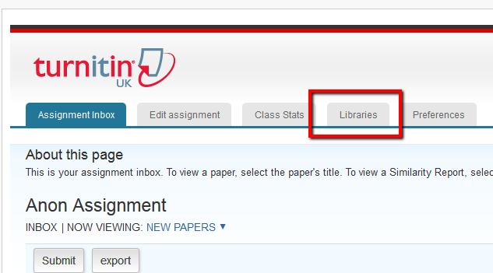
- Now click on Rubric/Form Manager
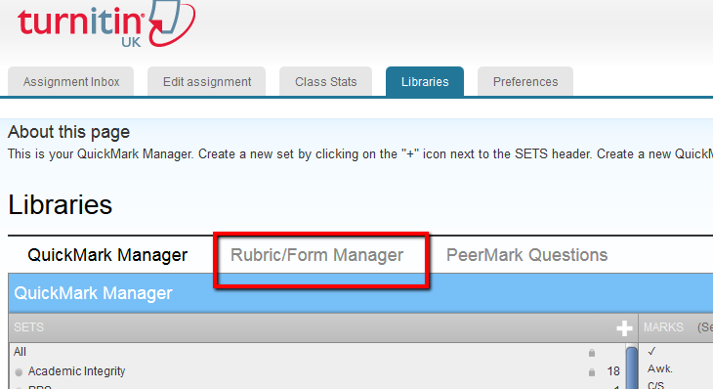
- 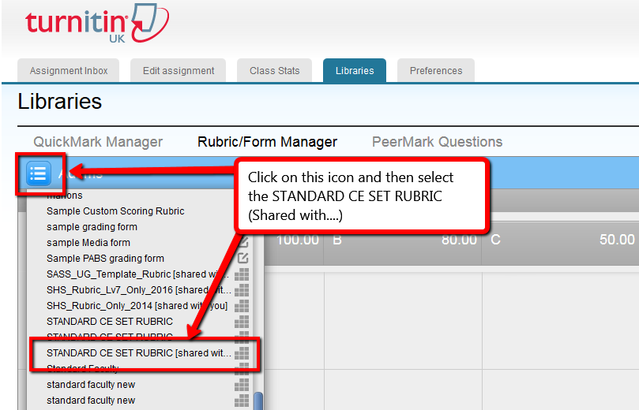

Editing the Rubric
- Now you’ve located and opened the Rubric you need to take a copy before editing the details for your own use
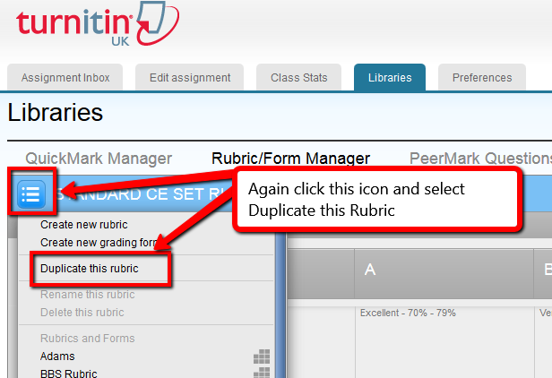
- Now all fields of the Rubric are editable, so you can and details relevant to your module. You can also add more Learning Outcomes if required.
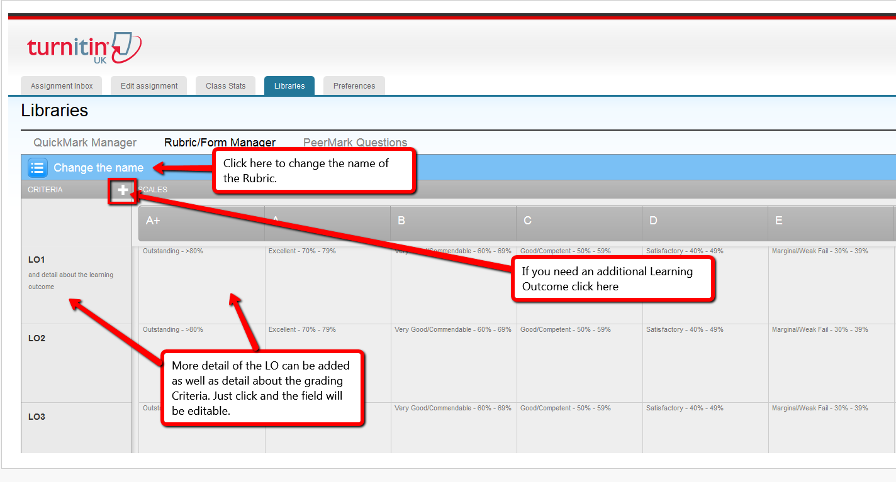
- Once done click the Save button.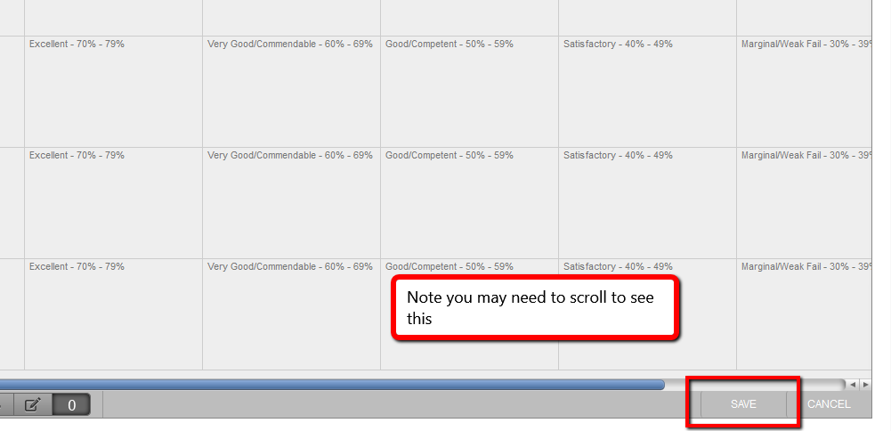

Attaching and using the Rubric
You can attach the Rubric either when creating the submission point or, if already created, by editing the submission point. Both are available from the same screen under ‘more options’
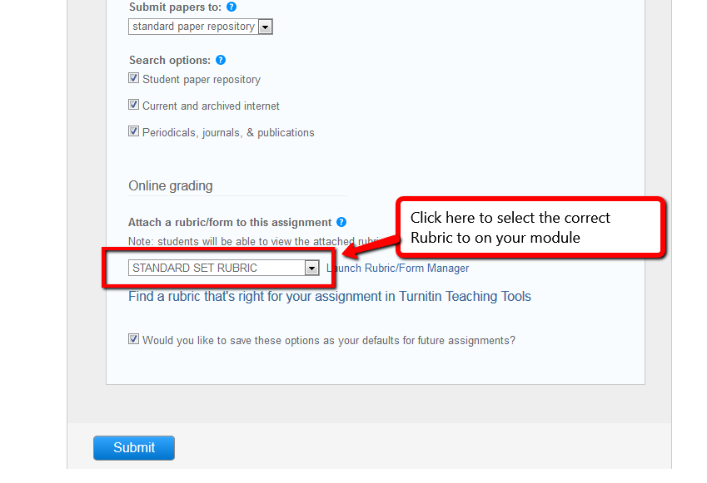

Marking using a Rubric
Once students have submitted their papers this is how you access the Rubric and mark against it.
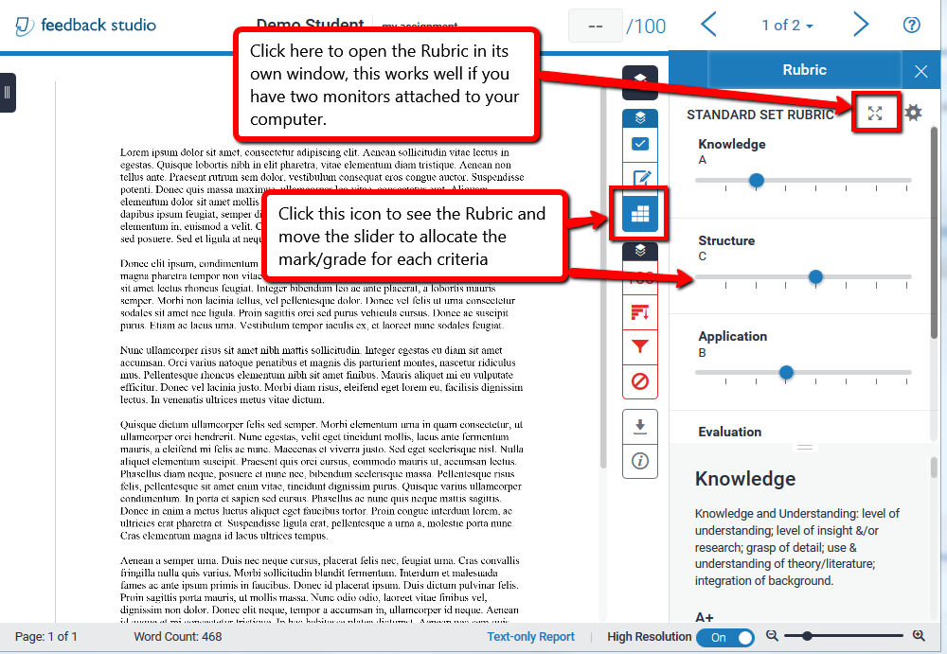
To complete the feedback you need to use the General Comments field to provide details on: Strengths, Areas to improve, To take forward in future assignments
