How a group submission point needs to be set up.
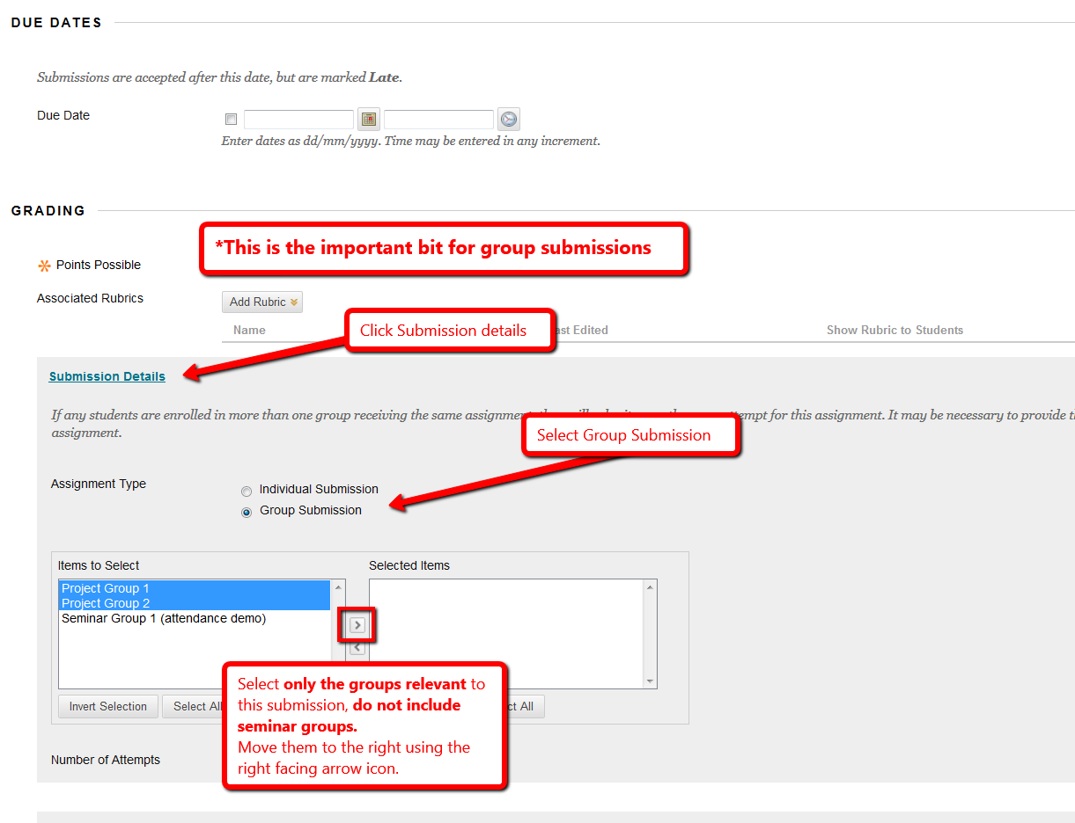
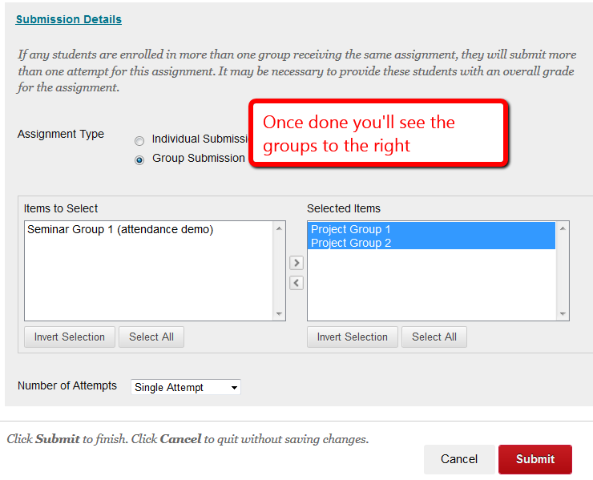

How to check existing submissions
If already set as a group submission you will see the groups involved in the submission. If there are groups listed that shouldn’t be that could mean students are in more than one group so the system won’t know which group to assign their submitted paper to. You will need to set it up again. See example below, which includes seminar groups in error.
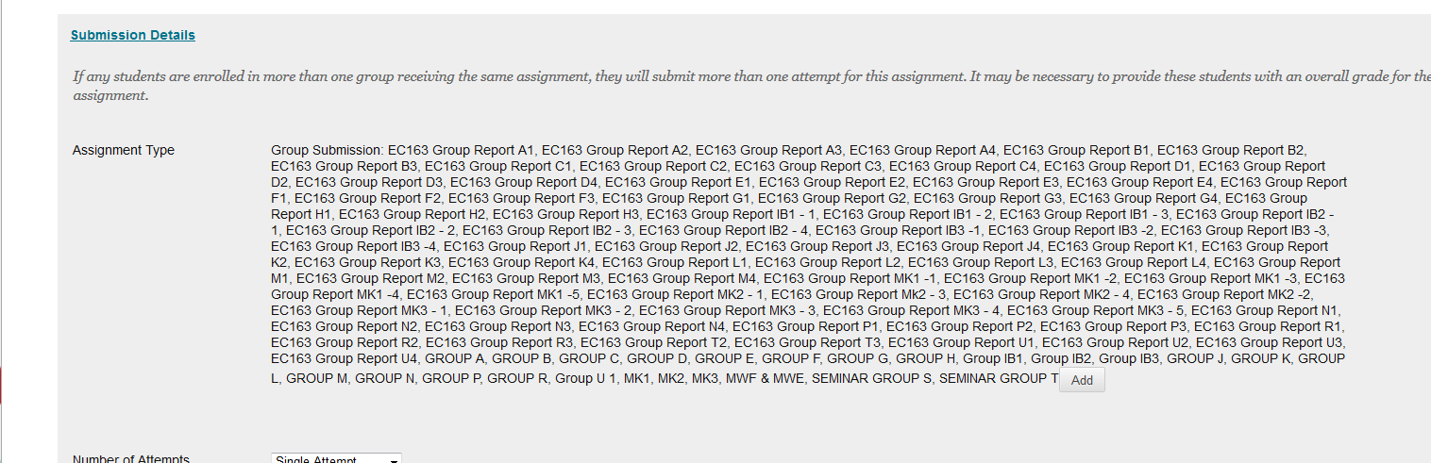
If set to individual submission not group submission again it will need to be set up again.

