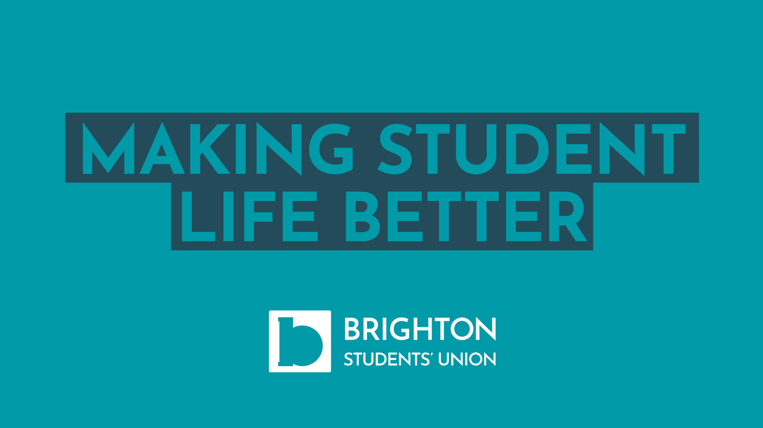

Brighton Students’ Union
The Students’ Union is an independent organisation that it set up to represent and support all the students at University of Brighton. BSU’s mission is to make student life better and this is done through providing a number of services and activities:

Advice and support for students facing difficulties
BSU Support are a team of professional advisers that provide independent and confidential support to students on matters such as: appeals, complaints, academic misconduct and mitigating circumstances.

You can reach them on bsusupport@brighton.ac.uk or visit www.brightonsu.com/support for more information.

Activities and Societies
The SU support over 100 societies which are a great way for students to get more involved in Uni life, and find like-minded students to create their own communities.

Check out the full list of societies, including how students join or start up their own, at www.brightonsu.com/societies.

Representing the student voice
BSU is led by a team of elected full-time and volunteer officers who are students at University of Brighton. They campaign on issues that affect the university experience and represent the student voice in meetings and committees, plus represent Brighton students at national level through NUS. We also run and support the Course Rep system, where there is a representative on every course at every level.

You can find out more at www.brightonsu.com/studentvoice.

Cafes and Shops
There are multiple SU cafes and shops across campus that provide students with budget-friendly food and supplies:
Grand Parade Art Shop (supplies high quality art equipment and materials)
Basement Central Café in Cockcroft, Moulsecoomb
Cockcroft SU Shop
Mithras House Shop (additionally supplies architecture materials)
The Hive Café in Ringmer House, Falmer
Falmer SU Shop

Visit www.brightonsu.com/shopsandcafes for more information.

Employability Skills
Students can gain a whole variety of great employability skills through working and volunteering with BSU. Over 150 student staff work as part of commercial and membership services within the union from retail and customer service to admin and communications. Also there are a number of voluntary opportunities for students to get involved with from society leaders to Course Reps.

