School of Environment and Technology
Personal Academic Tutoring Policy
Personal Academic Tutors in SET play a crucial role in supporting all students, not just those who are facing problems. This support extends from identifying students experiencing difficulty and signposting them to the range of additional support available to signposting tutees to opportunities designed to develop and extend them such as volunteering. A personal academic tutor (PAT) needs to be supportive and encouraging. Occasionally, PATs may also have to identify and discuss poor student engagement. Students arrive with a variety of entry qualifications (including low or non-tariff), from a range of participation neighbourhoods, with almost a quarter from the most disadvantaged areas (POLAR Q1 & 2).
Students from such backgrounds may lack the cultural capital which aids transition to Higher Education and are likely to also have the additional pressures of part time work or other responsibilities which compete for their time. Additionally this group of students are less likely to actively seek support when experiencing problems. Research into retention has shown that an early informal discussion/meeting about how students are settling in will help them make the transition to university more effectively and also identify any issues or concerns before these reach crisis point.
This policy document sets out the role and responsibilities of the personal academic tutor, how this role sits within the wider context of student support in the School and beyond, and outlines the personal academic tutoring system in the School. Specific practices at subject area level are outlined at the end of the document.
For guidance on personal academic tutoring and links to the University policy, see the CLT page here: https://staff.brighton.ac.uk/clt/Pages/CurrDev/personal-tutoring.aspx

The role of the Personal Academic Tutor (PAT)
A personal academic tutor:
- Provides a central point of consistent contact within the academic team for the student and to foster a sense of ‘belonging’ to the University, through creating a sense of academic community with the School.
- Provides information and guidance on Institutional processes, procedures and expectations
- Supports students to alleviate anxiety about what is expected academically (e.g. independent study) and to aid transition to Higher Education
- Refers students to other support services as required (SSGT, Student Services)
- Provides a holistic support for retention, progression and success for all students
- Supports students in regularly reviewing their academic progress and performance in line with the Personal Academic Tutoring policy
- Supports students’ awareness and use of academic feedback.
- Encourages students to reflect on their formal and informal learning more broadly (rather than focusing on individual modules) and how it contributes to their future development and career

Responsibilities of the PAT
- Maintaining regular contact with each tutee, the minimum of 3 times per year as per the Personal Academic Tutoring Policy.
- Welcoming tutees to Brighton, where possible this should be during the “post online enrolment” period (late summer and into welcome week)
- Following up students who are not attending classes regularly (including to scheduled Personal Academic Tutorials)
- Having a good awareness of tutee progression and engagement through MyGrades and other learning analytics
- Ensuring each individual student is known and valued and that their needs are recognised and supported.
- Encouraging and assisting with reflection on progress to date (including reflection on academic grades and feedback) and following up students who are not making satisfactory progress
- Liaising with other members of academic staff as appropriate (e.g. module leaders, module tutors, course leader)
- Referring to SSGT or Student Services as needed
- Advising and supporting tutees, for example, with the procedures for Mitigating Circumstances, late submissions
- Ensuring students know how to contact their personal academic tutor and how to request an individual meeting
- Responding promptly (maximum of 5 working days but preferably within 24 hours) to a request for contact or support from a tutee and to provide an alternative point of contact when unavailable through clear out of office messaging
- Discussing future employability and skills development planning and signpost students to Careers service where students can receive support for career planning, skills development and employability.
- Signposting students to correct complaints or appeal procedures if required and the help available through the SU Support Service.
- Helping students think beyond the course and encourage your tutees to actively participate in university life. Praising success; encouraging students to take on challenging activities.
- Maintaining confidentiality of the tutorial meetings unless the students is deemed to be a danger to themselves or others or discloses a disability which needs a referral to the SSGT and the disability team.
- Recording attendance at Personal Academic Tutorial meetings/tutorials (group and individual)
- Writing references.
- Advising tutees who are thinking about withdrawing from their course.

Support for Personal Academic Tutors
- As a personal academic tutor you can received support and training for this role from the Centre for Learning and Teaching (CLT), please contact your Deputy Head (L&T) to arrange this on an individual or group basis.
- A set of resources will be available for all staff on the CLT website and on the Student Services Website https://staff.brighton.ac.uk/clt/Pages/CurrDev/personal-tutoring.aspx
- A new member of staff will have a workshop on the role of the Personal Academic Tutor as part of their induction process with the CLT, to be arranged by the DH (L&T) or the staff member’s Line Manager.
- Your Deputy Head of School (L&T) is the designated lead in the School for Personal Academic Tutoring and will provide advice on any issues where guidance is required
- You can decline to act as the Personal Academic Tutor for individual students in exceptional circumstances and this will be managed by the DH (L&T)
- The role of the personal academic tutor will be recognised in your workload

Resources for Personal Academic Tutors

SET is piloting ‘Student Lookup’. From your StudentCentral home page there is a link which will enable you to ‘view’ your personal academic tutee, once tutor names and students have been set up on central systems. See image on next page for details.

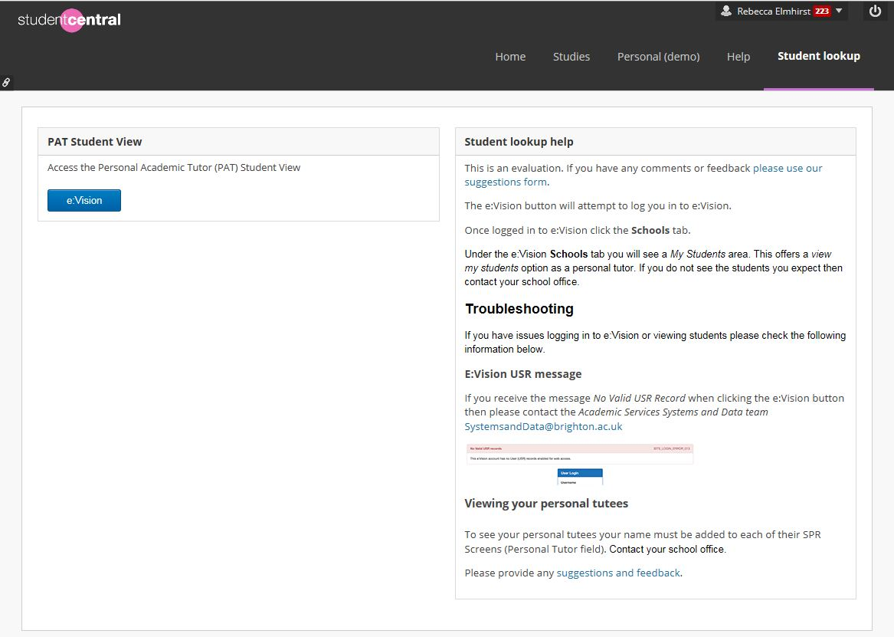

How the role of the Personal Academic Tutor works in relation to other course staff:
Module Leader and Module Tutors
The Personal Academic Tutor should not be answering specific questions about individual modules and module content and the student should be referred to the module leader or tutor
- Module Leaders provide a point of contact regarding academic content of modules for students, therefore are in a position to recognise students experiencing specific challenges. Attendance at lectures and tutorials, particularly at the start of semester 1, will be recorded in order to monitor student engagement. This will also serve as early identification of any students who may be at risk and in need of additional support, the module leader will discuss this with the Personal Academic Tutor.
- Module Leaders will make the Personal Academic Tutor aware of any concerns over their personal tutees

Course Leader
- Dealing with requests for extensions to deadlines for students on the course, using the appropriate University form (e.g. ARGEAR 1);
- Liaise with personal academic tutors as necessary.
- Holds responsibility for monitoring personal academic tutorial attendance

Subject Leader
- Providing the Personal Academic Tutors and Course administration team with a list of personal academic tutor allocations
- Liaise with personal tutors as necessary.
- Ensuring that the induction week programme is organised and appropriately co-ordinated. For some subject area in SET this role is devolved to the personal academic tutorials coordinator.

Student Support and Guidance Tutor
- All schools within the University have an assigned Student Support and Guidance Tutor (SSGT). SSGTs offer an invaluable source of information and advice to students and can be contacted by email, phone or in person. Contact details are advertised on posters throughout the school, online on StudentCentral and in-person introductions are made during induction week. SSGT’s are available to discuss a range of issues such as; homesickness and loneliness, problems with accommodation, problems adapting to study, difficulties with the course or decisions about potentially changing direction, stress-related issues and mitigating circumstances.

Deputy Head (L&T)
- Monitors the implementation of the Personal Academic Tutoring Policy through school boards and the SET Education and Student Experience Committee.
- Ensures that a process of attendance monitoring of Personal Academic Tutorials is in place
- Is responsible for agreeing School practice on recording outcomes of personal tutorials to maintain confidentiality (e.g. tutors emailing tutees the agreed actions or agreed outcomes of a meeting)
- Ensuring Personal Academic Tutors dealing with students under the age of 18 and vulnerable adults are aware of the safeguarding procedures, students services can provide support for this.

Other Academic Staff/Programme Administrator/Technical Staff
Technical and school office staff have key roles within the student experience, they often have first line contact with students and are often in a position to identify student who are experiencing difficulties
- Referring students to Personal Academic Tutors as necessary
- Programme administrator will provide personal academic tutors with information on students with a WP ‘flag’ on entry
- Programme administrators will hold a list of personal academic tutor allocations

STUDENT SERVICES

Student Services is a central department that provide a range of services to support students through university and to help them get the most from their student experience. Informatin on Student Services is available here: https://staff.brighton.ac.uk/ss/Pages/Home.aspx

Experienced and supportive staff offer advice on a range of issues, including:
- Advice about money worries and how to live on a budget.
- Support in finding jobs and volunteering opportunities.
- Help accessing academic support if students have a disability, learning difficulty or long-term medical condition.
- One to one support for students with worries or concerns in a safe, confidential space.

Below is an outline of some of the ways in which they assist students.

Careers Service
A range of services to support students to build employability skills and boost graduate potential - careers guidance, enterprise skills, and employment and volunteering opportunities. In addition, the course Career Planning Agreement can help students identify the employability skills they are developing from their academic study.

Chaplaincy
For all faiths or none, social events, retreats, worship, discussion, support and listening.

Childcare
With two Ofsted rated nurseries open to children of staff, students and the local community, the University of Brighton is an excellent choice for high quality, affordable and flexible childcare.

Counselling
Students can access Counselling for any reason – if academic life is a cause for concern, or for personal reasons. Counselling offers a safe and confidential space for student to discuss their issues. In the first instance students are offered an assessment appointment, followed by further guidance and support or referral to appropriate agencies.

Disability and dyslexia support
Support for students with a disability, specific learning difficulty or long term-health condition. We encourage students to disclose as soon as they can, so they can take advantage of the wide range of academic and personal support available.
Health and wellbeing
We have local links with GP surgeries (Eastbourne and Moulsecoomb) and health and wellbeing information and workshops to help students keep their minds and bodies in balance and get the most out of university.

Student Advice Service
When it comes to student finances at university it pays to be money wise; so for expert advice on financial issues, including fees, grants, bursaries, loans, and money management, contact the Student Advice Service. They can also help international students needing immigration advice, and help settling into the UK academic life.

Getting in touch
Further (student-facing) information about our services is available at http://www.brighton.ac.uk/current-students/index.aspx , or students can also access us via the ‘help and advice’ tab on student central for access to FAQs, ask a question or book appointments.

Email at studentservices@brighton.ac.uk access at each campus by visiting our student centres, or call us to find out more or book an appointment.
Eastbourne - Trevin Towers, Gaudick Road T: 01273 643845
Falmer –Student Centre, E Wing Checkland Building T: 01273 643584
Grand Parade – Student Centre, Ground Floor, main building T: 01273 643187
Moulsecoomb - Manor House, Moulsecoomb Place T: 01273 642895
Hastings – The Student Centre, Level 1, Priory Square T: 01273 644643

STUDENTS’ UNION SUPPORT
Union Support offer free, confidential & impartial advice to students.
Our team of advisers are very experienced in assisting students with any queries about their courses and can help if things go wrong.
We actively support hundreds of students every year by helping them make appeals, raise and resolve complaints, guide them through academic misconduct, disciplinary and fitness to practice matters, as well as gain extensions and support claims for mitigating circumstances.

In addition we help those who are in debt to the university and those having problems on their course. We always try to offer the information, advice or representation they need to make their situation better. If we can’t help we’ll find someone who can.
bsusupportservice@brighton.ac.uk
www.brightonsu.com/support
Students at Risk: Cause for Concern Procedure
Cause for Concern Procedure
https://staff.brighton.ac.uk/ss/Documents/Cause%20for%20concern.pdf
Personal Academic Tutoring in SET: Subject Area Arrangements
All subject areas in SET are required to offer scheduled individual personal academic tutorials three times per year at each Level of study. Personal academic tutors are allocated during welcome week of Level 4 (and Engineering foundation year). All students are advised that they can arrange individual meetings with their PAT on an ad hoc basis. Students are provided with email and telephone contact details to enable them to do this. Students should expect to remain with the same PAT throughout their course. Where a change is required (due to staff long term absence or departure), this is communicated immediately to the student.
Individual personal academic tutorials are held as follows:
At Level 4/foundation: emphasis at this level is on settling in and managing progression
Welcome week: group meeting
Early November: invitation for personal academic tutorial to check settling in and progress to date
Early semester 2: invitation for personal academic tutorial to check progress in sem 1 assessments and set goals for semester 2
April/May semester 2: invitation for personal academic tutorial to support student pathways (where there are option modules or possibilities to transfer to another subject area course), plans for subsequent year, and preparation for semester 2 assessments
At Level 5: emphasis at this level is on managing progression and enhancing employability skills through reflective learning.
October: to check settling in to Level 5, progress to date following first year
Early semester 2: invitation for personal academic tutorial to check progress in sem 1 assessments and set goals for semester 2
April/May semester 2: invitation for personal academic tutorial to support student pathways (where there are option modules), plans for subsequent year, and preparation for semester 2 assessments
At Level 6: emphasis at this level is on ensuring attainment and enhancing transition from university through reflective learning.
October: to check settling in to Level 6, progress to date following second year results
Early semester 2: invitation for personal academic tutorial to check progress in sem 1 assessments and set goals for semester 2
May semester 2: invitation for personal academic tutorial to support post-graduation student pathways and support plans for subsequent year

In ADDITION to the above, the following tutorial arrangements are in place to link PATs into modules.

GEOGRAPHY AND ENVIRONMENT
Group personal academic tutorials are held during welcome week, and the PAT supports induction into university systems (StudentCentral, module registration). Following induction, there are 6 further group study skills workshops during week 1 of teaching and in weeks 3, 4, 9, 10, 11, and 16. These meetings are held as part of GY471 Academic and Field Skills. All PATs are provided with a workshop plan for each of these sessions. These workshops are aimed at providing a supportive environment in which to make a smooth transition between college and University learning.
Group personal academic tutorials are also held within the core module GY572 Practising Geography, Archaeology and Environmental Sciences. At the start of semester 2 there is a second PAT, which focuses on student reflection on progression and attainment. Students are advised that they can arrange individual meetings with their PAT on an ad hoc basis.

CIVIL ENGINEERING
At Foundation Level: The personal academic tutors (PAT) for Engineering Foundation Year students are Civil Engineering academic staff. The students are invited to a first meeting by their PAT. The PATs invite through e-mail their tutees for a second meeting to discuss their progress and their settling in the University Environment. The Personal academic tutoring is managed by the CEM school office who track (through a SharePoint excel file) the attendance of students to the meetings.
At Level 4: each incoming student is allocated a personal academic tutor (PAT) during welcome week, whilst Foundation students continue with their PAT. Group workshops run by personal academic tutors with their tutees are held during welcome week and the PAT supports induction into university systems, to open door policy, campus tour, civil engineering laboratories, key member of staff offices, School Office.
Two meetings are scheduled within the module Civil Engineering Practice (CE472) in the first semester where the PAT will supervise the coursework assignment to the students and will provide the feedback, so to support student awareness and use of feedback. In the second semester there are two additional meeting scheduled in which the members of staff support the students during the Engineering for People Challenge.

BUILT ENVIRONMENT
At Level 4: Group personal academic tutorials are held during welcome week, and the PAT supports induction into university systems (Student Central, module registration). Following this, two further formal one to one meetings are scheduled as part of BE415 (Introduction to the Built Environment), these take place to coincide with the submission and feedback of two formative reports which are marked by the PAT. In addition to providing detailed feedback on the student’s submissions, the tutorials are planned to discuss any other areas of the course/university life that the student wishes too. The first one to one tutorial is planned in November, and the second in February, this also allows the PAT and student to review any Semester 1 marks and discuss progress so far.

MSc Personal Tutoring
MSc courses in the Geography subject area: Each L7 student is allocated a personal academic tutor during induction and there are 3 one-to-one meetings in the year of study. The role of the Personal Academic Tutor is part of a wider team to offer support to the students as there are responsibilities which lie with other colleagues to offer support.
MSc courses in the Civil Engineering subject area: the Course Leader acts as Personal Academic Tutor who provides overarching guidance which is not related to the content of individual modules, this includes assisting students to understand the value of feedback and aiding them in developing skills to reflect on their own skills and experience and provides relevant information about what the university expects of the student and relevant policies and procedures according to the University Personal Academic Tutoring policy.

see UoB cause for concern procedure https://staff.brighton.ac.uk/ss/Documents/Cause%20for%20concern.pdf and/or the UoB disability disclosure policy https://staff.brighton.ac.uk/ss/Documents/Disability%20Disclosure%20Policy.pdf
The procedure in SET for withdrawal is in this document: https://staff.brighton.ac.uk/reg/raf/docs/Guidance%20on%20processing%20student%20withdrawals%20and%20intermissions%20FINAL.docx

