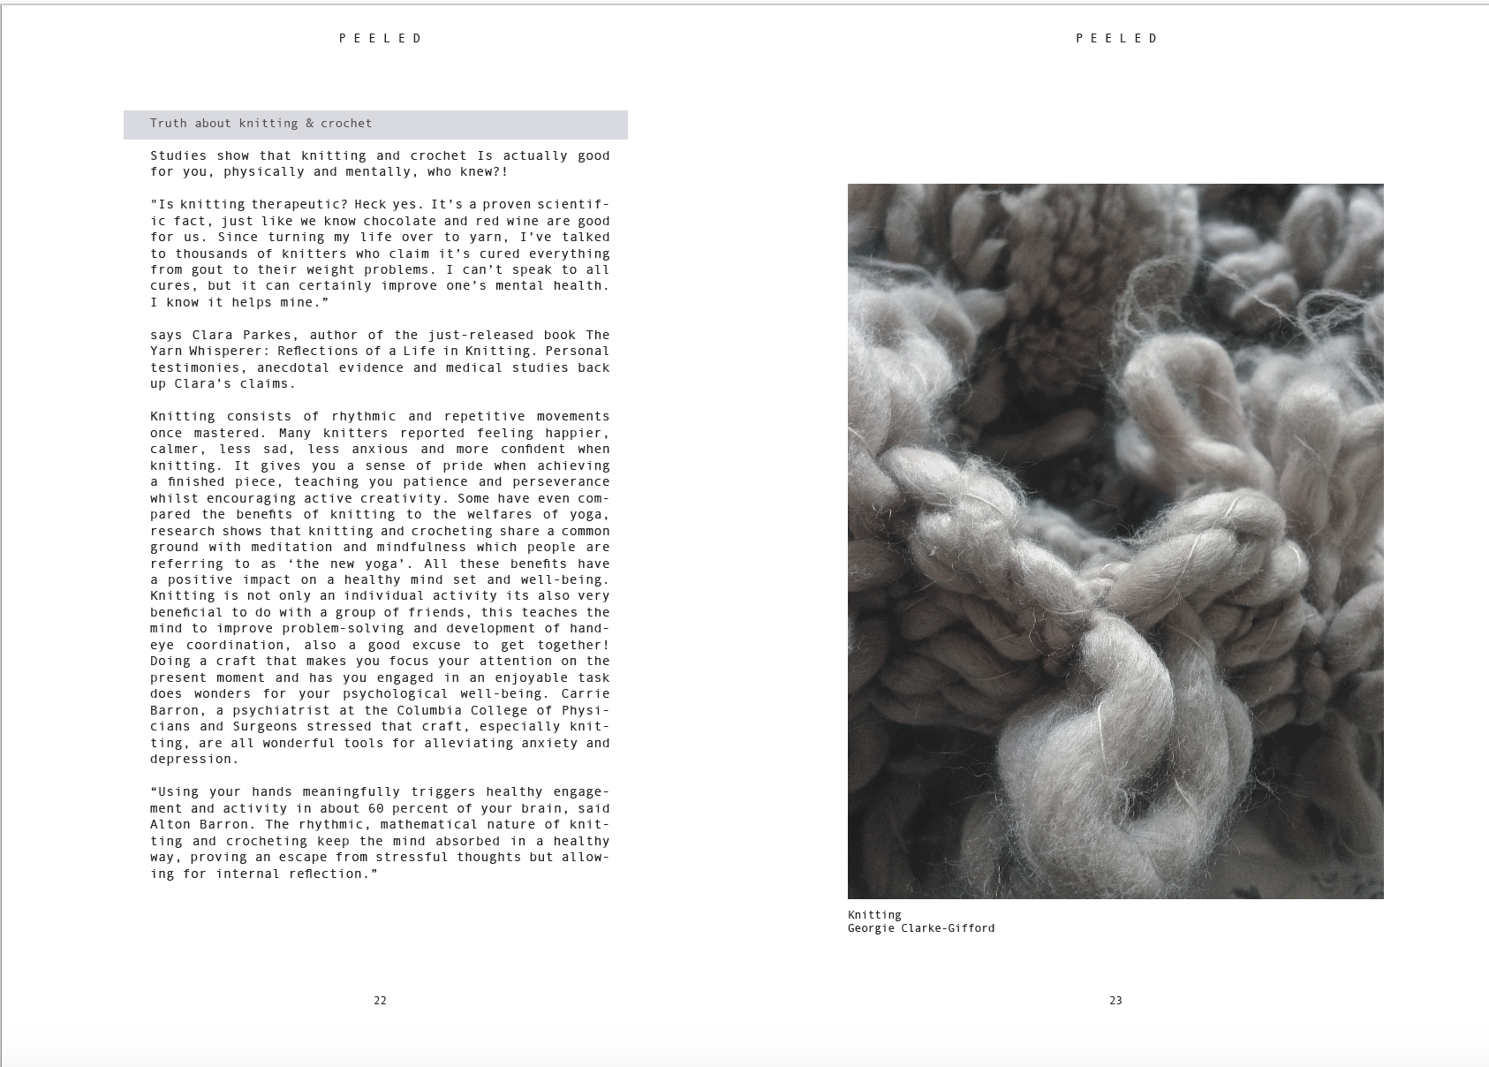

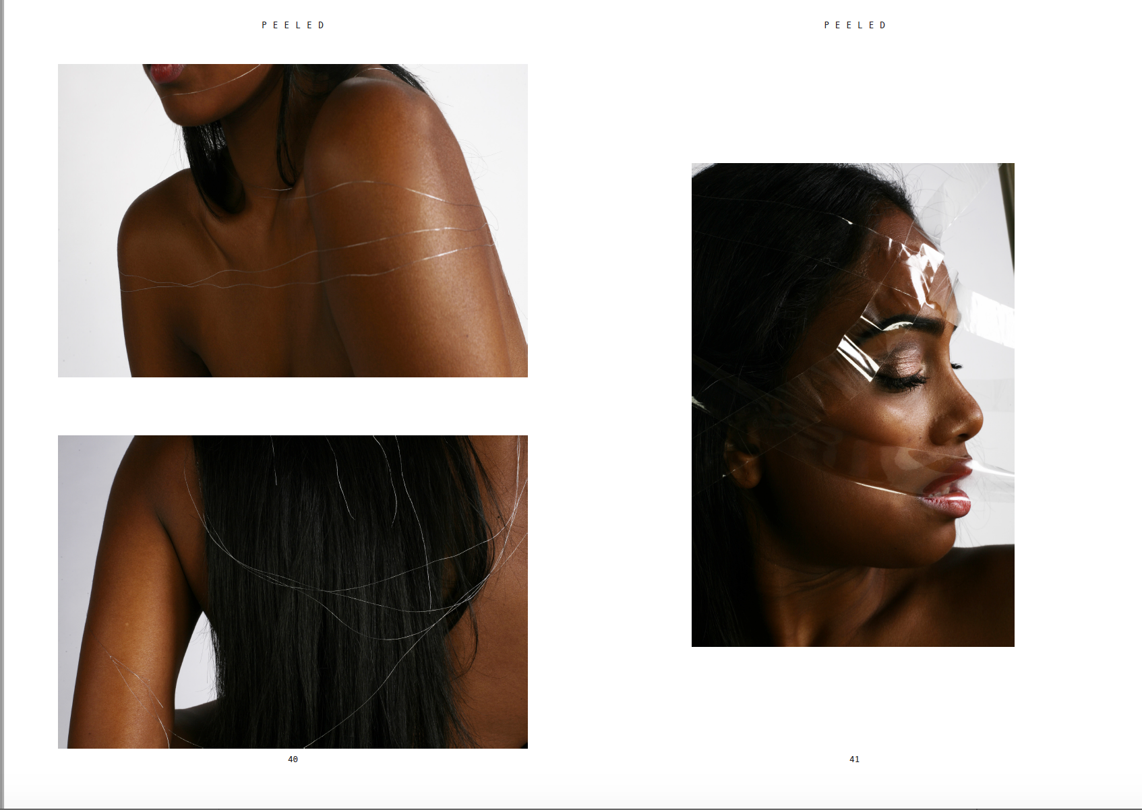

Peeled Magazine
Peeled is an organic magazine exploring the positive attitudes of fashion and healthy living through aesthetics. It is minimal in style yet dynamic with specialised content, printed on organic and recycled paper. It includes healthy food recipes, home made body scrub recipes, yoga tutorials, stylising help, subject matters regarding mental health issues and much more.

As a hardworking and environmentally friendly team we have produced a high quality, innovative magazine that explores issues and topics including mental health that are unspoken of in fashion today. Research has been put in place by a multitude of students to explore the real meaning of ‘healthy lifestyle’ and how one could improve there lifestyle by the smallest of things. Therefore we have found ways for one to embrace imperfections, insecurities and vulnerability by empowering of the mind and loving yourself for who you are.

Detail is at the forefront of Peeled magazine. We have thought strongly being the concept of the name ‘peeled’ as it signifies the unravelling of oneself, in order to understand and find themselves in a positive and enlightening way. Therefore a holistic approach informs all content throughout the magazine and supplies engaging ways to deal with lives challenges.

Unwanted exposure is about peeling away the layers of to reveal the real and natural beauty within. Therefore by reinforcing the acceptance of imperfections we have produced fashion shoots involving minimal, natural materials, by subtly exposing the figure, combined with a minimal use of make up.

Peeled magazine gets involved with recreational activities and hobbies such as knitting. They have been scientifically proven in order to reduce stress release which is a very common issue. This relates back to mental health and aids one who may be suffering to get involved.

Peeled magazine has an extremely relaxed approach in which individuals can self reflect upon. The topics covered are all coherent and hope it helps people have a healthier approach to there life style.

The target demographic is aged around 20 - 30 as we feel the content targets those who look to enjoy the simple things in life and pleasures like eating healthy.

The RRP is £8.00 for one issue.

The new, dynamic magazine ‘Peeled’ will be launched at the Barbican conservatory on April 28th.
Silk St, London EC2Y 8DS

Visit us on:
Website - www.peeledmag.co.uk
Instagram - @peeled_mag
Email - peeled@mag.co.uk

