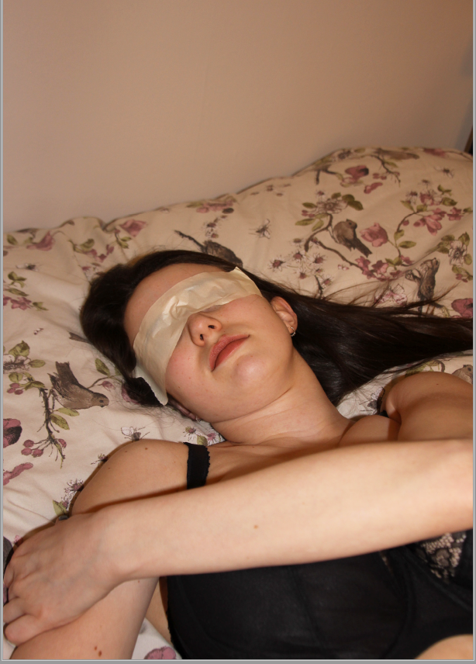

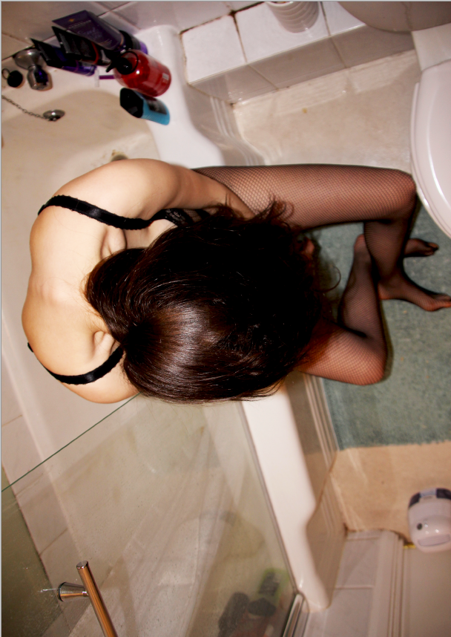
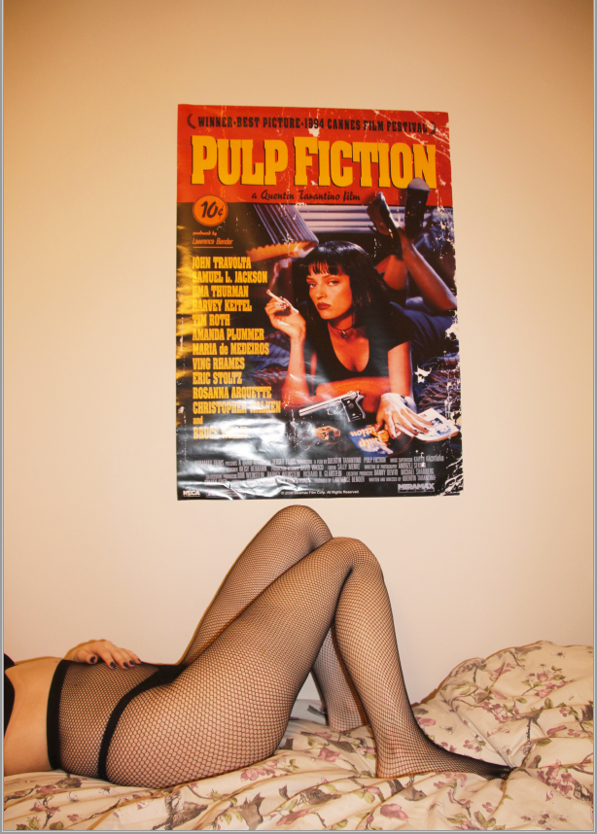

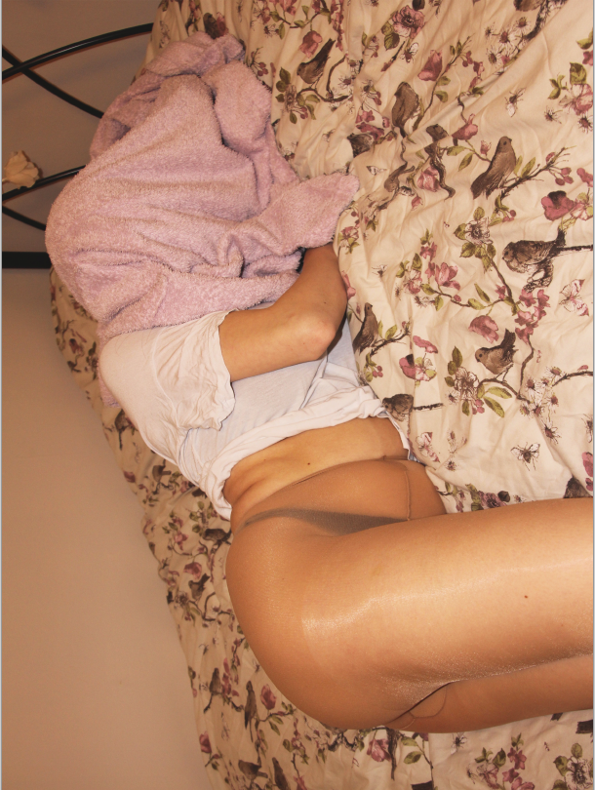

The Un-named
The Un-named is a body of work comprising of a series of photographs exploring sexualisation of the female body and its objectification. Representations of body sexualisation are in place with the removal of personal identity in order to highlight the ‘imperfect’ areas of the body. The images may be perceived in a sexualising way however they convey underlying issues which effect society today. The photographs are displayed on large billboards to enhance the perception of the unnamed girl, who feels like an oversized object.

Social media platforms have strongly impacted the way one is perceived in the 21st century; which one may argue has strongly impacted the rise in mental health issues. One may exploit themselves and there body through sites such as Instagram to gain confidence and convey themselves similarly to another popular Instagram user. There is now a strenuous link to mental health issues such as anorexia, bulimia e.t.c. and the communication platforms as individuals unconsciously compare themselves to others even though they can be very deceiving.

The feeling of pity lead by the characteristic of objectification that one may feel due to how photographs are perceived. As one may view a photograph and think its the most beautiful thing they've ever seen, whereas another may perceive it in a negative way. Therefore exploring identity and body composition will hopefully entice the viewer to want to find out who the unnamed girl is.

The Un-named collection hopes to build awareness that insecurities and self hatred is a common occurrence in society today however should not be the norm. After conducting numerous surveys and interviews the results show three in five individuals (mainly females) have a role model which aids them to change there self image.

The Un-named primarily shows how society today is strongly influenced by trends of visual appearance. These are starting to reflecting in personalities and unhealthy mental issues.

The collection of images are devoted for those aged around 16 - 35 who struggle with body image and want there photographs to be seen by others in a light of objectification. Also for those who constantly worry about there image and how many see those elements of there imperfections as beautiful.

The Unnamed collection will be exhibited on second floor at The Photographers' Gallery, 16 - 18 Ramillies St, London W1F 7LW from 10th August until 10th December.

Visit us on:
Gallery Website - http://thephotographersgallery.org.uk
Website - www.TheUnnamed.co.uk
Instagram - @TheUnnamed
Email - Unnamed@series.co.uk

