Creating multiple groups and Smartviews in studentcentral for managing projects and group submissions

Creating studentcentral Manual Enrol Group Sets
The group set allows you to set up a number of groups all at once.
This guide explains how this works for manual enrol groups. Manual enrol groups are Blackboard groups on to which you, the instructor, manually enrol students.
Control Panel
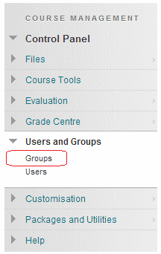
1. From your course Control Panel expand the Users and Groups section and click on Groups.
Group Set
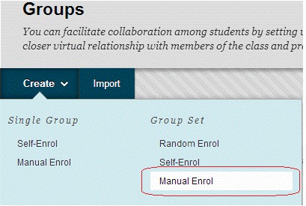
2. Hover your mouse over Create Group Set and choose Manual Enrol.
Name and Description
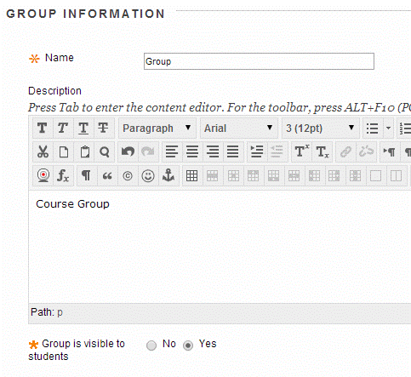
3. Enter a Name for the group. Later, depending on how many groups you request are created, Blackboard will add a number onto the name you choose. For example if you just enter “Group” and later choose to make five groups, Blackboard will call them Group 1, Group 2, Group 3, Group 4, and Group 5.
4. Enter a description if you wish.
5. If you wish for students to access the group, make sure Group Visible is set to Yes. If you only wish to use the group for your own purposes such as Adaptive Release or to email groups of students then do not make the group available.
Tools
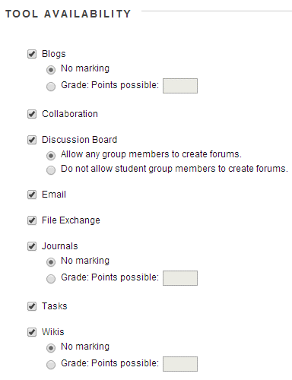
6. Choose which tools should be made available for the group to use.
Personalisation
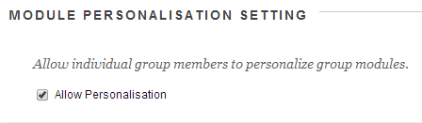
7. If you wish to allow the members of the group a small degree of freedom to personalise their group space select Allow Personalisation.
Number of groups
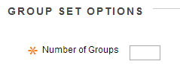
10. Enter the number of groups that you wish to make.
Smartview (check this box for your groups)
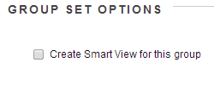
11. If you wish to have a smart view for the group shown in the Grade Centre tick this box. NOTE check this box as a default because you never know when it may be useful.

12. Click Submit.
Options
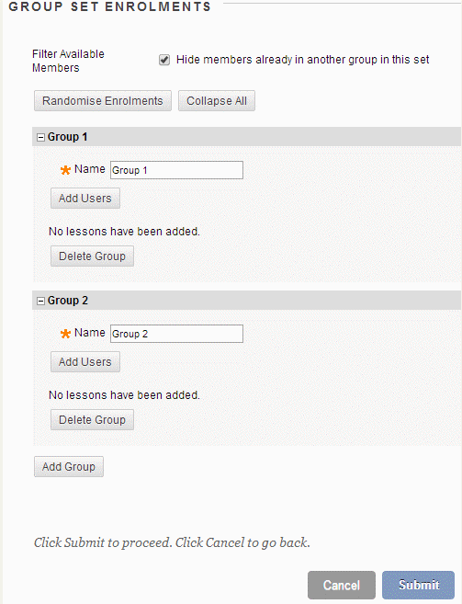
13. The next page is where you may add users to the groups you have created.
Filter Available Members – Hide members already in another group in this set.
Ticking this box (which is the default selection) means that as you allocate members to a group they are removed from the list of those who could be allocated to other groups. So if you un-tick the box then you can add a user to more than one of the groups.
Randomise Enrolments
Although Manual Enrol Group Sets are supposed to have individual members selected by hand you may automatically place students into the groups at random. A better choice would have been to create a “random enrol” group set. See the guide under What’s related to the right.
Add Users
Add users to each group by clicking on the corresponding Add Users button. Clicking this button brings up a list of course users and you may select from this list who should be place in which group.
Delete Group
If you realise that you created too many groups in this set you may delete superfluous groups.
14. Click on Submit to finish.

Creating studentcentral Self–Enrol Group Sets
The group set allows you to set up a number of groups all at once.
This section explains how this works for self-enrol groups. Self-Enrol groups enable you to set up groups into which students can self-enrol, useful for projects, events etc.
Note that when you make a self-enrol group set students can only join one of the groups.
Users and Groups
1. From your course Control Panel expand the Users and Groups section and click on Groups.
Group Sets
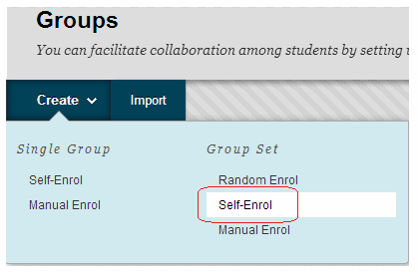
2. Hover your mouse over Create Group Set and choose Self-Enrol.
Name
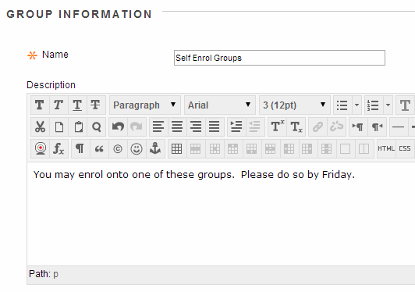
3. Enter a name for the group set. Blackboard will take this name and then add a number to it automatically depending on the number of groups you choose to set up. For example if you just enter “Group” and later choose to make 5 groups, Blackboard will call them Group 1, Group 2, Group 3, Group 4, and Group 5.
4. Enter a description if you wish. This description will be repeated for each group, so is not very useful.
How does it look?
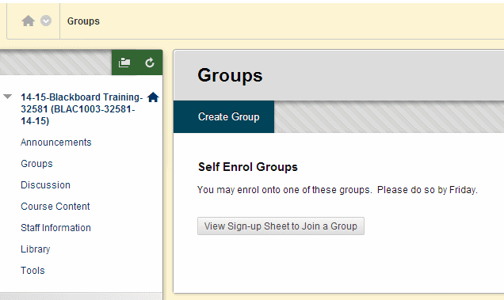
This screenshot shows how the settings chosen in the previous slide look from the student’s point of view.
First from the groups page it shows the name chosen and the description.
How does it look? (2)
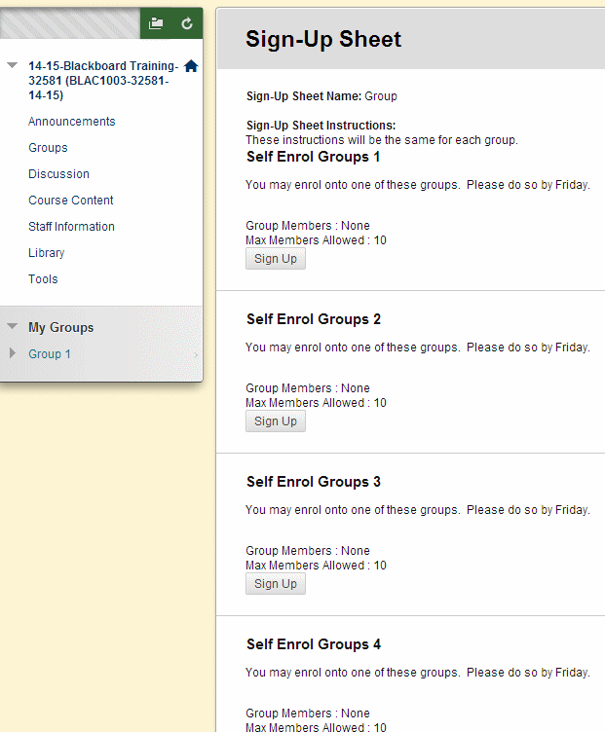
Then once the student has clicked to view the signup sheets they see the list of groups that use the name you chose, plus the number. The description is shown again.
Option
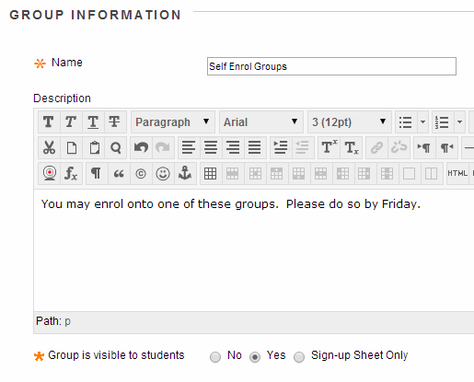
5. If you wish for students to access the group, make sure Group Visible is set to Yes. If you only wish to use the group for your own purposes such as Adaptive Release or to email groups of students then do not make the group available.
Sign-Up Sheet Only means that the students can sign up to join the group, but none of the group functionality will be made available to them and they will not be able to go into their “group area”. They will not be able to see who else is in the group even if you have enabled this option below. Therefore in most circumstances it is better not to use this option and instead make the group available.
Tools
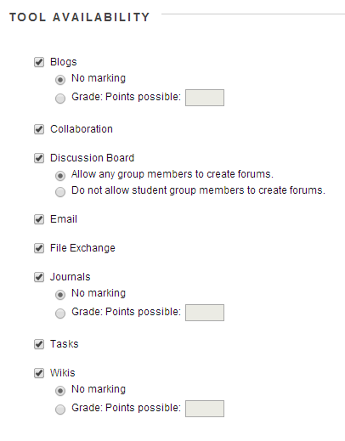
6. Choose which tools should be made available for the group to use.
Personalisation
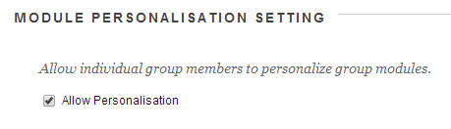
7. If you wish to allow the members of the group a small degree of freedom to personalise their group space select Allow Personalisation.
Instructions
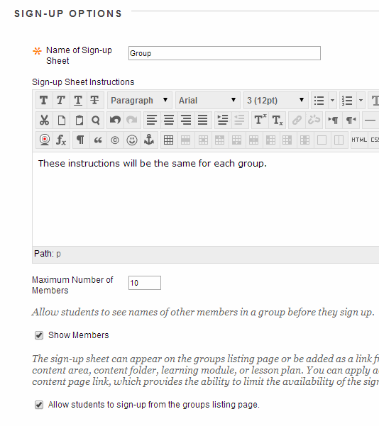
8. Enter a sign-up sheet name and instructions. The Sign Up Sheet Name and Instructions are shown when students are choosing which sign up group to join.
9. Set the following options according to your preference.
Maximum Number of Members
Set the maximum number of users who may be members of this group.
Show Members
If you would like to let users see who else is in the group before they join tick this box.
Allow Students to sign up from the Groups listing page
If you only want students to be able to sign up at any time from the Groups area tick this box. However if you want to restrict the availability of when students can sign up do not tick this box. You would then need to add a link to this group from a content area. This can be done from any content area by going to Add Interactive Tool and then choosing Group.
How it looks
The image above shows how the Sign Up Sheet Name and Instructions are shown to the student. You can see them at the top of the screenshot above.
Number of groups
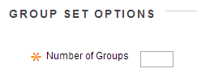
10. Enter the number of groups that you wish to make.
Smart Views (make sure you check this box)
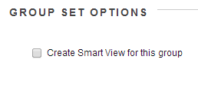
11. If you wish to have a smart view for the group shown in the Grade Centre tick this box.
12. Click Submit.

Smart views and the Grade centre in studentcentral
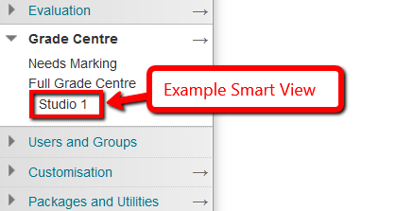
Because when you set up the groups you checked the box Create Smart View for this Group, you can now easily see you group in the Grade Centre by making your Smart Views a favourite.
- Go to the Control Panel>Grade Centre>Full Grade Centre
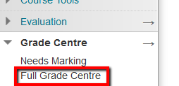
- Click the Manage button and select Smart Views
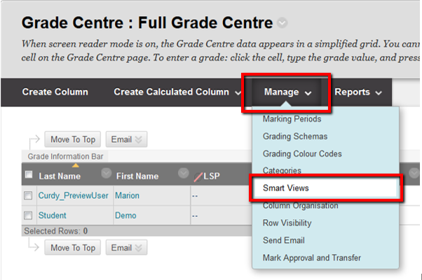
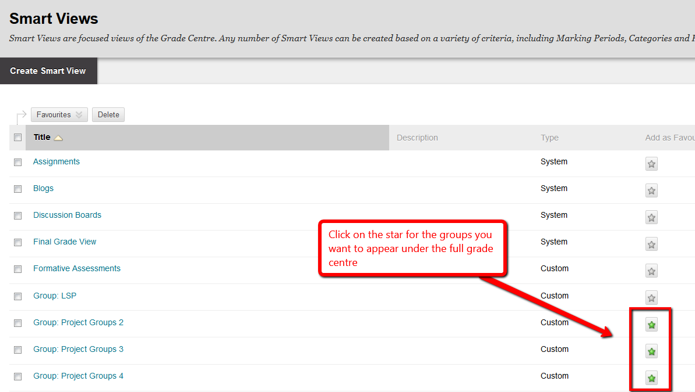
- Click OK and you’ll now see the groups in the Grade Centre
