Managing Formative and Summative Feedback and Grades in studentcentral in ARCH
Contents
Preparing the Grade Centre for marking 1
Providing formative feedback 2
Providing Summative feedback 3
Editing the Grade or Feedback 3

Preparing the Grade Centre for marking
If your Grade Centre has too many columns for you to manage here’s how you can maximise the space you have on screen.
- Hide the module menu
- Hide columns not in use
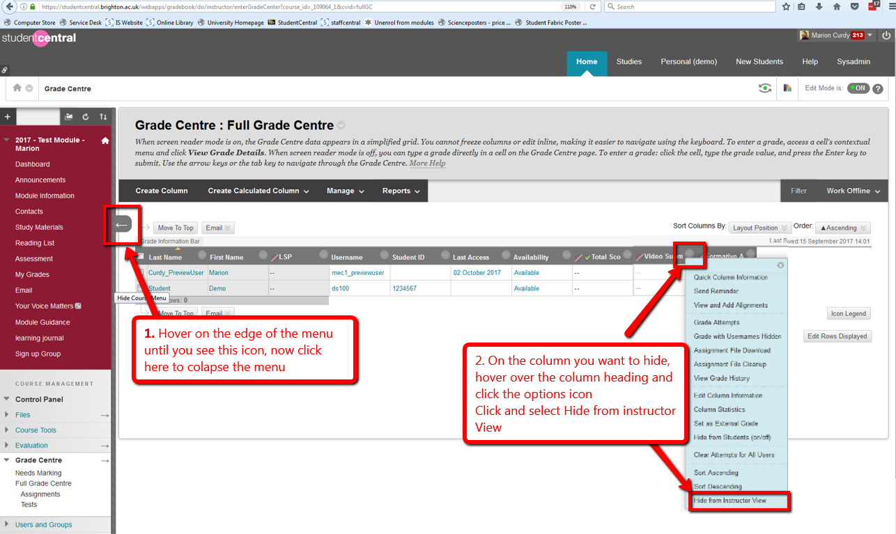
This will give you more onscreen space for marking and mean less scrolling.
NOTE: Preferred Browser for using the Grade Centre is Firefox

Providing formative feedback
Columns to facilitate the management of feedback should have been set up by the school office so you just need to enter you feedback. Here’s how:
- Open the module in studentcentral
- In the control panel go to the Grade Centre>Full Grade Centre
NOTE: studio groups may have been set up for you, if so click on the title of your studio group
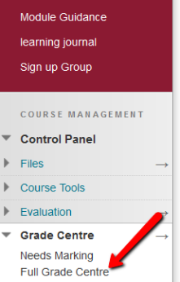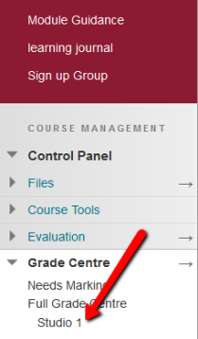
- Locate the correct column and student and click and select View Grade Details
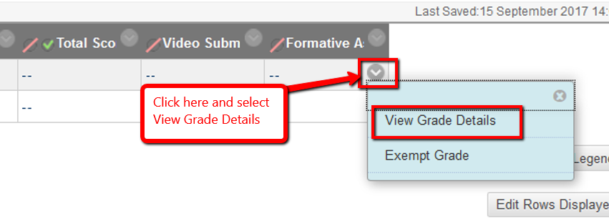
- Enter 1 in the Current Grade Field, and then feedback into the Feedback to Learner section (see screen shot below for details)
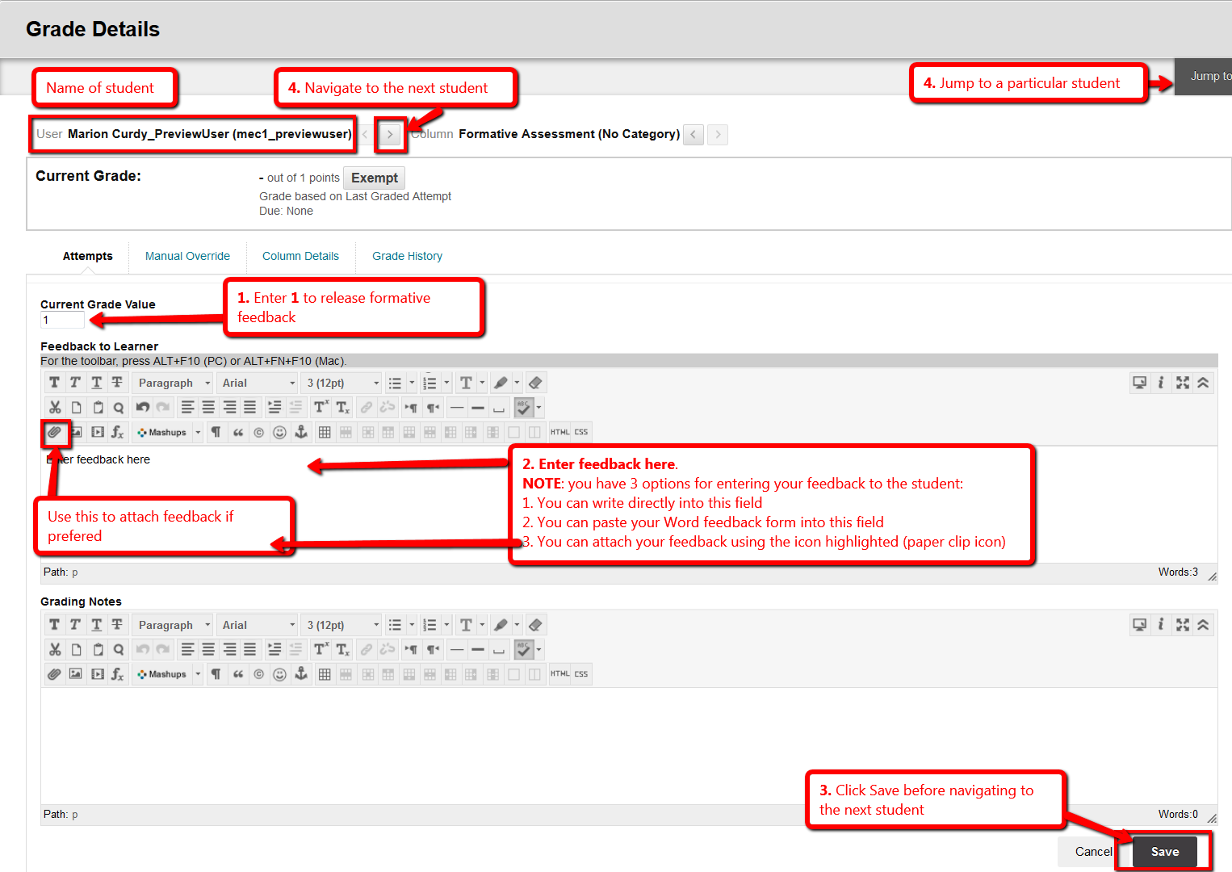

Providing Summative feedback
Repeat steps 1 – 3
- In step 4 instead of entering a value of 1 in the Current Grade Field you need to enter their actual grade.
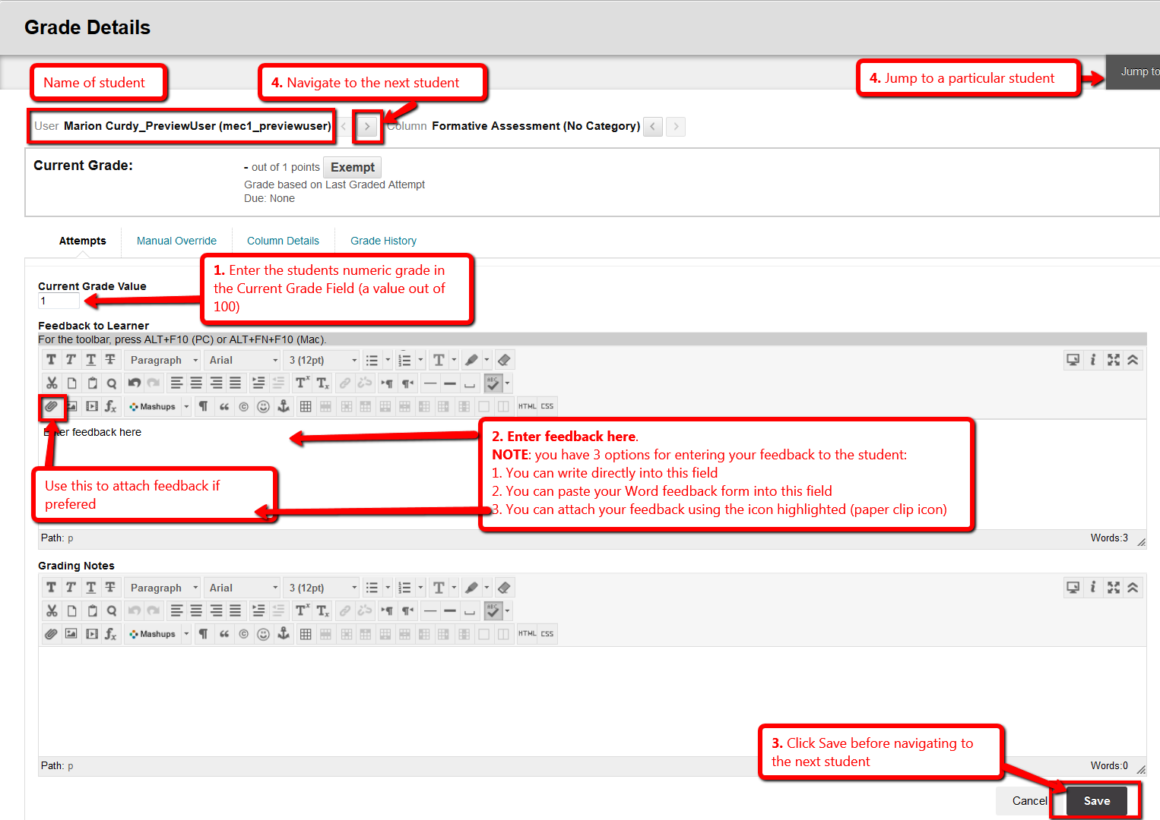

Editing the Grade or Feedback
- Go back to the Grade Centre and locate the student/column whose grade/feedback you need to change.
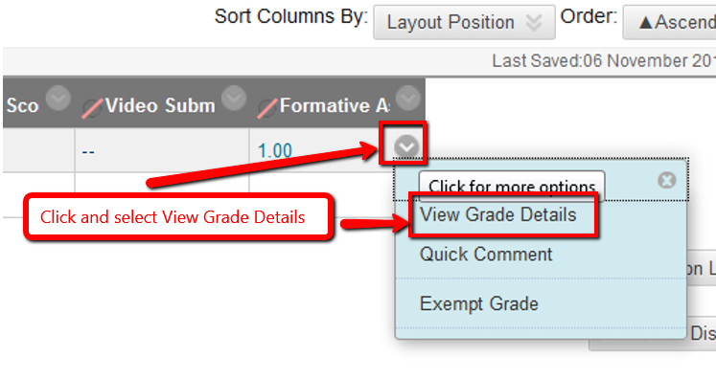
- In the screen that loads click the Edit Grade button.
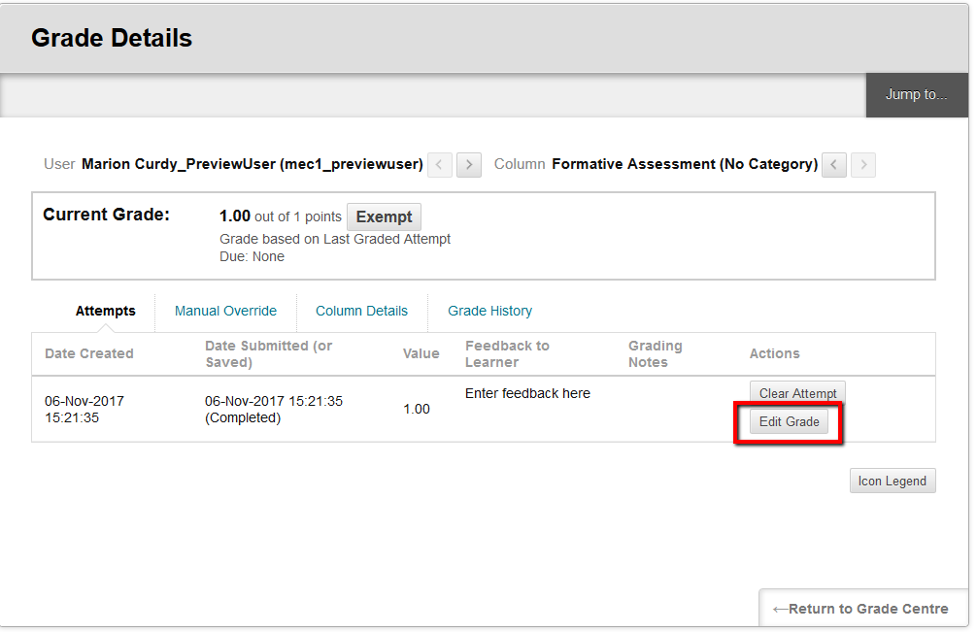
- Make the required changes and click Save

