Today I will be analyzing the website of one of the leaders in selling sports clothes, shoes and accessories - Adidas and I will also be comparing it to its 2 closest competitors Nike and Puma. Adidas is the largest manufacturer in Europe for this category of clothes, however Nike remains to be the largest sportswear manufacturer in the world. Founded in 1949, Adidas gained a good reputation in the eyes of the customers and established a strong market position. Nowadays, in the era of digital marketing Adidas is also using various social media platforms such as Facebook, Instagram, Twitter, LinkedIn, and YouTube. Adidas manages to keep a high standard for their website which in return brings them a lot of customers back.
Adidas targets certain customers in order to improve their financial performance and increase their profits. For a better understanding of its customers such techniques as creating buying personas are used. The main audience for the brand is customers with an average or higher income. In addition to that, while creating a buying persona it is important to analyze customers’ communication preferences and their lifestyle. Market segmentation plays an important role in defying a buying persona and selecting a preferable mean of communication for each segment. Therefore, customers of the elderly age are more likely to receive promotions via letter/mail/vouchers, yet the younger generation would probably check out Instagram or other social media platforms to see what is trending.
In 2018 websites are a way for companies to represent their brand, thus it is crucial to make customer journeys quick and efficient. Adidas website is simple and well categorized, which makes it easy to navigate and buy products. Their advertising campaigns are displayed on the website. However, some might argue the ethical side of the company, since they do not cater to people of the overweight range. Another issue is the availability of the stock regarding different sizes in all their products (Ex: A T-shirt was only available in S and XS sizes). Despite that they still look after their customers and a proof of that might be company’s potential to become fully eco-friendly (Plastic recycled shoes, fight animal testing etc..). Customer journeys open a possibility of seeing how close the customer is to buying a product, which links does he clicks on, where does he spends the most time and at which stage he is leaving the website. With the use of various software and tools customer journeys can be monitored and thus analyzed. Critical touchpoints are the moments when the customer is at its closest to the firm, they can be shown in green (positive) and red (negative). (Chaffey et al., 2017)
When I was exploring the three websites I came to some conclusions. They are all similar in their simplicity, categories and style, yet there few differences. On Nike website the first thing to catch my eye was a “free delivery” banner on the top of the main page along with a discount +promotion code announcement. On a psychological level it influences the customer and encourage his desire to purchase the product. Puma website surprised me with their calendar on the bottom of the main page, which shows the dates for further releases and sales. This may be one of the ways to increase customers’ loyalty and gain their trust. Talking about Adidas, I would say I personally like their aesthetics the most. Finally, all three compared websites have an option to create an account and check your basket in the top right corner. (SETHNA, 2016)
In my opinion, Puma, Nike and Adidas still have areas to improve to satisfy the customer. Perhaps, they can steal some ideas from each other and share their knowledge. After all, would the uniqueness of three competing companies saved?
Buying persona 1.

Buying Persona 2.

Customer Journey.
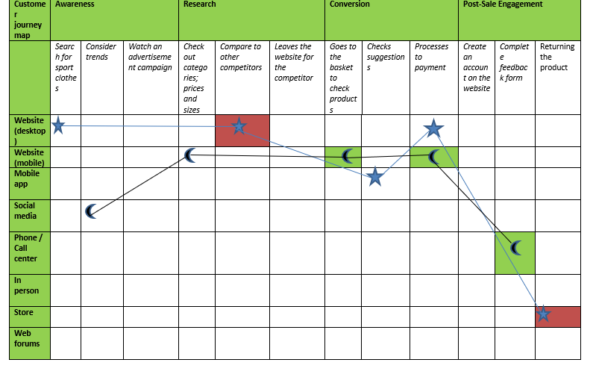
Buying persona number 2
Buying persona number 1
Negative critical touchpoints

Positive critical touchpoints

References:
SETHNA, Z. (2016). Consumer behaviour. London: Sage publications.
Eu.puma.com. (2018). PUMA.com | Forever Faster.. [online] Available at: https://eu.puma.com/uk/en/home [Accessed 14 Dec. 2018].
Chaffey, D., Ellis-Chadwick, F., Isaac, H., Mercanti-Guérin, M. and Volle, P. (2017). Marketing digital. Montreuil: Pearson.
Nike, (2018). [online] Available at: https://www.nike.com [Accessed 14 Dec. 2018].
Adidas, (2018). [online] Available at: https://www.adidas.co.uk/ [Accessed 14 Dec. 2018].

