Post Graduate Education Programme
School of Health Sciences
College of Life, Health and Physical Sciences
Seminar: Friday 21st April, 13.00 – 15.30
Westlain 217
‘Health Promotion - 30 years after the Ottawa Charter’
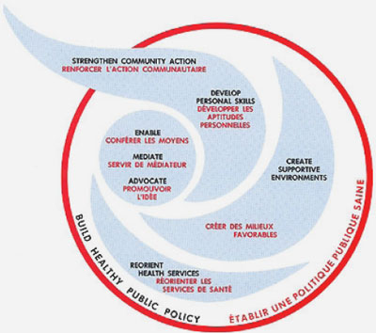

13.00 – 14.00
30 years on from the Ottawa Health Promotion Charter – What is the Same and What is Different?
Suzanne Jackson. Visiting Professor, Dalla Lana School of Public Health, University of Toronto. Co-Director, WHO Collaborating Centre in Health Promotion. Editor-in-Chief, Global Health Promotion

The 9th Global Health Promotion Conference since the signing of the Ottawa Charter for Health Promotion in 1986, was held in Shanghai in November 2016, sponsored by WHO. Suzanne Jackson will outline the significant outcomes of that meeting and the work done in Canada in October 2016 that contributed a different perspective on the future of health promotion. Both meetings connected health promotion to achievement of the Sustainable Development Goals.

14.00 – 14.35
Health Promotion, Health Improvement, Behavioural Health Sciences or Public Health? Blurred boundaries and responsibilities, or an emerging inter-professionalism. Why we retained ‘Health Promotion’ in our revised MSc Health Promotion and an update on the course. Carol Williams, Course Leader.

14.40 – 15. 20
What we are doing in Health Promotion Research. Round up of recent and current research projects. Nigel Sherriff, Carol Williams.

After the session there will be a chance to chat with the speakers and discuss opportunities for study, partnership projects, placements and research

This seminar is an occasional seminar organised by the MSc Health Promotion for Public Health Practice team and the Centre for Health Research in the School of Health Sciences. For more information please contact

Carol Williams Glynis Flood
Email: c.williams2@brighton.ac.uk Email. G.B.Flood@brighton.ac.uk
Tel:01273 644080 Tel:01273 644029

