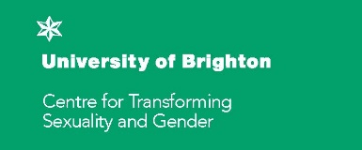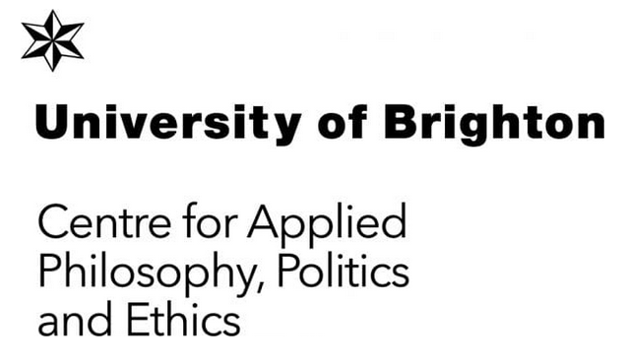

Centre for Transforming Sexuality and Gender (CSTG) and Centre for Applied Philosophy, Politics and Ethics (CAPPE) – ACTIVIST IN RESIDENCE APPLICATION FORM AY 2023

Please refer to the guidelines on our website when completing this application form.
Note the boxes will expand as you type
Email to: Karen Gainsford K.Gainsford@brighton.ac.uk
Deadline: 31 March 2023

1. Applicant Details
Your full name
Email address
mobile
Organisation (if any)

2. Details
Time How much time do you intend to spend at Brighton as part of this residency? Provide approximate dates. Please note: Residency must take place before end of June 2023.

Outline Please provide an outline of your project and its potential cultural and social impact. (Max 400 words).
Engagement and outcomes
How will you work or collaborate with CTSG and/or CAPPE staff during your fellowship?
How would you engage with students at Brighton?
How do you think you would you benefit from the activist in residency programme?
Briefly describe the activities you would like to undertake and any technical requirements for this project.
What are the planned outcomes of your project?
Would you like to give a talk or workshop at the Centres during your stay?

Would you be happy for the University of Brighton to feature your work on-line?

3. Budget
What is the budget breakdown for the £1,000 of your residency? E.g. travel, accommodation, materials etc. (Add rows as needed).
Item | Description/ details/ comments | Cost
Accommodation
Travel
production costs
Materials
Total

4. Signature
Electronic signature is acceptable | Date

Do you have any access needs?
Please give details here or let us know to contact you to discuss.

