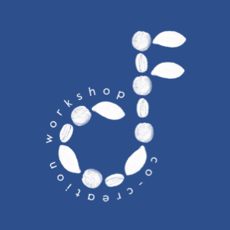
Subject: Expressions of Interest Sought for Prestigious Creative Methods Workshops

Creative Futures is delighted to announce a call for talented University of Brighton researchers to facilitate the first of 2 prestigious creative methods events in November 2018.

About
Creative methods is an exciting and rapidly developing area of research practice, and one in which the University of Brighton holds particular expertise. Creative methods involve approaches that are: arts-based; transformative, social-justice based; use technology in inventive ways; and/or incorporate innovative mixed-methods.We are keen to bring together the many scholars (from early career to established) working with these methods across the university to develop, apply and showcase creative methods. To this end, we are holding a series of Creative Methods Research Labs, which will include wide-ranging activities, discussion, and networking.

Workshop date and location
The first Lab will be on Tuesday 6th November 2018 (during reading week). It will be a day long event located in central Brighton (venue TBA).

Workshop facilitators
Workshop facilitators are expected to attend for the whole event. Workshop slots are for 1 ½ hours. Facilitators are expected to provide all materials for their own use; however basic materials such as a flipchart pad and pens, and paper for participants will be available. There is no money available to cover fees or travel expenses; however lunch and refreshments will be provided for all participants. Workshop submissions should be no longer than 300 words and cover the following:
- The facilitator/s’ name/s, institutional affiliation/department (Please note that we expect the lead facilitator to be based at Brighton, but are happy to consider joint presentations where one or more facilitators come from outside the University)
- The facilitator/s’ experience in the field
- How your workshop fits with the University’s Creative Futures agenda (see https://www.brighton.ac.uk/research-and-enterprise/brighton-futures/creative-futures/creative-futures.aspx)
- What your workshop will offer participants on the day

Submissions for workshops are due by midnight on Monday 15th October.

Workshop participants
Registration for this workshop is open now and will close at midnight on Monday 22nd October. Places will be limited to 15-20 participants at each event, and will be prioritised for those who have submitted workshop applications (including those which are unsuccessful). When emailing to express an interest in participating, please include your name, school and 2-3 sentences about your interest/expertise in this area.

Submissions
Please send your workshop/registration submission to Helen Johnson at: h.f.johnson@brighton.ac.uk. Submissions to facilitate workshops are due by midnight on Monday 15th October; submissions to attend the workshop are due by midnight on Monday 22nd October.

