Making paint
You will need:
- Charcoal
- Chalk
- Soft pastels in yellows, reds and browns (alternatively get some ochre, which comes in the same colours and is what Ice Age people used):

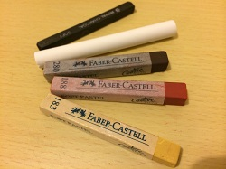

1. Break these into pieces and grind them into powder in a pestle and mortar. Ice Age people would have ground them using stones as well. | 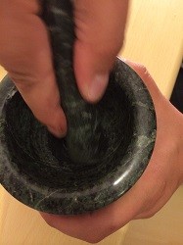
2. Combine each powder with a binding agent. A binding agent will make it into paint and help it stick to the cave wall. You could use oil, fat (like suet) or water.  Ice Age people used shells to mix their paint in, like the abalone shells at Blombos Cave in South Africa. | 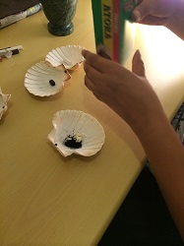
 | 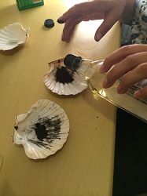
 | 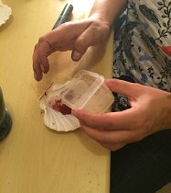
 | 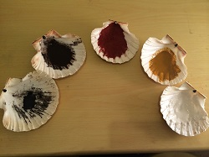
3. You could use a stick to draw an outline. | 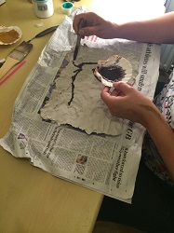
4. You could use a feather paintbrush to fill in with a large area of paint. | 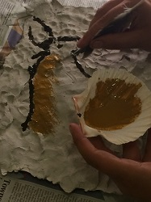
5. You could use your fingers to put in some details. | 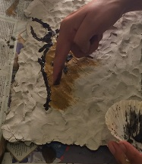
6. Ice Age people spat the paint from their mouths when they made their handprints, but some of the paint is toxic so we wouldn't do that now. Pour some paint around your fingers and use a straw to blow it. The water-based or oil based paint would work well for this. | 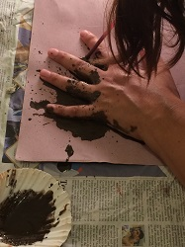
 | 

