Process of discovery
Discovery  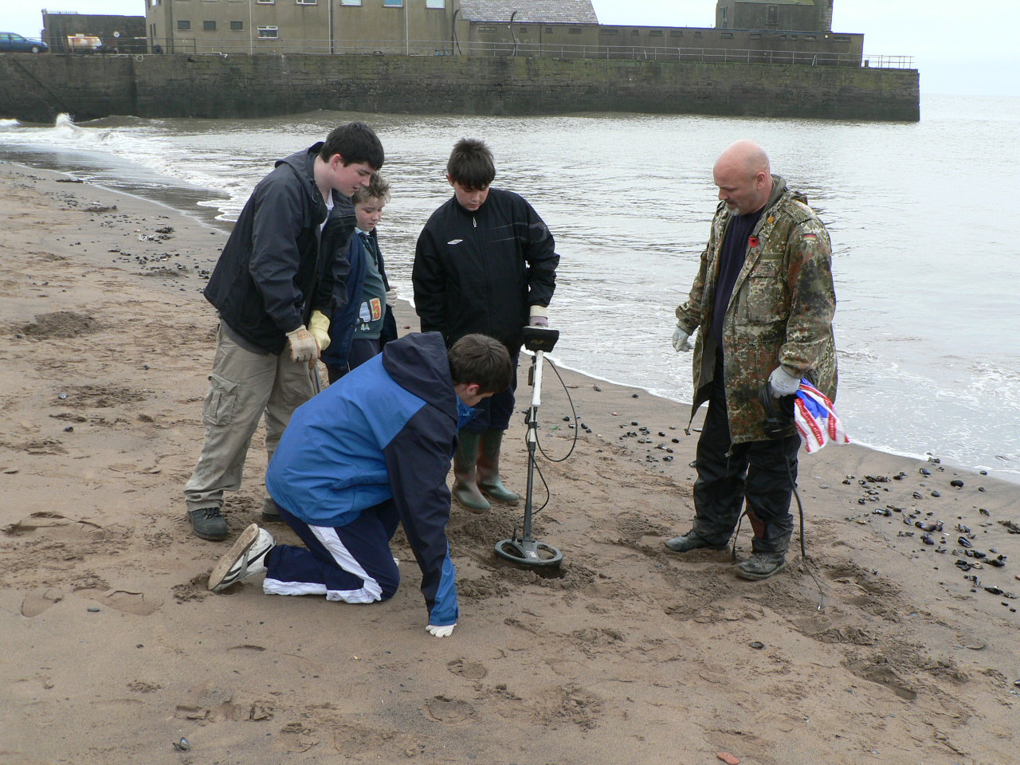  By Portable Antiquities Scheme from London, England - Whitehaven Young Archaeologists' Club, Uploaded by Victuallers, CC BY 2.0, https://commons.wikimedia.org/w/index.php?curid=10817946 | Digging  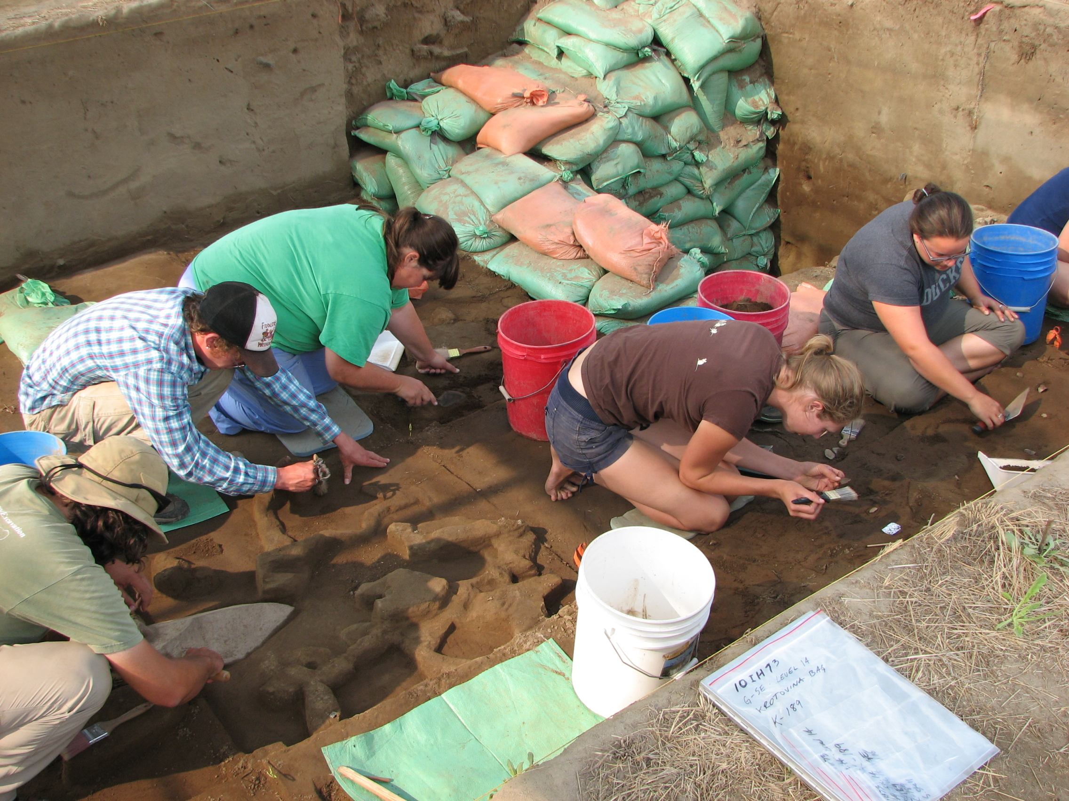  By Bureau of Land Management [CC BY 2.0 (http://creativecommons.org/licenses/by/2.0) or Public domain], via Wikimedia Commons | Sampling  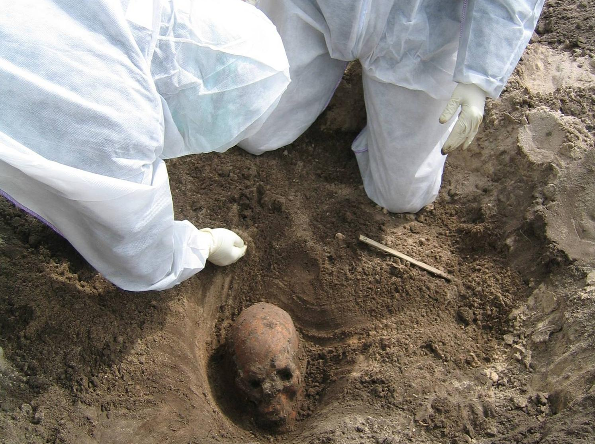  By Linea Melchior, Toomas Kivisild, Niels Lynnerup, Jørgen Dissing - doi:10.1371/journal.pone.0002214, CC BY 3.0, https://commons.wikimedia.org/w/index.php?curid=19021712
Identification  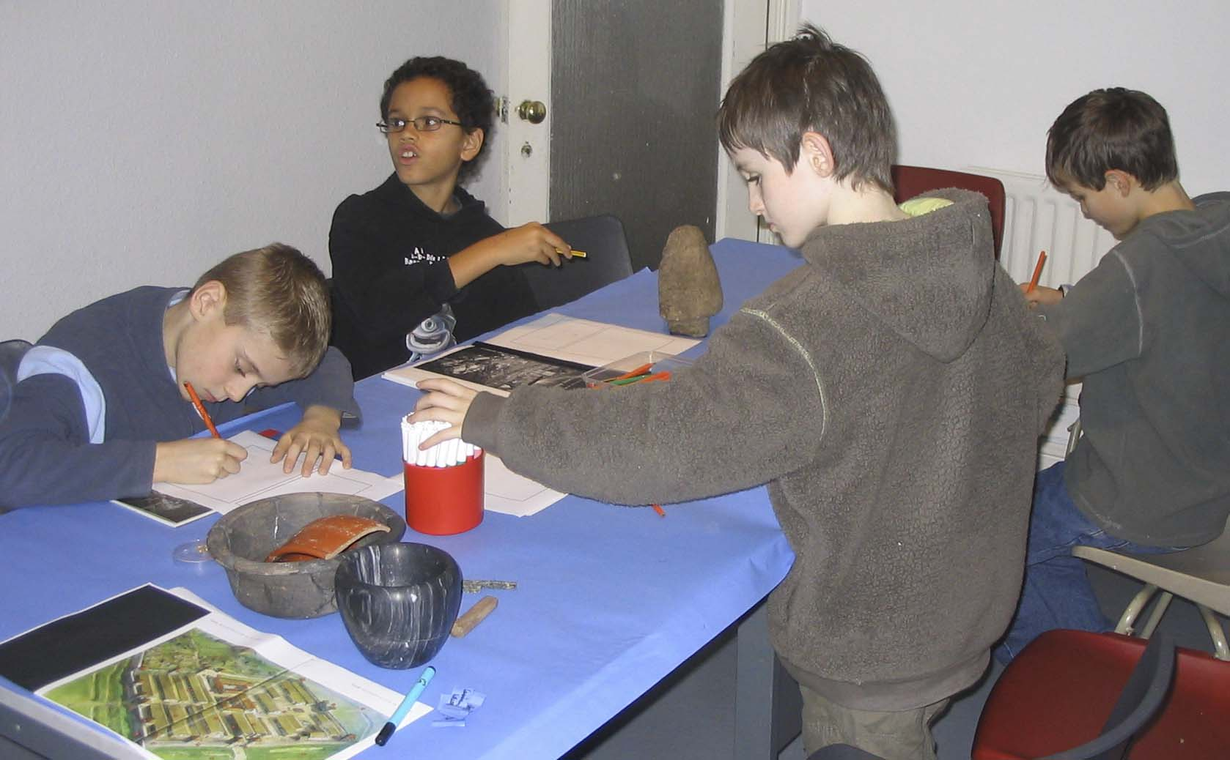  By Portable Antiquities Scheme from London, England - Kendal Young Archaeologists' Club, Uploaded by Victuallers, CC BY 2.0, https://commons.wikimedia.org/w/index.php?curid=10817990 | Analysis  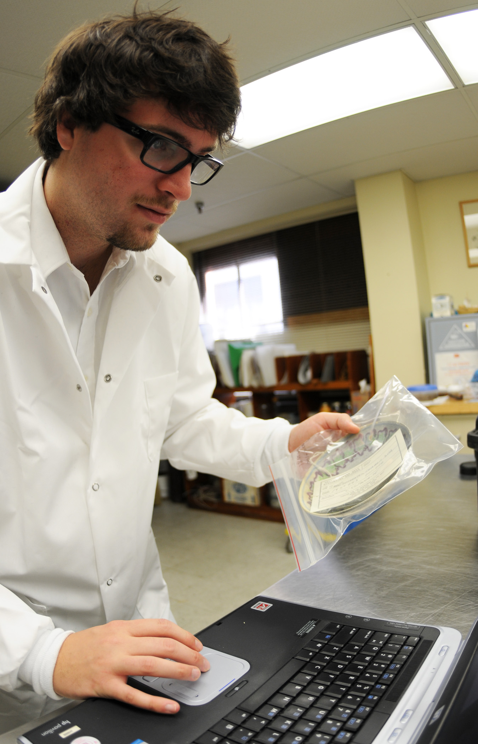  By T.K. - NHHC, Public Domain, https://commons.wikimedia.org/w/index.php?curid=33842206 | Presentation  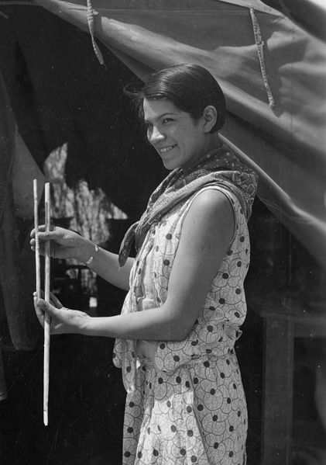  By Smithsonian Institution from United States Uploaded by Magnus Manske [No restrictions], via Wikimedia Commons

