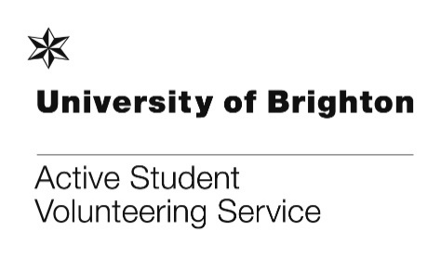
DB366 – DEVELOPING PROFESSIONAL PRACTICE IN BUSINESS MODULE 19/20
This information pack contains:
- Further information on the DB366 module for organisations
- Organisation Placement Checklist
- Organisation Project Brief form
- Organisation Service Level Agreement
- DB366 Case Study (for information only)

If you have any questions about the forms to be completed, please contact Suse Bentley, Active Student Volunteering Service, s.bentley2@brighton.ac.uk 01273 644145.
This pack is for public sector and not-for-profit organisations including charities, CICs and community groups. However, if you are interested in this module placement and you are a profit-making company, do complete this pack and send to Jim Simpson, j.simpson2@brighton.ac.uk.

DB366 MODULE INFORMATION FOR ORGANISATIONS - for November 2019 to March 2020 programme.
Thanks so much for your interest in working with our Brighton Business School students who are looking for projects for their final year module (titled DB366 - Developing Professional Practice in Business). The students are final year students who have not undertaken a placement year and are on one of the following courses, all undergraduate courses: Business, Business with Human Resources Management (HRM), Business with Marketing, Business with Finance, Business with Economics. The students will work in groups of 4 to 5 and will be self-managed. Self and team management alongside project management are some of the skills we are wanting them to develop further. ‘Client-teams’ will be supported by academic members of staff.
So that I can add your project to our projects list for discussion with the students in October, please complete the attached forms in full and email them to me at s.bentley2@brighton.ac.uk. Do call me with any questions about these forms (01273 644145). Completed forms should be emailed to me by midday 6th September.
I will be meeting with the students in October at the start of the new academic year and organisation projects will be assigned to their client-teams by the end of October. We will also be discussing expectations with them, both of what will be expected of them as consultants to you and what they can expect from you as a third sector/public sector organisation. Alongside their 30hrs (each) of consultancy, they will be expected to produce a final document or presentation for you to then use and take forward as you wish (e.g. a business plan, marketing campaign details, fundraising plan or other ‘artefact’). These documents are part of the student’s module assessment.
We do not guarantee student interest when selecting projects. However, if your project is not selected or it is not suitable for this module, we can talk further about the possibility of promoting it to our wider student audience as a volunteer role.
If your project is chosen, then a student client group will be in contact with you. We will pass your contact details on to the student group so that they can contact you to arrange an initial project-briefing meeting.
Project times generally run from November and we expect the majority of initial project briefing meetings to have taken place during November. Projects must be completed by the students by March 2020.
Do contact me if you have any questions about the consultancy projects process and the module.
We will be holding an organisation briefing evening. Provisional dates we are looking at are 1st, 2nd, or 3rd October 6.00pm-7.30pm in Mithras House, Moulsecoomb campus. Invites will be sent out nearer the time.
If you have any questions, my Active Student working days are Mondays, Tuesdays and Thursdays (s.bentley2@brighton.ac.uk 01273 644145).

Further briefing points about Business Student ‘Client-Teams’:

- Student are in the final year of their undergraduate business degree.

- This module helps you with having the fresh eyes and research outlook of a group of students to help you with a problem or opportunity. It helps the students understand better real-life organisational and business issues and how to try and solve them. It gives them a taster of working life too.

- Please make your description of the student support you want from us (on the Project Brief form) as specific, clear and measurable as you possible can. In their first meeting with you, and subsequent project plan, students will clarify with you plans and expectations and agree with you what they will deliver and when.

- Projects that students work on are many and varied. Those that have some research element, survey, service/product test, business plan, digital marketing or similar content work very well. This said, we have had students work on many other projects such as events management, risk management, and producing guidance and training materials.

- They have worked on group-based projects before but not ‘live’ projects for outside clients.

- Their studies have included modules in general business, research methods, marketing, finance, human resources/ organisational behaviour and economics plus more specialised and optional topics broadly in the business and management field.

- Mostly, they will not know the details of your working world so please take this into account. They will be assisted by us to read around and research the context of your project. Please encourage them to do this also.

- The resources available to you is approximately 120 to 150 hours in total (with 4 to 5 students) of research/development time from students as each student devotes around 30 hours each excluding writing up time over the November to March period.

- Communications and time management are key elements to enabling projects to work well, so please establish your availability and lines of communication with your team. It need not involve you in much time but will require some regular contact by email or in person.

- It’s important that, if your organisation does not have an office/organisation address, that any meetings with the students take place in public places, such as cafes, libraries or university cafes/libraries. Please do not meet with students in your personal/private address.

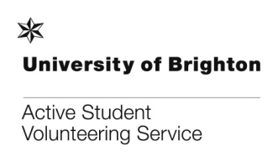
Placement Checklist
The purpose of this checklist is to ensure that students referred to you by Active Student at the University of Brighton are covered by procedures within your organisation to keep them safe and supported whilst they are volunteering with you.
Please indicate which policies your organisation currently holds. If there is anything you want to add use the details box. Where your organisation does not hold some of the policies/practices below or where it is not relevant to do so, please use the details box to explain why. You may like to consult this website to help you fill in this form: www.hse.gov.uk

Just a reminder – We expect the form to be completed in full before we are able to register your opportunity or place a student with you. If you would like to discuss this, please contact us: T. 01273 644145
Date: | What volunteering/community placement role(s) does this document cover? Please list:
Name of organisation:
Contact name and job title:
Address:  Postcode: |  | Telephone:
 |  | Website:
Email:

INSURANCE
Do you have insurance which covers the activities a volunteer will be involved in? Please highlight YES, NO or N/A and provide the policy number(s) and expiry date(s):
Public liability  Does this cover volunteers? | YES  YES | NO  NO | N/A  N/A | Policy Number:  Expiry Date:
Employers Liability  Does this cover volunteers? | YES  YES | NO  NO | N/A  N/A | Policy Number:  Expiry Date:
Professional Indemnity  Does this cover volunteers? | YES  YES | NO  NO | N/A  N/A | Policy Number:  Expiry Date:

HEALTH AND SAFETY
Please highlight YES or NO for the following questions: |  |  | Details (if appropriate):
Do you have a written health and safety policy for employers which cover volunteers? | NO | YES
Is the health and safety policy reviewed periodically i.e. is it reviewed at least every 2 years? | NO | YES
Do you have documented procedures in place to cover emergencies, such as accidents, first aid and fire? | NO | YES
Who is designated as your competent safety person responsible for informing volunteers about health and safety related issues and dealing with any issues that arise? | Name:
 | Position:
Do you have risk assessment(s) in place, covering all the activities which volunteers will be involved in? | NO | YES
Have you ever been prosecuted or received an Improvement or Prohibition Notice within the last 5 years under the H&S at Work Act? | NO | YES

EQUAL OPPORTUNITIES
Do you have an equalities and diversity policy or statement in place? | YES | NO | Details (if appropriate):
Please confirm you are aware of your obligations under the Equality Act (2010) to prevent unlawful discrimination | YES | NO

DISCLOSURE AND BARRING SERVICE (DBS) CHECKS
Active Student does not carry out DBS checks or seek references. It is the responsibility of your organisation to identify if a DBS check is a requirement of the volunteer/community placement role and to carry out DBS checks or seek references where required.

Does the role require a DBS check? | YES | NO | Details (if appropriate):
Do you carry out DBS checks for this role? | YES | NO | Details (if appropriate):

INDUCTION
Who is the person responsible for providing an induction for volunteers? | Name:
 | Position:
Please confirm that you will provide an induction on: |  |  | Details (if appropriate):
Introduction to the organisation and role, including responsibilities and expectations | YES | NO
A tour of the building and an introduction to other staff and volunteers as appropriate | YES | NO
Health and safety, including risk assessment information, first aid, personal protective equipment, emergency procedures | YES | NO
Information on your organisation’s policies and procedures, as appropriate, such as confidentiality, complaints, child protection etc. | YES | NO
Welfare arrangements and refreshment facilities | YES | NO
Anything else specific to the placement | YES | NO

TRAINING
Does the volunteer require specific training to enable them to carry out the role safely and appropriately? | Y | N
Please give details of the training you provide (if applicable):

SUPERVISION/GUIDANCE OF VOLUNTEERS
Who is the person responsible for the supervision/guidance of volunteers? | Name:
 | Position:

What is the format and regularity of supervision/guidance?

EXPENSES
Please detail the out of pocket expenses that you cover for volunteers: |  |  | Details (if appropriate):
Travel expenses to and from the place of volunteering? | YES | NO
Refreshments? | YES | NO
Other? (e.g. childcare, parking reimbursement etc.) | YES | NO

I confirm that the details I have given are correct and I have the authority to sign on behalf of the organisation. I will inform Active Student immediately if there are any changes to the information I have provided:
Print name: |  | Signed (please type name if submitting electronically): |  | Date:
To register your volunteering/community placement opportunity, please email the 3 completed forms in Word format to: s.bentley2@brighton.ac.uk. Electronic/typed signatures are accepted. If you do not have internet access, please post the forms to: Active Student, Careers Service, Student Services, University of Brighton, Manor House, Lewes Road, Brighton, BN2 4GA.
T: 01273 644145 W. http://about.brighton.ac.uk/careers/volunteer/

For office use only
Date Received:
DB366 PROJECT BRIEF FORM
Community Placement module students will view the details you provide on this form (italicised below) and will make choices about their project based on this, so please provide as much information as possible so we can promote your project fully.

Today’s date: |  | Organisation:
Contact name: |  | Contact’s job title:

Address of organisation: |  | Placement address (if different) (Please note, if you do not have an office/organisation address, we expect all meetings with students to take place in public areas, e.g. cafes, libraries, university cafes):
Postcode: |  | Postcode:

Telephone No: |  | E-mail address:
Fax No: |  | Website:

Organisation type
Please highlight one of the following
Not-for-profit Sector | Community & Voluntary Sector | Community Interest Company (CIC) | Statutory Body | Profit-making Company

The organisation/project
Please give brief details of your organisation/project

Title of the project

The project
Please give full information about the project you would like the students to undertake, including any particular requirements that students must have in order to participate in the project (e.g. skills, expertise, knowledge). This must be essential criteria to the project to avoid discrimination or bias.

Please email the three completed forms (this form, Placement Checklist and Service Level Agreement forms) to Susan Bentley at s.bentley2@brighton.ac.uk. If you do not have internet access, please post the forms to: Active Student, Careers Service, Student Services, University of Brighton, Manor House, Lewes Road, Brighton, BN2 4GA.

T: 01273 644145 W. www.brighton.ac.uk/volunteering

Service Level Agreement

This document is a signed agreement between the University of Brighton’s Volunteering Service (Active Student) and your organisation. It sets out the responsibilities of the parties involved in offering volunteering/community placement opportunities and constitutes a commitment to ensuring good practice in working with students.
On completion of a volunteering/community placement opportunity form, placement checklist and service level agreement, Active Student will ensure that:
- Your volunteering/community placement opportunity will be promoted to students

- Every student registered with Active Student signs a volunteer agreement to comply with equal opportunities, health and safety, confidentiality and any other code of conduct specified by the placement

- Students are made aware of the requirement for some organisations to carry out Disclosure and Barring Service (DBS) checks on volunteers for specified roles and that references may also be sought

- Students who express an interest in your volunteering/community placement opportunity and indicate they have the appropriate skills or experience as specified in the volunteering/community placement opportunity form, will be referred to your organisation

- Organisation contact details will be given to the selected student group.

- Students will be able to access support from Active Student and they will be expected to give and receive feedback on their volunteering/community placement experiences

- Student volunteers who have shown a commitment to their volunteering will receive a certificate from the university’s volunteering service.

Your organisation is:

- Responsible for deciding whether or not referred students are suitable for your volunteering/community placement role(s)

- Responsible for ensuring that adequate insurance is in place which covers volunteers involved in your organisation. This information needs to be resubmitted when renewed or changed

- Responsible for the health, safety and welfare of students while engaged in activities with your organisation. You are responsible for asking students for emergency contact details.

- Responsible for ensuring a suitable risk assessment(s) covering all the activities the students will be involved in is in place prior to the student commencing their volunteering/community placement with you

- Expected to report all accidents and near misses involving students to the Active Student Manager as soon as possible

- Expected to have an equalities and diversity policy or statement in place

- Expected to offer reasonable adjustments wherever possible and practicable to students with disabilities
- Responsible for undertaking DBS checks or seeking references on students if this is a requirement of the volunteering role
- Responsible for ensuring that students receive a suitable induction at the start of their volunteering/community placement
- Responsible for providing any specific training that enables students to carry out their role safely and appropriately
- Expected to give students ongoing supervision and support as required
- Should discuss appropriate issues or concerns regarding students with Active Student as soon as possible
- Expected to reimburse students all agreed reasonable out of pocket expenses, upon receipt of the appropriate documentation
- Responsible for ensuring that all staff supporting students are made aware of this service level agreement.

I agree to comply with the terms set out in the above agreement and I have the authority to sign on behalf of the organisation.

Organisation
Signed (please type name if submitting electronically)
Print name
Organisation
Date
Active Student Volunteering Service
Signed
Print name
Date

Sussex Community Rail Partnership
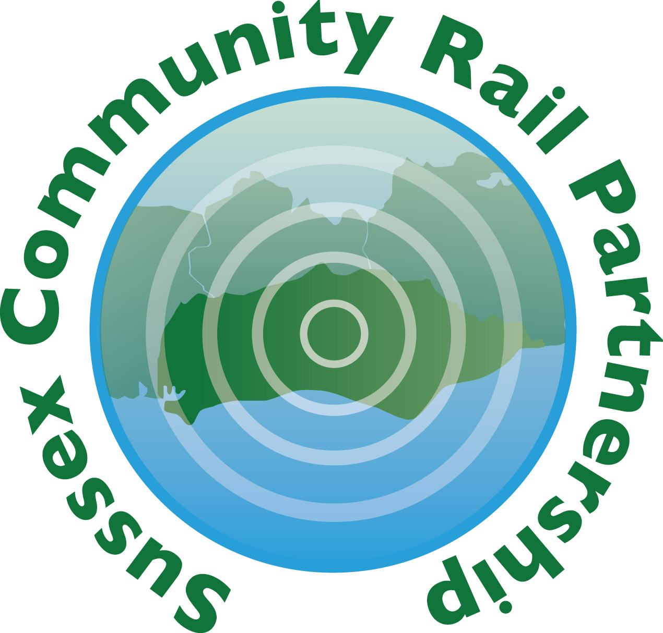

Brighton University students working with Sussex Community Rail Partnership on a Survey of station partners – November 2018 – March 2019 DB366 CASE STUDY
Background
A group of final year students from Brighton University’s Business School has been working with SCRP to conduct a survey of station partners and provide recommendations for SCRP to act on. The intention was to conduct the project on a consultancy basis in a real business environment.
Sussex Community Rail Partnership (SCRP) asked students Yuriy Ilin, Stefano Scanzani, Liam Lindsey, Andrew Singh, and Michael Waller to survey our volunteers working on community projects at railway stations across Sussex. The objectives of the survey were:
- To better understand the opinion of Station Partner volunteers and their current experiences
- To discover any barriers they face and how they could be overcome
- Key opportunities that could make their volunteering experience better
- How we can celebrate the work of both the volunteers and Sussex Community Rail Partnership.

In addition, the project contributed to SCRP’s objectives of providing work experience for young people and evaluating our activities.

The student team met with SCRP at our offices at Lewes railway station on 28 Nov 2018, 16 Jan 2019, 20 Feb and 6 March and presented their findings at the SCRP Strategic Advisory Board on 14 March 2019.
We asked the team to
- understand the context of volunteering in Community Rail
- familiarise themselves with existing research on the social impact of Community Rail and volunteering in general
- devise a survey questionnaire on volunteer experience, demographics, satisfaction and views using Qualtrics (courtesy of the University of Brighton).
- Analyse the results numerically and reflect on the implications for SCRP’s work
- Create a Powerpoint and present their results to SCRP’s Stakeholder Advisory Board

The students’ approach to the task was exemplary, delivering work to time and taking feedback on board, and bringing their own ideas and experience to the work, particularly with regard to ways of engaging with station partners and the wider public. Their findings were of great interest and will be put into action by SCRP. The main conclusions of the survey were:

- For better communication, we felt that the use of social media platforms such as Instagram, Youtube and Facebook would be good ways to improve both the awareness and engagement with SCRP. A Newsletter and Posters and plaques around partnered train station which highlights key events and activities, as well as what funding is available, while also increasing awareness of the artwork and gardens created by our volunteers.
- Volunteers feeling valued and celebrated is an important part of engagement. We feel like SCRP and the train companies could celebrate more through annual events. This would invite volunteers and local businesses from each region to come and share their experiences which will encourage further engagement and business funding. Celebration can also occur through plaques and memorials for each area which could include the names and images of the volunteers who helped create the activity.
- ‘Red Tape’. This word occurred frequently as a barrier. We recognised health and safety is important for the volunteers and is hard to remove. But we also understand that this ‘deadweight’ impacts social value highly and therefore this process needs to be easier for volunteers through further support and guidance.

Recommendations
To follow up the survey, the SCRP Ltd Board has agreed the following recommendations:
- To feed back the results of the survey to station partners, train companies and SCRP staff and directors
- To actively inform Station Partners that SCRP is able to assist with fundraising for station projects
- To respond to the wish from 65% of respondents for more information about what is happening at stations, by revamping SCRP’s quarterly newsletter. This will also be incorporated into the redesign of the SCRP website
- To pursue the suggestion of holding an annual event / celebration for station partners in recognition of their work throughout the year
- To promote our presence on social media, specifically website, Twitter, YouTube and Instagram
- To raise awareness and recognition of the work of station partners by ensuring that all station projects have information nearby about the station partner and SCRP.
- SCRP staff will actively ask station partners if they need help with renewing Site Access Permits, and will be in touch with them in person at least once a year.

