CALL FOR ARTISTS – EXCITING OPPOPRTUNITY FOR ART STUDENTS AT BRIGHTON UNIVERSITY
SPACES Brighton is a brand new building featuring co-working space, serviced offices, meeting rooms and a terrace with sea views opening up at the end of August this year! SPACES, originating from the Netherlands, features bright and modern interiors where statement pieces of furniture meet cool and stylish design, creating an exciting place to do business.
SPACES has many locations throughout the world, with six currently in the UK and a further three planned for the UK by June 2017. We want to create a distinctive Brighton look and feel in our building, ensuring that people know they are in this cool, colourful, quirky and sometimes crazy Victorian seaside city when they visit our venue.
When people think of Brighton, they naturally think of the Royal Pavilion, the pebble beach and the Pier. Beyond that, it is the thriving creative art scene, the eclectic mix of people and characters, the colourful houses and the many murals, landscape pieces, street art and graffiti around the city that all come to mind.
To that extent, we are inviting local artists to submit their ideas for a unique and bespoke piece of art for our venue that will showcase the artist’s talent while capturing the ‘SPIRIT OF BRIGHTON’. There will be several spaces to choose from over the coming months and we can keep you updated as soon as these are ready. But for now, we would like to feature a striking piece of Brighton-themed art to cover a wall on the fifth floor, next to the staircase that leads to the club lounge, rooftop bar and the roof terrace that has sea views. We would like the artwork to be completed during a live painting session at our launch event on Thursday 28 September, from 5pm to 9pm (should more time than this be needed we can arrange for the artist to do as much preparation as necessary beforehand and complete the work during the launch event).
We plan on capturing this in a time-lapse video which we will happily provide to the artist for their own use. We are inviting guests from all over Brighton to our launch event, including from the local business community, the Brighton & Hove Chamber of Business, start-ups, meet-up groups, organisers of local events and festivals, representatives from the two universities as well as local press and media.
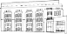 | ROBERT ELLWOOD  COMMUNITY MANAGER  Mocatta House, Trafalgar Place,  Brighton, BN1 4DU  +44 (0)7760 391 403

The image below shows the wall and the dimensions:
Length: 4.95 meters
Height: 2.5 meters
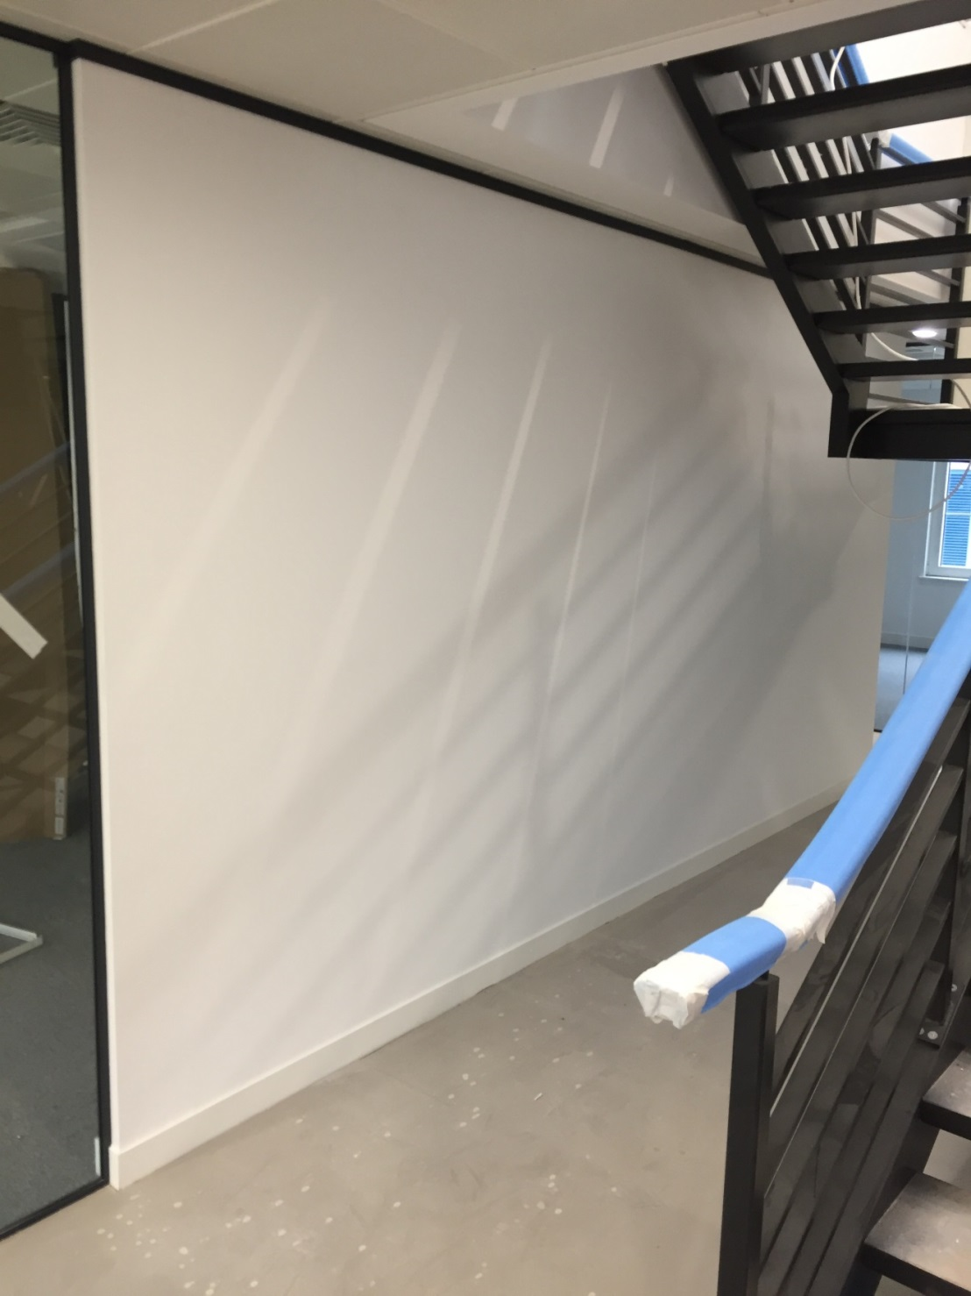
In return, the successful artist will receive:
- complimentary membership in our co-working space for 6 months (worth £1,500)
- access to all our business networking and social events for 6 months
- cost of materials and associated expenses eg. travel to and from the venue (up to £1,000)
- exposure to up to 200 guests at the launch event
- the opportunity to exhibit more of their artwork (framed or on canvas) in the venue for six months after the launch
- exposure in all post-launch comms and follow-up
- a copy of the time-lapse video for their own use and to add to their portfolio
- free underground parking at the venue while the artist is working on the mural
Please register your interest using the form below, explaining why you should be chosen to paint the wall at our launch event, and giving a rationale about the piece that explains why it would be suitable for the venue.
Artists Name: ____________________________________________________________________
Telephone: ______________________________________________________________________
Website: ________________________________________________________________________
Address: ________________________________________________________________________
____________________________________________________ Post Code: __________________
Please describe the style of art you do and your preferred medium: _________________________
________________________________________________________________________________
________________________________________________________________________________
________________________________________________________________________________
Please explain a bit about the idea you have for the wall and why you think it would be suitable. Please provide any sketches or images to support your idea: ______________________________
________________________________________________________________________________
________________________________________________________________________________
________________________________________________________________________________
________________________________________________________________________________
________________________________________________________________________________
How long do you think you would need in total to complete the artwork? ____________________
Are you available from 4pm - 9pm on Thursday 28 September to attend the launch event and complete the artwork? YES NO NOT SURE YET

All submissions need to be made no later than Friday 25 August 2017. The successful artist will be notified by Friday 1 September 2017. Should you have any questions and would like to talk in more detail about this opportunity, please contact me on the number below. Many thanks, and good luck!
Robert Ellwood – Community Manager, SPACES Brighton
robert.ellwood@spacesworks.com
Mobile: 07760 391 403

