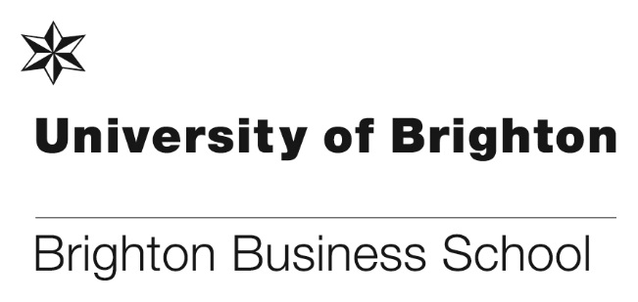

Long service awards for staff
In 2019 and 2020 Carol Suwala, School Finance Officer and Virginia Goodwill, Industrial Placements Officer both received long service awards for 25 years working at the University of Brighton. Below are some reflective pieces from Carol and Virginia about their time working at the university.

Virginia Goodwill

Who would believe I have been at BBS for 25 years. How things have changed. When I first started (Covering maternity leave for Tracey Taylor) there were only 2 degrees in BBS that had placements, the BSc (Hons) European Business with Technology (The best degree ever) and the BA (Hons) Business Management and placements were compulsory.
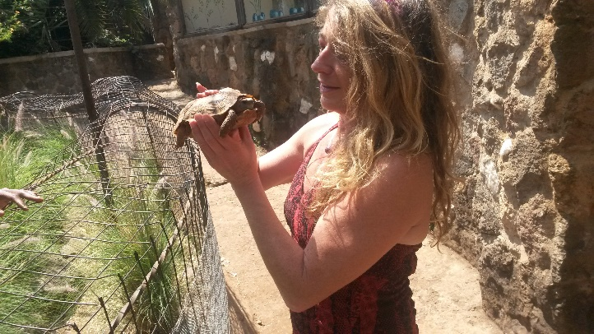
We had about 120 students across both degrees and everyone (well nearly) found a placement as they were compulsory. It was so different to the current application process as technology didn’t exist. All the vacancies were hand written and displayed on the notice board outside our office, on pink paper (think that was my choice). CVs were either faxed (who remembers faxes) or posted in a hand written envelope. Interviews were very relaxed or didn’t exist at all.

With the EBT degree the placements were 6 months in the UK and 6 months in Italy and I literally often slotted people into placements. I also regularly travelled to Italy for meetings and latterly Paris and once even flew First Class! Now we’re lucky if we can get a First Class stamp. The Course Leader and I would spend our meal allowance on G&Ts in Café Di Torino as it was the cool place to be in Turin.

As I’d come from Industry, University life was a bit of a culture shock and I soon ditched the business suits and out came the DMs and Flip Flops. I remember the first time we were introduced to The World Wide Web by Dr Robert Griffith Jones, there was no internet connection or WiFi so a lead trailed from the window of the Technicians Office down into what was then The Rover Room. We didn’t have emails but hand written or typed memos and internal envelopes took them to other sites. Who ever thought that technology would have moved on at such a pace that now we can work remotely and have access to everything we need and hold all our meetings and teaching via our laptops.

In the 25 years I have met inspirational colleagues and students that I am still in touch with now and whom have become my employers. I’ve even been invited to weddings and family celebrations and had many gifts, some very odd such as the pink walking oinking pig which still resides in my office in Mithras House. When I first joined BBS there was talk of a new Business School building. It only took 25 Years to lay the foundation stone.

Carol Suwala
I joined the Business School on 3 October 1994. My son was four months old and I decided that having spent 14 years working in hotels in London, Brighton and Hove, that the hospitality industry wasn't the ideal place to bring up a child in. With a College Diploma in Hotel Book-keeping and Reception and a certificate in City and Guilds 709, I wasn't sure that applying to a University was the right thing to do, but I did anyway.
I was interviewed by Philippa Kennedy and Val Chitty, our then Faculty Officer and Assistant Faculty Officer respectively. Within a few hours I received a call to say I had the job. I told Philippa that I had no knowledge of HE or computers but was reassured that I only needed to be honest, reliable and willing to learn. For the first few weeks I felt frustrated and confused as to how emails worked - after all, I'd never had any problems with a Gestetner to run off memos! I decided I'd give it a month and then look for another job.
Having now spent 26 years here (nearly half my life!), I have learnt many new skills, attended workshops, attended City College to complete the AAT (Association of Accounting Technicians), increased and broadened my workload, attended summer BBQ's, team-building events, Christmas parties and treasure hunts. All of which I have been able to take something from to enrich both my work and personal life.

I've seen Schools merge, Faculties change, staff come and go, been located in three buildings and eight offices but all the time, the one thing that has remained consistent is the staff. They have been like a family, have always been and continue to be supportive, friendly and caring and rare to find so many members of staff remain working together for such a long time in one place. When I joined the Business School this was the one thing I didn't imagine and yet has been the most enriching part of my journey.

Brighton Open Podcast: Black in Business Episode 3
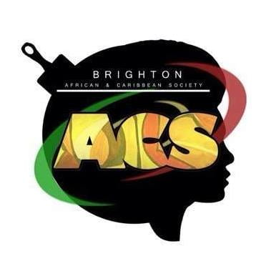
Brighton Business School alumni, Marvin Okai and Denzil Lawrence, are back talking to us through a new podcast series; BOP (Brighton Open Podcast) about their journey to becoming Chartered Accountants and why they developed their blog Black and in Business to share their experience.

In this third episode of the series, Denzil and Marvin chat about their student accommodation, from halls to house shares, their different experiences in managing their finances, and how student unions like the Brighton Afro-Caribbean Society helped them meet other students from the Black and Asian community.

You can watch the episode at the link below.
Brighton Open Podcast: Black in Business Episode 3 | Brighton Business School
Funding opportunities for PhD students

2 funding opportunities are available for future PhD students. The first headed by Dr. Anne Daguerre and Dr. Adaeze Okoye is a University of Brighton and South Coast Doctoral Training partnership project titled, ‘Investigating the role of employee ethnicity as a risk factor for exploitative labour practices in the UK adult social care industry: a focus on East Sussex and Hampshire’.

The research investigates how funding shortfalls in social care impact local ethnicised care markets. The project examines whether ethnicity represents a risk factor in exposure to labour standards violations in a social care environment. Anne welcomes PhD applications in the field of the external environment of HRM, especially local labour market policies and employability, as well as welfare to work.

Full details can be found here.

The second is titled, ‘The impact of migrant remittances on promoting small and medium-sized enterprises in home countries’ and is a PhD studentship which offers an opportunity to conduct international comparative research and utilise a range of quantitative methods to study the impact of migrant workers’ remittances on small and medium-sized enterprises (SMEs) and business cycle synchronisation. The student will analyse existing data sets and compile new primary data to model remittance effects in different panels of data for the selected countries. The supervisors are Dr. Eugenia Markova and Dr. Sushil Mohan and full details can be found here.

The BBS pro bono law clinic provides successful advice

In November, the pro bono law clinic was asked to give emergency legal advice to a northern city based Tree Defenders Residents Group. The group were peacefully gathering, with Covid safe measures in place, around mature trees in the city. The residents were knitting, exercising and trying to stop the council contractors from felling the trees unlawfully. However the new Coronavirus Regs 1200/2020 appeared to have removed all meaningful ability to gather to protest peacefully, according to local police. This was despite the Home Office being advised just before lockdown that peaceful, Covid safe protest was a lawful right under ECHR even in times of lockdown.
Over a period of two days the police came with a fairly heavy handed approach, arresting residents, issuing fines and, at one point, threatening a water cannon. A team of 3 law students Sarah Khaddar (PgDip Law), Jasmine Hale (LLM Law Conversion) and Sinead Gallagher (LLB Law) supervised by Brontie Ansell provided legal advice on how the residents may gather and save the trees lawfully within the Covid Regs and within govt guidance in lockdown, in order to exercise their human right to peaceful protest.

After a nerve wracking 48 hours of legal research and writing up advice, South Yorkshire Police conceded the group were lawfully able to protest and rescinded all fines issued over the period of the gathering. Some, but not all of the trees, were saved and the residents were really impressed with the clinic and the team.

Jasmine said, “I was very excited when I heard that the University ran a legal clinic that we were able to be involved in. As a post graduate student, I have experienced first-hand the difficulties of finding work opportunities post-graduation, so I was particularly eager to gain as much real-life experience as possible. Helping the clinic with this case was extremely exciting and I was very pleasantly surprised with how much trust and responsibility the clinic gave to us. I felt extremely supported throughout the experience and Brontie reassured us that any help we could give would be amazing. I was hesitant at first as Environmental Law is not an area I am experienced in, and to be completely honest, was not a subject I had paid a great deal of attention to in the past. Despite this I never felt out of my depth, Brontie was clear and helpful in guiding us in the right direction and I became very invested in the case. I would highly recommend getting involved in the clinic in any way you can. It is an amazing opportunity to expand your knowledge with real life cases and it gives you the opportunity to provide a vital service to those who need it most.”

Sarah said, “When I received the email to help on the legal research for the legal clinic I felt both nervous and reluctant as I really doubted myself and felt I lacked the confidence to perform a good job. However, upon starting the research and hearing the facts of what we were researching I instantly felt drawn in and motivated to research the best I could possibly do. I found myself not being able to stop looking into different ideas from the moment we received the email. Over time I started to become a lot more confident and with Brontie’s brilliant support and encouragement I really felt a lot better about my ability to research and perform. Overall I have come away from it feeling a lot better about my skills which I cannot thank her enough for.”

Sinead said, “I would 100% recommend getting involved in the legal clinic as this really motivated me in my future career and gave me the direction I needed to go forward, it also gives you the best insight on how to research for real cases and looking at every angle possible within the law. It gives you experience to take away but also gives you a learning point to improve. Also you work with lovely people and coordinate your skills and ideas and also have a laugh and rant at the same time. Additionally, and the most important thing to take away is you’re helping people who need your help.”

The case was featured in the Independent Newspaper on 25 November and you can read the article here.

You can also follow the story on Twitter here: https://twitter.com/kateneeeedham

Congratulations Brontie, Sarah, Jade and Sinead.
Contribution at the Association of Tourism Practioners of Nigeria (ATPN)
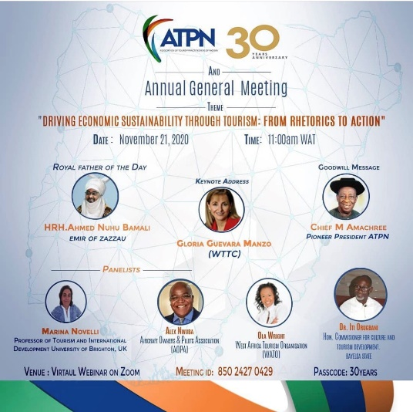
Professor Marina Novelli was invited to contribute as Expert Member by the Association of Tourism Practitioners of Nigeria (ATPN) which took place on 21 November 2020 via a webinar on Zoom. Marina present at the 30th Annual General Meeting on: Driving Economic Sustainability through Tourism: From Rhetorics to Action.
Students visit Shoreham Port

On 4 November just before the second lockdown some of our International Logistic and Finance students visited Shoreham Port accompanied by tutors Peter McCullen and Clare Millington.

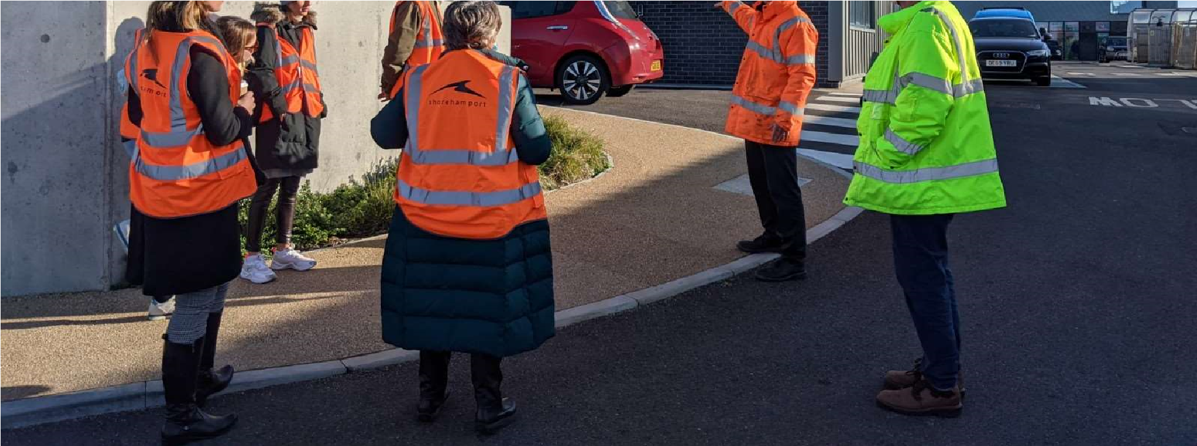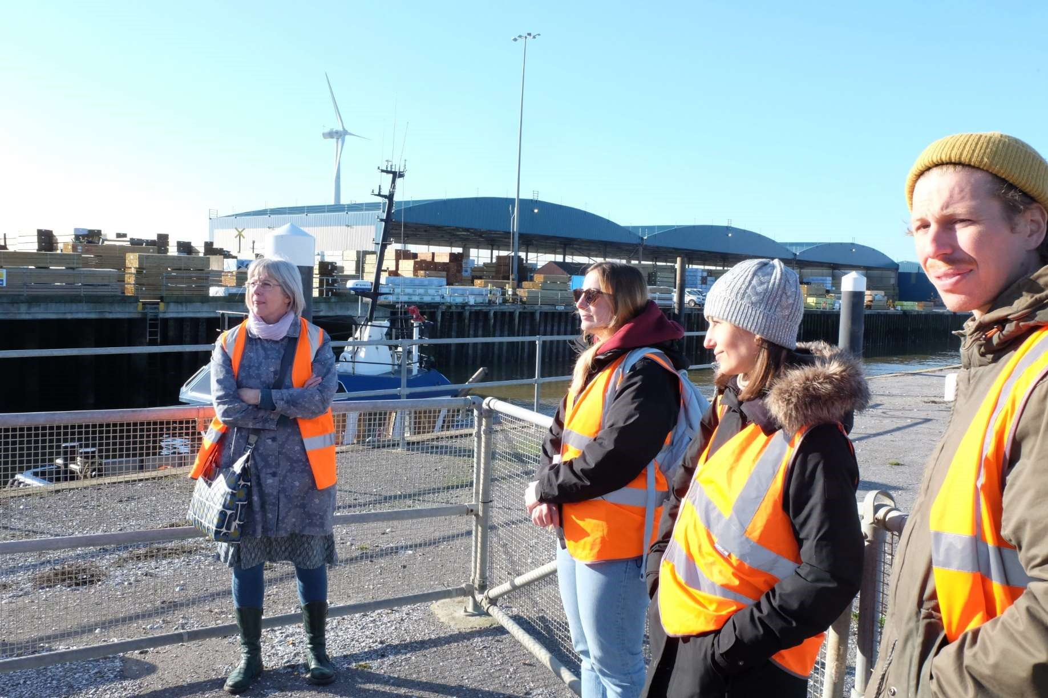
Engineering manager Brian Rousell started the tour showing a recently completed commercial building. He explained that there are three main income sources: Harbour Fees, Port Operations (cargo handling) and Rents from property.

The visit also included a tour of the many locks within the port where students saw the quay for unloading timber and the open timber warehouse.
The tour also included a visit to the strip of land between the sea and Southern quays, where Brian pointed out the harbour entrance and wind turbines, which generate enough electricity to power the pumps that maintain the water level in the canal.

Also on the Southern quay the students saw the grain terminal which is used to store and export Sussex grain to mainland Europe.

The visit also included seeing the Parker Steel gantry crane system, the oil terminal for petroleum products and witnessing a trawler come into and dock in the port via the Prince Philip Lock.

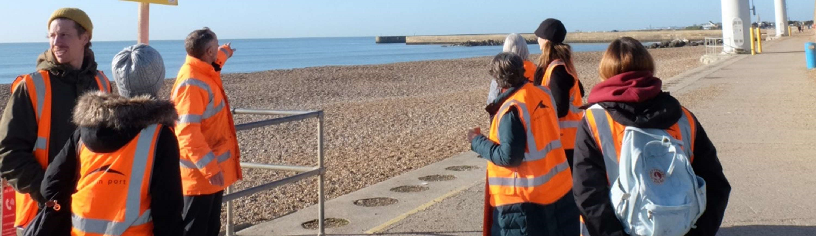
Brian told students that of all the products coming into the port the highest value product passing through is fish, currently scallops, caught in French waters, by Scottish trawlers, and exported to mainland Europe.

Many thanks to Brian Rousell and Emily Kenneally of Shoreham Port for arranging a great trip for students on the International Logistics and Finance Module.

PhD student post on WIPCS Peace Matters blog
PhD research student Chinwe Stella Umegbolu has recently had a post published on the Wisconsin Institute for Peach and Conflict Studies (WIPCS) Peace Matters blog. The post titled ‘Violence against Women in Nigeria’,
This essay argues that there are some cultural biases or nuances that point towards violence against women in Nigeria. The author uses Johan Galtung’s typology of Violence and Peace, as well as primary and secondary data, to analyse violence against women in Nigeria. The conclusion touches on the implications of the reviewed literature for the community leaders, government parastatals, parents and the victims to take a proactive stand on addressing violence against women in Nigeria.

You can read the full piece at the WIPCS blog here.

Congratulations Chinwe.

Matria Puglia network meet with Italian prime minister and minister for Equal Opportunity and the Family
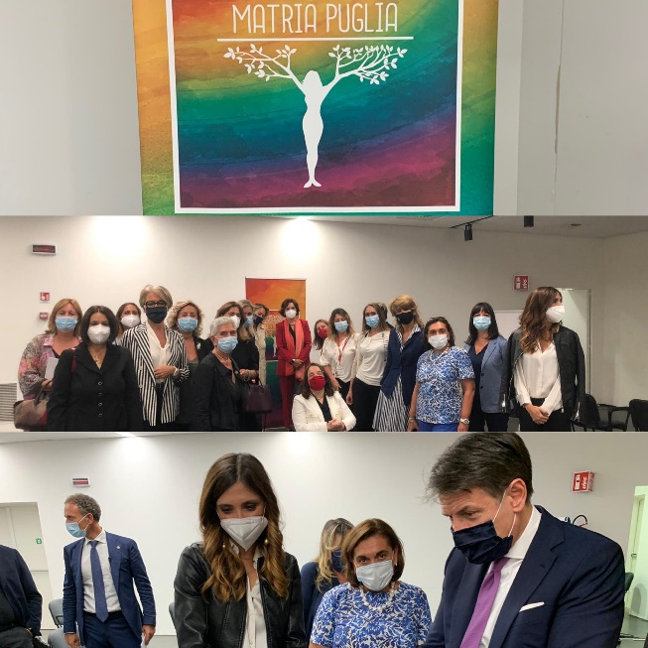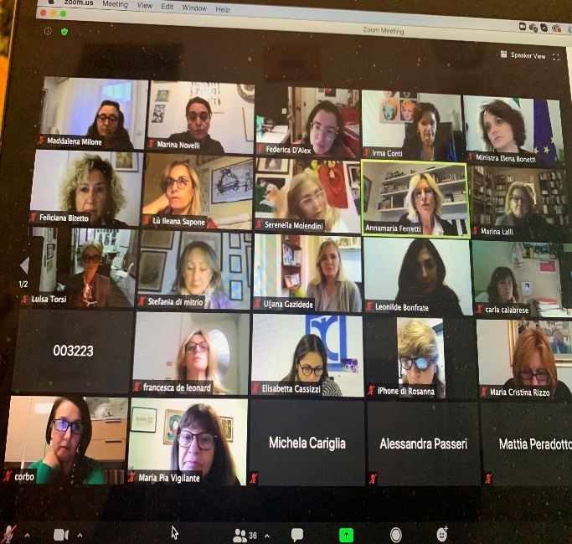
Meeting with Italian Prime Minister Giuseppe Conte Online meeting with Elena Bonetti Italian Minister for
Equal Opportunity and the Family
Professor Marina Novelli was invited to contribute to Matria Puglia's official meeting with Italian Minister for Equal Opportunity and the Family Elena Bonetti which took place on the 17th November 2020. Matria Puglia is a network of 100 southern Italian women and other women from the Global South. The group are involved in a set of action oriented activities aimed at shaping a post-COVID19 agenda for action, centred around gender equality in the Mezzogiornom and the Global South.

This meeting follows on from a previous preliminary meeting that Professor Marina Novelli also attend which took place on 4 October 2020. The members of Matria Puglia met with Italian Prime Minister Giuseppe Conte where a full agenda for action was presented to him for his attention.
In the view of the current recovery strategy for the nation, Matria Puglia is well poised to contribute to the shaping of new initiative of socio-economic and environmental relevance at time of crisis and beyond.

Trends and new dynamics of sustainable entrepreneurial ecosystems discussed in cutting edge webinar promoted by CENTRIM

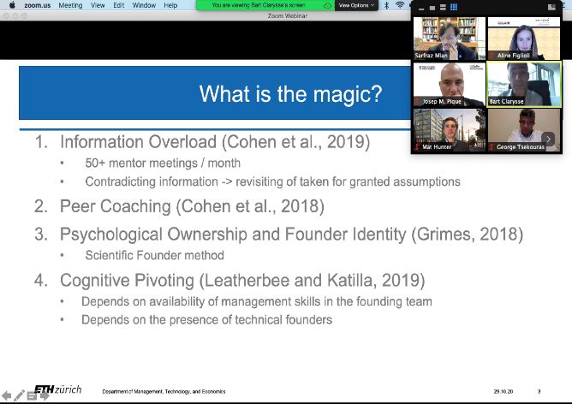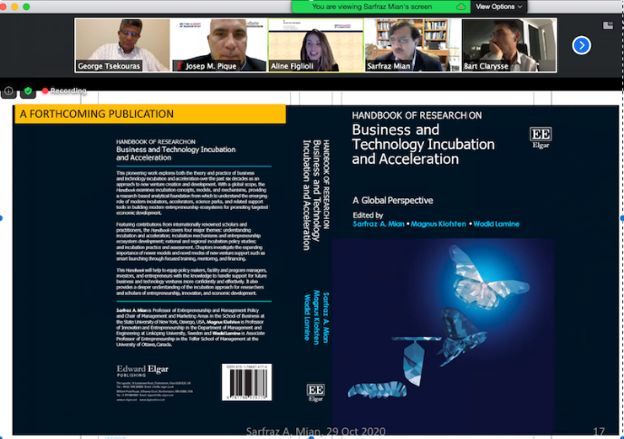
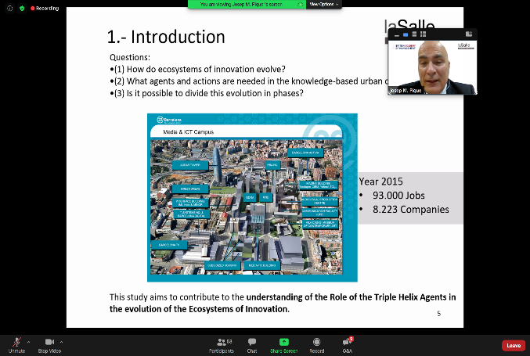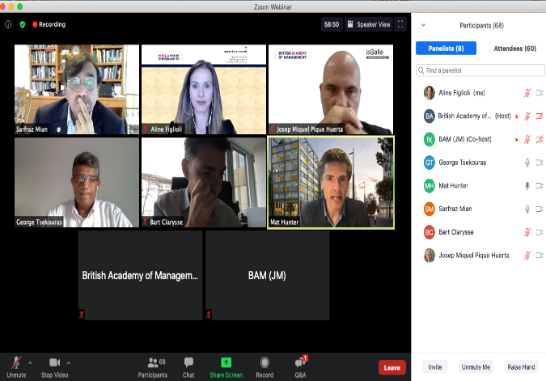

On 29th October, CENTRIM promoted a world-class webinar on Innovation Habitats with the contribution of an international panel of academics and practitioners. More than 60 attendees, from Australia to Colombia, had the opportunity to listen and discuss the state-of-the-art research on business incubators, accelerators and science and technology parks.

The webinar “Sustainable Entrepreneurial Ecosystems: New Modes and Changing Roles of Entrepreneurship Intermediaries and Innovation Habitats in the Aftermath of Covid-19” was organised by CENTRIM with the support of the British Academy of Management, in alignment with the Innovation Special Interest Group, chaired by Dr. Nick Marshal, member of CENTRIM. The panel, chaired by Dr. Aline Figlioli, Research Fellow at CENTRIM, had presentations from the following speakers:

Dr. George Tsekouras, Head of CENTRIM, started the event by presenting the fruitful history of CENTRIM in promoting research with impact in the “real-world”, closing the loop’ between academy and the wider society (more about CENTRIM at: https://www.brighton.ac.uk/centrim/what-we-do/index.aspx);

Mat Hunter, Co-CEO of PLUS X Innovation Hubs, introduced the BRITE programme, a partnership between the UoB and PLUS X (find more about BRITE at https://plusx.space/innovation/brite/), an ignited the discussion with questions about the future of innovation hubs;

Sarfraz Mian, Professor of Entrepreneurship and Policy, and Chair of the Marketing & Management Department at the State University of New York, discussed the changing landscape of business incubation;

Bart Clarysse, Chair and Professor of Entrepreneurship, ETH Zurich, from Switzerland, focused on the acceleration of technology entrepreneurs and its relation with the local entrepreneurial ecosystem; and

Josep Piqué, CEO of La Salle Technova Barcelona, and Past President of the International Association of Science Parks (IASP), from Spain, discussed the role of Modern Urban Science Parks and Areas of Innovation.

A very rich discussion took place among the panellists, with questions from the audience, about the trends and new dynamics of sustainable entrepreneurial ecosystems in times of rapid change and crisis.

In the last part of the session, Professor Sarfraz Mian discussed the prospects of a Special Issue on the subject addressed in the webinar in a high-ranked academic journal and introduced the forthcoming publication “Handbook of Research on Business Incubation and Acceleration: a Global Perspective”, that has as co-writers Bart Clarisse, Josep Pique and Dr. Aline Figlioli.

Publication - Power in community-based tourism: empowerment and partnership in Bali

Professor Marina Novelli and fellow author Claudia Dolezal have recently had a paper published at Taylor and Francis Online in the journal of Sustainable Tourism. The paper titled, ‘Power in community-based tourism: empowerment and partnership in Bali investigates the ‘social empowerment’ that results from interactions between community based tourism (CBT) actors, and the factors that support or hinder residents’ empowerment through CBT in rural Bali.

Abstract
In a tourism industry historically dominated by outside influences, the island of Bali has striven for greater local resident involvement. Community-based tourism (CBT) has thereby become an increasingly preferred tourism development approach rooted in promises of more inclusive opportunities for community empowerment, a notion reflected in the UN Sustainable Development Goals (SDGs). Drawing upon SDG17 – Partnerships for the Goals – and specifically focusing on SDG17.9 – Capacity building, SDG17.14 – Enhancing policy coherence for sustainable development, and SDG17.16 and SDG17.17 – Multi-stakeholder partnerships, this paper investigates the “social empowerment” that results from interactions between CBT actors, and the factors that support or hinder residents’ empowerment through CBT in rural Bali. This paper presents empirical evidence from an ethnographic study in three villages at different stages of tourism development.

You can read the full paper here.

Student shares fantastic insights into his internship
Final year Business Management student Georges Nikolic shared some fantastic insights into his internship with Dr. Hasan Gilani. George’s internship is at The Borgen Project that focuses on global poverty and hunger and he is one of 5% of people who got through the recruitment process.

The scope of the internship ranges from HR, journalism, marketing, PR and even approaching US congress to voice concerns and raise issues of global poverty and hunger.
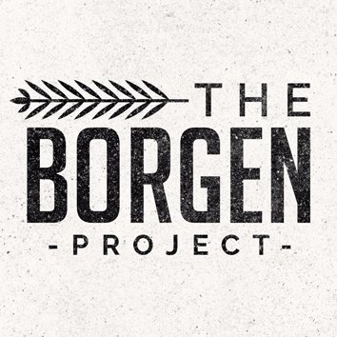
This fits in with our prime focus on SGDs which has poverty alleviation as its first priority.

Georges said about his internship:

“The company my internship is based on is called The Borgen Project. I found this organization from an advertised job on Indeed. The application process involves a quiz based on The Borgen Project as a company itself to test your knowledge. If you do well, you go onto the interview stage. Only 5% of applicants get accepted. The Borgen Project is a non-profit organization where ending global poverty and hunger is the aim. “

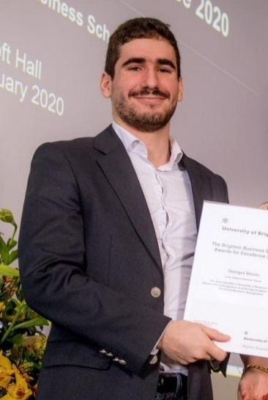
“The Borgen Project believes that leaders of the most powerful nation on earth should be doing more to address global poverty. They are the innovative, national campaign that is working to make poverty a focus of U.S. foreign policy. Addressed issues are Global Poverty & U.S. Jobs, Poverty & National Security and Poverty & Overpopulation for example. Ways to act can be contacting US Congress as well as internships, both in-office and remote, ranging from HR, Journalism and Non-profit Leadership for example. I am a Marketing and Public Relations Intern.”

Left Georges Nikolic

“This internship is 12 weeks long where I will be involved in contacting influencers and media to spread the word about the Borgen Project about their mission statement and help those in need by gaining support. Assignments vary every week. This week, I was supposed to find my US Congress but as I'm based in Brighton (UK), I can do alternate tasks. Other tasks involve creating a fundraising campaign, writing articles on The Borgen Project's website for example. There's more to come with this internship which I am excited for.”

It is great to know that Georges is not only one of the most engaging and interacting student in his lecture sessions, but also doing wonders in his career profile. Students like him surely make it worth the unlimited hours of efforts we all put in to see such fantastic results.

Congratulations and good luck Georges.

Paper published online with the Journal of Energy and Natural Resources Law (JENRL)
Dr Adaeze Okoye has now had her paper published with Taylor & Francis online in the Journal of Energy and Natural Resources Law (JENRL). The paper is titled, ‘Tax deductible flare gas penalty payments in Nigeria – context, responsibilities and judicial interpretation’.

Abstract:
The judicial interpretation of the Associated Gas Re-injection Act (Nigeria) with regard to the legality of tax deductions, which are based on the payment of gas flaring fees or penalties, illustrates some of the inconsistencies between the legality of tax action under the literal terms of the statute and the purpose of the statute to achieve a desired ethical environmental conduct.

This article will examine the context and cases of gas flaring fees, their interpretation for tax purposes and highlight the potential role of judicial interpretation which could take into account contextual factors, through purposive interpretation. The fees for flaring gas and its assessment for tax liabilities are an exemplar of potential contradictions that present a challenge for legal interpretation and (ir) responsible action. The use of relevant interpretation approaches may help deal with the issues, which arise from contradictory overlaps. Even if these approaches, may themselves be subject to dispute. The paper suggests a purposive two step test that takes into account the specific purposes of the legislation and the general context of gas flaring and corporate responsibilities.

You can read the full paper here.

Congratulations Adaeze.

Save the date! Development day update.
Plans are underway for the programme for the University wide staff development day which is now taking place in January (date to be confirmed). The theme for the day is INCLUSIVITY and INNOVATION. Please look out for emails in January confirming the date and further details for the day.

#Don’t forget to read all the latest stories on the Business School blog - http://blogs.brighton.ac.uk/bbsblog

