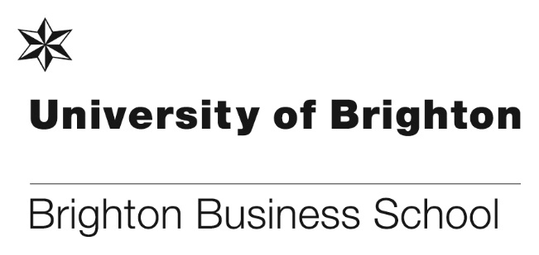

Highly commended paper award

Ex-colleague Dr. Jude Emelifeonwu has recently won an award for a paper that is credited to the University of Brighton. The award is the Human Resource Management Track highly commended by the British Academy of Management. The paper titled, ‘How Green HRM and Technological Turbulence Predicts Green Product Innovation: A STARA Tale’, was co-written with Dr. Samuel Ogbeibu, Curtin University, Malaysia, Professor John Burgess, RMIT University, Australia and Associate Professor Vijay Pereira, Khalifa University, Abu Dhabi.

Abstract
Challenged by constant technological advancements in smart technology, artificial intelligence, robotics, and algorithms (STARA) amid global warming concerns; several organisations in developed and emerging economies are probing into future oriented avenues for engendering green product innovations (GPI). With rising governmental demands for emerging economies like Malaysia to go green, and develop organisational human capital to drive GPI, organisations’ human resource management (HRM) programs are required to support the workforce in realising environmental objectives. Research therefore, suggests complementary Green HRM (GHRM) programs to constantly develop STARA related leader competencies. This research investigates how GHRM, technological turbulence and leader STARA competence (LSC) acts to predict GPI. Results indicate that technological turbulence negatively predicts GPI and reinforces the positive relationship between GHRM and GPI. While GHRM positively predict GPI, LSC’s prediction of GPI is insignificant. However, LSC amplifies the positive relationships between GHRM, technological turbulence and GPI. Policy implications are subsequently discussed.

You can read the full paper here.

Article publication and interview

Dr Paul Levy recently had an article published on the theconversation.com. The article is titled: Companies are trying to connect remote workers with ‘virtual water coolers’ – but it’s harder than it sounds.

The article looks at what has happened to the informal conversations that take place in the physical workspaces. Where has the water cooler gone? What has happened to those unplanned and often valuable corridor conversations? Paul looks at a new app called Donut that tries to revive the water cooler in a new form in the digital world. Paul offers some practical advice for creating "liminal" spaces online.

You can read the full article here. It has also been published on the BBC here.
Paul also has had an interview recorded on Faculti the expert source for academics’ views. The interview is based on Paul’s paper ‘Ink and Pixel, Pen and Stylus’ that was published in 2020 in the AMED Journal for Organisations and People. In the interview Paul talks about the difference between digital and physical writing processes.
You can listen to the interview here. Please note you will need to register for free to listen.

Latest (4th edition) e-book now available online for students

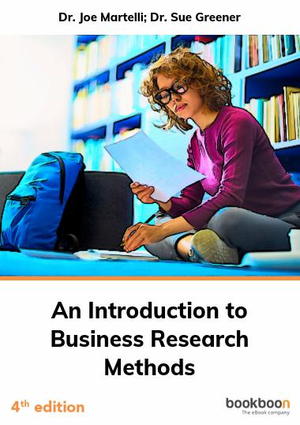
Dr Sue Greener’s (4th edition) eBook that she co-authors with Dr Joe Martelli at Findlay in the US is now available online with bookboon.com.

The book is free to download for all students and is based on an original eBook Sue produced in 2008. It is regularly updated including a range of issues, review questions, guideline answers, etc. It is not intended to replace the best Research Methods authors but to supplement and provide an easy way in for students.

Please search www.bookboon.com for Introduction to Business Research Methods.

Launching To Practise_Practice
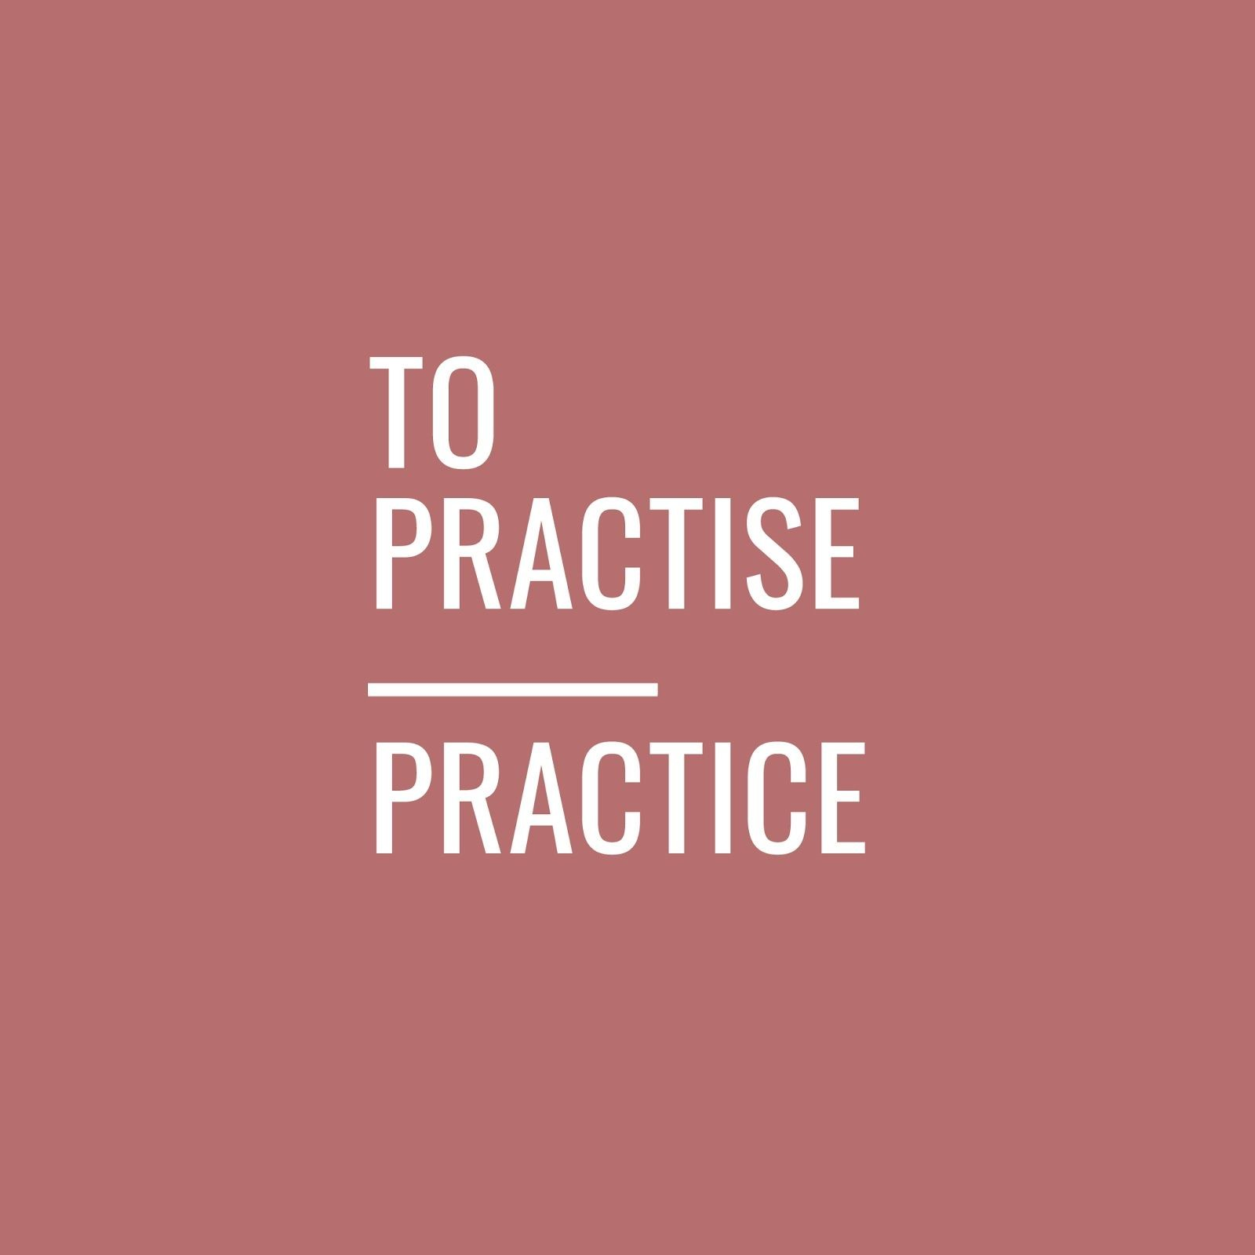
After being awarded her PhD of Business in March 2020, Dr. Erika Wong and her team have developed her academic research to create her new digital platform, To Practise_Practice (TP/P), for public use.​

In addition to the main digital platform, they can be found on Slack, Instagram, Twitter and Dr. Wong co-hosting her podcast, Hyde or Practise​​, on Anchor.fm. To find links to all of these communities, go to 2​ pp.fyi/links.​

As part of her commitment to a sustainable art practice, Dr. Wong and her podcast co-host, Alexis Hyde, participated in the live streamed event 2020 Ad Art show from MvVO Art from Manhattan. You can find the recordings, and the latest episode of their podcast on the TP/P resource hu​b.​ Finally, you can find further information, and exclusive content, on their University of Brighton blog here​. ​

About To Practise_Practice
TP/P is a digital-discovery platform that gives early-career artists the toolkit they need to survive in the real world of the art industry. It identifies the best ways to break down the barriers of entry with tried-and-true resources from our own experiences that can be personalised to your specific journey.

Our solutions address the frequent challenges that educationally trained artists face related to technique and craft. Our research shows that very few students are able to contextualise the required tools to understand the business of art. And most importantly: how to sustain your practice once you get in the industry.

Once you’ve defined your focus and goal, you’ll get a professionally designed road-map that includes what works best for you and your journey, such as articles, podcasts, workshops, and downloadable kits.

BSc(Hons) Economics students pass in style
Following the introduction of a new course BSc(Hons) Economics, we are pleased to announce that it’s first tranche of students graduated this year. All students passed first time with really impressive results. Many are going on to Postgraduate study at Imperial, Edinburgh and we are also pleased that some are staying here with the University of Brighton. We hope that the students can celebrate their success at the February graduation ceremony.

Well done to all of the students and thanks to all colleagues that worked on the development of and taught the students on the new course.

BBS PhD student is shortlisted for ‘Publication of the Year’
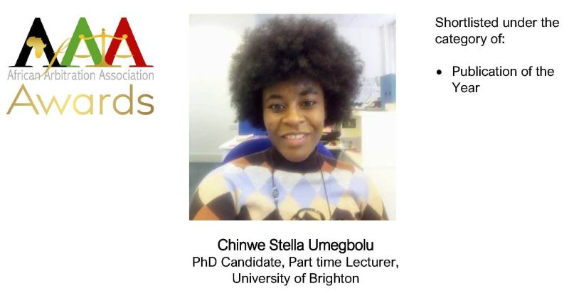
Congratulations to BBS PhD student Chinwe Umegbolu who has had one of her publications shortlisted for an award by the African Arbitration Association (AfAA).
The publication is titled 'Bargaining in the shadow of the law: The Facts of Divorce as They Stand Today’. The article addresses the expression relating to how couples bargain concerning family wealth and custody during divorce. It also sets out to prove that the Traditional African Method (TAM) of settling dispute was packaged or formalised as the present-day Alternative Dispute Resolution (ADR). Click here for full article.
Further details can also be found on the AfAA LinkedIn page here. Also on the AfAA website https://afaa.ngo.
Good luck Chinwe.

PhD success
Nadia Lonsdale recently defended her thesis successfully and is now set for conferment of her PhD entitled, ‘Corporate Environmental Responsibility in Russia: Paradoxes in the Oil Industry’.

Using qualitative exploratory approach she wanted to understand why Russian companies have low regards for their environmental responsibilities. The project concluded that the Russian oil companies (ROC’s) practice highly contextualised corporate environmental strategies, which are deeply embedded in complex inter-institutional dynamics that emerged from Russia’s geography and history.

In response to government signals framed by unique traditional and Soviet induced cultural characteristics oil companies interpret CSR as complex two-level paradox. ROCs’ concentrate vast amounts of resources on providing solution to immediate societal and economic tension, leaving the imbalance between societies/economic concerns and environmental responsibilities to be resolved in the distant future. The results suggest that ‘po-russki’ paradox of environmental governance faced by the oil industry can be resolved and all three CSR demands can be attended to simultaneously, if a system-wide proliferation of responsible education is ensured to develop ethical business practitioners.

The journey to completion of the project was a long one, but now that it is finished she is happy to say she is glad she did it. Nadia sends sincere thanks to her supervisors Kevin Turner and Steve Hogan for their invaluable advice and guidance. She is particularly grateful to Professor Toni Hilton and Steve Reeve who made the completion of the thesis possible. She also would like to thank Francisca Farache and Keith Perks who have held her hand throughout the post viva stage.

Well done and congratulations Dr. Lonsdale!

The ability to lead and to sell

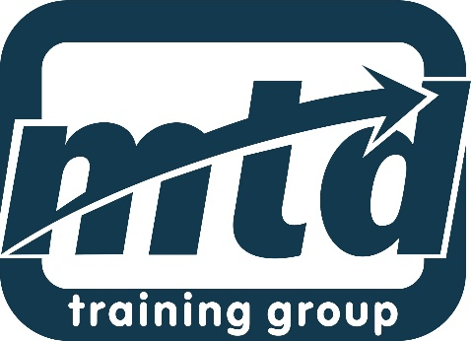

Each year, Brighton Business School holds two award ceremonies for students, to recognise them for their academic achievements during their course. These prizes are sponsored by industry, and this year, we’re delighted to announce that MTD Training sponsored two awards for 2020/21.

Due to COVID-19 we were unable to present the prizes physically, so we will be doing this at an awards ceremony in February 2021. But, MTD was so proud of their prize winners, they wanted to share their names and congratulate them now!

Amy Rea, was awarded the MTD Sales Training Prize for the best performing student on MK331 Marketing Management and Leadership – a new core module on BSc(Hons) Marketing. Amy’s prize is a 2-day Essential Selling Skills training course with ISM Accreditation worth over £525.

Abi Lebbon, was awarded the MTD Management Training and Development Prize for the best performing student on HR380 Managing and Developing final year core module across the BSc(Hons) Business programme. Abi chose a 2-day Essential Management Skills training course with CPD Accreditation work over £544.

You can read full details about the awards here.

“Let’s get ahead of the game” – the paper pushing for an effective Covid-19 vaccine strategy

University of Brighton professor and social marketing expert Professor Jeff French has contributed to a paper which is advising governments on how to encourage vaccine uptake, should one emerge.

The paper, titled ‘Key Guidelines in Developing a Pre-Emptive COVID-19 Vaccination Uptake Promotion Strategy’, highlights 10 key points which governments should consider when deciding how to roll out a potential Covid-19 vaccine, and how to make sure as many people as possible are vaccinated once a safe and effective version is approved.

More than 170 teams worldwide are currently working on a vaccine, with many in phase 3, large scale trials. Many experts believe an effective vaccine, should it come, should not be expected until late 2020 or more likely, early-middle of 2021.

Speaking to the University of Brighton podcast, Professor French, who teaches in the Brighton Business School, works with the UN and is CEO of Strategic Social Marketing Ltd, said: “Let’s project forward a few months. January, February next year we have a vaccine that works, that’s safe and we’ve managed to produce millions of doses, now the job is to get it out there. So there’s a logistical job, but very importantly there’s also a promotional job, because a lot of people will be saying no way am I going to have that, I don’t trust it.

You can read the full story here.

#Don’t forget to read all the latest stories on the Business School blog - http://blogs.brighton.ac.uk/bbsblog

