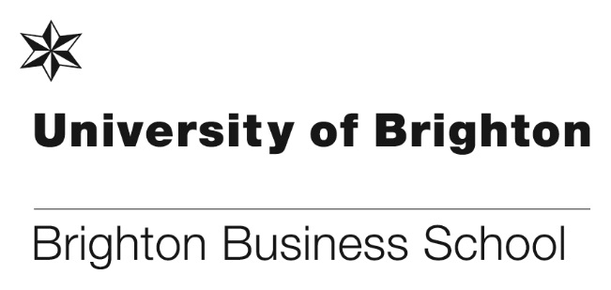

Celebrating over 30 years together

The Centre for Academic English Language Development has been hosting groups of students from the Ivory Coast on a bespoke Business English Language Course since the 1980s.
​The current students at CAELD are in the third year of their business degrees at Institut National Polytechnique Felix Houphouet-Boigny, specialising in marketing or finance.
Thanks to the successful collaboration with Dr Andrew Grantham in the Brighton Business School, the 8-week course we offer now includes an invitation to participate in weekly lectures and seminars, giving the students an invaluable opportunity to experience authentic UK undergraduate environment and work alongside UK home students.
The Ivory Coast groups demonstrate exemplary levels of engagement and abilities and will always be welcomed very warmly. The University is confident that the course will continue to evolve and respond to student needs and wishes.

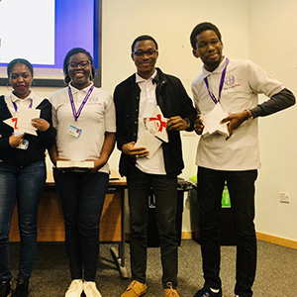
Ivory Coast students

Escape room fun!
As part of Enrichment Week, students and staff were invited to take part in an Escape Room activity. After choosing teams and a theme for the challenge, including The Haunted Rollercoaster or The Abandoned Cabin, participants spent the afternoon solving puzzles and cracking codes to ensure their escape. This was a great way of exercising teamwork, creative thinking and problem solving skills in a setting beyond lectures or the office and will be offered again in the future.

One group of students said,

“I think that this task was very enjoyable and should be open up to students again as it requires a lot of patience and concentration which will be useful within a work environment. It also tests the group as a whole and allows them to see what kind of roles they prefer to take on in a team.

Personally, as a group, we believe this was an enjoyable task and that it allowed us to work better and bond more. This was a very interesting task to work on”.
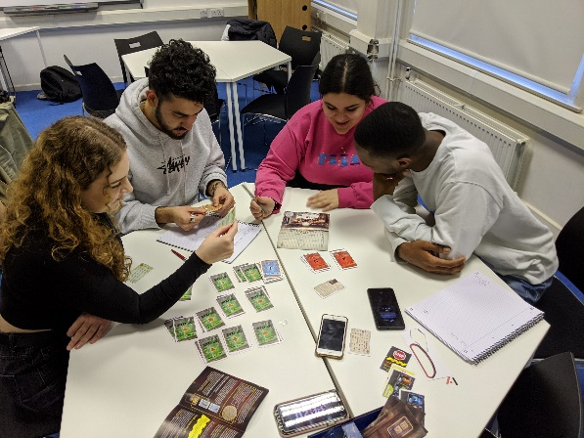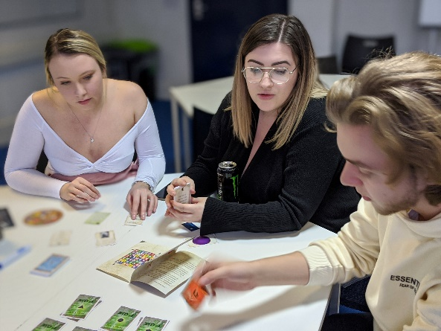
Students enjoy the Escape Room activity

Brighton and Hove City Council Climate Action Team Visit
Students on the Integrated Foundation Year programme study a semester two module focusing on climate action and climate emergency. To set the scene, Giles Rossington from Brighton & Hove City Council’s climate action team delivered a presentation on what the council is doing to respond to the climate emergency.

He spoke about the council’s goal to become climate neutral by 2030, explaining the level of reach BHCC has to influence progress in this area, and explained how the forthcoming Climate Assembly will work. The council is keen to learn about students’ attitudes towards climate action so we aim to extend links with BHCC to help inform their work.

Connecting with industry at the UoB Connect: Be More launch event
On Thursday 13th February, a new collaborative initiative led by BBS in partnership with four other Schools was launched to support students in developing their pre-professional identity and articulating their skills and experience. Based on research carried out by Dr Clare Forder and Julie Fowlie, the event was designed to increase students’ capital and confidence in activities such as networking, using LinkedIn, and actively finding out about the opportunities and assistance the University provides. Key to the success of the event was the support of the alumni who returned to offer advice and guidance on life after university and engaged with participants through informal networking. We were delighted to welcome external guests, Philip Gaffney and Matthew Francis from Merranti Consulting/Institute of Directors who provided LinkedIn and networking advice. Many colleagues from across the university also gave their time generously to make sure the day ran smoothly. Almost 100 students participated, with positive feedback such as:

- “Entrepreneurship support was fantastic alongside building networks.
- I would like similar events to be held regularly.
- This event was so helpful – I cannot thank the University enough for providing this. Such wonderful advice and support that I didn’t think was available before coming to this.
- Don’t stop doing events like these! This was incredibly helpful.
- Very happy about the event. I loved the support that the university gives to its students and ex-students.”

This was a launch event for a wider initiative that will continue in each of the Schools throughout the rest of the academic year. A follow up alumni event specifically for BBS students is planned for mid-March and we will be seeking students’ input for further activities.

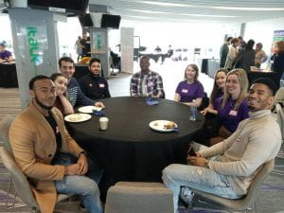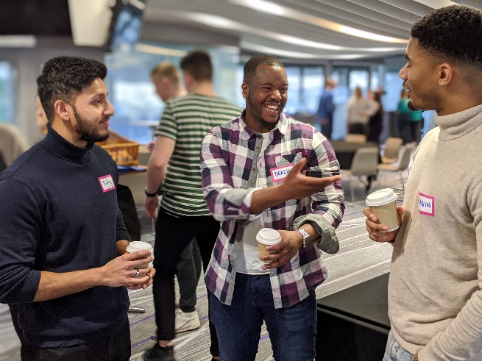

Alumni and representatives from industry attended the event to speak to students

Read more about the event from an alumni perspective and from a participant’s perspective.

A night celebrating our student’s success
The annual Awards for Excellence ceremony was held on the evening of Thursday 20 February at Cockcroft Hall. The event was attended by 19 1st and 2nd year prize-winning students along with their friends and family, sponsor of prizes and staff to celebrate the academic success of these exceptional students.

Winning students were presented with prizes from sponsors, the University Merit Scholarship awards and the BBS alumni and friends awards. Some of the winning students received more than one award showing that their hard work during their first and second years have paid off and recognised at this special event.

The award ceremony was followed by a celebratory buffet where winning students and their guests could mingle with sponsors and members of staff.

Many congratulations to all of our winning students.

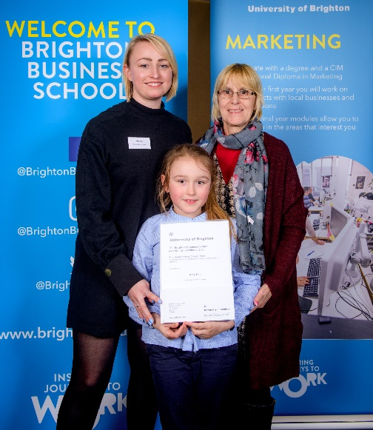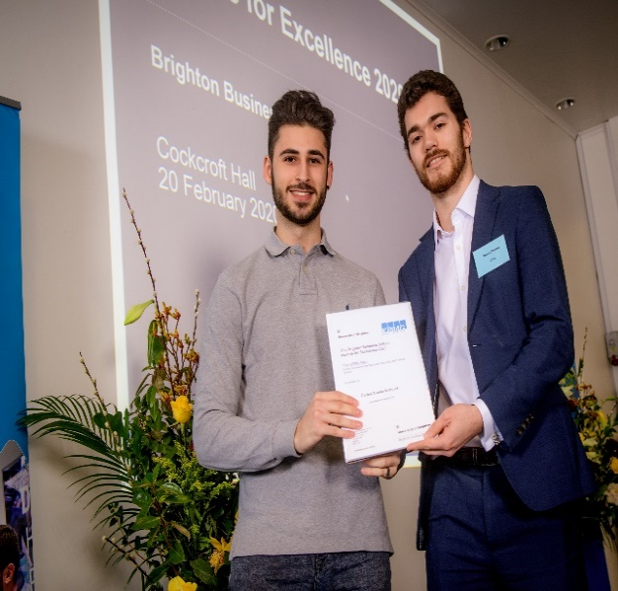
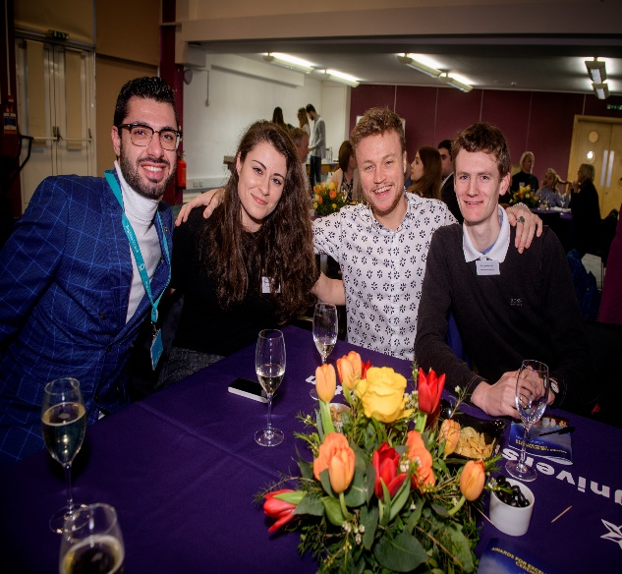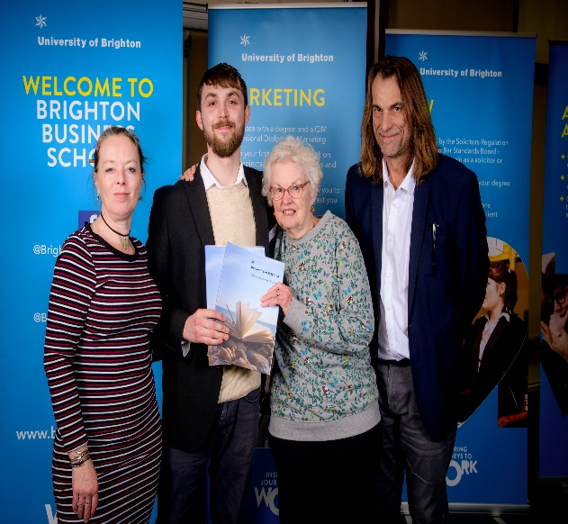

Prize winners, friends, family and sponsors enjoying the celebration
Google Digital Garage event
Second year Marketing Management student, James Veale, organised a Google Digital Garage event for University of Brighton and University of Sussex students as well as members of the public. Supported by BBS, Silicon Brighton and James Chase, where James works part-time, this large-scale event welcomed over 140 guests onto campus. They heard from Google Garage Trainer, Nikki Rae, who spoke about digital marketing strategies, Google Analytics, and building effective presentations.

BBS alumni Steve Rackley also introduced Silicon Brighton, a technical knowledge share and networking platform. The afternoon was such a success that a Google Digital Brighton 2 may take place in the near future!

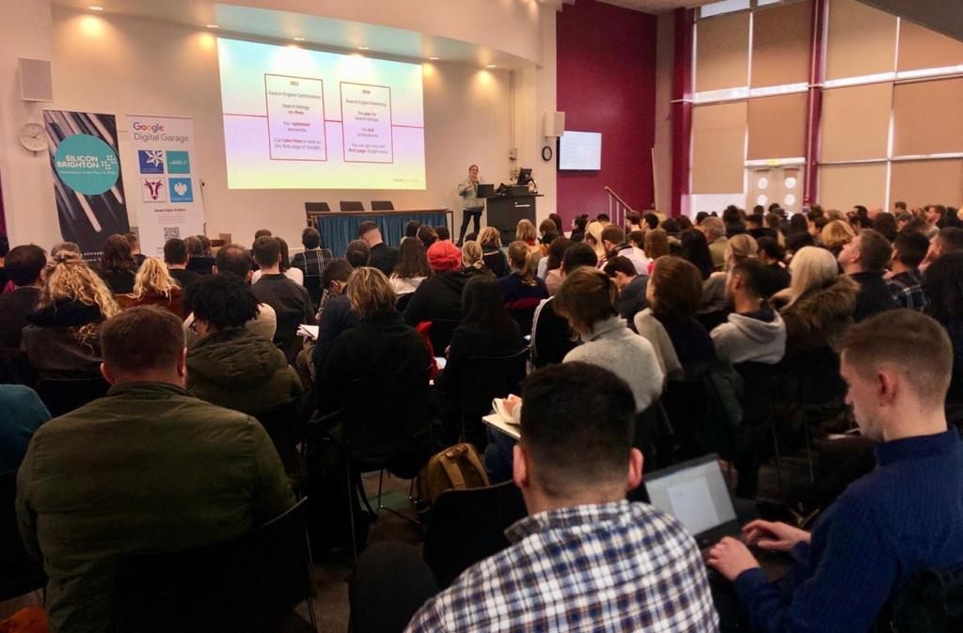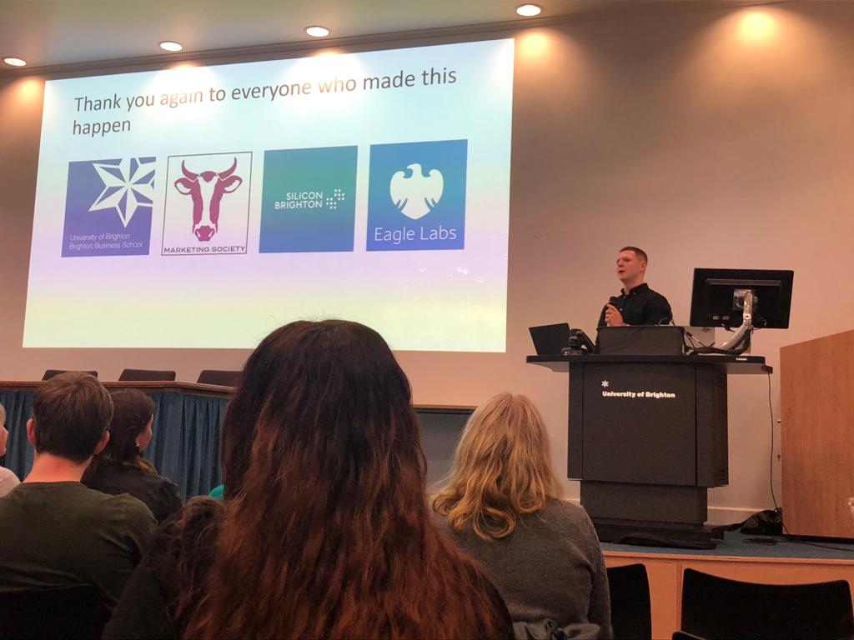
Students enjoying the Google Digital Garage event

Institute of Directors networking skills evening
Philip Gaffney, Institute of Directors (IoD) member and principal consultant at Merranti Consulting, visited BBS to host a Networking Skills evening for the Business School’s student members of the IoD. He offered useful advice about on- and offline networking, including how to build and polish your personal brand.

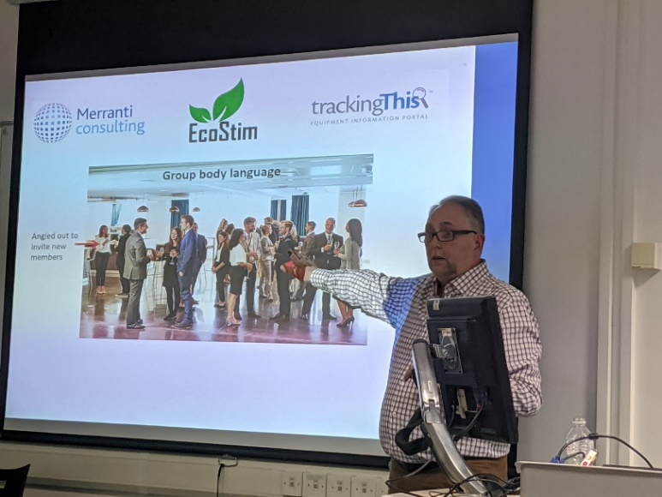
Philip also provided guidance to students on how to articulate themselves during interviews – valuable tips for participating final years currently looking and applying for graduate roles. The workshop was followed by an opportunity to put advice into practice and students were able to network informally with each other, Philip and members of staff.

Philip Gaffney IoD member & principal consultant at Merranti
Consulting

National Student Survey launch
The National Student Survey (NSS) was launched at the University on Monday 3rd February. To support BBS students’ participation, the final year Student Engagement Champions (SECs) organised NSS Pizza Lunches where students are encouraged to take a few moments to complete the survey then enjoy some pizza afterwards.

In addition, the SECs spend time reminding students to reflect on their whole university experience. They worked together to come up with ideas for a Did You Know…? mini campaign highlighting key points about the Business School, the opportunities it provides and its responses to student feedback. Our Marketing Officer, Lisa Wood, kindly designed a set of postcards for this, which have been shared with students across the School.

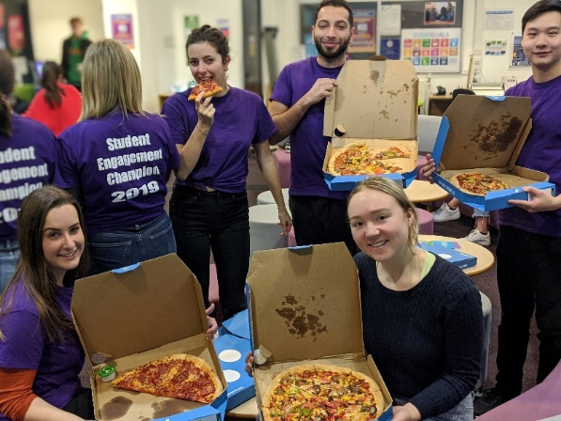

Students enjoying the NSS pizza lunch

Why laptops could be facing the end of the line!
Dr Paul Levy recently wrote an article for The Conversation, which is an online forum for authors to write features covering Arts & Culture, Business & Economy, Health & Medicine plus more. Paul’s article was titled ‘Why laptops could be facing the end of the line’ went viral attracting over 130,000 readers in just over a week. There was also a lively discussion in The Conversation readership about the content of the article.

Paul said ‘This is obviously good for the reputation of the Business School and leads to visits to the University website and enquiries into our courses. I do recommend writing these articles as they raise esteem for BBS and The Conversation is offering on-campus workshops and one-to-ones to get you started.’

Details for the workshops can be found here on-campus workshops.

Paul now has over half a million readers of his articles and has found it a rewarding way to reach a wider audience and feels it personally and professionally fulfilling, as well as raising the profile of BBS.

Read the full article here: https://theconversation.com/why-laptops-could-be-facing-the-end-of-the-line-130649

Client interviewing regional competition success
On Saturday 15 February, two of our post-graduate law students, Emily Sloyan and Rebecca McDonough, competed in the Regional Client Interviewing Competition at the South Bank University in London. They were accompanied by Andy McKay, one of our law lecturers and a practising solicitor, who has been training volunteer undergraduate and post-graduate law students in the skills of client interviewing since October.

Twelve teams from universities across the south-east took part in our regional competition. We are delighted that, after two rounds of client interviews judged by an impartial panel of expert judges, Emily and Rebecca made it through to the National Finals in London on March 14. Emily and Rebecca were one of just four pairs to qualify and this makes it the second year in a row that University of Brighton students have got to the National Finals. Following the results of all regional competitions Emily and Rebecca are currently joint 3rd in the country. The winning pair of the national competition will go to America to compete internationally.

Good luck to Emily and Rebecca for the national finals on 14 March.

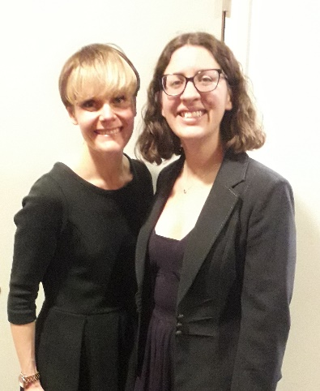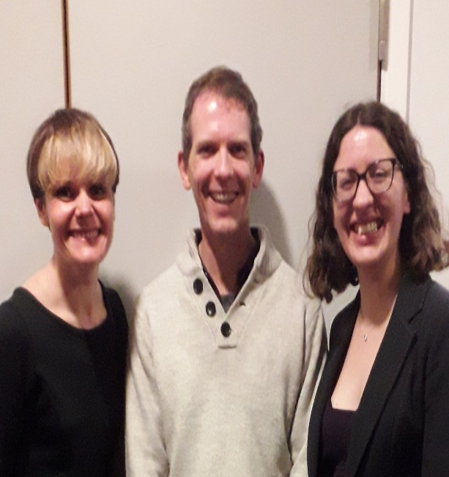
Emily, Rebecca and Andy after the success at the regional competition

#Don’t forget to read all the latest stories on the Business School blog - http://blogs.brighton.ac.uk/bbsblog

