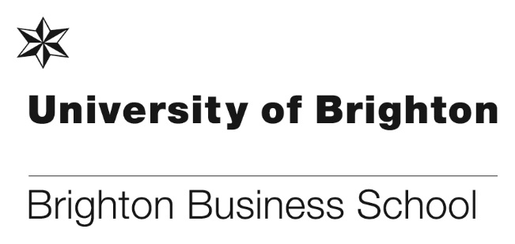

**Making the most of Enrichment Week – a student’s perspective by Tsun Lam**

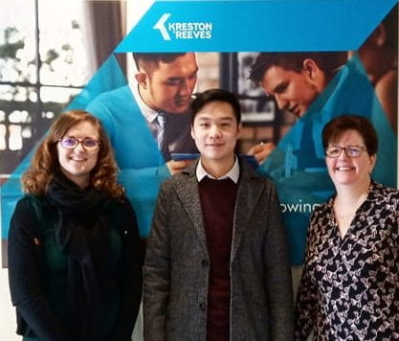

Enrichment week. What do students normally do in enrichment week? Go home and have a chilled weekend? Take a short trip? Spend time reading? Or maybe lie in bed watching Netflix all week? Well, I decided to do none of the above and go along to an opening morning in London held by Kreston Reeves, Chartered Accountants and Financial Advisers. The university sent the opportunity round to all students studying accounting and suggested we go along and start to build our professional profiles by attending a networking event.  I was a bit nervous as I have no idea what to do in a networking event.

After a few hours of traveling, I arrived outside feeling a bit apprehensive. The receptionist buzzed me in, and I walked into the office to be greeted by friendly faces.  We were shown into a meeting room and settled down to let the morning officially begin.

During the morning, professional accountants, managers, and students gave us an insight into the industry. I used to think accounting would be an office-based job; just compiling spreadsheets and analysing data. However, I soon found out that this isn’t the case. Accounting and auditing is often more active than you think, accountants often travel to meet with clients at their own offices. I also got to experience the working culture around the office and talked to staff and their colleagues.

At the end of the morning the Q&A session was the most beneficial. It was my opportunity to ask questions more specific to my own situation in one-to-one basis. This way, I could find out about the skills that recruiters look out for from graduates, which will allow me to develop my future employability skills.

Finally, I am truly thankful to the university for providing me with this fantastic networking opportunity. I look forward to attending more events which may help me in my future career.

**Brighton Business School graduate receives royal honour**



Sheila Flavell, Brighton Business School graduate, received a CBE in the 2020 New Year Honours list

**Sheila Flavell,** University of Brighton graduate and a champion for women in tech, received a CBE in the Queen’s new year honours. Sheila, who received a Marketing MA and an MBA from the Brighton Business School, is Chief Operating Officer of FDM Group, the Brighton-based international professional services company and global leader in the recruit, train, deploy sector.

She was awarded a CBE for “services to gender equality in IT and graduate and returners”.

Sheila said: “Women represent 50% of the population but only 17% of the IT workforce. Encouraging more women into a career in tech is a business imperative. Its not just a nice thing to do, it’s the right thing to do for numerous reasons not least to create greater diversity of thought and to help combat the growing skills gap within the sector.”

Sheila spearheads FDM’s Global Women in Tech and FDM’s Getting Back to Business programme which provides opportunities for people returning to work. She also chairs the Institute of Coding Industry Advisory Board, offering advice and guidance to a number of universities in England. She sits on the main Board of techUK and is often called to advise government committees, especially on the digital skills gap.

Sheila, also gave a keynote speech during the University of Brighton’s 2018 summer awards ceremony, has won numerous awards including a Lifetime Achievement Award by Scotland Women in Technology, Woman of the Year at the information Age Women in IT awards, and Leader of the Year at the everywoman in Technology Awards.

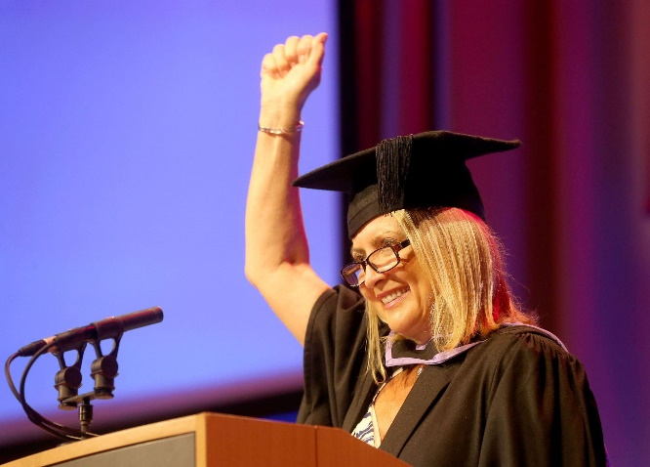

Sheila Flavell, Brighton Business School graduate speaking at the Brighton Business School graduation ceremony in 2018.

**Welcome to our new colleague!**

**Dr Noor Muhammad Lecture in Strategy, Innovation and Enterprise**

**Dr Noor Muhammad** joined Brighton Business School in November 2019. He has a PhD in Entrepreneurship and Enterprise Development from Huddersfield University Business School.

Prior to joining BBS, he worked for over 6 years at The Ghulam Ishaq Khan Institute of Engineering Sciences and Technology, one of the most prominent institutions in Pakistan. He held the position of Assistant Professor of Entrepreneurship and Enterprise Development as well as teaching undergraduate and postgraduate courses.

Noor has also worked as a key entrepreneurship mentor in GIK Incubation Centre at GIK Institute, where students launched new ventures under his direct supervision.

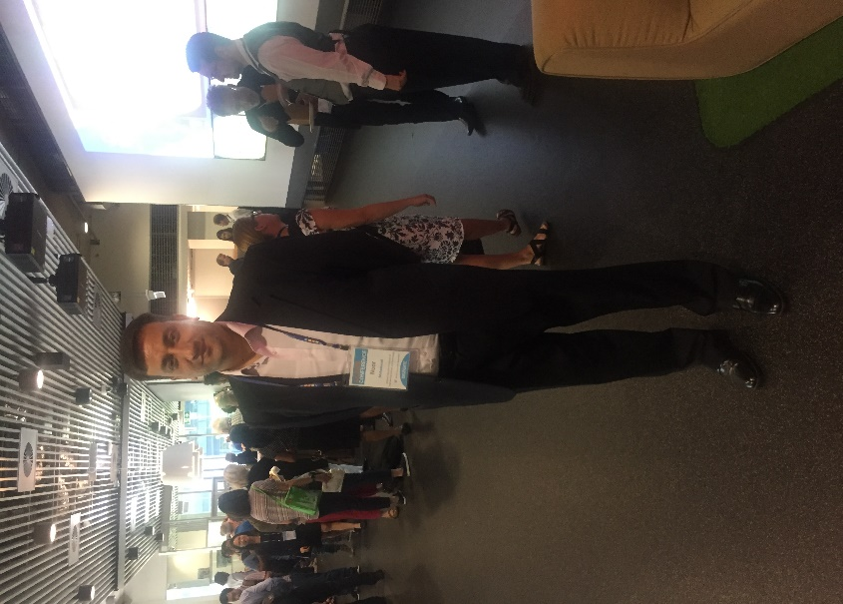

His research interests include entrepreneurship in conflict zones, women and entrepreneurship, enterprise development and multidisciplinary research. Entrepreneurship in conflict and rural regions has been recognised by academic scholars and researchers. International funding agencies provide opportunities for researchers to carry out this research in those countries facing conflict. The research shows how entrepreneurship and new enterprises can contribute to providing employment opportunities in the deprived regions. Noor has developed realistic possibilities not only for further research projects and publications but also for collaboration with other international organisations who are interested to support his research further.

Regarding women and entrepreneurship, his research focuses on how women entrepreneurs operate small businesses in conflict environments who face formidable challenges, there is currently little research to explore this.

Noor also publishes papers in other areas of interest in order to conduct a multidisciplinary approach, including operations research, economics and health care innovation management. Noor is also a member of Australian Centre for Entrepreneurship Research Exchange, Social Entrepreneurship Harvard University, and Institute of Small Business and Entrepreneurship (ISBE) UK.

# **Students negotiating their way to London**

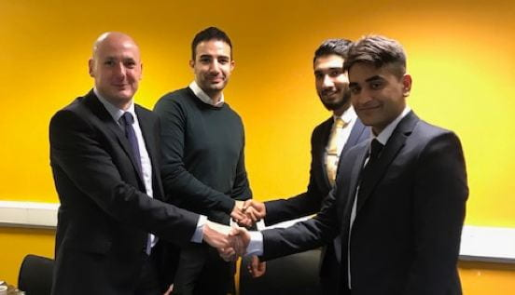

*Winners of 2020 Brighton Law School heats Ehab Ahmad & Hardeep Singh are headed to London for the regional finals.*

Students studying law at Brighton Law School flexed their negotiating skills against each other in an effort to win a place at the regional heats of the CEDR National Negotiating Competition in London.

The competition pits pairs of students against each other to negotiate a number of challenging fictional scenarios.  Students have the opportunity to hone their negotiating skills not only with each other but in front of a panel of judges from local firm DMH Stallard.

The winners **Ehab Ahmad** and **Hardeep Singh** impressed judges, Jay Barnett and Neil Farrow from DMH Stallard and have also won themselves a week’s work experience at the firm.  The runners up will also have a chance to take part in the regional heats as the school is entering two teams.

The regional heats will take place on 22nd February in London and teams will each take part in two negotiation scenarios. 12 teams will then progress to the National Final in Manchester, where they will participate in three new scenarios (including a three-way negotiation).

The winners of the national competition will earn the right to compete in the International Competition representing England, which is taking place in Missoula, Montana, USA at The University of Montana in 2020.

Well done Ehab and Hardeep and good luck for the next round!

**Brighton Business School features in The Brighton Effect special issue on sustainability**

The Brighton Business School features in the special issue on sustainability of The Brighton Effect. The half page feature highlights how in June 2019 we adopted the UN’s Sustainable Development Goals (SDGs) as a framework for progressing our new vision and mission built around ‘Responsible Enterprise’.

**Julie Fowlie** is quoted saying ‘Our mission is to advance, support and shape responsible enterprise through education, research, collaboration and thought leadership’.

The school is one of only a select few in the UK to adopt these goals.



The full feature can be found here:

<https://issuu.com/universityofbrighton/docs/_be_alumni_magazine_2019/8>

**Brighton Business School PhD student secures internship**

**Ben Brindle** one of our PhD students will be joining the International Organisation for Migration (IOM), the United Nations’ migration agency for a six month internship in Geneva, Switzerland. Ben decided to apply to the internship on the off-chance as it strongly related to his PhD which looks at the impact of immigration on the UK labour market.

With the help of the South Coast Doctoral Training Partnership (SCDTP) who fund Ben’s studies, Ben successfully navigated the different application stages and was successful. The SCDTP will also be funding and supporting Ben’s living costs while in Geneva.

Ben will be working in the Migration Policy Research Division, where he will support the preparation of a range of migration publications, including the IOM's flagship publication, the World Migration Report. Specifically,he’ll be conducting the initial research and writing for a chapter which looks at regional migration events and trends across the world.

Congratulations Ben and wishing you a successful internship.

**Brighton Business School and UoB Connect - Be More Challenge Special Launch Event**

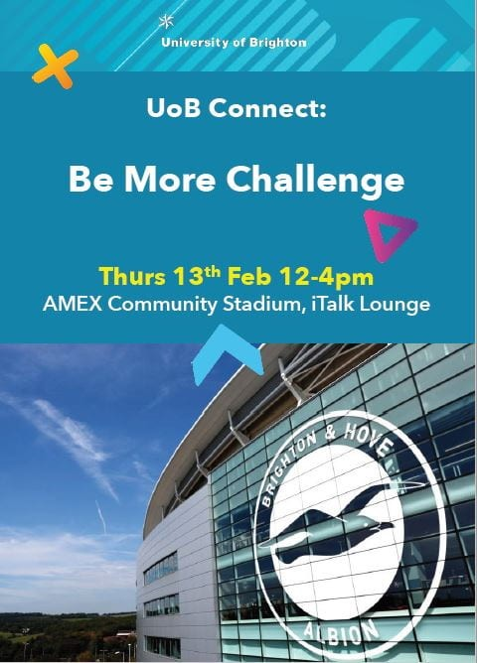

Brighton Business School students have been invited to the BBS and UoB Connect ‘Be More Challenge’ launch event taking place on Thursday 13 February at the AMEX community stadium. It is a free event for students.

This is an exciting project designed for students to [Be More: Employable, Skilled and Connected.](https://www.brighton.ac.uk/current-students/employability-and-careers/employability-outside-my-course/index.aspx)  It is open to all (UG & PG), particularly if they are a commuter student, first in family to attend university or identify as Black, Asian or Minority Ethnic. It's also a perfect opportunity for our students to get to know students and staff on other courses from other Schools.

The event will take place on Thursday 13th February from 12-4pm and will be held at the American Express Community Stadium in Falmer. A great range of activities will be available for those taking part, including:

* Learning how to network session
* Informal networking with alumni
* Finding out about LinkedIn
* Getting a FREE professional LinkedIn headshot
* Discovering more about volunteering (Active Student)
* Exploring the possibility of getting a mentor (Momentum programme)
* Talking to staff from the Careers Service
* Collecting information and advice on entrepreneurship and start-ups from beepurple and Springboard
* Taking a Sport Brighton mini challenge and finding out more about the Parklife scheme

When students arrive they will be given a UoB Connect: Be More challenge card. As they participate in the activities listed above, they get their challenge card stamped. Once the card is full, they can exchange if for a certificate of participation which they can then upload to your LinkedIn profile/CV #BrightonWorks #BrightonAchieves

**BBS undergraduates get creative with a local business**

As part of their Creativity in Enterprise module, Brighton Business School first year undergraduates took on the role of business consultants with David Sewell, owner of [Pavilion Gardens Cafe](https://www.paviliongardenscafe.co.uk/), a local business that has an eighty-year history in the city.

Located at the west end of the Royal Pavilion Gardens Estate in the centre of Brighton, owner-manager David shared the history of this family-owned business and posed a practical challenge to the students – to explore how the business can find a balance between its popular traditional brand and ensuring it is a modern, responsive, proactive enterprise.

Students made use of some of the creative problem tools they had learned on the module and developed practical and innovative ideas and recommendations for David to take away.

According to David: “This was a very useful session. Some of the ideas confirm we are doing the right things; others I hadn’t thought of and will certainly be considering.”

Our students were highly engaged during the session and pleased to put what they have learned so far into practice. At the end of each of the three group sessions David invited students to visit the cafe and to try one of the cafe’s legendary rock cakes, baked to a secret family recipe for over half a century!

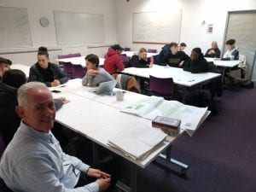

David Sewell working with groups

David believes the business has been thriving for nearly a century because it has never departed from its traditional values of friendly customer service, using local suppliers and encouraging customers to see the cafe as a community space in the heart of a busy city. Yet the business is also open to change and innovation. The visit was an example of how local enterprises can work with our students who bring fresh, creative perspectives and thoughts that disrupt for all the right reasons.

The sessions were led by **Paul Levy**. According to Paul: “Pavilion Gardens Cafe is a place I often go to write. Our students demonstrated some fine creativity and I look forward to seeing what changes the cafe will make.”

**Don’t forget to read all the latest stories on the Business School blog -** [**http://blogs.brighton.ac.uk/bbsblog**](http://blogs.brighton.ac.uk/bbsblog)