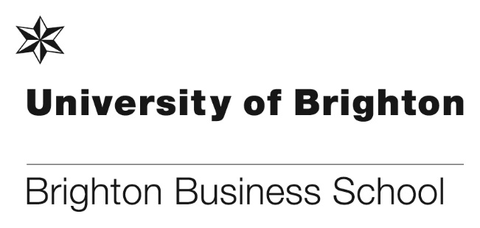
Welcome to our new colleagues!
Dr Solomon Akpotozor – Lecturer, Accounting
Solomon Akpotozor joined Brighton Business School as a Lecturer in Accounting in August 2019. Before this, Solomon worked as an Associate Lecturer at the Queen Mary University of London in a range of Accounting and Finance modules, where he also obtained his PhD which examined corporate social and environmental accountability in Nigeria.

Solomon’s research interests focus on social and eco-justice issues such as social and environmental accountability, human rights and modern slavery accounting, climate change, Sustainable Development Goals (SDGs), corporate disclosures and counter accounting. Solomon welcomes collaboration in this area and other related corporate governance topics.

Before commencing his academic journey, Solomon worked as a government Accountant at the Office of the Accountant-General of the Federation in Nigeria. He uses his practitioner experience alongside active learning pedagogies to teach his students.

Before commencing his academic journey, Solomon worked as a government Accountant at the Office of the Accountant-General of the Federation in Nigeria. He uses his practitioner experience alongside active learning pedagogies to teach his students.

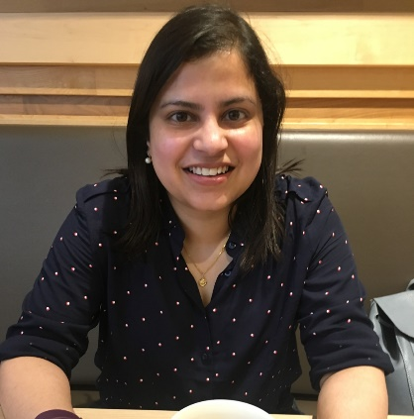
Dr Avanti Pinto – Lecturer, Economics
Avanti joined BBS in August 2019 as a Lecturer in Economics. Prior to that she worked at the University of St. Andrews as an Associate Lecturer in Environmental Economics; and at the University of Aberdeen as a Lecturer in Economics; from where she also completed her PhD that focussed on the impacts of environmental agreements on welfare, trade and carbon leakage.

Her research interests include environmental cooperation, international trade and welfare. She has experience in consulting and research across the fields of finance, real estate, labour rights and trade unions.

Avanti will be leading the module on Game Theory and will be teaching other economics modules for first and second year undergraduate courses.

Dr Tri Tri Nguyen – Lecturer, Accounting
Tri is a Lecturer (accounting) in Brighton Business School. He just finished his PhD in accounting and finance at the University of East London. Tri holds a master degree from the University of Sydney, Australia. Before he joins Brighton Business School, he was an hourly-paid lecturer at University of East London and served a short period as a teaching fellow at University of Ulster. He also had more than ten years of teaching experience in Vietnam. Tri used to be an auditor for Deloitte Touche Tohmatsu Vietnam.).

His teaching focuses on financial reporting, auditing, business ethics and corporate governance. His research interests are about earnings management, accounting conservatism, Benford’s Law, boards of directors, chief executive officers, risk taking, and cash holdings. Tri presented his research in many prestigious conferences in the field, e.g. annual conferences organised by European Accounting Association, European Financial Management Association, British Accounting and Finance Association. His research was also featured in the Columbia Law School’s blog, which is one of the most influential blogs for practitioners (http://clsbluesky.law.columbia.edu/2017/02/24/using-the-profile-of-ceos-to-detect-earnings-management/

Dr Kamila Walters – Lecturer, Supply Chain Management
Kamila Walters completed her PhD in Physics and joined the University of Brighton for the first time in 2007 to work on an Anglo-French research project in (at the time) the School of Environment and Technology.

She left the University in 2008 to work in Industry for a Fast-Moving Consumer Goods SME company based in West Sussex; however, she continued to participate – part-time - in research within the Materials Science field. In Industry, she worked in all areas of the Supply Chain and Operations, most recently utilising her analytical skills and multidisciplinary experience in the Business Intelligence Unit - in the role of Finance Business Partner.

In June 2019, after just over 10 years in Industry, Kamila returned to Academia, to join the Brighton Business School, thereby bringing her real-life business experience into the teaching of Supply Chain, Logistics and Operations Management.

Kamila’s interests are focussed on the exploration of modern, local and global, integrated supply chain management (covering traditional supply chain topics, such as: procurement, inventory management, operations, quality management, logistics and transportation) and the use of data analytics and quantitative methods in the supply chain to improve decision-making for all activities across the supply chain.

A performance at the Edinburgh Fringe

In August Paul Levy had the privilege to be part of a live performance at the Edinburgh Fringe Festival. This year the influential 1.5 Degrees Report was released and Paul was invited to read a part of that report up in Edinburgh. The entire report was read out to audiences over 3 days.

The report which is extremely evidence-based, highlights the vital difference between a 1.5 and 2 degree rise on global temperature. At 2 degrees the planet will suffer significant negative change. If we can peg that rise back by just a half a degree, we can prevent a lot of that environmental damage. In a dedicated performance space Paul read a section about the impact of 2 degrees rise compared to 1.5 degrees on small island nations. At 2 degrees, the impact is huge with whole island nations devastated.

You can find out more here: https://1point5degreeslive.org/
And download the free report here:https://www.ipcc.ch/sr15/

European Conference on Social Media

On 13 and 14 June Wybe Popma and Stuart Francis hosted the 2019 European Conference on Social Media in the Huxley building. Asher Rospigliosi gave the opening keynote titled, "What's wrong with social media", other keynotes included:
- When Social Media doesn’t work - Asher Rospigliosi, University of Brighton
- 'Social Listening' Evolves into 'Consumer Research' : a Five Year Perspective Ben Hackett, Vizia Commercial Specialist at Brandwatch
- Finding voices: The Role of Users in Generating Content that Works Hannah Brookes, UX Content Strategist, Jellyfish Digital Marketing Agency
The conference was a huge success and congratulations go to Wybe and Stuart. Further details on the conference can be found here: http://www.wikicfp.com/cfp/servlet/event.showcfp?eventid=79291&copyownerid=8438

Brighton Sailing Club hosts postgraduate social evening

It’s not all work and no play when you’re studying at Brighton Business School and with the longer days and warmer evenings upon us we decided to take advantage of the weather and host a social evening for postgraduate students.

As is befitting for one of the UK’s most vibrant cities by the sea students from MSc Logistics and Supply Chain Management and MSc Marketing headed to the beach. Tucked away at the foot of i360 under the arches amongst the bars, restaurants and clubs is Brighton Sailing Club our venue for the evening.

With a view across the promenade towards the catamarans the sound of their halyards chiming in the gentle evening breeze we sat and enjoyed the chance to find out more about each other over a chilled drink.
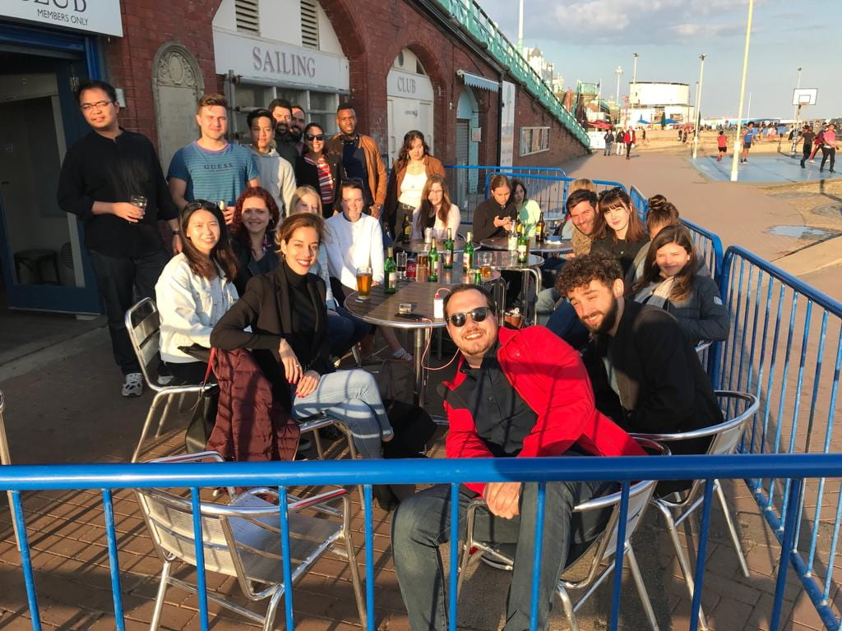
Student teams help local businesses and the community

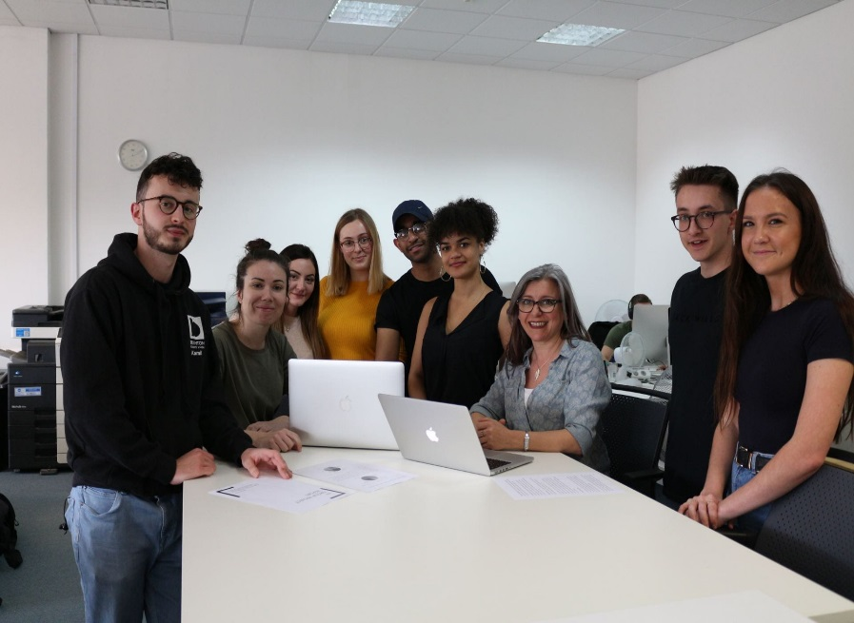

Here at the Brighton Business School we have a large number of student research/business project teams available to work on local projects (in and near to Brighton and Hove) from November 2019 to March 2020.

‘Developing Professional Practice in Business’ provides teams of 5 students to work with local businesses to help them develop a project they have that needs resourcing. The projects might want to investigate a particular activity or direction; test something out with customers/clients; run a survey; or carry out some marketing. The module helps final year students develop their employability and project management skills through the completion of a business project.

Students will be working in small groups to go in to an organisation to work on a project for 30 hrs per student in total (excluding writing up and feeding back time). So this is quite a useful resource for organisations to take advantage of and it is free. The students are supported to deliver a project by the module tutors and the Active Student Volunteering Service.

Previous successful projects have included:

- Surveys for a community rail partnership; a University department; and small businesses
- Evaluating careers and employment guidance tools
- Creating a business plan for an organisation that had recently become a charity (from a community group) – the business plan the students created helped the organisation gain a year’s funding for their local project
- A digital marketing plan and trial for a restaurant
- An employee handbook for a local bakery
- Product testing new software
- Evaluating and enhancing the digital marketing strategy for a boutique
- Creating a marketing plan and social media engagement plan for a public sector body
- Running events

We are now delighted to offer this opportunity to businesses, third-sector organisations and public sector partners.
Sponsor secured for the new legal clinic

We are pleased to announce that following a meeting in June between Brontie Ansell and Tom Barnard at Irwin Mitchell the firm has agreed to a number of 3 year PQE solicitors and a senior associate, to act as supervising solicitors for the new legal clinic. This support will comprise Irwin Mitchell providing the PQE solicitors who will attend clinic and supervise students and in addition they have a specialist immigration team. Irwin Mitchell are really keen to see us expand from commercial matters to more mainstream social justice issues.

This is brilliant news and will be such a fabulous opportunity for our students, not only with the client work, but also to meet solicitors who are at a prestigious national firm.

Congratulations to Brontie for securing this for the new legal clinic.

Papers accepted for publication

We are delighted to announce in May 2019 Dr Tim Laing had 2 papers accepted for publication. The first paper called, ‘Climate Impacts on Capital Accumulation in a Small Island Developing State’ is a collaboration with colleagues Dr Eric Kemp-Benedict at the Stockholm Environment Institute, Ms. Crystal Drakes at the University of West Indies and Dr Jonathan Lamontagne in Sustainability, Tufts School of Engineering. Tim and his colleagues modelled damage to productive capital from tropical storm damage in Barbados in the context of climate change and shows the impact that anticipatory investments can have on mitigating these damages.

Further details can be found here: https://www.preprints.org/manuscript/201905.0151/v1

The second paper called, ‘Small man goes where the large fears to tread: Mining in Guyana: 1990-2018 in Resources Policy’, is a paper where Tim examines the unique features of Guyana’s mining industry and how political, economic and geological factors have created a locally-owned small-scale mining industry. He focussed on the role that legal instruments have played in creating this industry and the economic and environmental implications of the nature of the industry.
Further details can be found here: https://www.sciencedirect.com/science/article/pii/S0301420719301035

An ‘honorable mention’ for PhD student Akinyo F Ola

Between 8-11 August 2019 BBS PhD student Akinyo F Ola attended the American Psychological Association Convention (APA2019) in Chicago, Illinois. We are pleased to announce that Akinyo received an Honorable Mention: Single Institutional Projects for his paper on ‘Improving Project Capabilities. A Case Study within the United Kingdom Public Sector’, further details can be found here.
https://apps.apa.org/convsearch/article.aspx?id=192600&type=abstract
Many congratulations to Akinyo.

BBS colleague interviewed for Independent article and BBC Radio

In May Paul Levy was interviewed for an article in The Independent was published on 26th May. The article was entitled: Social media has brought charity shops back to life – and made second hand shopping even more addictive and was written by Irena Barker. Paul commented on the rise of charity shops as successful small retail businesses that have become places for online conversation and news sharing. Charity shops have become smart places for shopping but also places online where groups share images about what is on offer. Some of this content sharing is cruel and based on darker humour. It isn't surprising that the traditional view of the charity shop is changing, as these shops become the real survivors on the high street. This offers a challenge for the sector to engage more effectively and in a more planned way with the online conversation around their activity.

The full article can be read here: (https://www.independent.co.uk/news/long_reads/charity-shops-shopping-twitter-instagram-brexit-climate-change-addiction-a8893516.html).

Also on the 4 June Paul Levy was interviewed on BBC Radio this morning about the question of whether mobile phone use at work should be banned.

Paul talked about recent reports that some companies are exercising greater control over personal use of mobile phones at work. There is more control being exercised over use of work phones as well. Phone addiction is still on the rise and research suggests that we are becoming less productive with continual mobile phone use and digital distraction. Paul suggested that many organisations do not train staff (or leaders) in the right skills for mobile phone use, including how to multi task effectively, as knowing when and how to place mobile use and content effectively. Message replication also occurs where a lack of confidence in decision making via email, texting and online collaboration leads to replication by phone call and meetings. Different methods of communication are appropriate for different types of work task and decision making.

Commendation received from the Chartered Institute of Marketing (CIM) for BBS students!

In an outstanding effort 21 final year Business School students were awarded their BSc and their CIM Level 6 Diploma in Professional Marketing from the Chartered Institute of Marketing.

The University received a Letter of commendation from the CIM for the excellent standard of results achieved by students for the Driving Innovation and Digital Strategy modules of the Diploma in Professional Marketing. So huge congratulations to them for not only achieving such a high standard as individuals but also for representing our University to a very important professional accrediting body. No other university comes close to this achievement.

Many thanks to Tim Lane and Liz Hawkins who led superbly on these for us this year.

New AACSB mentor appointed

Our original AACSB mentor Professor Geoff Perry has had to step down because of changes in his professional life, however we are delighted to announce that a new mentor has been appointed. He is Professor Tony van Zijl, Professor of Accounting & Financial Management at the School of Accounting and Commercial Law, Victoria University, Wellington, New Zealand.

In December 2010 he helped secure Victoria University to become the first university in New Zealand (and the third in Australasia) to obtain AACSB accreditation in both Business and Accounting. In late 2011 the University was awarded EQUIS accreditation from the European Foundation for Management Development and are now one of around 75 business schools (from around 13000 worldwide) to hold EQUIS, AACSB (Business) and AMBA accreditations (the ‘Triple Crown’) and among the Triple Crown holders are the only school to also hold AACSB Accounting accreditation. In 2011/12 he was a member of the AACSB Special Committee on the Value of AACSB Accreditation. In 2014 he was a member 4 of 32 of the AACSB Peer Review Team for the University of Sydney Continuous Improvement Review. He has also served as AACSB mentor for Institut Teknologi Bandung (ITB), Bandung, Indonesia.

We look forward to welcoming Professor Tony van Zijl on his first visit to the Brighton Business School on 7-8 October 2019.

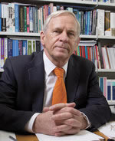

Professor Tony van Zijl

Brighton Business School Prizegiving 2019
The annual Brighton Business Prizegiving ceremony was held on Friday 2 August at the Sallis Benney Theatre, this year saw 50 final year students attend with their friends and family to celebrate their success on their academic achievement. The students received prizes from 39 sponsors including, MTD Training, DMH Stallard, ACCA UK, Brighton and Hove Bus Company, Institute of Directors, Thomson Reuters, plus many more.

The event was also attended by representatives from 32 of the sponsor companies, which gave the winning students the chance to network with them during the post ceremony celebration.

All guests were welcomed to the awards ceremony this year by Professor Toni Hilton and students were called up on stage to receive their award by Peter McCullen.

The sun shone for the celebratory lunch and everyone that attended agreed it was another successful event, Jeremy Spiller, Director at Fitz Digital Ltd said “It's an honour and a pleasure to be able to support the school and many thanks for inviting me to do so. Also many thanks for the picture and a very enjoyable event. I had a chat with Matt after the event and am now keeping an eye open for any suitable opportunities for him”.

Thanks to all of our sponsors, without them we would not be able to offer the prizes and hold the event. Also congratulations to all of our prize winning students, we wish them all the best and lots of success in the future.

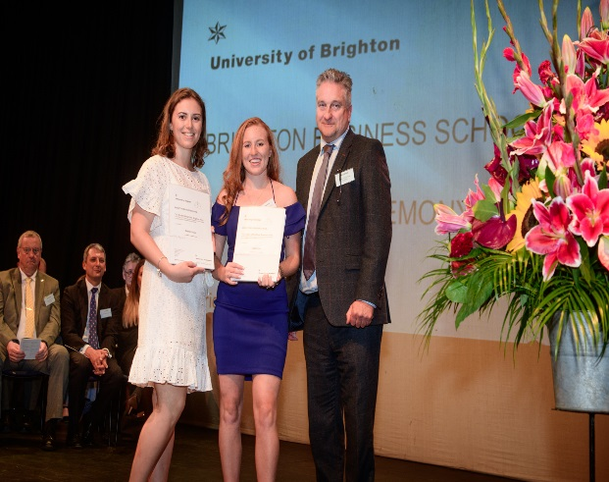
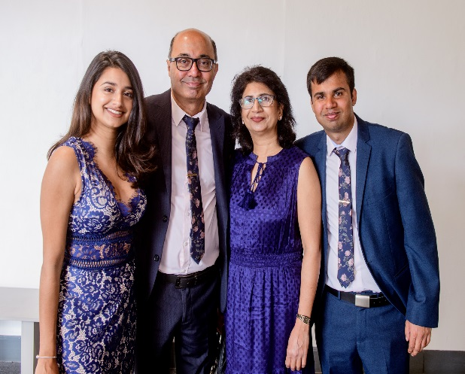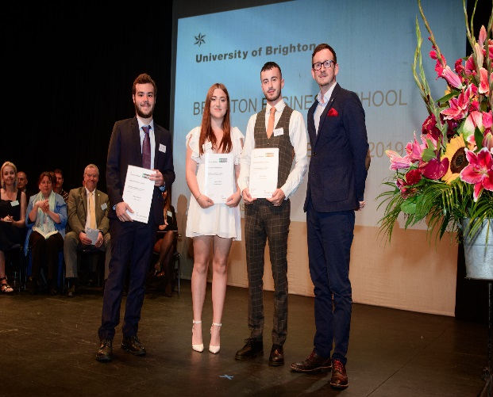
Sponsors, prize winners at their guests enjoying the prizegiving ceremony
MSc Logistics and Supply Chain spring visit to Liz Earle

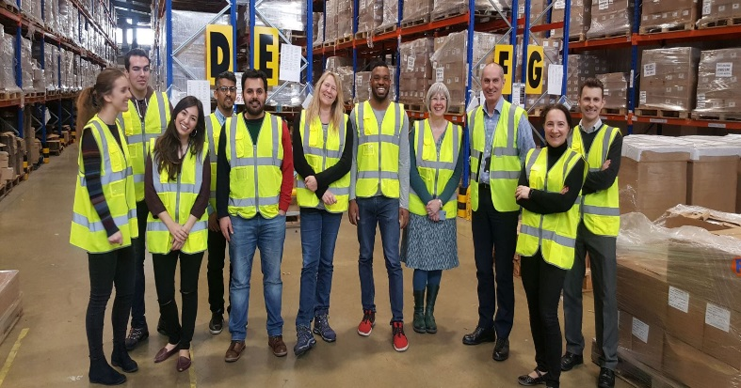

Each spring the MSc Logistics and Supply Chain students go on a field trip to industry to witness first hand some of the challenges organisations encounter in bringing their products to market.

This time the students visited Liz Earle, a natural beauty products company located on the Isle of Wight. A short boat ride off the southern coast of England, the visit normally involves a ride on a Hovercraft, but due to some inclement weather we had to take the ferry.

The students met with the company’s Operations Director, Supply Chain Planning Manager and Packing Operations Manager who provided insights into the strategic challenges of multi-channel distribution and strategy, as well as capacity management of warehouse and packing operations.

After a working lunch the students took a tour of the order fulfilment centre to see the production line and gained valuable insights into the customer service and online retail operations of this growing B2C business.

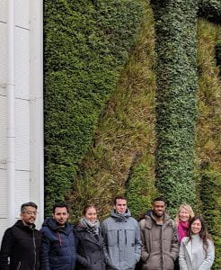
Liz Earle, Naturally Active keeping the ethos alive with a living wall

Leavers, new appointments and Honorary Fellows
In 2018/19 a number of staff left the school some of whom were long standing members of staff. The leavers for the academic year are:
Keith Mattacks
Jim McLoughlin
Dr Keith Perks
Professor Lew Perren
Gary Priddis
Dr Mona Rashidirad
Professor Howard Rush
Babak Sodagar
Tove Sorensen-Bentham
Dr Pascal Stiefenhofer
Dr Matt Wood
Stephen Young

Tessa Allgeier
Dr Jeanette Ashton
Helen Berry
Professor Tim Brady
AJ Cilliers
Trish Coffey
Professor Marc Cowling
Professor Marie Dembour
Rachael Halstead
Phil Holden
Sue Holland
Dr Mark Hughes
Dr Richard Lang
Barry Lee-Scherer

We would to thank all of them for their dedication, their hard work and taking so many students through this life changing time in their lives. We wish you all the best for a happy and relaxing future.

We are pleased to announce that some of the members of staff have been appointed Honorary Fellows to the school. Our new Honorary Fellows are:

Professor Howard Rush
Dr Mark Hughes
Dr Matt Wood
Babak Sodagar
Barry Lee-Scherer
Tessa Allgeier
Jim McLoughlin

Congratulations to them all and we look forward to benefiting from their continued contribution on a voluntary basis in various roles such as PhD student supervision and sitting on school committees.

Change in Status:-

Finally we are pleased to announce following recent interviews that Nadia Lonsdale and Sarah Cork have been appointed to permanent positions in Marketing. Congratulations!

It’s students v staff in Radio 4 quiz show

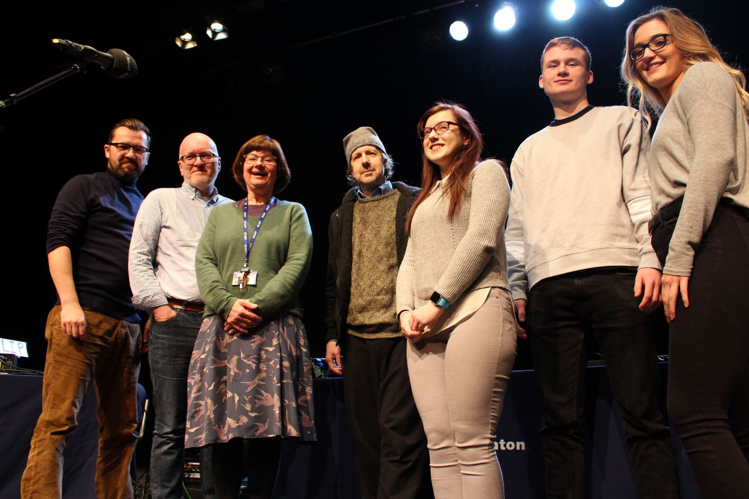

Brighton Business School students and staff were amongst the challengers going head-to-head on BBC Radio 4 quiz show The 3rd Degree on Monday 19 August. The show, hosted by writer, comedian and actor Steve Punt, was recorded in front of an audience at the University’s Sallis Benney Theatre in January.

After a rigorous selection process, students Sara Letham (Biomedical Science), Vincent Kane (Marketing Management) and Rachael Baylis (Globalisation: History, Politics, Culture) were chosen to represent the student team. Dr Sarah Pitt (School of Pharmacy and Biomolecular Sciences) Dr Jon Watson (School of Humanities) and Phil Holden (Brighton Business School) made up the academic panel.

The three students went up against three lecturers in their relevant subjects in a series of themed rounds, including specialist knowledge, general knowledge and quickfire bell-and-buzzer rounds. Producer David Tyler, whose producing and directing credits include Spitting Image and Little Britain, said: “It was an absolute treat to come and record in Brighton.

More information about The 3rd Degree here: https://bbc.in/2KSgKXh

Don’t forget to read all the latest stories on the Business School blog - http://blogs.brighton.ac.uk/bbsblog

