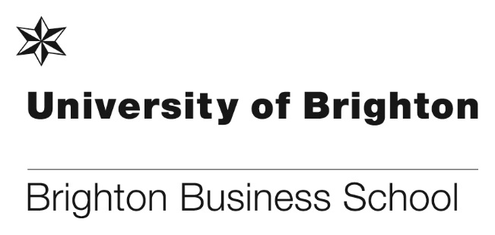
Celebrating Professor Marie-Benedicte Dembour’s €2.5 million European Research Council

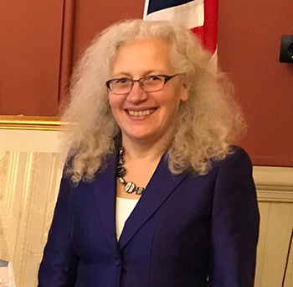

Congratulations to Professor Marie-Benedicte Dembour who has submitted and successfully won a highly prestigious €2.5 million ERC grant for her ground-breaking human rights research. The research project called DISSECT will shed light on the way evidence is collected, submitted and used by international human rights courts. It will provide insight for the future benefit of victims of human rights abuses and human rights bodies. The 60 months study will examine the rules and practices which govern the treatment of evidence in international human rights adjudications.
Marie said: “I’m very grateful to have received this grant and excited about embarking on what is vital and unprecedented research. DISSECT is urgently needed by victims of human rights abuse who are seeking redress and don’t know exactly what evidence is required from them, as well as human rights bodies at risk of losing their legitimacy if they cannot demonstrate they are acting logically, consistently and fairly.”
“With concerns about ‘truth decay’ in wider society, DISSECT is a timely study that will enable new insights about evidence, truth and power.”
DISSECT will also investigate the political uses of the international human rights evidence system, including dismissals of politically sensitive complaints on the pretext they are not sufficiently evidenced by the victim.
Marie’s findings will identify ‘best’ and ‘worst’ practices and enable her to generate specific recommendations for policy and practice. She said that she hopes the research will allow International human rights evidentiary regimes to be studied as a “social phenomenon” rather than as purely legal instruments.
This ground-breaking research is likely to have global impact and goes to the heart of BBS positioning around responsible enterprise and social justice, evidencing how we make a difference.

Please note that there will be a special all school meeting to celebrate Marie’s remarkable achievement. We cannot overstate the significance of Marie’s successful ERC bid for her career, our school and the University of Brighton. At the meeting Marie will share details of the research project, what it is about and why it is important. It is a rare opportunity to celebrate an achievement of such momentous importance so please come along on 13 June, 12-1pm in room 218.

Conference session Chair at the international ICSIMAT conference

Dr Ioannis Rizomyliotis has been selected to be a session chair at the 8th International conference on Strategic Innovative Marketing and Tourism (ICSIMAT) that will be held in northern Aegean Greece between 17-21 July 2019. The conference advisory board, the scientific committee, the invited speakers and the supporting universities are of the highest standard, with last year's conference proceedings published by Springer received more than 73000 downloads.

Ioannis will chair a session on Digital Marketing: Communication and Interaction via Social Media and Mobile Marketing. Ioannis said “it would be an honour to have colleagues from the school among us”.

Further information about the conference can be found here: www.icsimat.com

PhD success
Congratulations to Dr Stuart Hill who successfully defended his thesis on the 22 March. Stuart’s thesis is entitled ‘What is fair pay? Employer motivations for adopting the Living Wage’.

Stuart said, “I used mixed methods research to survey and analyse pay-related ethical assurance schemes in the United Kingdom. My in depth qualitative research examined employers who had adopted the popular scheme of the Living Wage.

With a local focus, my research was bounded to the Brighton and Hove Living Wage specifically. I found employers were motivated to adopt the ethical assurance scheme of the Living Wage because the conceptual basis of this intervention aligned with how they conceptualised fair pay”.

Thanks to the excellent supervision team of Professor Jackie O'Reilly and Dr David Lain.

Dr Pascal Stiefenhofer wins University of Brighton Rising Star award

Following the award panel of the University of Brighton Rising Star scheme on the 4 April, we are delighted to announce that Dr Pascal Stiefenhofer has been awarded of £8,100.00.

The panel noted that Pascal’s proposal was ranked 6th out of 26 applications, saying that the application detailed a feasible publication plan, was very ambitious and provides an opportunity to launch an international leadership role.

The Rising Star Award enables Pascal to initiate a world-leading research project with a prominent international researcher team on theoretical and empirical aspects of the retired poor in advanced economies such as the UK and Japan.

Congratulations Pascal on another successful bid.

Nominations received for the Brighton Students’ Union Awards 2019
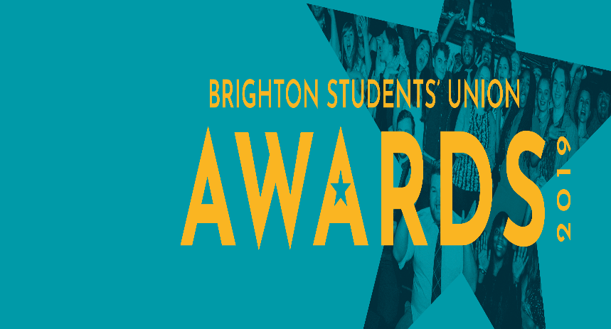

We are delighted to announce that the school and members of staff have been nominated by students for the Brighton Students’ Union awards 2019.
The shortlisted nominees for 2019 are:
Nigel Padbury and Zoe Swan for Innovative Teaching
Sue Endean for Inspirational Teaching
Louise Letchford for Support Staff Award
The Brighton Business School for School of the Year
Good luck to all nominated staff and the school.

A visit from the world’s biggest boutique digital marketing agency

In the beginning, there were websites…

And in 2019 it is estimated that those websites will account for over 63.6% of all global media ad spend, a sum of nearly $327.28bn. The revolution that was the World Wide Web dominates societal, economic, and political change around the globe and is the fastest growing global economy.

We were, therefore, delighted to welcome Alessio Messaggi, Paid Search Specialist, at Jellyfish the world’s biggest boutique digital marketing agency to talk to us about the science behind Google, the scale of the digital ecosystem and the different ways he spends his clients’ paid media budget.

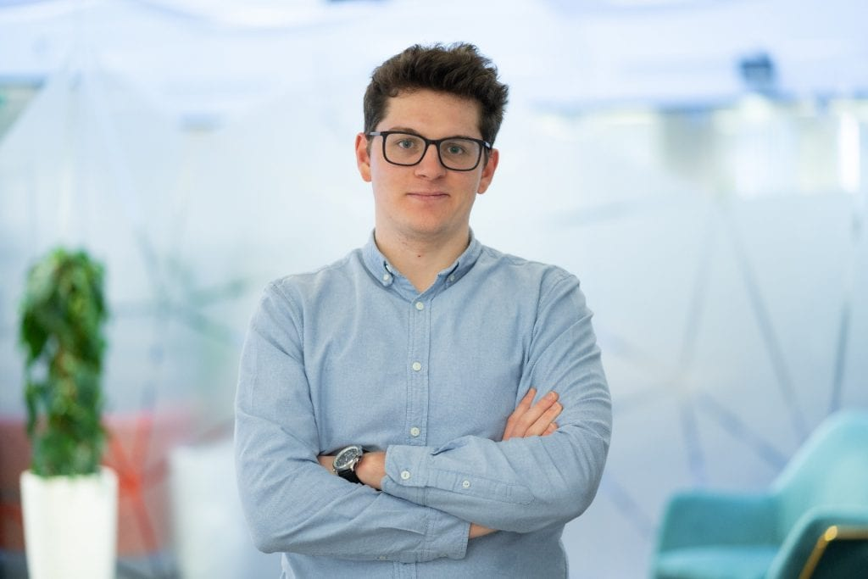
Alessio Messaggi
Paid Search Specialist
Jellyfish

Alessio delivers paid media strategies for his clients using a combination of platforms. During his talk he outlined the key tactics he uses to build his campaigns including: programmatic and display ads, paid search, YouTube and paid social channels. The digital landscape is becoming ever more integrated and consumers are being targeted by one platform depending on their interaction with another making the possible depth of targeting greater than ever before.

Alessio also emphasised the need to test and learn from creative at every touchpoint and what tactics can be deployed to optimise activity to maximise budget and deliver intelligent campaigns.

With a rapt audience of next generation digital marketers scribbling away, Alessio also shared thoughts on what the future might be for an industry that’s rapidly evolving.

Jaguar Land Rover Factory Tour
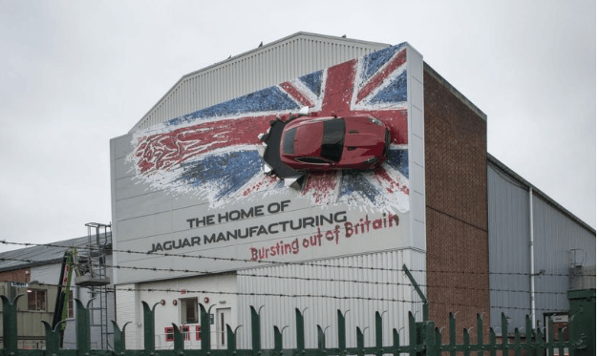

In March students from MSc Logistics and Supply Chain Management enjoyed a visit to the home of Jaguar in Birmingham.

As a part of their module on Operations Management for Logistics, students visited Jaguar Land Rover’s Castle Bromwich plant near Birmingham. The factory tour was preceded by an introduction to the brand, its values and supply chain.

The tour of the factory included the ‘Body in white’ area where the aluminium pressings are assembled by rivets and glue in a highly automated production line with many robots.
Students then visited the final assembly and trim line for the Jaguar F Pace. The tour included coverage of the company’s lean operations and outsourced logistics.

The evening before, students enjoyed a meal together and a tour of Birmingham’s historic canal hub, one of the country’s first integrated logistics systems.

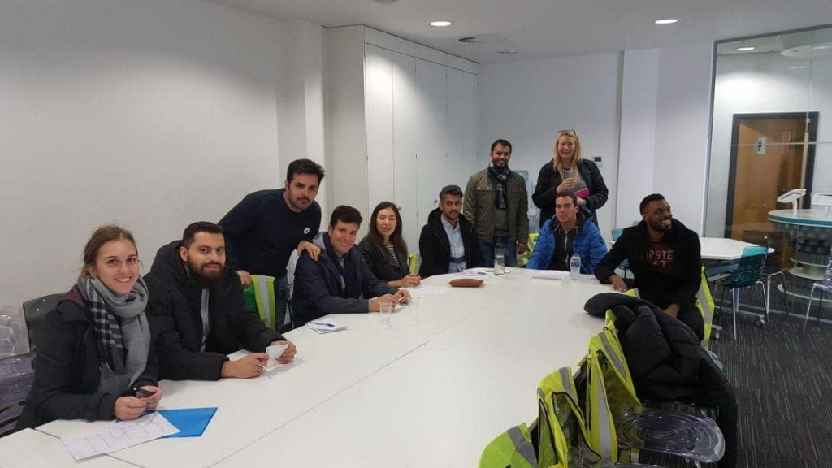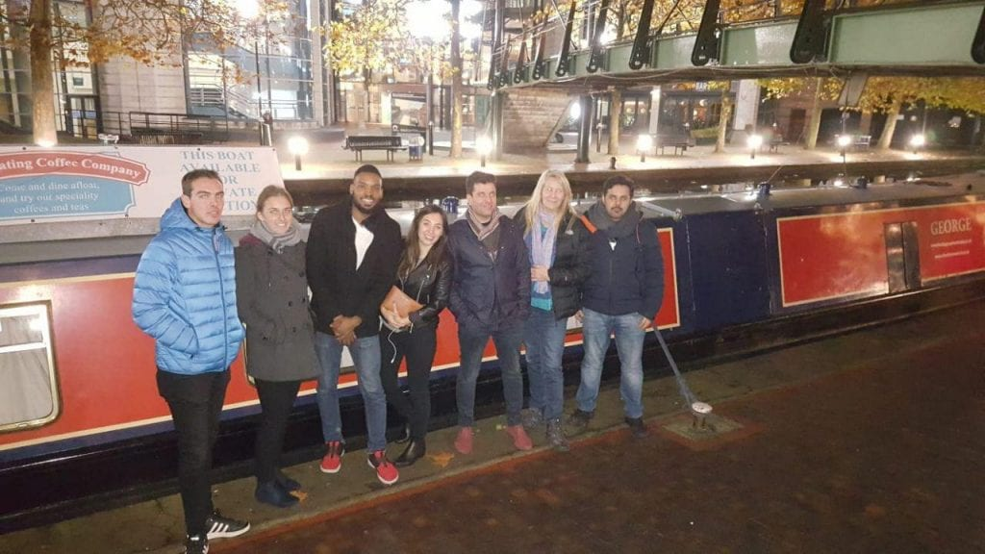
Students enjoying the visit to Jaguar and Birmingham’s historic canal hub.

All Aboard for the Startup Cruise

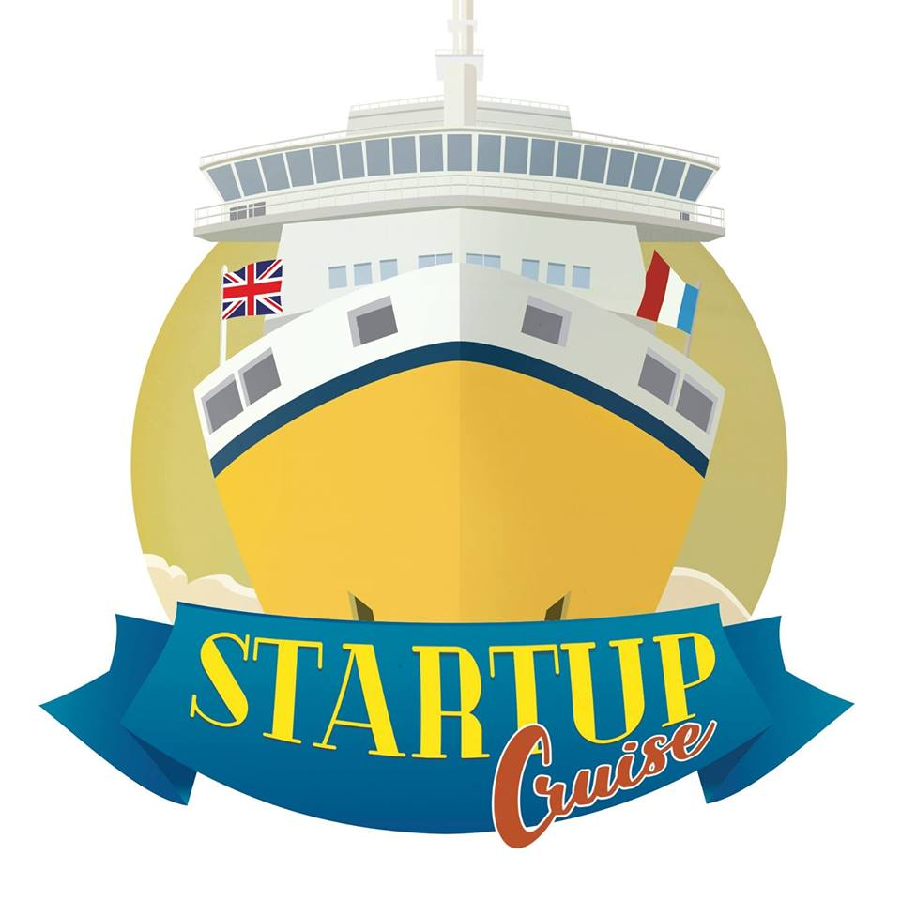

On the 4 April Dr Paul Levy stepped on board a boat from Newhaven to Dieppe to co-facilitate the Startup Cruise. An idea inspired by the award-winning DIAL (Drop-in Action Learning) Project, where thirty startups from the UK will explore the innovation and growth potential of their small businesses through a journey of discovery.

Arriving in Dieppe they were met by a cohort of French small businesses who then climbed aboard and joined the group on the journey back to Newhaven and sharing ideas and experiences.

A mix of workshop activities and guest speakers aboard the ferry aimed to inspire the entrepreneurs to reflect on their businesses and arrive at new ideas and actions for taking their startups to the next level.

Paul said, “I am excited. There are plenty of research opportunities here. How do alternative meeting venues stimulate innovative thinking? What possibilities exist for small business collaboration arising from such a journey? Newhaven is a town in need of regeneration and the ferry could play a big role in this. There is scope for us here at Brighton to also become a player with potential funding in the future”.

Participants also got to meet the captain on the bridge and learn about navigation and the importance of the horizon!

Managing the impacts of tourism
First year International Tourism Management BSc(Hons) students recently visited the Royal Pavilion in Brighton to learn how the attraction manages the impacts caused by visitors to the property. The trip was organized by their Impacts of Tourism module leader Dr Nigel Jarvis.

The students had a 90-minute detailed guided tour led by Nick Kay, Conservation Assistant. Students learned about the fine balancing act the Pavilion takes to maximize revenue from tourists while limiting the negative effects they cause on the former royal residence of George IV.

Student Arshia said: “I learned about how fingerprints on copper causes problems, how chewing gum and general foot traffic damages the carpets, tourists’ handbags can bang against doors, and some visitors may steal objects.”

Student Sarah said “I didn’t realise how damaging tourism impacts can be from leaning against walls to touching surfaces…The maintenance of a historical building is difficult enough, let alone the cost of repairing damages, it must be extraordinary and almost impossible or futile.”

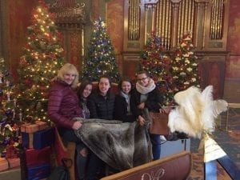
International Tourism Management students enjoy the visit to the Royal Pavilion

Don’t forget to read all the latest stories on the Business School blog - http://blogs.brighton.ac.uk/bbsblog

