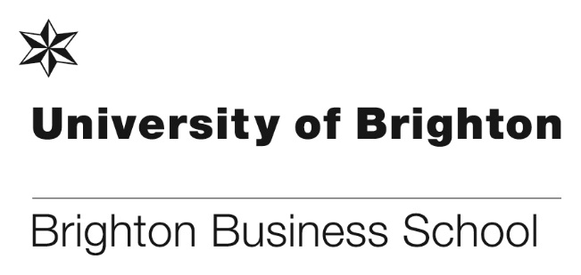

Accelerating innovation and insights for the digital future
For ten years, Clare Millington has championed the introduction and teaching of SAP to the students at the Business School. This work has recently been recognised earning the Business School a SAP Next-Gen Chapter ‘Centre of Excellence’ award. As one of only five in the UK, this award is real ‘feather in the cap’ for Clare and her work.
Congratulations to Clare for her foresight and effort in establishing the teaching and the use of SAP here.
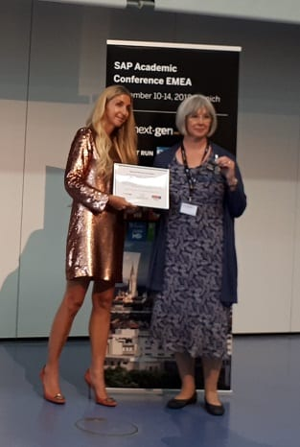
Clare Millington, our Business Management (Top-Up) course leader, represented the university at the SAP Academic Conference EMEA, where the new chapter members were announced. Pictured with Ann Rosenberg, Senior Vice President, Global Head of SAP Next-Gen.

Please see full details here: http://blogs.brighton.ac.uk/bbsblog/2018/10/01/accelerating-innovation-and-insights-for-the-digital-future/#.W8S13mdcjOt
Exciting guest lecture for MK285 Marketing and Responsibility students
On 24th October, Nicky Wells co-delivered the marketing and responsibility lecture focusing on working with internal and external stakeholders to improve the social and environmental impact of brands. She shared her experience as Marketing Manager and Brand Manager for leading Unilever brands including the real beauty campaign for Dove, developing rainforest alliance accreditation for PGTips and the challenges of developing a ‘health campaign’ for Marmite to counter the growth of competitor, Nutella. As well as benefitting from this real-world experience in the lecture theatre, students enjoyed a question and answer session to find out what it’s like working in marketing and to hear Nicky’s top tips for employability.
Q: What’s the most important thing, beyond ‘technical knowledge’ that potential marketeers need to success in marketing?
A: Creativity. Not just thinking of ideas but thinking around situations, thinking about solutions to challenges.
Analysis – being able to understand and use data and look for trends and opportunities.
Relationship building – being able to work with lots of different stakeholders in the organisation.
Q: What do you wish you’d learnt / done at university to prepare you for work in marketing?
A: Been more aware of what’s going on… read the news, business press, find out what companies are doing. Have a broad awareness of what’s going on to be able to spot opportunities.
Q: What’s the best thing about working in marketing?
A: Working with lots of different people / creative people / agencies and as a brand manager having ownership of the brand.
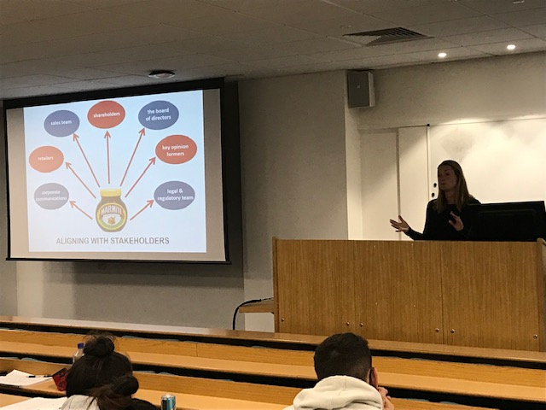
Nicky Wells presenting her lecture to students

Head joins national council for business schools
Professor Toni Hilton, has been elected to serve on the Chartered Association of Business Schools’ (Chartered ABS) Council.

Chartered ABS acts as the voice of the UK’s business and management education sector by supporting “members to maintain world-class standards of teaching and research, and help shape policy and create opportunities through dialogue with business and government”.

Other newly elected members include:
Martin Broad
Dana Brown
Julia Clarke (re-elected)
Robert MacIntosh (elected, previously co-opted)

Who join fellow Council members:
Simon Collinson
Veronica Hope Hailey
Angus Laing
Heather McLaughlin
Zoe Radnor
Donna Whitehead
Baback Yazdani

Professor Hilton said: “It is a great honour to contribute to advancing the national business school agenda at this challenging time. Chartered ABS provides a terrific collaborative network for Brighton Business School staff to develop and benchmark their academic leadership practice through committee membership, development programmes and conferences.”

Many congratulations to Toni.

PhD success!

Congratulations goes to Kamal Mahmes who was successful in his recent viva and defence of his thesis! Well done too Rosie Boxer on her first supervision; and many thanks for the valuable expertise from Professor Kenneth D’Silva of London South Bank University.
Steve Reeve said “I too was involved so am very proud of Kamal’s viva performance”.

Pascal Stiefenhofer receives best paper award

Pascal Stiefenhofer won the excellent paper award at the International Conference Japan on Consumer Theory. In his paper, entitled “Towards a Characterization of the Ethical Consumer: Conspicuous Ethics”, Pascal provides the theoretical underpinnings of ethical consumption and introduces the concept of conspicuous ethics, an idea rooted in Veblen’s Theory of Leisure. The seminal paper leads to a future research agenda focusing on the mathematical formulation of ethical preferences and the modeling of social labels.
Below is the paper abstract.
This paper considers a group of consumers who have preferences over how a good is produced and distributed, -rather its traits alone. Moreover, it is hypothesized that these preferences also depend on prices, and that prices inform consumers about the way goods are produced and distributed. In this paper we define the motivation, and state the assumptions and conditions representing the consumption behaviour of the ethical consumer. It is shown that a price dependent direct utility function provides the necessary structure in the characterization of the consumption behaviour of the ethical consumer
The paper is available on demand, please contact Pascal directly.

New appointments across the school
Following a call for Expressions of Interest for a number of academic leadership roles across the school, interviews were held and the following appointments have been made:
PG Programmes Lead: Dr. Claire-Michelle Smyth
UG Progammes Lead: Dan Bennett
MSc Management Course Leader: Dr. Ya (Angela) Gao (from 10th Feb 2019)
School Board Chair: Asher Rospigliosi
School Research Ethics Committee Chair: Dr Sue Greener

Congratulations goes to them all and we wish them much success in their new roles.

Don’t forget to read all the latest stories on the Business School blog - http://blogs.brighton.ac.uk/bbsblog

