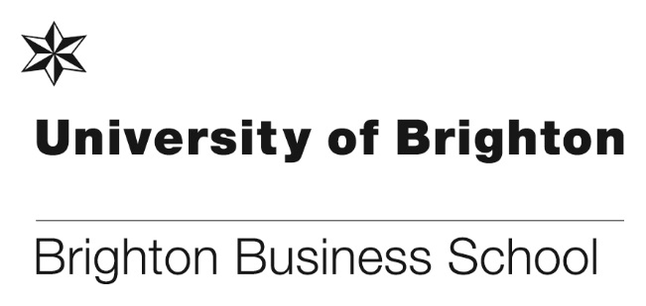

OSTC Brighton v Sussex Trading Challenge 2018

The OSTC Trading Challenge provides a unique opportunity for finance students to test their trading skills on a live simulated trading platform. The virtual environment allows students to trade financial derivatives across a range of products including; commodities, equities and fixed income.
This year’s event was very well received with over 40 students attending each of the launch events and it was a close affair with Brighton taking the overall victory for the second year in a row! This takes the overall series to 3-3 making the competition in 2019 even more exciting.
The aim of the event is to offer students a taste of life as a trader to allow them to make an informed decision as to whether this is the career for them. It also enables OSTC to interact with students who have a passion for the financial markets. OSTC Brighton have a number of alumni from both Brighton and Sussex universities, Sam Baker of OSTC and a Brighton Business School alumni said, ‘as an alumni of Brighton University, it give me great pleasure to offer the same opportunity to others that I received when I left university. Working with OSTC not only gave me a great start to my career, but changed my life too’.
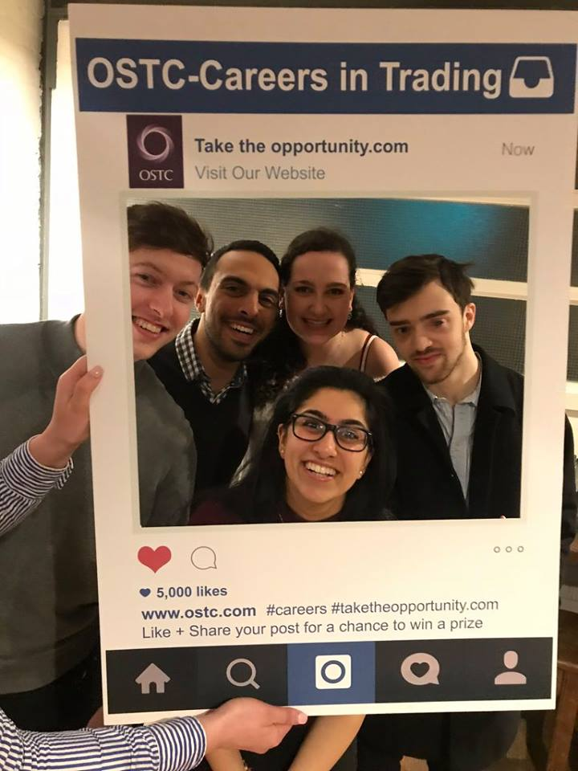
BBS students enjoying the event

Successful Seed funding bid

Innovation Intensive Action Learning (IIAL) by Strategic Learning Assignments (SLAs)
Innovation Intensive Action Learning (IIAL) by Strategic Learning Assignments (SLAs) Dr Dave Francis and Professor Howard Rush have been successful in their bid for Seed funding from the University in order to develop an action learning tool which is focused on Innovation Management. In the early 1970s a disruptive innovation occurred in the management development industry. Reg Revans, succeeded in promoting a methodology that he called ‘Action Learning’. By 1980, Action Learning was a rapidly maturing product. It had a coherent set of principles, well-articulated methods for implementation and an impressive, if limited, track-record.

When Action Learning was initially developed, knowledge assets were scarce, expensive and dated. Improvement methodologies, such as lean processes, were under-developed or absent. The pace of change was significant but nothing like that of modern industries which can undergo revolutions almost annually. Technical change, a core driver of innovation, was slower and permitted fewer disruptive changes. The need for efficiency and effectiveness dominated priorities rather than agility or effective change-management.

When viewed from the perspective of Innovation Management, it is apparent that the traditional approach to Action Learning was not focused on creating value from ideas that are new to the unit of analysis. Rather (traditional) Action Learning is almost entirely concerned with problem-solving. CENTRIM decided that a new approach might be valuable and a pilot study was undertaken to investigate whether Action Learning approaches could be redesigned so that they became innovation-orientated.

Based upon the results and feedback from the pilot project (with a Danish Company), CENTRIM have been awarded Seed funding (£8,684) to further test and develop a tool using action learning concepts directly applied to innovation management and prepare a commercial product.

Motaz Alsolaim – PhD Business Student wins best presentation award

Business School PhD Business student Motaz Alsolaim attended the WASET ICCGE 2018: 20th International Conference on Corporate Governance & Entrepreneurship on 26-27 March in Madrid. At the conference he presented his paper titled: ‘Why very few small start-up businesses survive for longer than three years: An explanatory study in the context of Saudi Arabia’.

We are delighted to announce that Motaz was awarded the Best Presentation Award competing against others that presented at the conference. At the conference Motaz also volunteered to Chair one of the sessions, in the absence of the original Chair and achieved a ‘Chair Leader Certificate’ for doing this. Motaz said, ‘it was a great experience to be a chair, asking questions to presenters and managing the session’.

Many congratulations to Motaz.

What Rebecca did next! - Life after graduating with a Law LLB – Rebecca Railton
Rebecca Railton graduated with Law with Business LLB(Hons) in 2015. Rebecca’s now working as an Airport IT Contract Manager for Amadeus IT Group, based in Madrid. We asked Rebecca to tell us how she got her role and pass on any tips to current students
“In 2015 I graduated from Brighton University in LLB Law with Business. I knew I wanted to pursue a career in law and aimed to qualify as a solicitor but I did not know when or how I wanted to do this. In the April before graduating, I began looking for paralegal roles and training contracts. From having an English law degree I had not explored the idea of working in another country however, I was told about an internship going in a company called Amadeus IT Group, in Madrid, so I applied.”
“After being offered the position, I started working at Amadeus on 7th January 2016 in the legal department, specialising in Data Protection. I initially wanted to stay for 1 year to gain experience and to learn Spanish but as the months went by, I enjoyed the international environment and work life balance that Amadeus offered so, I decided to stay.”
“In July 2017, I started to explore new options and I was offered a new role as a Contract Manager and an in-house training contract. As I worked in Data Protection for 2 years I was able to backtrack my training 6 months which was very helpful. I am now working towards my seats in M&A and Commercial and due to finish my Training Contract in July 2019.”

Rebecca Railton graduating in 2015

Gatwick Diamond Business Awards 2018
For the second year running, the University of Brighton sponsored the Gatwick Diamond Supply Chain Excellence Award in March 2018. It is one of the annual Gatwick Diamond Business Awards, which recognises achievement for businesses in and around the economically important Gatwick Airport area.

Teaching staff from the Brighton Business School Operations and IT subject group were invited to judge the four applicants in the Supply Chain Excellence category. Accompanied by Daryl Parsons from the University's community relations team, Patrick Ballin spent two fascinating afternoons meeting the businesses and looking around their facilities. The four entrants were all really high quality, and it was tough for the team to make a final decision.

The eventual winner, PVL UK, supplies and fits reflective markings for emergency service and security vehicles. We had no idea that vehicle marking could be so technical! From its base in Burgess Hill, PVL UK has managed to create a substantial export business as well as working with police, ambulance and fire services in every part of the UK. https://www.pvluk.com/

The other entrants were:
Eightspace, a company in Crawley that designs and fits offices, schools and university classrooms. https://www.eightspace.co.uk/
Cleankill, which cleverly and diligently manages a very varied supplier base, to obtain innovative pest control products and services for its clients in Sussex and Surrey. http://www.cleankill.co.uk/
Eezehaul, one of the largest operators in the national TPN parcel service, who showed impressive commitment to customer service, supply chain performance and to leading innovation and collaboration within the TPN network. http://www.eezehaul.co.uk/
Arvind Upadhyay, attended the ceremony at the Effingham Park Hotel on 15th March at which the Supply Chain Excellence Award was presented. All the finalists felt there was real value in collaborating in this way with the University, including potential for student projects and placements. Further details can be found here: http://www.gatwickdiamondbusinessawards.com/111-2018-winners.html
Sabbatical announcements
We are delighted to announce that Dr Adaeze Okoye has received funding this year for her sabbatical application.
The University’s annual Sabbatical Scheme is part of the Research & Enterprise Strategic Plan 2017-21. The scheme offers awards of up to £10,000 each to enable staff to take a period of sabbatical away from their substantive role at the University in order to undertake research and/or enterprise activity.
Adaeze’s successful application will enable her to pursue her research in modern slavery in supply chains in African business ethics, and in corporate social responsibility.
Many congratulations to Adaeze.

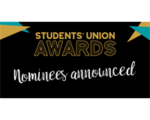
The University of Brighton Students Union have recently announced the nominees for their awards for 2018, and we are delighted that the school and 2 members of staff have received nominations. The Business School has been nominated for the School of the Year award, Ya Gao (Angela) and Julie Fowlie have both been nominated for teaching awards, and the school’s Law Society have been nominated for Society of the year, please find details of each award below.
School of the Year
Brighton Business School – Brighton Business school have developed new and innovative ways in getting feedback from students, holding events throughout the year that look to gain student feedback on courses. They have also offered huge support for students looking to run events like the end of year ball.
Innovative Teaching
Ya Gao – Ya or Angela to students has been an ‘amazing’ lecturer and teacher. She has great skills for teaching and employs a student focussed approach. She has gone out of her way to simplify information for students making topics easily understandable.
Inspirational Teaching
Julie Fowlie – Julie has offered incredible support to her students this year, helping students that had lost their way, to get back on course, supporting students with personal issues and motivating the entire group when work got tough.
Society of the Year
This award is to recognize a society who has gone above and beyond to create a positive community for their members by running successful events and/or activities and engaging with Brighton Students' Union and the wider university.
The Law Society have achieved ‘outstanding’ in the Brighton SU society accreditation scheme this year. They have organised networking opportunities for their members, a ball and raised over £6,000 for charities across the year.

The Law Society will be competing against:
- Youth Stop Aids –A new society for this academic year.
- Debating – The Debating Society who have had a very successful year.
- Paramedics – The Paramedic Society, which only started in January.
Full details about the awards and nominees can be found here:
https://www.brightonsu.com/news/article/pageassets/Union-Awards-Shortlisted-Nominees-Announced/
There will be a special awards ceremony held at The Komedia in Brighton on Tuesday 15 May at 7pm, and the Head of School and 7 members of staff will be attending.
Good luck to Julie, Angela, The Law Society and the Brighton Business School.

Celebrating 25 years
Event to celebrate 25 years of the Business School at the University of Brighton
When the institution gained university status in 1992, we had already delivered 15 years of business education as a Polytechnic, and it was great to welcome alumni and former staff who could remember those days. The afternoon started with a keynote from Laura Carleton (Business Management with Finance 2007) who is currently a VP with American Express. Laura reflected on technological changes and cultural changes affecting her organisation, e.g. the way that a phone call has become the last medium of communication rather than the first, and could now be seen as ‘almost rude’. Drawing on her experience of implementing business processes in different countries, she highlighted the impact of culture, contrasting one country which followed processes ‘by the book’ with another which took a more pragmatic, although ultimately disastrous, approach, by missing out ‘step 5’. Reflecting on her education at BBS she praised the career preparation embedded into the Managing People module whereby final year students design and operate assessment centres for first year students. Thinking about how we should develop the curriculum for today, she suggested a ‘what if?’ module to help students to anticipate the impact of planned changes.
Ranjeet Kaile (MBA Public Service Management, 2011) opened the subsequent panel discussion by reflecting on how he had learned about distributed leadership on the MBA, which he had implemented in his own organisation South West London and St.George’s Mental Health NHS Trust. He felt that the MBA had given him the confidence to lead this initiative. Stefana Brown (International Business, 2003 and MSc Business Process Management 2004) reflected in how the business environment in Financial Services had changed. Rather than developing the business through a process of specifying inputs and expected outputs, digitisation means that feedback comes much faster. New services are launched and the sales outcome is known almost immediately. Business development becomes ‘see if it works’ and ‘move on’. Stefana felt that we need to prepare students how to accept failure. We also discussed the relevance of scientific method to business, and the increased role of experimentation – something that does not feature highly in the business curriculum other than A-B testing in Digital Marketing. Laura reflected on the ready availability of information, and the reduced need for fact-based learning. Thinking about the training offered to staff in her department, she talked about the emphasis placed on the connections and relationships that would help staff to find the answers. The panel included Audrey Charowa, a current student on the International Business degree. Audrey emphasised the need to develop critical thinking. Reflecting on the Brexit debate she commented that there was ‘lots of emotion’ but not much on ‘what the Brexit world would look like for different people along the social scale’. The audience developed the theme of critical thinking in some interesting ways, speculating on the reasons for the IT problems at TSB, and whether the board had given enough critical attention to IT. There was an interesting general discussion with interesting contributions from alumni, staff and former staff members.
Suitably stimulated, the 90 participants moved on the fun part of the day. This included an amazing introduction to aroma therapy chillax from Law Course Leader Zoe Swan. People also enjoyed Rob Hayward’s trading simulation in the Trading Room, where thousands of pounds were gained and lost! The craft beer tasting and Sussex cheeses session was also popular, the two things more complementary than you would imagine. It was fabulous that some current students came along too, and participated in a speed networking event with alumni run by Julie Fowlie.
The day was concluded by a reception at Brighton Museum, where we were able to wander among the exhibits with glasses of Prosecco, regularly refilled by attentive staff. Talking to our own staff, I have discovered that many useful contacts were made with alumni offering to guest lectures and other ways of supporting the business school. It was a fantastic day, and thanks to all for participating.
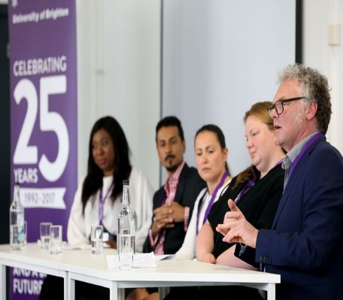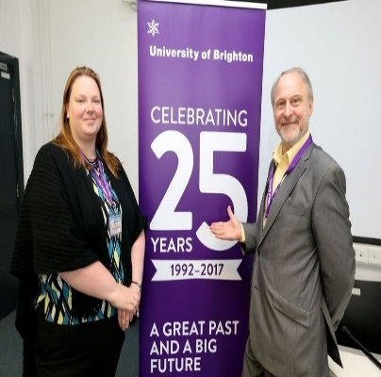
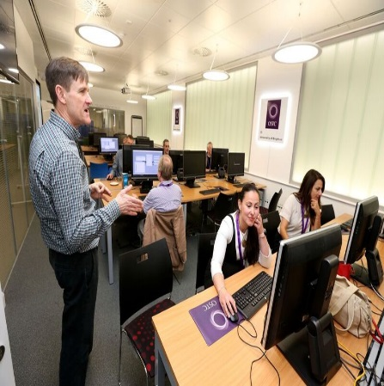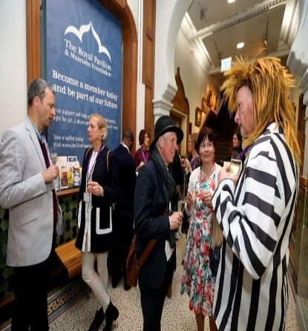
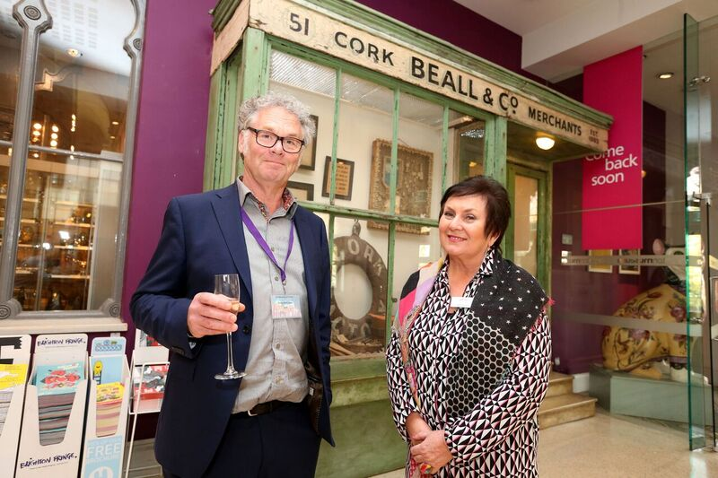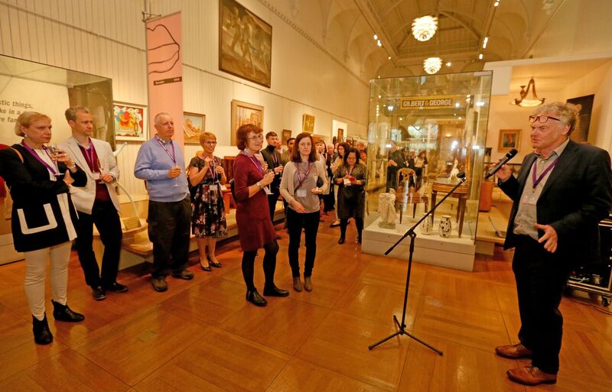

Don’t forget to read all the latest stories on the Business School blog - https://www.brighton.ac.uk/bbs/index.aspx

