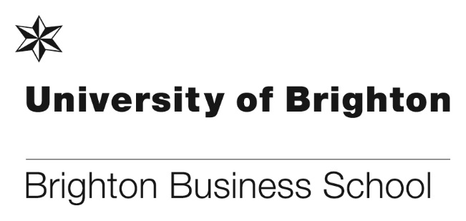

**Business Management within the third sector**

Our graduate Zac Hill, who graduated in 2010 with a degree in Business Management, is in the process of launching his own business, This is All (<http://www.thisisall.co.uk>), which aims to help other social enterprises to improve their internal operations. Zac talks about how his course and experiences at Brighton led him to work within the third sector.



The full article about Zac can be found here:

<http://blogs.brighton.ac.uk/bbsblog/2018/03/06/business-management-within-the-third-sector/#.WqFQwGrFKUk>

**Research anthology on CSR communication and digital media.**

Keith Perks and Francisca Farache advised students and staff that their recently published anthology A Critical Reflection on the Role of Dialogue in Communicating Ethical Corporate Social Responsibility through Digital Platforms. (Perks, K.J., Recalde Viana, M., Farache F., & Kollat, J), is now available online. The e-book version in the library catalogue and the publishers allow users to download and print one pdf chapter.

You can find the [e-book](https://ezproxy.brighton.ac.uk/login?url=http://search.ebscohost.com/login.aspx?direct=true&scope=site&db=nlebk&db=nlabk&AN=1662124) version in the [library catalogue](https://capitadiscovery.co.uk/brighton-ac/home) here, and the book title is:

Adam Lindgreen; Joelle Vanhamme; François Maon and Rebecca Watkins (Eds).  (2018). Communicating Corporate Social Responsibility in the Digital Era (2018). Routledge: Abingdon, UK. ISBN 9781472484161

**Women of Impact: Dr Claire-Michelle Smyth**

To mark International Women’s Day the University celebrating the achievements of just some of the academics working here at Brighton. Brighton Business School’s Dr Claire-Michelle Smythe was featured for her work on championing human rights. Having completed a Master’s Degree in International Human Rights Law, Claire-Michelle graduated from Queens University Belfast with a PhD in 2015. Her research focused on whether the European Convention on Human Rights could be used to strengthen and make justiciable social and economic rights in Ireland.

Claire said ‘I am a passionate advocate of human rights. I endeavour to educate people as to their rights under international human rights law and to further the discussion on the legal status of social and economic rights in the UK.



You can read the full feature on Dr Claire-Michelle Smyth here:

http://blogs.brighton.ac.uk/bbsblog/2018/03/08/women-of-impact-dr-claire-michelle-smyth/#.WqpccE2yqUk

**New case study in finalist place**

Veronique Boulocher-Passet and her co-author Sabine Ruaud, have recently submitted their new case study at the NACRA Conference for reviews and improvement. They have subsequently submitted the case at the (Associate Francaise de Marketing) AFM conference who each year deliver the Prize for Best Marketing Case Study of the year, and the good news is that the study has been selected as one of the top 3 finalists. Good luck to Veronique and Sabine.

For further information and abstract details please contact Veronique.

**Celebrating 25 years**

To celebrate 25 years of the University of Brighton, the Business School will be holding an event on Saturday April 28between, at Mithras House between 14:00-18:00. Alumni, ex-staff, current staff and current final year students will be invited to attend.

There will be a schedule of events involving current students and alumni running throughout the afternoon, finishing with a drinks reception at the Brighton Museum. The event is free to staff and all are encouraged to attend. If you want to attend please contact Chris Matthews.

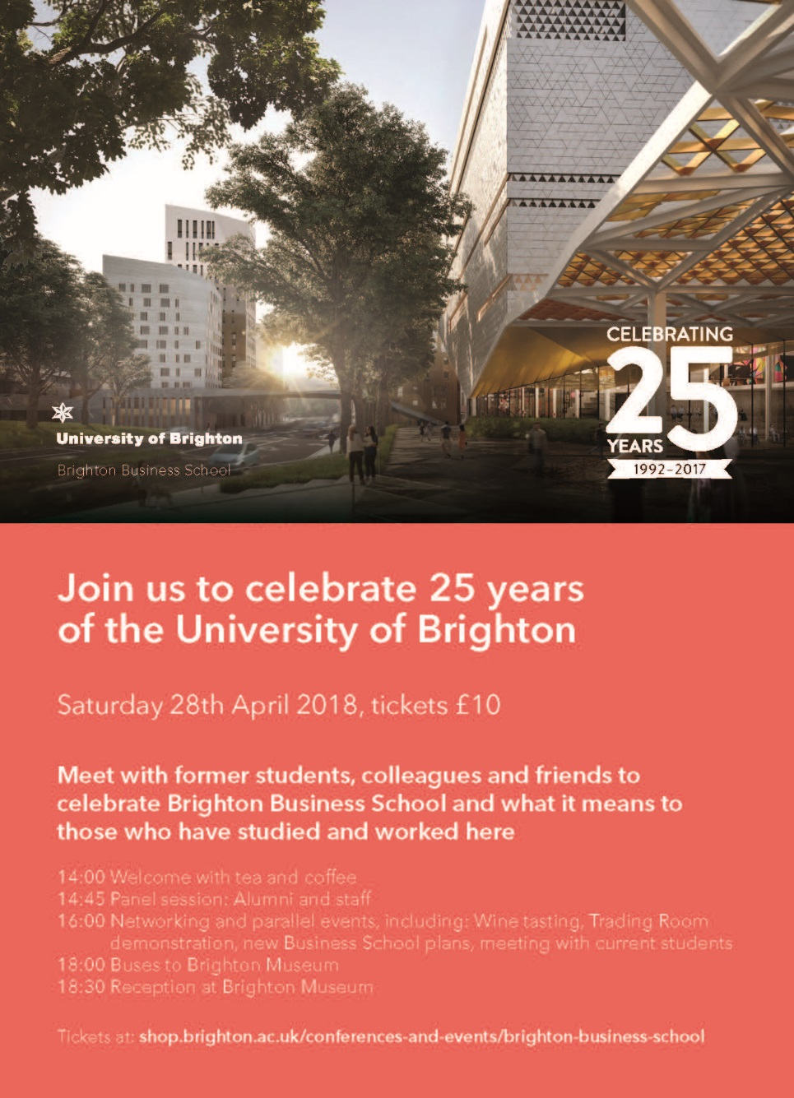

**Tales from the cutting edge of online retail marketing**

To help celebrate International Women’s Day our Business Management, Marketing Management and Law students were invited to hear from Business graduate, Zoe Ashford.

Zoe graduate from Brighton Business School in 2004 and has since gained over 12 years’ experience from senior digital marketing positions with the Arcadia Group, Debenhams, John Lewis and more recently as the E-commerce Marketing Director for fashion brand Lipsy. Zoe’s guest lecture took students through her career journey, the lessons learnt, and the latest digital marketing techniques being used, full details can be found here:

<http://blogs.brighton.ac.uk/bbsblog/2018/03/08/tales-from-the-cutting-edge-of-online-retail-marketing/#.WqpbUU2yqUk>

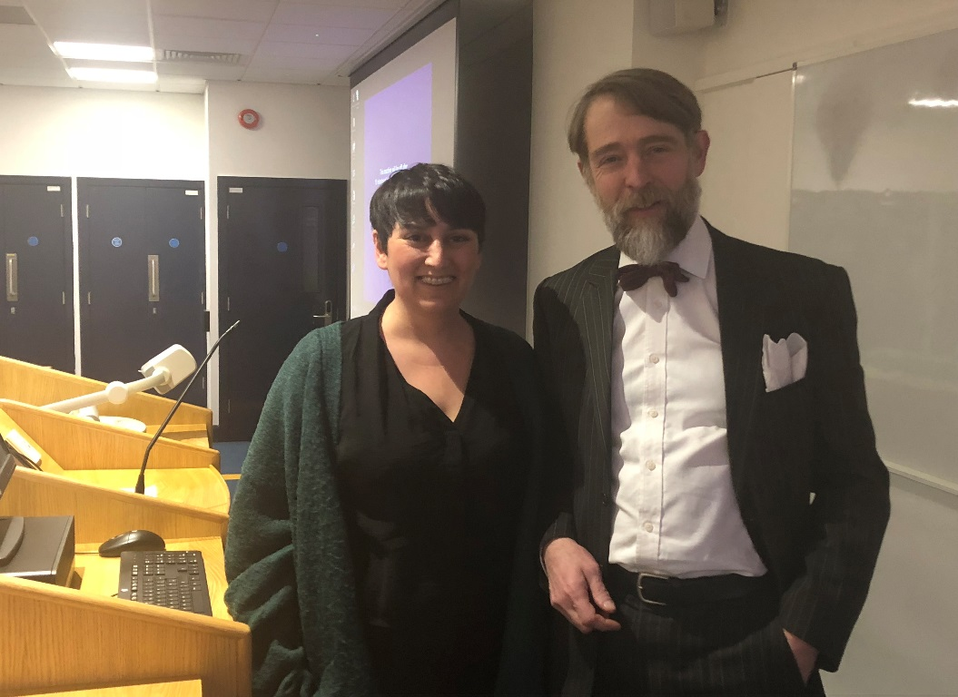

Graduate Zoe Ashford with Principal Lecturer, Asher Rospigliosi

**Final year Family Law students and CLOCK legal companions**

Final year Family Law and CLOCK legal companion volunteers were invited to watch a family law arbitration demonstration at Sussex University on 22 February organised by Yres and supported by 1COR chambers and Good Law, two of our clock partners. As well as seeing arbitration in action and being asked what their decision would be, the students and tutor Jeanette Ashton had the chance to meet junior family lawyers practising in East Sussex.

Please find further details here: <http://www.resolution.org.uk/East_Sussex/about>

**Your School Annual Learning & Teaching and Professional Support Staff Awards 2017/18 - Winners announced**

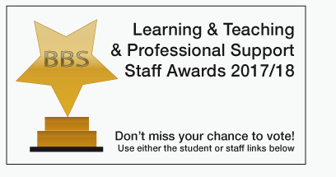

This year there were 32 staff in all who were nominated by students and staff, which is a fine reflection of the quality of teaching and professional support in the school. All of the nominations showed real merit and the judging panel (Sid Hayes, Director of Education, Julie Fowlie and Sharon Blows) had a hard time picking the winners. We are now pleased to announce the winners of this year’s Your School awards, the winners are:

**Learning & Teaching Awards Professional Support Staff Awards**

Rob Hayward Stuart Bullen

Bobby Kahlon Rachel Carver

Cath Matthews Donna Clarke

Mona Rashidirad Lucy Fullbrook

Asher Rospigliosi

Pascal Stiefenhofer

Each winner will receive £250 to spend on their choice of staff development, and they will receive their award at the Learning and Teaching Conference 2018, being held on 6 July 2018 at Grand Parade. Please save the date for the conference and keep an eye on the L&T blog for further details [BBS L & T blog](http://blogs.brighton.ac.uk/bbsqlt/teaching-learning/annual-lt-award/your-school-annual-learning-teaching-award-250-cash-prize-and-trophy-2017/).

Many congratulations to all staff that were nominated and to the winners!

**Enterprise Initiative – successful bid**

Head of CENTRIM, George Tsekouras and Karen Cham, Professor in Digital Transformation Design at the School of Media recently submitted a bid under the University of Brighton’s Enterprise Initiatives. The project ‘ Profitnet Digital to Facilitate Knowledge Transfer in the CDIT Sector’ is intended to bring together the outcomes of several pieces of previous research relating to peer-to-peer learning networks, the management of open innovation in SMEs and innovation in the Creative, Digital and IT (CDIT) sector.

We are pleased to announce that the application submitted to the Proof of Concept Fund has been successful and the panel voted to award £22,666.00, which was the full amount of funding George and Karen applied for.

Many congratulations to George and Karen on their successful bid.

**The Brighton Business School Graduation Ball 2018**

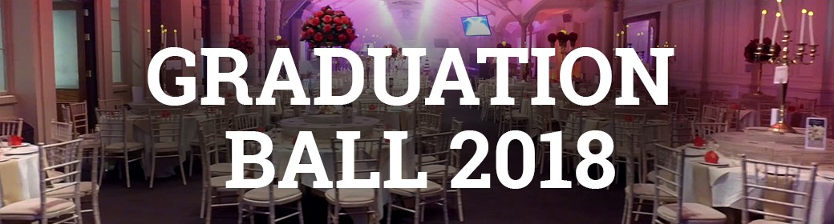

We are pleased to announce that there will be a Brighton Business School Graduation Ball this year. The event is being organised by some of our final year Student Engagement Champions and other students and is supported by the Business School. The ball will be held at the Grand Hotel on Friday 15 June 2018, and the price per ticket is £38. This will include:

* Welcome drink
* 3 course meal
* Half bottle of wine or soft drink
* Music and photos

The final year students would love staff to attend, so please save the date and further details and how to book will follow.

**Students gain feedback and valuable contacts through recent Final Year Social Marketing Poster Competition and Networking event**

Final year social marketing students were joined by health, environment and social marketing professionals and colleagues from across the university to present their initial findings from their research projects to encourage and enable a positive health, social or environmental behaviour.

The event gave them a chance to peer review each other’s work, gain valuable feedback from professionals and tutors and network with people working in the areas they are investigating.

Feedback from professionals was really positive, with a member of the public health team at Brighton and Hove Council particularly praising the passion and commitment shown by some of the students towards tackling a range of challenging issues.

A professional’s choice award was given to Eve Nicola, for her work to reduce meat consumption, with the students voting for the eye-catching design and thought-provoking work, by Chloe McCance, exploring a social marketing approach to reducing youth homelessness in Brighton and Hove. Students also found the event really valuable as a means of formative assessment.

‘I feel that this interactive session has significantly aided the direction I will take with my current findings and research that I will undertake…. the use of posters to visually present our ideas, meant that I could identify how other students had utilised their primary and secondary research to provide insight into the issue at hand. This was encouraged by completing a peer review. ….

Myself, and many others who presented their posters; found the interactions between our tutors, and professionals within the university to be highly beneficial. Personally, I have gained a lot of insight and suggestions from key environmental stakeholders within the university by attending this event; who I am now able to contact outside of the session.

Personally, I think this event should be a compulsory activity; as myself, and my peers now feel a lot more confident in our ability to produce a high level dissertation. Thank you for your efforts, we all found it thoroughly engaging and beneficial to our learning!! “

We’re looking forward to seeing the feedback used to produce excellent final reports!!

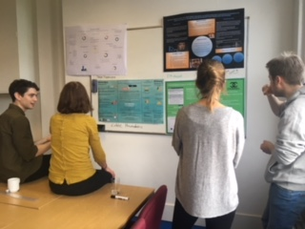

**Don’t forget to read all the latest stories on the Business School blog -** [**https://www.brighton.ac.uk/bbs/index.aspx**](https://www.brighton.ac.uk/bbs/index.aspx)