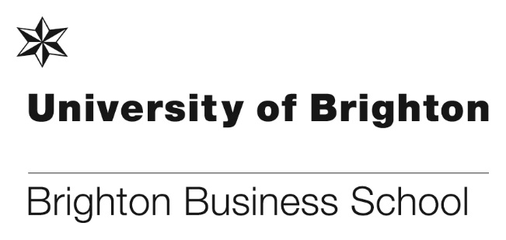

# **Ben Hackett from Brandwatch – guest lecture on social listening**

On Thursday 8 February Ben Hackett from Brandwatch gave a guest lecture to students and staff titled: ***Understanding online conversation – a whistle-stop tour of the ever changing world of social listening technologies.***Social listening is a hot topic and Brandwatch materials will be used in future student workshops.

Brandwatch are a Brighton based technology company with offices in Singapore, San Francisco, Berlin, Paris and New York. They build marketing leading software currently deployed in 30% of Fortune 100 companies.

A message from Ben Hackett: “I joined Brandwatch as the 80th employee in my early 20’s and witnessed impressive company growth. Now with over 400 staff, 3 new offices and millions of pounds of investment I have had the pleasure of seeing a company rise to prominence in the market and been part of that success in my commercial role, selling to the largest marketing agencies in the world. A belief in the power of true insight made available in the digital age and how this insight connects organisations to the consumer and aids them make game changing decisions”.

You can find out more about Brandwatch here <https://www.brandwatch.com>

**Employability fortnight for Business School students**

Brighton Business School students were invited to take part in the Employability Fortnight delivered by the University of Brighton Careers Service. The event took place between 12th to 23rd February at various locations around the University.

Highlights for Business School students included:

* Mock Assessment Centre by FDM (14th Feb)
* Mock Video Interview Practice (12th – 15th Feb)
* Law Careers Question Time (13th Feb)
* Lots of employers stands and *Plan for your future* events

The full programme for the fortnight can be found here: [Employability Fortnight flyer EFfinal 2018.pdf](https://studentcentral.brighton.ac.uk/bbcswebdav/pid-761982-dt-announcement-rid-5816433_1/xid-5816433_1)

**The NSS ‘Big Night In’**

On Thursday 8 February the Brighton Business School Student Engagement Champions organised the ‘Big Night In’ for final year students to share their experiences and to have the NSS explained to them. 100 students were there on the night and many completed the NSS.

The Student Engagement Champions also organised a ‘Start, Stop and Continue’ session where vital data was captured, which will be used in the future.

The event was a huge success – please see pictures below.

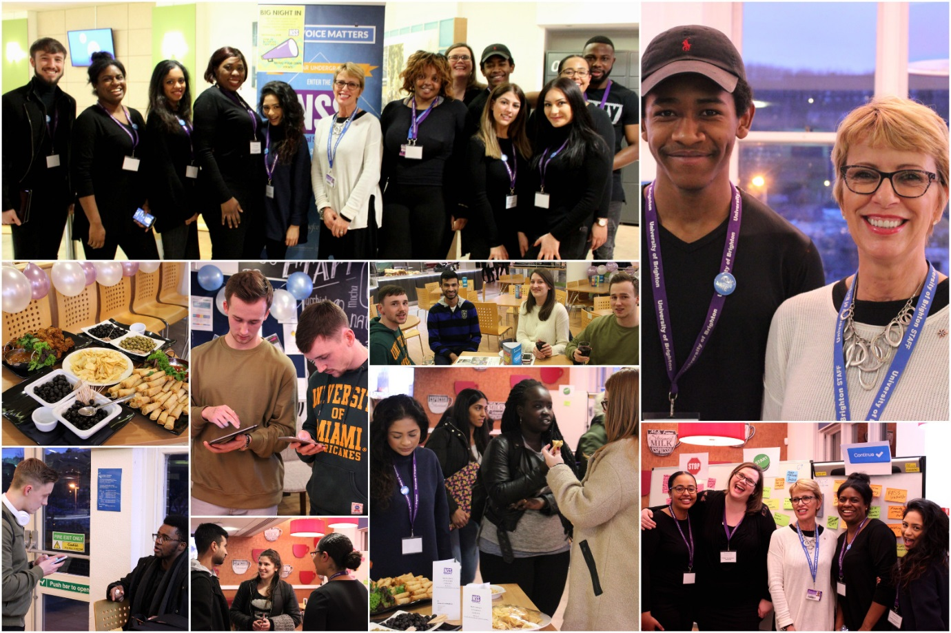

**Zoe Swan judges at the London Regional round of the annual CEDR Negotiation Competition**

On Saturday 17 February Zoe Swan had a brilliant day judging the London Regional round of the annual CEDR Negotiation Competition at the CEDR Headquarters in Fleet Street. 30 teams competed and 5 will go through to the National Final, results will be announced in 10-14 days, after other regional competitions have taken place.

A big round of applause go to all of our first year students James Patterson, Salman Al-Mayahi, Jade Chalker, and Samuel Nicholson, who represented Brighton. They did a fantastic job at stepping up and making the most of the opportunity.

Further information can be found here: <https://www.cedr.com/foundation/competition/>

**Your School Annual Learning & Teaching and Professional Support Staff Awards 2017/18**

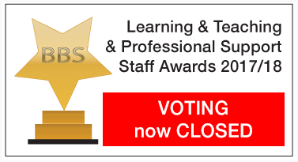

The nominations for this year’s annual BBS Learning & Teaching and Professional Support Staff awards closed on Friday 9 February. This year saw a total of 34 staff nominated across both academic and support staff and shortlisting will be take place next week.

The shortlisted nominees will be announced towards the end of next week and the winners will be announced at the Learning and Teaching conference in July. We wish all nominated staff good luck.

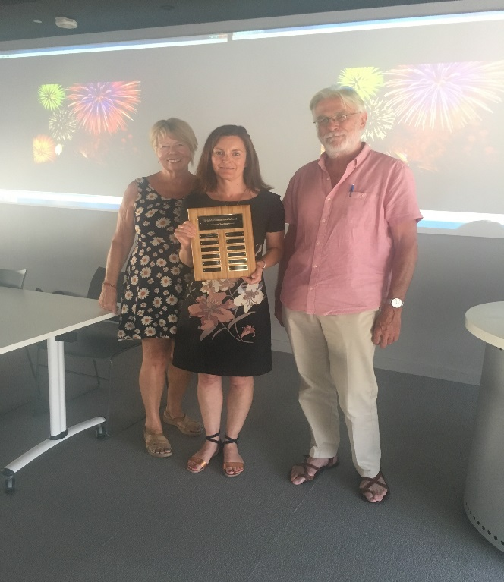

Last year’s winner Jeanette Ashton receiving her award at the Learning and Teaching Conference 2017

**Recruiting in Germany**

Max Healey visited Germany with the British Council to attend recruitment fairs taking in 4 cities in 4 days. The cities visited were Dusseldorf, Hannover, Hamburg and Berlin, in Germany there is still a high interest in UK degrees, and Brighton is a huge draw for German students. The University of Brighton were part of a group with some very strong Russel Group universities and the Brighton Business School stand more than held it’s own.

**Applicant Days 2018**

February 10th saw the first Applicant Day of 2018 and a very promising turnout despite some less than helpful weather. Visitors had the opportunity to interact with course leaders, student ambassadors and Clare Forder represented the new Employability Hub.

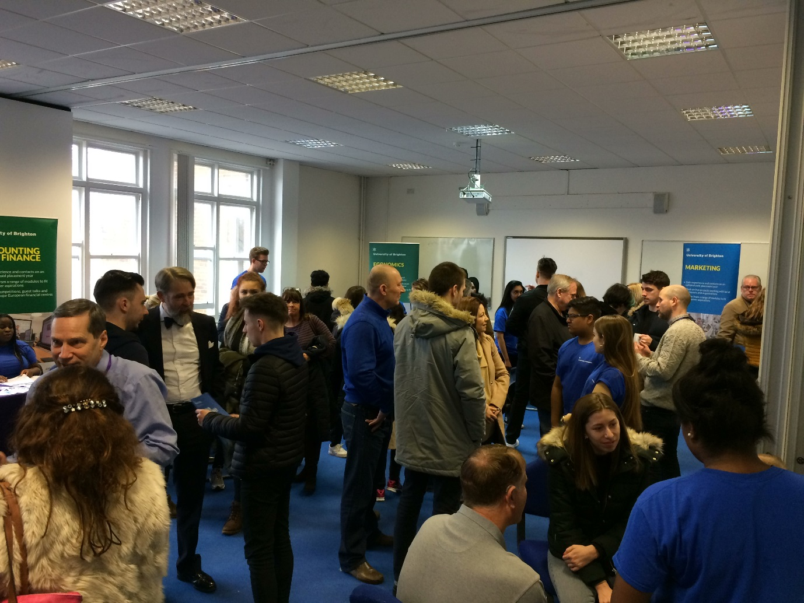

**British Academy of Management conference 2017 - Best Paper Winners Announced**

At the annual *British Academy of Management* conference held in September at Warwick Business School, Dr Mark Hughes won the organizational transformation, change and development track best paper prize.  His paper was entitled *We proceed with an assumption that leaders have a significant influence on organizational change - that’s interesting!* This paper is being developed for submission to a leadership journal and Mark hopes to present the paper at a BBS staff seminar at the beginning of the Summer Term.

On announcing the winners the British Academy of Management stated that the quality of the papers at BAM2017 was very high, but particular mention needs to be made to the papers that won Best Paper Awards.

Many congratulations to Mark!

You can find out more about BAM here: <https://www.bam.ac.uk/about-bam>

**The NSS - The Mithras Munch**

The BBS student engagement champions are continuing their activities to promote and engage students in the NSS and have organised the ‘Mithras Munch’. On 2 dates in March students will man a stall in Mithras on 13th & 22nd March in the student lounge and will include: – drop in – stop start continue – update on progress. The events are open to students from all years, and it is hoped that first year students will attend to make them aware of the NSS and the importance of completing the survey in their final year.

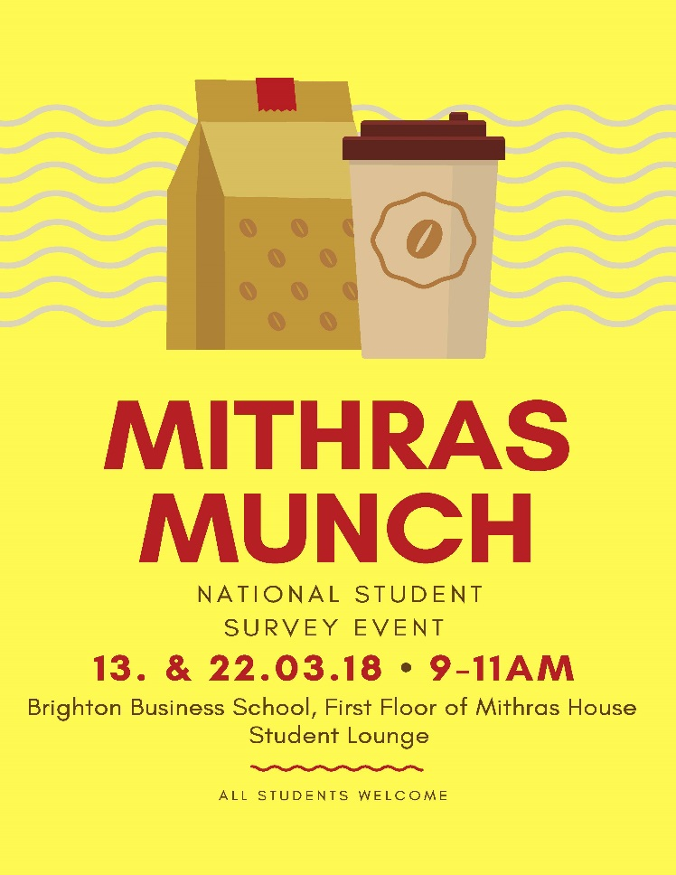

**Don’t forget to read all the latest stories on the Business School blog -** [**https://www.brighton.ac.uk/bbs/index.aspx**](https://www.brighton.ac.uk/bbs/index.aspx)