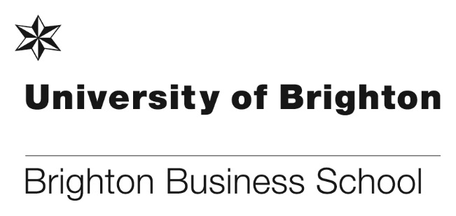
Jo Wilding, Lecturer at the Business School has recently had 2 articles published, the first article published in the Conversation is about the shrinking level of legal aid to refugees, please use the following link to read the full article.
https://theconversation.com/revealed-legal-advice-for-asylum-seekers-disappearing-due-to-legal-aid-cuts-86897

Jo’s second article titled ‘Unaccompanied Children Seeking Asylum in the UK: From Centres of Concentration to a Better Holding Environment’ was published in the International Journal of Refugee Law and is based on the unaccompanied refugee children research that she carried out before starting her PhD. The abstract for the article can be found by using the following link.

https://academic.oup.com/ijrl/article-abstract/29/2/270/3850522?redirectedFrom=fulltext

MBA students gain insights from founders
As part of our MBA International Strategy module we work with our local business partners to help students understand how successful entrepreneurs approach new market entry challenges. Recently, our Brighton MBA students visited two local companies, PVL and the Learning People.
The group had dedicated time with the founders of both companies as well as a venture capital investor, with Chatham House rules ensuring that the answers to students’ searching questions were usefully candid.
At the Learning People students were taken through the company’s segmentation, goals and strategies. Our students said they found it really insightful, and were impressed by the strong passion of the senior team, as well as the cultural aspects like the Banksy wall art, the beer fridge and free fruit.
Moving onto PVL, students were also taken through the strategy of the business and how their focus on strong customer relationships has helped the business grow.
One of our MBA students, Vicki Wickens, said “having worked for big corporates for the last 20 years, it was refreshing to visit a smaller company and one in an industry that I have very little experience in. I appreciate the amount of time Nick spent with us, and his being so candid with feedback and answers to our questions. His passion for the product was clear to see.”

About the Learning People
The Learning People is an EdTech (Education Technology) company which focuses on delivering training to individuals and employees who are looking to advance their career through gaining qualifications in subjects such as project management, coding and cyber security. Its bespoke platform enables their customers to study at their own pace but with support from the Learning People’s dedicated Studentcare team.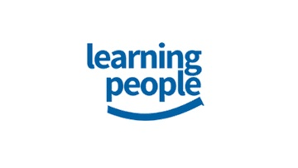
Image courtesy of the Learning People
About PVL
PVL is a manufacturer of high visibility livery and corporate branding for commercial fleet vehicles, such as those used by the Police and Ambulance services. It has built strong customer relationships within the UK and a growing number of international markets.
Image courtesy of PVL

Making friends and learning about CSR through the BBS Annual Poster Competition
First-year students recently took part in our annual BBS Poster Competition. Our 2017 poster competition invited submissions from all students from business management and marketing courses, with each group producing a poster based on Corporate Social Responsibility and Business.
Sustainability is a core value for the University of Brighton. We recognise the value and critical importance sustainability has for the future of our students, staff, partners and community. This competition was specifically designed to help introduce students to this core value – encouraging them to understand and investigate how they can contribute whilst at University as part of their learning, and in their future workplace.

This year’s winning poster “The Price of Orangutans Lives. Is Palm Oil Worth it?” investigates the ways that corporations could minimise the use of Palm oil, which appears in a wide range of food and cosmetic products as well as in manufacturing processes. The effect of the farming of Palm oil includes Indonesian deforestation, which destroys habitat and contributes to climate change – affecting the lives of Orangutans.

The student’s in the winning team were:

Eloise Laskey Culley BSc (Hons) Business Management;
Nooran Ibrahim BSc (Hons) Business;
Elena Sturza BSc (Hons) Business;
Carl Kansinde Middleton BSc (Hons) Business Management;
Sofia Rose O’Neill BSc (Hons) Business Management;
Tamanna Yasmin BSc (Hons) Business.

For more details on the poster competition and other winners please go to:
http://blogs.brighton.ac.uk/bbsblog/2017/12/12/making-friends-and-learning-about-csr-through-the-bbs-annual-poster-competition/#.Wk-JblVl-Um

Recruiting in Europe
The Business School continued its forays into Europe during the Autumn term, with Max Healey, Francisca Farache and Keith Perks traveling to PG recruitment fairs in Vienna, Warsaw, Stuttgart and Berlin. Some of the fairs were busier (Stuttgart in particular) than others but overall they collected contact details from over 80 students and already have 2 applications from very interested students. The prospective students at the fairs like our ability to deliver a Master’s degree in one year, and the size and diverse nature of our cohorts.

During January Max will be travelling to Germany with the British Council to visit four cities in four days before rounding off our EU recruitment activities in Dusseldorf at the end of April.

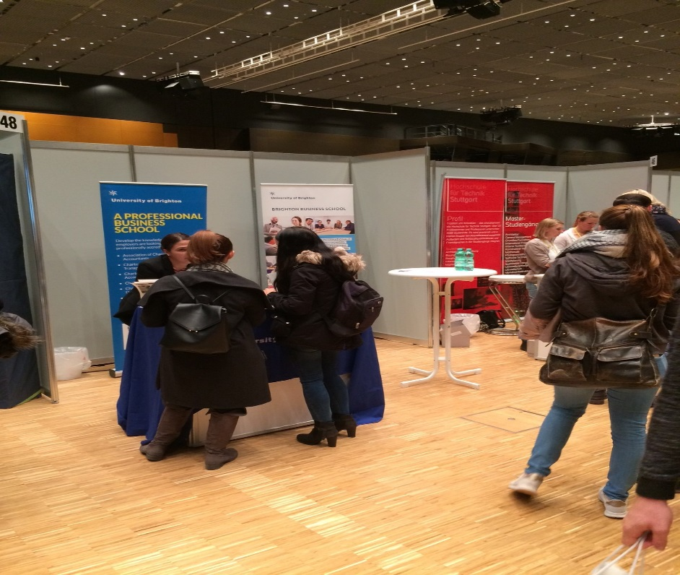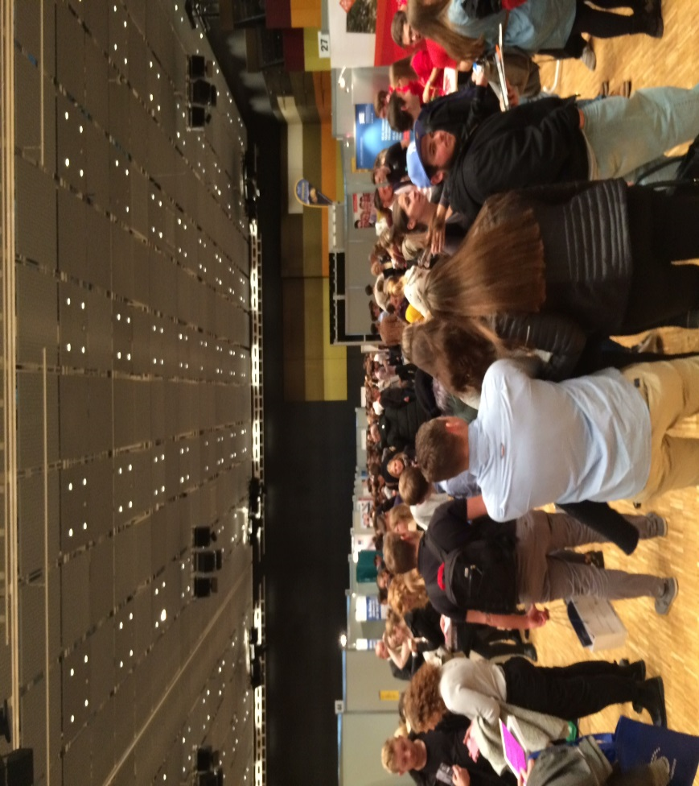
National Student Survey (NSS) – Big Night In
As part of the NSS promotion our final year Student Engagement Champions are organising the ‘Big Night In’. All final year students are invited to the event to share their university experiences. They will also hear about the purpose of the survey, the vital data it captures and the importance of completing the survey to ensure their voice is heard to bring about significant and positive changes in higher education.
The event is taking place on Thursday 8 February at 5pm in the Mithras canteen, food, drinks and music will be provided for all students attending.

‘The University of Brighton delivers well-rounded learning with Lynda.com’ - a Linkedin publication featuring Julie Fowlie, Deputy Head of School (Learning and Teaching)
Linkedin have published a feature on how the University of Brighton have rolled out a digital transformation initiative to better prepare students for employment in the modern world, using Lynda.com. The initiative involved training staff and students to ensure they are up-to-date on the latest trends in technology. Julie Fowlie, Deputy Head of learning and teaching at the Brighton Business School explained, “Students regularly use programs like the Adobe Creative Suite or Microsoft Word, and their skills sometimes need improvement. We needed a way to teach them the basics so they could focus in class.” “With Lynda.com, we’re driving solution-based feedback and complementing what we’re doing in the classroom.”
The full article can be found here:

Researchers of the year awards 2017
The fully-functioning university – a summary
By Tom Bourner, Linda Heath & Asher Rospigliosi

Our most recent research comprises a series of four papers on the ‘fully-functioning university’. The concept of a fully-functioning university originated in an attempt to answer the question: ‘what common endeavours can be found in all the stages of the development of the western university?’ We looked at the history of the western university with this question in mind and found evidence of the advancement of knowledge, the higher education of students and service to those beyond the walls of the university. This meant that the common perception of this ‘tripartite mission’ as being an invention of the land-grant universities in the USA in the 19th century was misconceived and, in reality, it extended back to the medieval universities. However, we also found that in different ages one part of the tripartite mission had come to dominate the other two, which were then interpreted in ways that served the dominant part.

These conclusions led to another question: ‘what would a university be like if it valued each part of the tripartite mission for its own sake and saw the three parts as complementary rather than competing goals?’ We termed such a university a fully-functioning university to contrast it with a university that pursued one part of the tripartite mission at the expense of the other two. This led to a third question: ‘how can each part of the tripartite mission be pursued in ways that support the other two parts?’ Most of the papers on the fully-functioning university are attempts to answer this question.

Law Society Ball
The University of Brighton, Brighton Business School Law Society are organising the first ever Law Society Ball, it will be a monumental event and will set a new tradition within university. The ball is taking place on Friday 16 February at The Grand Hotel, Brighton and the following companies and guest speakers are already confirmed:

- DWP- Advice employability and recruitment
- SEO London- They help place students in top tier firms such as Freshfields, Norton Rose Fulbright, Jones Day, Bird & Bird etc.
- 1st Class Oxford/Cambridge University Masters/PHD: life as a student, tips for study, application tips
- BPP Scholarship Award student- He overcame adversity and sued his previous university for discrimination in an on-going case in the High Court. He’s also published articles for Kings College, Mayor of London and London top set chambers.
- Also 4 Barristers from 1 Crown Office Row.

Guests will be able to enjoy a 3-course meal with a glass of wine and entertainment will be provided.

Government Ministry report recognises the work of BBS
High recognition has been given in a recent Government Ministry report on work undertaken by the University of Brighton Business School. This external engagement Change Leadership and Management Initiative is led by Steve Reeve with Chris Matthews as the administrative lead. Workshops headed by Mark Hughes and Steve Reeve over the last nine years have gained a significant reputation with courses over-subscribed by 255% and attendance at 95%. The client commented on how the BBS staff were approachable, were clearly experts in their academic field, and had an excellent understanding of a very specific environment and well-pitched approach for the audience. The workshop activity was very interesting and the learning environment made it relaxing and ensured it was easy to learn with interactive lessons and thought-provoking discussions.
Congratulations to Steve Reeve, Mark Hughes, Chris Matthews and Tim Brady.

