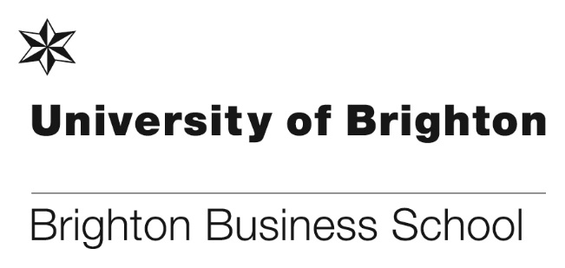

**PhD success!**

PhD student Dicle Kortantamer has been awarded Best Paper for an early career researcher at the IRNOP Conference in Melbourne. The paper was titled ‘Sharing delivery leadership in major transformation project portfolios: illustrations from the UK central government’.

The 14th IRNOP conference and IRNOP doctoral symposium was held in Melbourne, Australia and was hosted by RMIT University. The doctoral symposium was on Sunday 9 December 2018. The conference was from Monday 10 to Wednesday 12 December 2018 and focused on RMIT’s logo theme “a skilled hand and a cultivated mind”, which is particularly apt for this conference of applied research on Project Management, and project-based organisations.

Many congratulations Dicle.

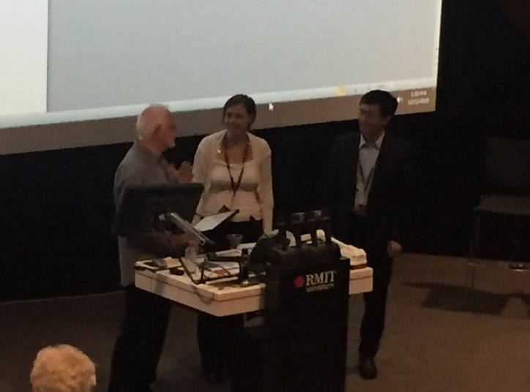

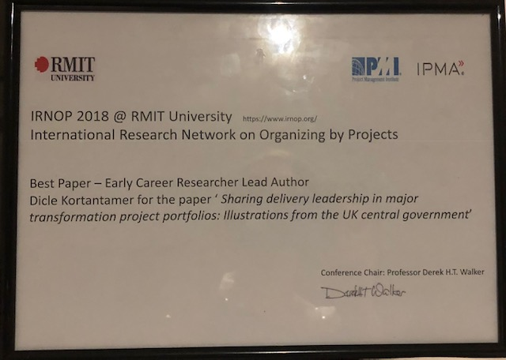

Dicle receiving her award from the Conference chair Derek Walker, and the award

**Marketing student shortlisted for the Sussex Sports Awards 2018 Young Volunteer of the Year**

One of our current [Marketing Management with Placement Year](https://www.brighton.ac.uk/courses/study/marketing-management-with-placement-year-bsc-hons.aspx) students was recently nominated as a finalist for the Sussex Sports Awards 2018 Young Volunteer of the Year.

Tom Amber, a final-year Business School marketing student, was shortlisted for the award because of his involvement with Woodingdean Wanderers and his volunteer work associated with the University of Brighton’s Sport Brighton Parklife programme.

Held at The Grand Hotel, this year’s event received a record number of nominations from across the county. The black-tie gala dinner, organised by Active Sussex, welcomed special guest and co-host, Eddie ‘The Eagle’ Edwards.

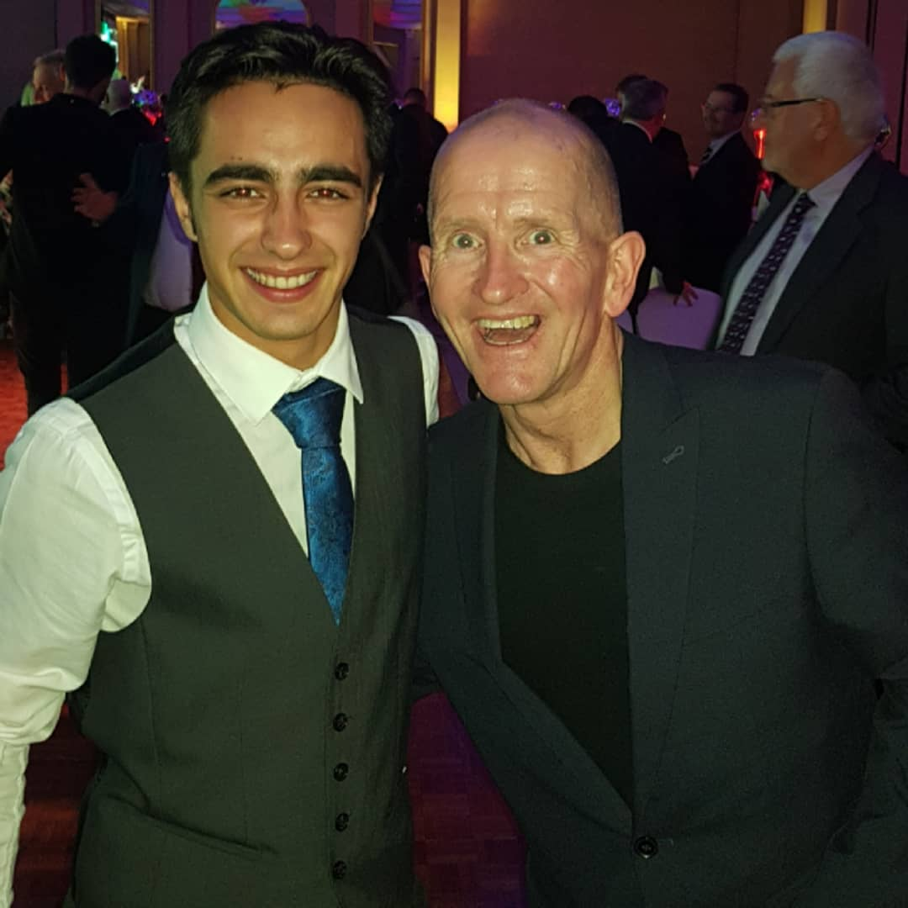

Tom Amber, left, pictured with Eddie ‘The Eagle’ Edwards

**Business Management students enter the Dragon’s Den**

On the 29 November twenty groups (with 4/5 students per group) of [Business Management BSc(Hons)](https://www.brighton.ac.uk/courses/study/business-management-with-placement-year-bsc-hons.aspx) and [International Business Management BSc(Hons)](https://www.brighton.ac.uk/courses/study/international-business-management-bsc-hons.aspx) students pitched their ideas to twenty members of the [Brighton & Hove Chamber of Commerce](https://www.businessinbrighton.org.uk/) to pitch their Business Start-up ideas.

Students worked together in teams; to construct their own business start-up ideas. They thought creatively and then developed their ideas using sound business reasoning including production costs, market research, market strategy, pricing, legal implications and so on. They then presented their proposals to a panel of commercially experienced ‘Dragon’s’.

The business ideas being pitched included concierge services, mugs which can retain their heat, new bespoke gyms, a part-time student employment agency, a Brighton spa, and a coconut mouthwash. The Dragon’s, the majority of whom are entrepreneurs themselves, listened carefully to the students’ business pitches and gave individual, practical and realistic feedback about the students’ start-up ideas.

Pete Jenkins, our Entrepreneur in Residence and founder of Gamification+, organised the event with the support of Rachael Carden, course leader for our [International Business Management BSc](https://www.brighton.ac.uk/courses/study/international-business-management-bsc-hons.aspx) and other members of the teaching team.

**Another successful annual Country Conference**

On Wednesday 14th November, the BSc International Business Management annual Country Conference was held at Mithras House. This is an opportunity for the whole degree programme to meet and network. Participants include our Country Managers, level 4, level 5 and level 6 BSc International students who all had jobs to do at the Event!

Joining them were our Exchange students who come from some of our 20 partner universities in 14 countries (both EU and non-EU). The Exchange students provide local food and drink from their countries such as beer, lots of chocolate and a large quantity of biscuits. Other food items ranged from peanut butter and jam sandwiches (from USA); fairy bread (Australia);  breads, cheeses and cooked meats (France, Italy, Belgium, Netherlands); pancakes and maple syrup (Canada) and beers and wines from all over the world.

Our final year students showcased their year abroad research to the first and second years in the form of academic posters. These posters not only gave insights into the research that the students had done during their year abroad or placements but also their reflections on their personal development. The standard was very high this year.  The feedback (as ever) was very positive from both students and staff alike. Next year why don’t you come along and find out about our partners for yourself?!

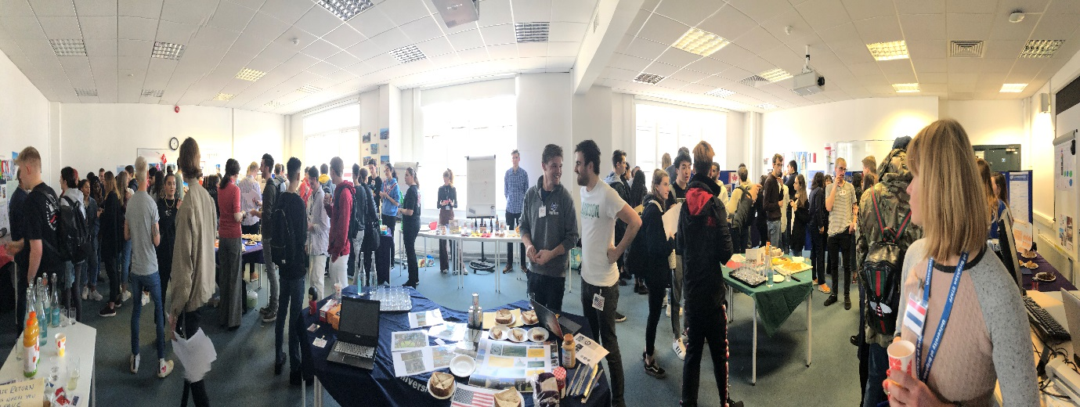

Students and staff enjoying this year’s Country Conference

**Publication success**

Colleagues may be interested to know that, thanks to Nikos Daskalakis, University of Brighton staff and students now have 2 year’s free access to the **International Review of Entrepreneurship**; this was a special offer from the publisher as Nikos has submitted articles for publication with this journal.

Nikos said “Not long ago I submitted an article titled "Users’ Perceptions of Motivations and Risks in Crowdfunding with Financial Returns" to be published in IRE. The paper eventually got published in October and the Editor offered a 2-year free institutional access to the University, aiming at maximizing the impact of the article and the Journal generally”.

This is fantastic news and you can access the full-text of the journal via the [Online Journal Finder](http://yq8bm2zc4p.search.serialssolutions.com/ejp/?libHash=YQ8BM2ZC4P#/?language=en-US&titleType=JOURNALS) or the [library catalogue](https://capitadiscovery.co.uk/brighton-ac/home)

**Law at Brighton Rocks**

On 4 December Brighton Business School and Zoe Swan hosted the first ever Beginning Your Next Chapter event for final year students in conjunction with University of Law, Careers Service and Alumni Dep and two of our amazing law grads Chay Niak and Jack Norman. It was brilliant! 3 hours of really insightful info and some laughs too.

This was followed by a meeting Zoe had with Vanessa Long at 1 COR to discuss setting up a 'unique' mentoring scheme with chambers for our law students. Vanessa is so inspiring! Zoe and Vanessa are putting together a paper for chambers approval, so fingers crossed!

Later in the day there was a chambers tea with members of chambers and Kayleigh Mcchambell (2014) who is currently in her first 6 of pupillage there!

And finally ……..

**Client Interviewing Competition Final**

On the 4 December the Brighton Business School held the annual Client Interviewing Competition and following what was the closest final we've ever had, the winners who will be representing the University of Brighton in the Client Interviewing national competition are Jane Cleasby and Arllen Orias (both CPE/LLM students).  They and the runners-up Fred Campbell (Year 1 LLB) and Louise Mackay (CPE/LLM) will be attending a national training day in London and Jane and Arllen will receive prizes including partner shadowing with our new sponsors Coffin Mew LLP.

Well done to all involved, thanks to those supporting and a very special thank you to our fabulous 'client' Eden.

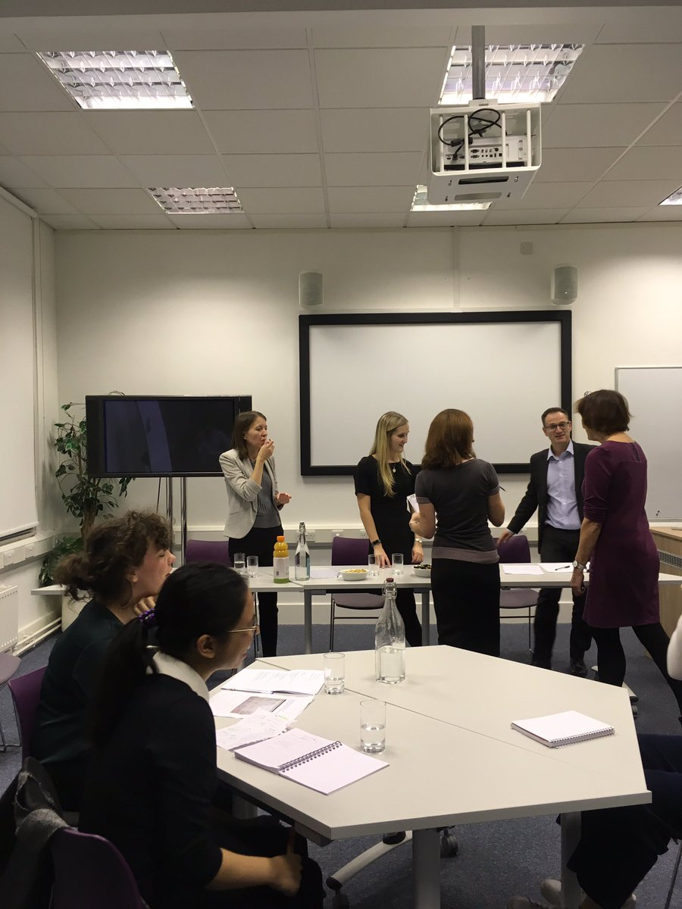

Students and staff at the Client Interviewing final

**The influences on the increase of upper degrees**

A research report on grade inflation authored by economist Dr Ray Bachan from Brighton Business School and commissioned by Universities UK on behalf of the UK Standing Committee for Quality Assessment (UKSCQA) has been published on the Universities UK website along-side a UK-wide consultation document. Ray is also our course leader for our [Finance and Investment BSc(Hons)](https://www.brighton.ac.uk/courses/study/finance-and-investment-bsc-hons.aspx).

The report has helped to guide the formulation of the consultation document which seeks to address concern over grade inflation from the office for students. It has received national interest and finds that whilst there are a wide range of factors, part of the increase in upper-degrees (1st and 2:1 classifications) is due to the influence of performance monitoring by government and university focus on league table position.

It also highlighted that there is a risk that if the number of top degrees continues to increase it may undermine the value of a degree from a UK university, making the classification system less useful for employers and students.

Our Vice-Chancellor, Professor Debra Humphris, who is also Chair of the UUK’s Student Policy Network, said:

“We have some of the best teaching in the world and highly motivated students who are eager to learn, but we cannot ignore the legitimate concerns about grade inflation. It is essential that the public has full confidence in the value of a degree, and that degree classifications are meaningful for employers and students.

“We want to see greater levels of transparency and consistency in academic standards. This report and the upcoming UK-wide consultation will help universities consider how they can best protect the value of qualifications over time.”

Ray will be developing the research project further with UUK. A copy of the document can be found at: [https://www.universitiesuk.ac.uk/policy-and-analysis/reports/Pages/degree-classification.aspx](https://staffmail.brighton.ac.uk/owa/redir.aspx?C=yMyLs29t4Fn22Qs9szEcnnKjvfFdIl5FO_Z8MNKoc3ArG_R29lXWCA..&URL=https%3a%2f%2fwww.universitiesuk.ac.uk%2fpolicy-and-analysis%2freports%2fPages%2fdegree-classification.aspx)



**The first Brighton Business School Staff Development Day**

The first BBS Development Day happened on Tuesday 18th December. The morning began with a session on Athena Swann led by Francisca and Penny, and then continued, post-mince pies, with a choice of a “Stop, Start, Continue” action session led by Julie or the opportunity to complete mandatory online training. Everyone then reconvened in Mithras Restaurant for Christmas lunch and made merry.

The afternoon was split between research and games (unfortunately the weather was not suitable for a walk – but next time!). The research sessions were led by Sue (Research Ethics), Howie (Impact Case Studies for REF), and Pascal (Support for Maths and Stats).

Rosie Mulgrue who attended the Athena Swan session said, “The Athena Swan session was excellent. So good to hear how far the Business School has moved along, and though there were still one or two eye opening trends, there was a clear sense that everybody’s thoughts and good ideas are being listened too”.

Hopefully, this will be the first of many!

**A big thank you goes to all staff for their hard work during the first term.**

**Have a very Merry Christmas – relax, eat, drink and be merry.**

**Here’s to a prosperous and successful New Year.**

[](https://www.google.co.uk/imgres?imgurl=http://static.wixstatic.com/media/e04455_67d0433b8bd5486c97e44d6b486c7af4~mv2.jpg/v1/fill/w_486,h_324,al_c,lg_1,q_80/e04455_67d0433b8bd5486c97e44d6b486c7af4~mv2.webp&imgrefurl=http://womenscentreja.wixsite.com/wcjf/single-post/2016/12/25/Merry-Christmas-Happy-New-Year-from-the-WCJF&docid=oj9XnPs8Ac4OUM&tbnid=2RrEKP_eWr-5UM:&vet=10ahUKEwjepd2igKzfAhVCyoUKHfX9AyoQMwh5KBUwFQ..i&w=486&h=324&bih=985&biw=1920&q=Christmas%20and%20new%20year%20images&ved=0ahUKEwjepd2igKzfAhVCyoUKHfX9AyoQMwh5KBUwFQ&iact=mrc&uact=8)

**Don’t forget to read all the latest stories on the Business School blog -** [**http://blogs.brighton.ac.uk/bbsblog**](http://blogs.brighton.ac.uk/bbsblog)