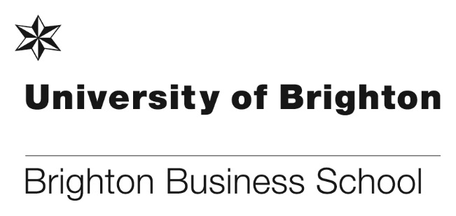

**Art of Management and Organisation Conference 2018**

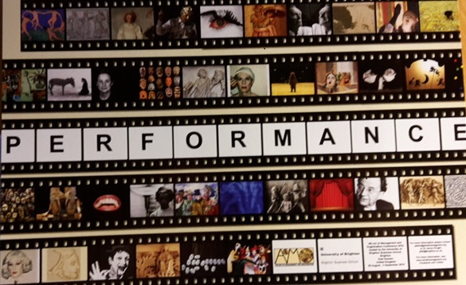

“A experiência de estar em meio à Royal Philarmonic Orchestra tocando só para nós no Royal Pavillion, eleito um dos dez prédios mais lindos da Europa!

Impossível descrever :-) ser parte do Art of Management Organization! “@artesdalideranca #arteimporta  
#artesdaliderança #maisempatia #nofilter #taoestrategia #aomo2018 @ Brighton Palace Pier  
  
...in other words  
  
“The experience of being in the middle of the Royal Philharmonic Orchestra playing just for us at Royal Pavillion, elected one of the ten most beautiful buildings in Europe!  
Impossible to describe :-) being part of the art of management and Organization! “  
  
This from a delegate based in Brazil who attended the four day long Art of Management and Organization Conference hosted by Brighton Business School in late August/Early September this year. And messages from all over the world thanking us for our planning, our generosity and our efforts to make the event truly memorable. We have had personal thanks from the USA, Japan, Denmark, Brazil, Germany ... l could go on but it has been an absolute pleasure to have created such an incredible event for academics all over the world.  
  
For anyone who has missed the detail, here is a link to the AoMO website, as well as to the final programme we put together for our guests.  
  
<https://artofmanagement.org/category/brighton-2018/>  
  
I am really grateful to those lovely colleagues who cancelled their weekends to work so hard (and yes - it was such hard work!) to take care of our guests. This was a very complex conference to host, comprising direct performance, dance, art, poetry and song writing, all underpinned by solid academic research. The credentials of those attending were seriously impressive, and I’m so happy to report that they were thrilled by the kind, polite and accommodating attitudes of the Business School staff who threw themselves into the project.  
  
This conference has put the Business School ‘on the map’ internationally, and I have already been asked to collaborate on a number of arts based projects focusing on organisational life. I’m delighted to be part of a new and dynamic approach to understanding organisational life and will continue to use arts based practices in my teaching, to engage and inspire students.  
  
What’s more....we made a (small) profit, even after having a keynote speech from Richard Olivier, a concert from Richard Durrant, a live dance performance at the gala dinner, a band on the opening night and the Royal Philharmonic Orchestra in the Royal Pavilion!   
  
(Oh, and I won the poetry slam too). RESULT!  
Jenny Knight - (Conference lead Convener)

Team: Chris Matthews, Jenna Ward (AoMO Committee) and Lucy East  
Helpers at the event - to be thanked with a meal out: Simon Letchford, Louise Letchford, Virginia Goodwill, Leonie Moore, Tracey Taylor, Colin Harris, Vicky Richards, Tessa Allgeier, Max Healey, Geoff Courts, Max Tookey, Carol Suwala and Sarah Field

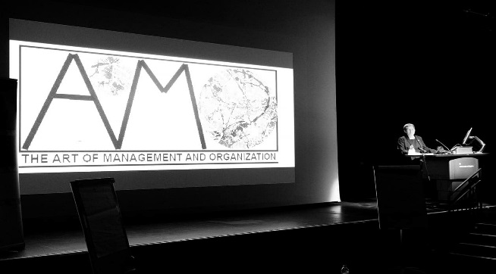  

Some of the highlights of the conference.

**Business School placement student case study**

Reade Whiteman a BSc(Hons) Business Management student took a sandwich placement year as a Team Manager to work at Gist a global freight management company. His role was to manage a team of up to 40 people on a daily basis. Reade said, “Being 20 years old I would say all of the responsibility has helped me to quickly and efficiently develop new skills, as well as help mould me into the confident manager I am today”.

Following his successful year with Gist, senior management and board members have chosen Reade to be Gist’s Industrial Placement student as a case study for the annual RateMyPlacement ‘Top 100 Undergraduate Placement & Internship Employers Guide’ for 2018/19.

 Congratulations goes to Reade on a successful placement year

Further details and the full press report can be found here: 

**Successful bid for a Learning and Teaching Scholarship 2018/19**

**Mona Rashidirad and Hamid Salimian have successfully awarded the learning and teaching scholarship 2018/19**, offered by the Centre of Learning and Teaching of the University. This award provides funding for small, innovative and creative projects, aligned with the University of Brighton Strategic Plan, which will pilot or explore developments in learning, teaching and assessment practices. Mona and Hamid’s project aims to **explore the usability and applicability of mobile apps in teaching and learning Business and Management in UK Higher Education from students’ perspective.** As a result of this project, they are hoping to enable BBS to promote and enhance the practice of mobile-enabled methods of teaching and learning to promote our teaching practices and facilitate the process of learning, working and creating knowledge for both teachers and students.

This project which is undertaken from 1 September 2018 to 31 August 2019 is employing a case study approach on five business schools within the UK South East area (BBS, Sussex, Kent, Surrey and Southampton Business Schools). The research findings will be expected to assist BBS to learn the best practices in other business schools and find the ways that we could put them in practice at BBS in order to enhance our students’ satisfaction and performance.

**Brighton Business School Prizegiving 2018**

The annual Brighton Business Prizegiving ceremony was held on Friday 3 August at the Sallis Benney Theatre, this year saw 48 final year students attend with their friends and family to celebrate their success on their academic achievement. The students received prizes from 43 sponsors including, ACCA UK, Brighton and Hove Bus Company, Institute of Directors, Thomson Reuters, plus many more.

The event was also attended by representatives from 27 of the sponsor companies, which gave the winning students the chance to network with them during the post ceremony celebration.

The awards ceremony this year was conducted jointly by Deputy Heads of School, Julie Fowlie and Lucy Jones, who did a fantastic job of calling students to receive their awards from the sponsors.

The sun shone for the celebratory lunch and everyone that attended agreed it was another successful event, Steve Maycock who is an ex-Board of Governor and a sponsor of the Maycock HR Prize said, “I thought the event was very successful, BBS really has attracted a large number of sponsors and awarding organisations. A credit to the team!”.

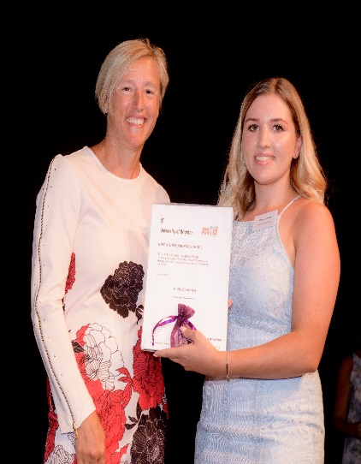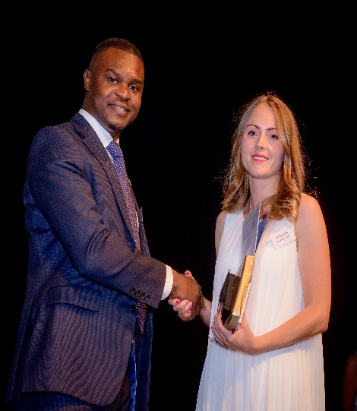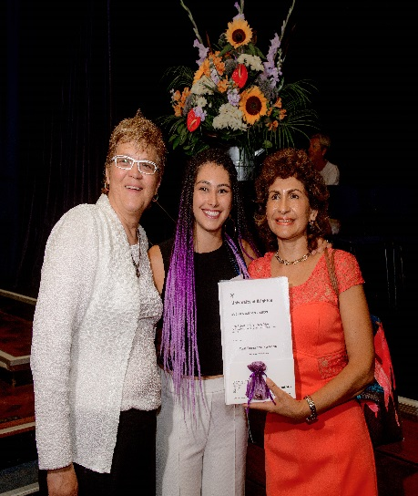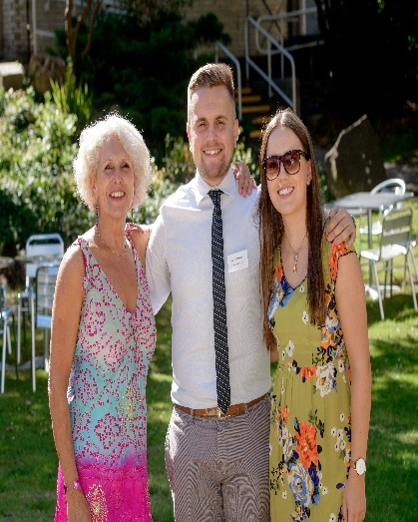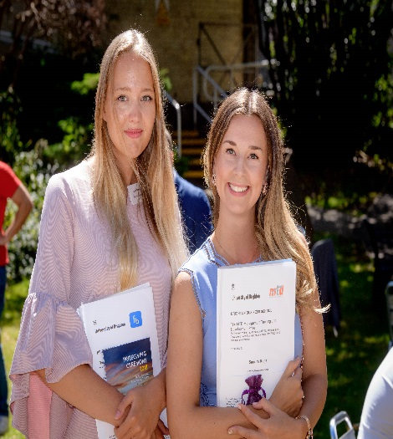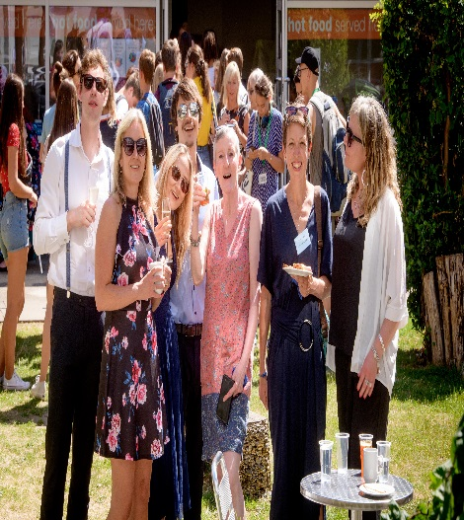

Sponsors, staff, students and their guests enjoying the prizegiving event.

**New book published on Complex Equality and the Court of Justice of the European Union**

In August our very own Richard Lang, senior lecturer in EU law launched his new book.

The Court of Justice of the European Union has long drawn criticism for its almost total reliance on Aristotle’s doctrine that likes should be treated like, and unlikes unlike.  In this book, Richard Lang proposes that the EU’s judges complement the Aristotelian test with a new one based on Michael Walzer’s theory of Complex Equality, and illustrates how analysing allegedly discriminatory acts, not in terms of comparisons of the actors involved, but rather in terms of distributions and meanings of goods, would enable them to reach decisions with new dexterity and to resolve conflicts without sacrificing diversity.

The book will be of great interest to those studying, teaching or practising European law, anti-discrimination law and human rights law, and those studying or teaching jurisprudence, philosophy, political science, social science, postmodernism, and disciplines concerned with minorities.

Available as an e-book or hardback from [Brill.com](https://brill.com/abstract/title/32082?rskey=boNw8f&result=1).



Dr Richard Lang Senior Lecturer in EU law

**Logistics and Supply Chain in practice**

At the University of Brighton, we seek to give students experiences that help to underpin the theoretical knowledge delivered through the programme. During the last year our Logistics and Supply Chain students visited various locations and companies to see first-hand how logistics and supply chains work on the ground.

During the autumn term a group visited a canal system in Birmingham built in the 18th century. This was followed by a visit to Jaguar Land Rover’s Castle Bromwich site for a full tour of the Body in White and Final Assembly areas. The robotic technology is impressive and the plant gave useful insights into lean operations and the complexity of the inbound supply chain.

During the spring term the group visited the University of Greenwich in London for the annual student conference of the Chartered Institute of Logistics and Transportation (CILT). A visit to the fast-growing beauty products company, Liz Earle provided insights into the strategic challenges of multi-channel distribution and strategy, as well as warehouse and packing operations. The students also undertook a consultancy project for 3T Logistics in Leicester.

[](https://blogs.brighton.ac.uk/bbsblog/files/2018/08/Picture1-1wp2o8c.png)

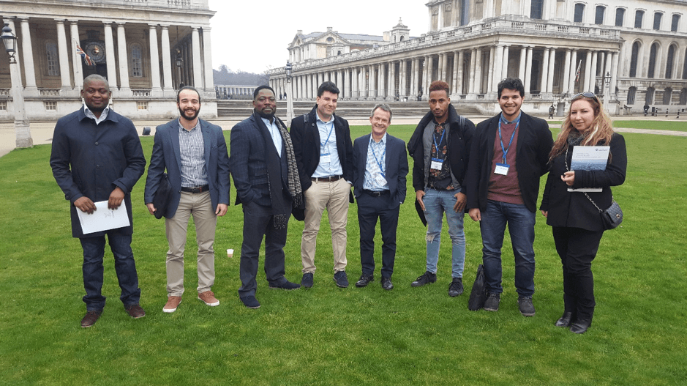 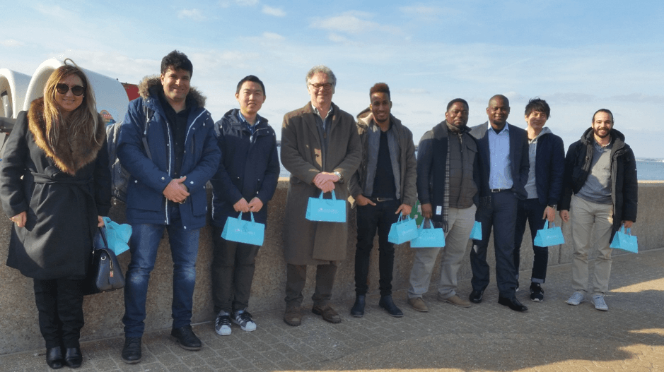

Students enjoying their visits to various locations and firms during the year.

**Three Peaks Challenge**

On 11 and 12 August this year the [MSc/PG Dip HRM programme leader](https://www.brighton.ac.uk/courses/study/human-resource-management-msc-pgcert-pgdip.aspx) Dr Penny Simpson undertook the Three Peaks Challenge in a team of five for the charity [Dreams Come True](https://www.brighton.ac.uk/courses/study/human-resource-management-msc-pgcert-pgdip.aspx).

The Three Peaks Challenge involves attempting to climb the three highest peaks of Scotland, Wales and England in 24 Hours. The first climb was Ben Nevis, which Penny and her team of five started at 11am on 11 August. Conditions were perfect for this first climb. The next climb was Scarfell Pike which was at night. Conditions that night were so poor two of the team members turned back on the way to the top. The final climb was Snowdon, in Wales, where conditions were better although very wet. All five team members attempted the final climb however one of the team ended up with a broken wrist which ended the team challenge.

Full details about the challenge written by Penny can be found here:

[**http://blogs.brighton.ac.uk/bbsblog/2018/08/29/three-peaks-challenge/#.W6tMzE2WyUk**](http://blogs.brighton.ac.uk/bbsblog/2018/08/29/three-peaks-challenge/#.W6tMzE2WyUk)

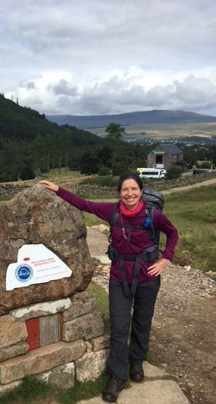

Penny enjoying the climb and the view from Ben Nevis

**Microlearning Platform Offers a Student Prize to Brighton Business School**

We are delighted to announce that microlearning platform, Skillshub, will be offering a 12-month subscription to one of our students for the second year running for the 2018/19 academic year.

Skillshub are [microlearning](https://www.skillshub.com/) experts that specialise in the delivery of short online learning sessions that allow you to take immediate action.

Their library of online resources already consists of 300+ [microlearning videos](https://www.skillshub.com/microlearning-videos/) in areas such as management and leadership, sales, equality and diversity, project management, finance, customer service, communication skills, personal skills and human resources.

This prize last year was won by Paige Hall who provided these kind words:

“I feel very proud and pleased to receive the Skillshub award as the 1-year subscription gives me the opportunity to microlearn various topics related to HR, Management & Leadership and more. I will definitely utilise Skillshub as an online learning tool to strengthen my current skillset and career progression in HR”. Paige Hall [BSc(Hons) Business Management with HRM](https://www.brighton.ac.uk/courses/study/business-management-with-human-resource-management-and-placement-year-bsc-hons.aspx) graduate 2017/18.

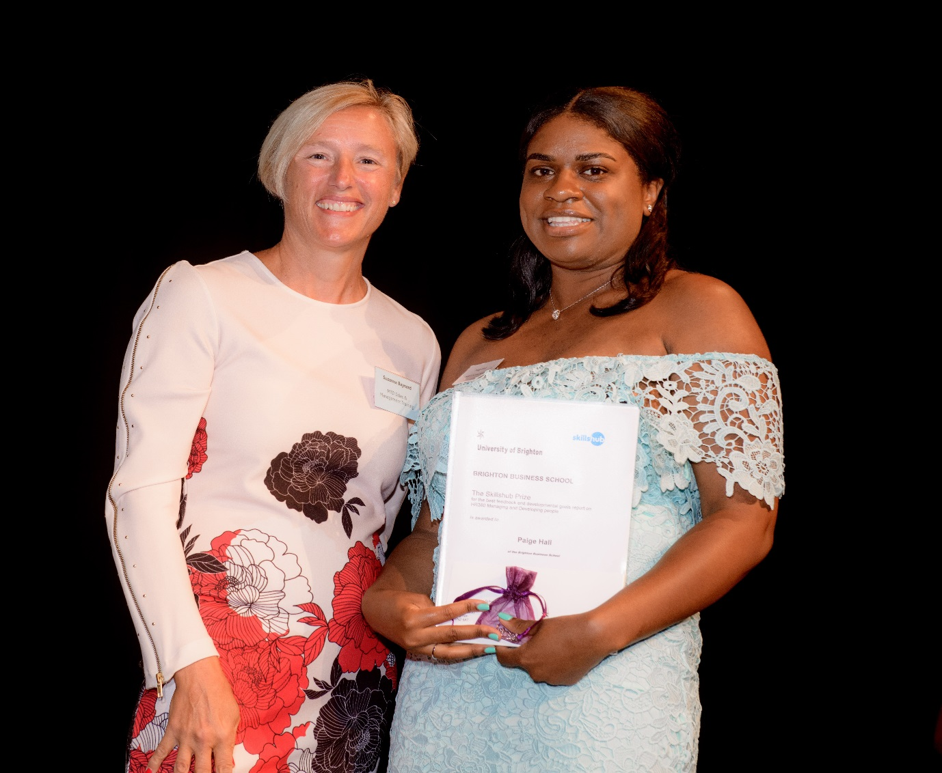

Paige Hall (pictured right), winner of the Skillshub Prize for the student with the best feedback and developmental goals report on our Managing and Developing People module, with Suzanna Baynard, Finance Manager at MTD

**Hit the Ground Running!**

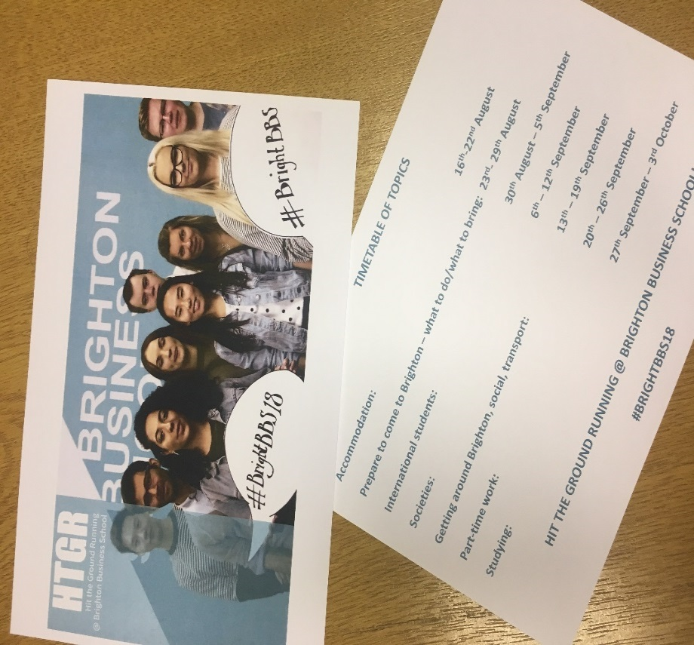

**Hit the Ground Running** is a new BBS initiative which has 9 student ambassadors who are using the #BrightBBS18 on twitter, Instagram, Facebook  to try and connect with new students who are about to join the University. The idea is to share things they wish they had known before coming to the University.

There is a special module area HTGR and discussion board. If you use social media please join and post any information that you think new students might need to know.

**A warm welcome to our new staff**

And finally a warm welcome goes to all of our new staff who are:

Dr Jack Thompson, Lecturer in Law

Phil Holden, Senior Lecturer in Marketing

Dr Carmen Lopez, Senior Lecturer in Marketing

Jim Simpson, Lecturer in Public & Third Sector Consultancy

Dr Jose Christian, Lecturer in Entrepreunership and Research Methods

**Don’t forget to read all the latest stories on the Business School blog -** [**https://www.brighton.ac.uk/bbs/index.aspx**](https://www.brighton.ac.uk/bbs/index.aspx)