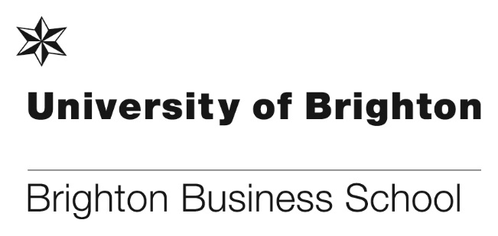

Brighton Business School becomes member of AACSB

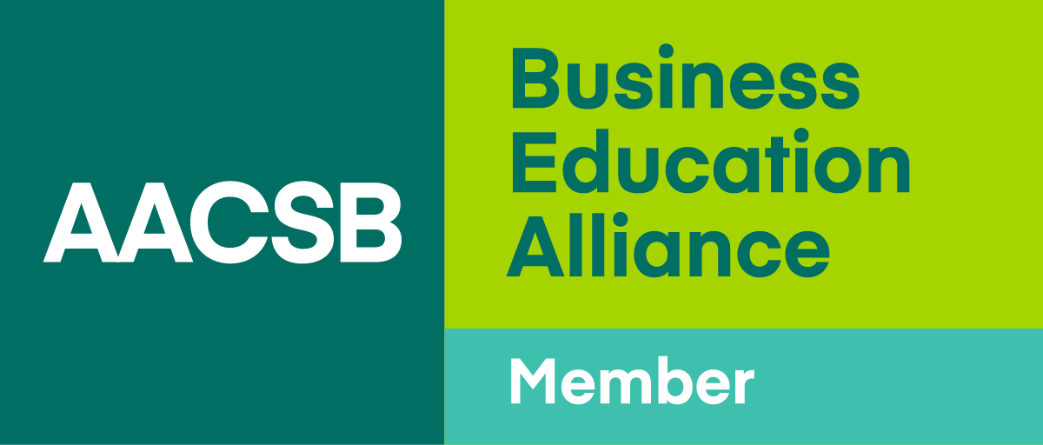

We are delighted to announce that the Brighton Business School is now a member of the Association to Advance Collegiate Schools of Business (AACSB). AACSB is one of the largest and most widely recognised business school accreditations in the world. As a member, Brighton Business School now has access to a global network of Business Education professionals, enabling us to benchmark our academic leadership practices and student outcomes against world-class business schools – influencing the way we prepare students to become impactful leaders.

“We are proud to be endorsed by over 14 professional bodies, ensuring our programmes deliver practice-relevant learning, and in many cases, additional qualifications to students.

“The global AACSB network provides a collegial environment in which we can learn, develop and share best practices. Our participation in this influential network will support our ambition to evidence the practices and outcomes associated with world-class business schools.” Professor Toni Hilton, Head of Brighton Business School.

An evening of fun at the Brighton Business School Graduation Ball
Friday 15th June 2018 saw BBS’ first Graduation Ball in more than 25 years. Over 120 students and staff came together at the Grand Hotel to celebrate this year’s graduating students. Professor Toni Hilton opened the evening, congratulating everyone’s hard work and wishing students well as they take their first steps into new careers, and also reminding them to stay in touch as alumni. Following a wonderful three course dinner and drinks, staff offered their words of wisdom and congratulations in some heartfelt speeches which you can view here (with thanks to Audrey Charowa). The evening continued with staff and students getting down on the dancefloor, showing off some memorable moves!

Special thanks must go to the student organising committee: Alexia Theodosiou, Andrea Harpas, Amy Attewell, and Sarah McLellan, without whom the ball would not have taken place. From arranging venues, to sourcing quotes and organising DJs, decorations, and photographers, their hard work made the evening a huge success – so much so that we are already planning next year’s event!

Similarly thanks must also go to Chris Matthews and Simon Letchford for their help in making sure everything ran smoothly from start to finish. Again, the night would not have been such a success without them giving so generously of their time.

Here’s to the next one!

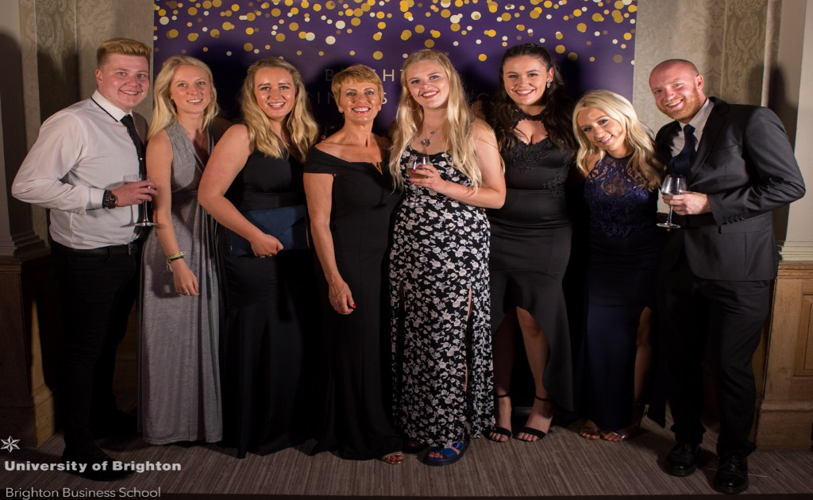
Students and staff at the ball.

Developing responsible leaders with PRME

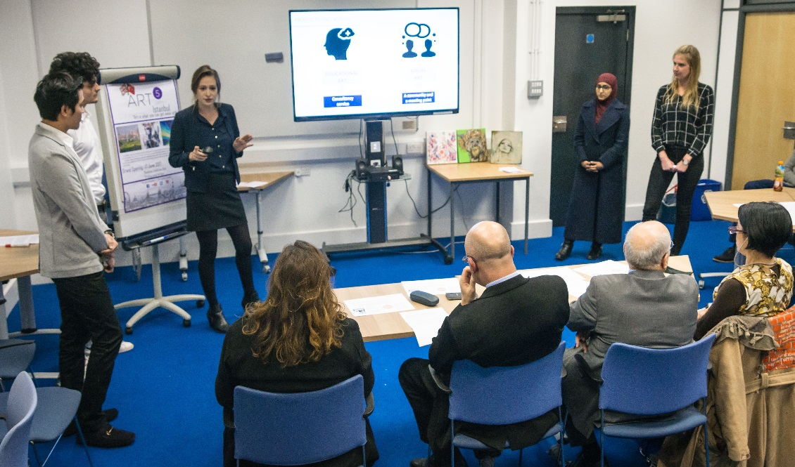

MSc Management students taking part in a Dragon’s Den style competition to come up with expansion ideas on behalf of a local business.

We are proud to announce that the Brighton Business School has become a member of PRME. The Principles for Responsible Management Education (PRME) is a United Nations supported initiative founded in 2007 as a platform to raise the profile of sustainability in schools around the world. This will help equip today’s business students with the understanding and ability to deliver change in the future. As a voluntary initiative with over 650 signatories worldwide, PRME has become the largest organised relationship between the United Nations and management-related higher education institutions.

Professor Toni Hilton said, “As a university-based Business School involved in the development of current and future managers, Brighton Business School is committed to implementing the Principles of Responsible Management Education – starting with those that are more relevant to our capacities and mission, report on progress to our stakeholders, and exchange effective practices related to these Principles with other academic institutions.

“We understand that our own organisational practices should serve as an example of the values and attitudes we convey to our students.”

Another successful publication for Claire-Michelle Smyth
Congratulations goes to Claire-Michelle Smyth who has recently had her latest book published by Business Expert Press (BEP). The book titled ‘Contract Law – A Comparison of Civil Land and Common Law Jurisdictions serves as an accessible introduction to the law of contract, with headings chosen for examination that track the main points in the lifetime of a contract. It also provides studies of other areas including third party rights and damages

For further details and information on the book please see link below.

https://www.businessexpertpress.com/books/contract-law-a-comparison-of-civil-law-and-common-law-jurisdictions/

PhD success for Bob Smale

Following the successful completion of his doctorate last year on the subject of trade union identities and the role of niche unionism, Bob Smale has been given a contract by Bristol University Press to write up a book which continues and develops his doctoral research. Last month Bob delivered a paper on his research at the British Universities Industrial Relations Association conference held at University of Middlesex which created significant interest. Although he is retiring from his teaching role at BBS this September, Bob plans to continue researching and disseminating over the next few years.

3rd Annual BBS Learning and Teaching Conference 2018
Over 80 BBS staff participated in this year’s conference at Grand Parade on Friday 6th July, the theme of this year’s conference was “the future of the Business School”.

Our two key note presentations clearly laid out the challenges and ways BBS can build on our strengths and create a future which is unique to us. The first from was fromToni Hilton - Head of Brighton Business School - "What is the future for Business Schools and how might we address that at BBS”, and Katie Piatt – e-Learning Services Manager, Jason Bailey & Marion Curdy– Learning Technologies Advisors – Learning Analytics the next steps for BBS

We made the presentations to the 2017/2018 Learning & Teaching Awards Winners: Rob Hayward, Bobby Kahlon, Cath Matthews, Mona Rashidirad, Asher Rospigliosi, Pascal Stiefenhofer and Professional Support Staff Awards Winners: Stuart Bullen, Rachel Carver, Donna Clarke, Lucy Fullbrook

Programme with links to the content

Members of staff nominated for the Crampton Remarkable Colleague Awards 2018

We are delighted to announce that 2 members of our Professional Support Staff were nominated for the 2018 Crampton Remarkable Colleague Awards. Simon Letchford, Technical Support and Chris Matthews, Senior Research and Events Administrator were both nominated and attended the awards ceremony on Thursday 19 July, in the glorious sunshine on the terrace at the Checkland Building.

Thanks to the generous donation made by Professor Julian Crampton CBE 2 years ago, the awards were established. This year saw 124 nominates, the highest number yet for just over 70 staff. The awards highlight the importance of every member of staff across the University in being able to face the challenges the changing Higher Education Sector offers up. For this reason the recognition of staff and particularly those who selflessly go above and beyond is crucial.

Congratulations goes to both Chris and Simon, and to Simon who received the highly commended award.

A successful year for the CLOCK Legal Companion Scheme

The CLOCK Legal Companion scheme, led by Jeanette Ashton in collaboration with Sussex University, has seen our students assist around 150 unrepresented litigants in the Brighton courts in the 2017/18 academic year. Students assist with filling in court forms; signposting to legal and third sector services; organising court paperwork and accompanying litigants into hearings to provide support. Feedback from the people we've assisted, organisations signposting to us, and the students participating has been very positive.

For the first time the Business School will provide a prize for the CLOCK Legal Companion of the year, for a student who has excelled in their role. Research on the student experience in participating in CLOCK, co-authored by Jeanette Ashton and Ben Waters, Canterbury Christchurch, is due for publication summer 2018 in the International Journal of Clinical Legal Education.

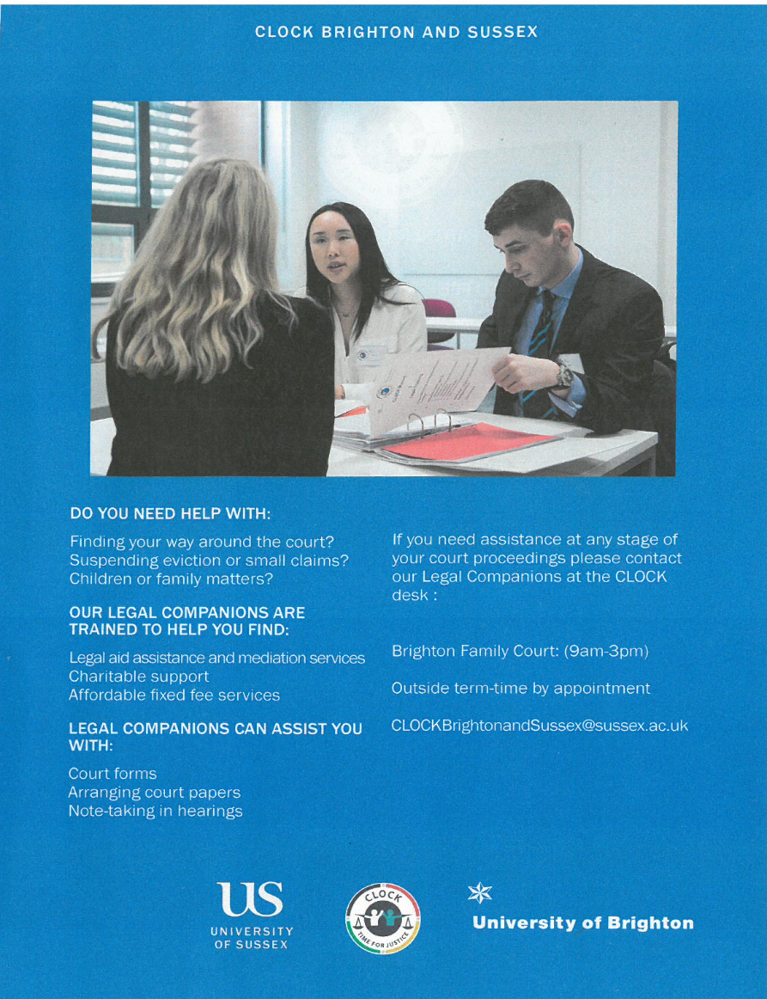

Don’t forget to read all the latest stories on the Business School blog - https://www.brighton.ac.uk/bbs/index.aspx

