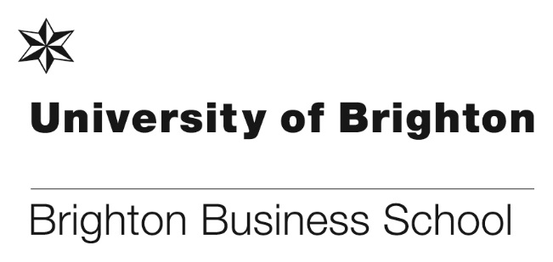

**Success at the Postgraduate Research Festival**

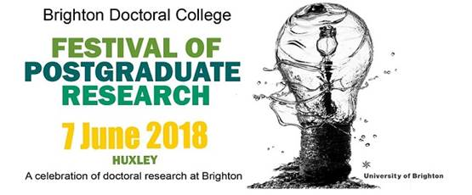

Congratulations goes to Akinyo Ola, one of our studentship funded PGR students who won the £500 prize with a colleague from PABS for the ‘opposites attract’ initiative at the Postgraduate Research Festival held at Huxley on 7 June 2018.

The Opposites Attract Collaboration Challenge pairs up postgraduate researchers from different disciplinary areas and invites them to work together for a seven week period to produce an output. The output might be a blog, poster, video, grant proposal, game, conference paper, hands-on display – the choice is yours!

**Akinyo Ola** is supervised by Professor Tim Brady and Steve Reeve. His area of research is ‘Improving Project Capabilities in the Public Sector’. The case study of the United Kingdom, involved collaboration with **Heather Baid,** a PhD student in the School of Health Sciences, and whose research is a grounded theory study about sustainability in critical care practice. The project aim was to explore staff wellbeing and social auditing within healthcare.

[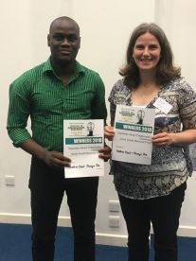](https://blogs.brighton.ac.uk/doctoralcollege/2018/06/13/festival-of-postgraduate-research-2018-round-up/oppsattwinners2018-wxlf4m/)

Akinyo and Heather with their award

Futher details can be found here: <http://blogs.brighton.ac.uk/phdcollaboration/>

**A message of thanks from Network Rail**

In 2016 we were approached by Network Rail to tender for a training and development opportunity in business change management. Clive Dodds, who is Lead Business Change Manager for Network Rail’s Safety, Technology and Engineering Department was looking for training and developmental opportunities for his business change team. He was keen to have training that was not standalone, where attendees came away thinking they had been developed as Business Change Managers. Clive was looking for a training and development programme that would develop individual competency, and support organisational development.

Following discussions about course content, expectations and learning style, Steve Reeve successfully secured the contract for 4 modules. Clive stated that no other academic institution that he interviewed, offered the mixture of theory and practical experience that the Brighton Business School was offering.

The course started in May 2017, and many of the attendees were apprehensive and their historical academic levels varied. Steve Reeve along with colleague Mark Hughes carefully navigated all attendees and within days all of the team were engaged, keen and motivated to develop their learning. Following positive results in Module 1, the team have now successfully undertaken 5 modules with the expert guidance and facilitation of Steve, Mark and Professor Tim Brady.

Network Rail have now extended the contract to deliver a further two modules which will provide the opportunity for many of the course delegates to achieve a Postgraduate Diploma. Clive said, ‘this is to the credit of the Brighton University team, the service they have provided to us, the thought provoking challenges and the valued learning.  I would encourage Brighton University to promote this modular learning to other organisations, and I would happily recommend this opportunity to other organisations, thank you once again to the Brighton University Business School Team.’

**Professor Andros Gregoriou - External Reviewer for the next REF**

Professor Andros Gregoriou of Brighton Business School has been invited to externally review the REF submission of the University of Southampton, for Business and Management. This is great news for the academic esteem of Brighton Business School, to review the REF submission of a Russell Group University.

**Laura Maechling wins best PhD Paper and Presentation**

Laura studied at BBS as an exchange student from the Ėcole Supérieure de Commerce, Business School in Paris, for a double degree in International Business, with a major in Entrepreneurship and Innovation and BSc (Hons) International Business.

During her year with us, Laura enrolled on IT383: Innovation in E-Commerce and her final submission was a review titled:  “Creation and Crowdfunding: the Marketing of Arts”.  Laura received a 1st for this submission and was encouraged to upgrade and submit a proposal to the European Conference for Social Media hosted by Limerick Institution of Technology in Ireland 21-22 June 2018.  Her paper was accepted for the PhD Colloquium for Social Media and she participated alongside 6 other students.  I am delighted to say that Laura was awarded for the Best PhD Paper and Presentation.  BBS are hopeful of hosting an internal conference for all undergraduate students next year and Laura’s response to our congratulations was “I am glad this will help create an opportunity for other students to get some more recognition, it's awesome!”.”

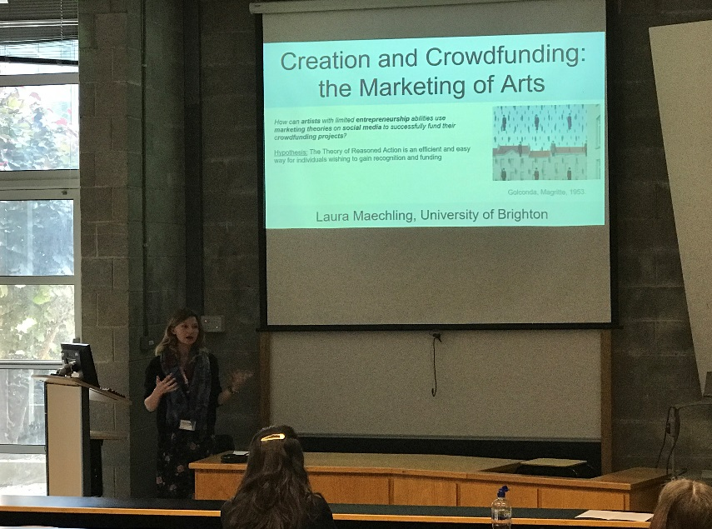

Laura presenting at the conference

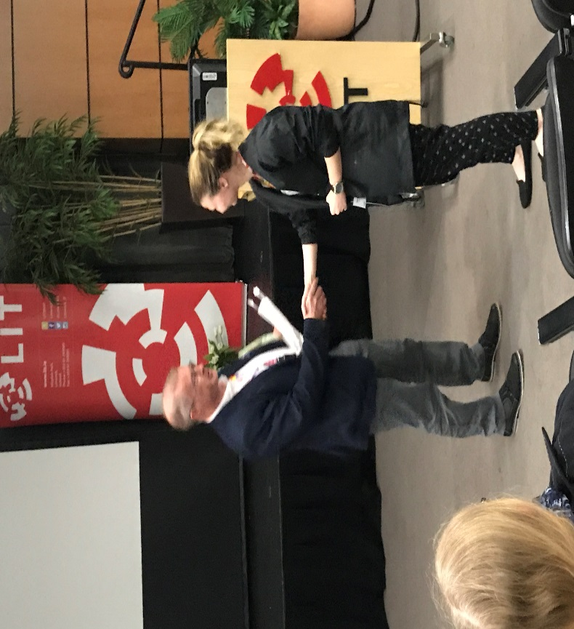

Laura being presented with her award

**Clifford Conway encourages Sussex business exports**

Dr. Clifford Conway on behalf of University of Brighton’s Business School attended the Sussex International Trade Forum (SITF) with some of his fellow committee members Ana Christie Chief Executive, Sussex Chamber of Commerce and Lev Denker, Trade Advisor for Dept of International Trade.

The role of the SITF committee is to plan and run events to encourage greater levels of export performance especially in this era of Brexit. Dr. Conway cites a number of sectors where Sussex companies lead the way: “Sussex has a fine reputation for the export in sectors such as quality food and drink, financial and business services, specialist motor engine research, and green technologies”.

[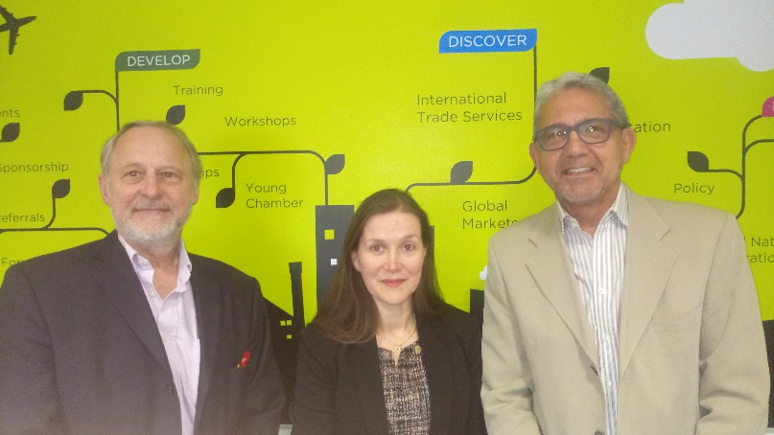](https://blogs.brighton.ac.uk/bbsblog/files/2018/05/blog-r3eluu.jpg)

Pictured left to right: Dr Clifford Conway, Ana Christie Chief Executive, Sussex Chamber of Commerce and Lev Denker Trade Advisor for Dept of International Trade

**Our Business and Management courses boost graduate wages**

The BBC recently published an article ‘Which university courses boost graduates’ wages the most?, posing the question ‘Going to university should mean you earn more over your lifetime. But how much difference does the choice of university and subject actually make? Data has been calculated for the first time by the Institute for Fiscal Studies, showing graduate earnings five years after leaving their university relative to the average degree for a man and a woman.

We are delighted to see findings show that graduates from Business and Management at Brighton Business School scores well for increased salary by earning +£6,073 for men, and +£5,602 for women. There is however, an anomaly with our Law courses where findings showed that women graduates earned +£3,726, while men were -£5,875.

You can read the full article here <https://www.bbc.co.uk/news/education-44413086>

[**Don’t forget to register for the 3rd Annual BBS Learning and Teaching Conference 2018 on 6th July**](http://blogs.brighton.ac.uk/bbsqlt/2018/05/02/3rd-annual-bbs-learning-and-teaching-conference-2018-on-6th-july-registration-now-available/)

[](https://blogs.brighton.ac.uk/bbsqlt/files/2018/04/NEW-LT-conference-graphic-2018-pwddni.png)

This year the conference will be take place at Grand Parade on Friday 6th July. It will be another all day affair followed by a BBQ in the gardens, the conference is open to all staff.

The theme of this year’s conference will be “the future of the Business School”. If anyone would like to make any contribution either around this theme, or beyond then please email Julie Fowlie (copying in Chris Matthews).

**We are delighted to confirm the following Key Note presentations**

* Professor Toni Hilton – Head of Brighton Business School – Welcoming Key Note
* Katie Piatt  – e-Learning Services Manager, Jason Bailey & Marion Curdy– Learning Technologies Advisors – Learning Analytics the next steps for BBS

You can [**Register Here**](http://blogs.brighton.ac.uk/bbsqlt/2018/05/02/3rd-annual-bbs-learning-and-teaching-conference-2018-on-6th-july-registration-now-available/)for the conference.

**Research and Enterprise Excellence**

Marc Cowling, Head of Research has recently reviewed research and enterprise activities and achievements over the last three years. The results show that there has been an incredible amount of work and activities that have made an impact and difference in a lot of different communities, locally, nationally and internationally. You will find Marc’s full report ‘Performing Above the Bar and Making a Real Difference’ attached at the end of this news round-up.

Congratulations goes to all staff involved in this brilliant and ground-breaking work.

**Don’t forget to read all the latest stories on the Business School blog -** [**https://www.brighton.ac.uk/bbs/index.aspx**](https://www.brighton.ac.uk/bbs/index.aspx)

Brighton Business School

Review of Research & Enterprise Activities 2015-2018

**Performing Above the Bar and Making a Real Difference**

Professor Marc Cowling

**Forward**

It is with great pleasure that I write this review of our research and enterprise activities and achievements over the last three years. Why? For a number of reasons: First of all, *as a school we are performing at an all-time high in terms of the volume of research and the number of staff meaningfully engaged in research and enterprise activities*. Secondly, many of our staff are engaged in R&E activities that (a) have traction beyond the sheltered domain of academia, and, (b) are externally recognised as contributing to positive change in businesses, governments, and the socio-economic welfare of citizens not only in the UK but much further afield. And thirdly, the new CENTRIM was born just 12 months ago and under the stewardship of George Tsekouras has already established itself as a leading centre for knowledge creation in the areas of entrepreneurship, innovation, and change management.

Internationally, we have a truly global reach with tangible activities in a large number of countries, and with supra-national organisations such as the United Nations (Howard Rush and Marie Benedict Dembour), and The World Bank (Marc Cowling). Within the UK, our R&E staff have influence with a dazzling array of government departments including HMRC, MoD, DfID HMT, DBEIS, Cabinet Office, Innovate UK and DWP. For businesses, we provide support for change management and growth to a diverse range of large organisations (e.g Network Rail, Steve Reeve) and SMEs (through Profitnet, George Tsekouras). We are also widely networked with national and international HEI institutions, including SPRU (Sussex), London School of Economics, Trinity (Ireland), Bath University Management School, Deakin (Australia), Wittenburg (Germany), The Sasakawa Foundation [Pascal, Japan], Politecnico di Torino (Italy) Lappeenranta University of Technology (Finland), Institute for Management and Innovation and Technology (Sweden). Our PG students are drawn from all four corners of the globe and, as a testament to the dedication and professionalism of our PGR supervisory teams, are amongst the happiest in the entire university.

And this has all been achieved against the backdrop of Brexit, a fundamental re-organisation of the UK institutional structure relating to research and enterprise, university wide changes in the way R&E is administered, significant changes to the Research Excellence Framework (REF) “Rules of the Game”, and a substantial reduction in our R&E central budget allocation. Below I briefly summarise what, in my view, our achievements are, and more specifically the achievements that led me to give this review the title “Performing above the Bar and Making a Real Difference”. Finally, sincere apologies to those whose achievements are not listed. I am but one person with many obvious failings, but one tasked with oversight of the extensive R&E activities of more than 130 staff.

**Highlights**

***Performing Above the Bar***

* **The new CENTRIM** – Happy 1st birthday. Impressive start across all R&E metrics, and their seminar series is rapidly gathering strength
* **Record R&E Staff Numbers** - We now have an all-time high of 70 staff engaged in R&E activities. This represents an increase of 70% since the 2014 REF period
* **Record Research Outputs** – These researchers have produced an all-time high of 281 research outputs. This represents an increase of 76% since the 2014 REF period
* **4 Star Outputs** – We are just one 4* output behind our entire REF 2014 submission with 2 years to go
* **ECR Success** – Cath Matthews is on the research fast-track with 3 new outputs in the last 18 months. A testament to her personal qualities and to BBS practical mentoring support
* **R&E Bids** – Q1 and Q2 of 2018 saw the largest ever number of bids in preparation and ‘out of the door’
* **Happy PG Students** – Our 41 PhD students are amongst the most satisfied in the entire university
* **Top Economists** – Marc Cowling has consolidated his position in the Top 8% of economists in the world according to RePec (June, 2018)
* **Leading Management Scholars** – Andros Gregoriou’s esteem in the discipline has been recognised by his appointment to the Editorial Board of the UKs leading B&M journal (the British Journal of Management)
* **Making an Impact** – Under the stewardship of Howard Rush, BBS has a high quality portfolio of impact case studies which should maintain our position in the Top 5 of UK Business Schools for real world impact

***Making a Real Difference***

***Locally***

* **Developing Local SMEs** – The Profitnet programme continues to successfully assist and train owners and managers of local SMEs more than a decade after its conception
* **Smart Specialisation Strategy** – Marc Cowling in collaboration with Paul Nightingale (SPRU) developed a Smart Specialisation Strategy for the Greater Brighton Economic Board

***Nationally***

* **Innovate UK** **Loan Fund** – Marc Cowling designed a new innovation loan product which was originally announced by the Chancellor in the Autumn 2015 budget and went ‘live’ in November 2017 with an initial capitalisation of £50m allocated to 5 competitions over 2 year period
* **Network Rail** **Commendation** – Our team received a written commendation from Network Rail regarding the quality of their training and development services offer in the area of change management (Steve Reeve, Mark Hughes and Tim Brady)
* **MoD** – Steve Reeve and Mark Hughes have also run a short course programme for representatives from the MoD for the past 8 years. The success of this highly commended programme has ensured a third contract which will run until 2021
* **Tackling the Big Issues in HE** – Asher Rospigliosi, Tom Bourner, and Linda Heath have produced a body of work dealing explicitly with big current issues around learning, transferable skills, and what universities should look like in the future
* **Advising Government** – We have truly excelled in this area:
* Marc Cowling was elected onto 2 leading UK advisory committees: The *Productivity Insights Network* and the Innovate UK *Innovation Caucus*. He also was invited to present evidence and policy solutions to No.10 regarding UK productivity which he did in April 2018
* Howard Rush completed his internationally recognised project on Crisis Innovation, commissioned by the Department for International Development
* Marie-Benedicte Dembour and Jo Wilding have contributed to EU and UK select committees discussing the needs of unaccompanied minors as they take refuge in European countries
* **Are UK Grades Really Inflated?** – Ray Bachan is about to uncover the real truth about this widely held view that grades have been consistently inflated over the last two decades in an exciting new project for Universities UK.

***Internationally***

* **Developing SMEs in Europe** – George Tsekouras is the PI on two major EU projects; SPARK and INSPIRE, being the lead partner on the latter. The projects focus on improving the capacity of social enterprises to deliver sustainable and high impact innovations (SPARK) an investigating the management of open innovation in SMEs across Europe in order to create an innovation toolbox for companies (INSPIRE)
* **Regulating EU FinTech Markets** – Nikos Daskalakis is on a key European Union advisory group who are developing a new regulatory framework for FinTech, and particularly Crowd Funding, which balances consumer protection with a desire not to regulate the market out of existence.
* **Helping Swedish Economic Growth** - Marc Cowling was invited by the Swedish Government Growth Agency (Tillvaxtanalys) to present a case for a Small Firms Loan Guarantee Scheme for Sweden at a seminar attended by Swedish Secretary of State (with responsibility for Company Management, Competition, and State Ownership of Enterprises) Eva Lindström in March 2018. Marc articulated a case for the introduction of a new loan guarantee scheme in Sweden to alleviate problems around access to finance for smaller firms. His proposal is now being given further consideration by the Secretary of State. This builds upon Marc's recent work on loan guarantees for the Inter-American Development Bank, DG Regio of the European Union, and The World Bank
* **Helping Africa** – Howard Rush and David Francis have run Managing Innovation courses with both Unicef and the European Red Cross as they find innovative new ways to deliver humanitarian aid to crisis-hit, developing countries

**Final Words**

When I wrote the first paragraph I thought I had enough evidence to support my title and my general contention that we were doing exceptionally well and making a real difference. But every time I noted one incidence of great achievement, I immediately thought of two more. Even now I know I haven’t really told half the story. So let us agree that this gives us all a flavour of how well we are doing not only in the more academic aspects of R&E, but in terms of positively affecting the lives and socio-economic welfare of refugee children, displaced populations in Africa, and more generally improving the way businesses and government conduct their activities in many communities, countries and regions of the world. Of course there is always latent potential and we should try and engage with our colleagues to release this potential in the coming years. What I am convinced about is that our unwavering commitment to a longer-term strategy that goes beyond annual accounting metrics and idiosyncratic short-termism has paid dividends and will continue to do so.

Reviewing our capabilities has also inspired me to think of new directions and pathways for the future. I think one obvious area in which we can look to build capacity and make a huge contribution is in respect of the 17 United Nations Sustainable Development Goals. We have expertise in human rights law, innovation, entrepreneurship, and change management. This body of knowledge, skills, and expertise is all directly relevant to making progress towards achieving these worthy goals. And we are already active in many key areas. Watch this space. Finally, a huge thanks to Rosie M and Chris M, without whom we would not have been able to achieve the successes documented in this review.