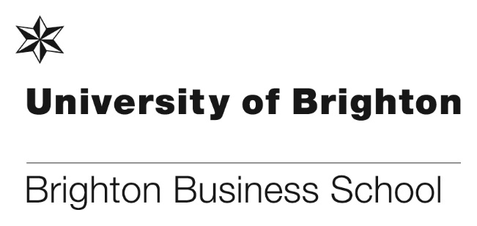

**Black and in business**

Marvin Okai and Denzil Lawrence, BBS graduates in Accounting and Finance developed a blog, [Black and In Business](https://blackandinbusiness1.com), to document their journey to becoming Chartered Accountants. Now graduated, they are continuing to produce their blog, with the aim to encourage diversity in the world of Finance and to share with other students how they overcame some of the obstacles they faced, and still face.

**Brighton Business School Seminar - Economic and Social Rights: From International Law to Everyday Life**

Access to an adequate housing, education, health, food, social security and an adequate standard of living are globally recognised as human rights. The UK has ratified a number of international treaties that say so, the most important of which is the [International Covenant on Economic, Social and Cultural Rights](http://www.ohchr.org/EN/ProfessionalInterest/Pages/CESCR.aspx). However, by and large these rights have not been incorporated into national laws and policies. What are the pitfalls to enforce economic and social rights effectively? What are the opportunities to bring them home?

**Dr Claire-Michelle Smyth**, Senior Lecturer in Law at the University of Brighton, talked about the status (and the gaps) of economic and social rights in international law. **Dr Koldo Casla**, Policy Director of Just Fair, addressed the key challenges and opportunities for economic and social rights in the UK, as well as the role of civil society in defending and promoting these rights. [**Just Fair**](http://www.just-fair.co.uk/) monitors and advocates economic and social rights in the UK in light of international human rights law.

**MBAs**

As part of their International Strategy module, members of the 2017/18 Brighton Business School MBA cohort were given just three hours to deliver a market entry strategy for [Sugru](https://sugru.com) and its amazing mouldable glue product… which is amongst Time Magazine’s 50 Best Inventions.

The students analysed two potential geographical markets and considered a range of critical factors including the resources and capabilities of Sugru, the challenges that might manifest in each market, the macro factors that might create opportunities & risks, the key competitors and alternatives and the key verticals and players. They then delivered a formal presentation of their recommended entry strategy to Katie Cannon, Head of Strategic Projects at Sugru.

**Brighton Business School Employability Week**

The Business School held its first Employability Week to coincide with the launch of the new [Brighton Advantage Award](https://folio.brighton.ac.uk/group/brighton-business-school-advan?login), as well as the first of this year’s Development Centres. A range of events was put on to help all BBS students improve, articulate or showcase their employability, including: LinkedIn workshops, drop-in sessions hosted by Active Student and the Careers Service, a talk on working abroad, and a #dreamjob Twitter campaign, with students from a variety of year groups and courses taking part. In addition, the Employability Hub launched its new Placement Mentors scheme.

Twelve final year returning placement students have been appointed and will be paired with second years just starting out on the placements process to provide them with informal peer support on areas such as staying motivated, balancing studies with placement applications, and how to have a successful year in industry.

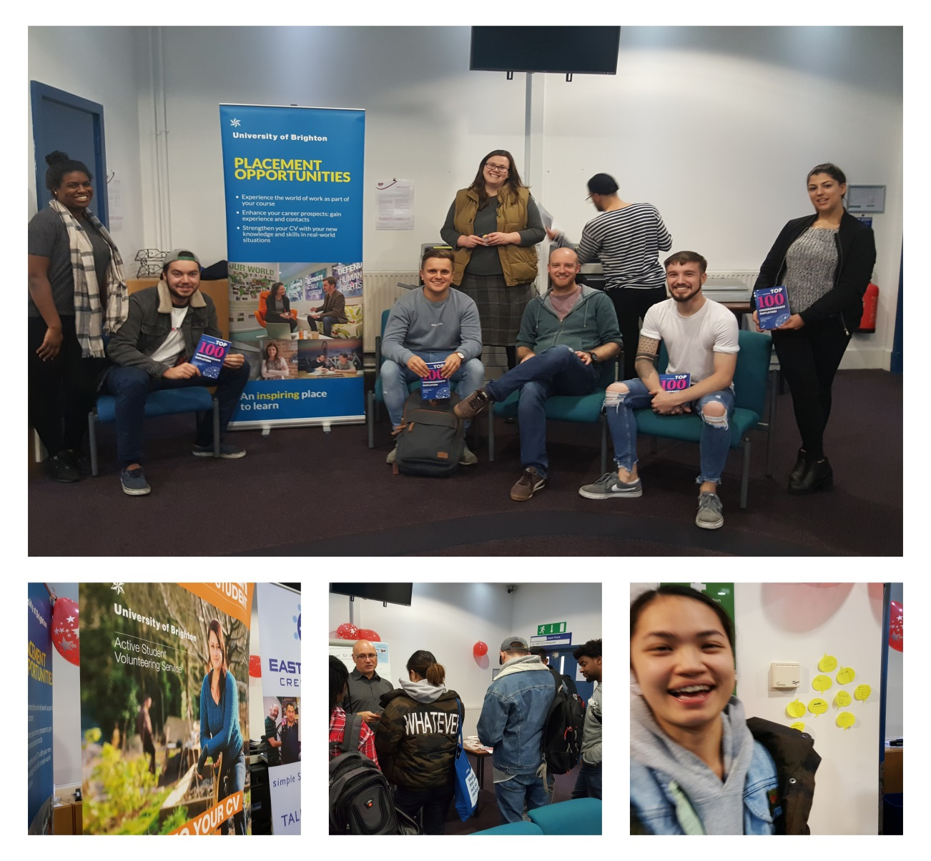

**Dr Stephanos Avakian gives a key note talk for Oracle**

Oracle wants to foster a greater level of engagement about technology and the way corporations are affected by upcoming technologies like Cloud computing [www.oracle.com/uk/](http://www.oracle.com/uk/). Stephanos was asked to participate by doing a short interview about the impact of technological change on organizations. In the interview he focused on the concept of the *organizational narratives* and how technology firms are often focusing on the instrumentality of technological features often ignoring challenges about the accommodation of the new information.  Two BBS students (Paige Hall and Lucie Kadidlova) also took part in the video and it was a positive experience for all of us. The film was made by Branch Road ([www.branchroad.co.uk](http://www.branchroad.co.uk)) who are a public relations firm that helps design Oracle’s training programmes for its clients. A final version of the video is to be submitted so that Brighton Business School can also use it for its marketing purposes.

**Thirteen NSS student advocates**

Following the recruitment of Gilliane Williams as the school’s Student Engagement Champion, Gilliane has now recruited and secured 13 new student NSS advocates from various courses across the school. The student advocates will add to how the School listens to its students and play an important role in providing a positive voice to feed back to other students all the good work and developments on the School. The advocates will work with staff and students at various events leading up to and during the NSS to encourage and engage students to complete the survey.

**Launch of the Brighton Business School Advantage Award**



The Brighton Business School Advantage Award was launched on Friday 24 November, students attended the event in the Student Lounge between 11am-1pm. By joining the award programme students will be able to build a range of evidence to showcase their personal and professional development, so that when they leave university they will be able to demonstrate that they have a collection of skills and experiences to complement their academic qualifications and start on a career that is right for them.

Students will be supported by the School, [Careers Service](https://www.brighton.ac.uk/careers/index.aspx), [Active Student](https://www.brighton.ac.uk/careers/volunteering/index.aspx) and [BeePurple](https://www.brighton.ac.uk/careers/start-your-own-business/index.aspx)  to create a skills audit which will include a CV, a Linkedin profile, etc. working towards a bronze, silver or gold award in their final year.

**BBS graduate’s money business**

The Mayor of Worthing Cllr Alex Harman cut the ribbon on a new foreign exchange shop launched by a University of Brighton graduate.

Mohammad Golam Hossain, an international student, said the launch wouldn’t have been possible with support from the university: “I could not start a business in the UK without the university because of my immigration status. The university endorsed me for a year and allocated a mentor to support my business plan and research.”

The new shop ‘Worthing FX’ is in Montague Street, Worthing, and Mohammad has ambitions to open more outlets throughout Sussex and the South East.

He gained his [MSc in Accounting](https://www.brighton.ac.uk/courses/study/accounting-acca-msc-pgcert-pgdip.aspx) from the university and an Association of Charted Certified Accounting qualification earlier this year.

**Learning & Teaching Awards and Professional Support Staff Awards 2017/18**

The Learning & Teaching Awards and Professional Support Staff Awards 2017/18 was launched on 4 December 2017. This year more staff will be recognised for their excellence in teaching and professional support, there will be 8 awards for Learning & Teaching and 4 awards for Professional Support Staff.

Nominations can be made by students or staff colleagues NOW!! Go to your home page on studentcentral, then look for the award image below, click on it to take you to the nomination forms, do not forget to scroll down and nominate both a member of the teaching staff and a member of professional support staff! (***or click on the link below as that works as well***)

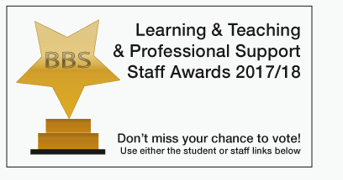

[Learning & Teaching & Professional Support Staff Awards 2017/18](http://blogs.brighton.ac.uk/bbsqlt/teaching-learning/annual-lt-award/your-school-annual-learning-teaching-award-250-cash-prize-and-trophy-2017/)

**International students host a Country Conference**

The Business School host annual networking events for our ERASMUS (and International) students. Students who are joining us from our partner Universities in France, Belgium, Spain, Sweden, Canada, USA, Australia, Japan, Germany, Bulgaria, the Netherlands, Turkey and Denmark have the opportunity to meet those of our BBS students who have returned from studying at the partner Unis or have worked abroad on placement.

On Wednesday 15th November the International Students held a Country Conference. This year the exchange students provided the food, drinks and local knowledge; the returning final year students presented their excellent academic posters which summarised their research projects and experiences and first and second year students collected primary data to input into their cultural module assignments and helped with food, drinks and hosting the event. It was a successful event which provoked very positive feedback from the students and staff.

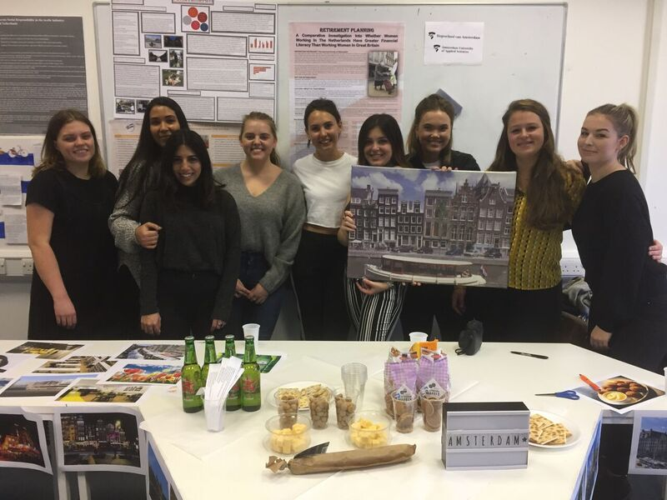

Students from Amsterdam enjoying the conference

**Brighton Business School Excellence Awards 2017**

The Brighton Business School Excellence Awards ceremony was held on Tuesday 28 November between 5:00-7:30pm in Cockcroft Hall. This year saw 25 award winning students attend with their family and friends to celebrate their academic success. The awards included the Merit Scholarship Awards, Alumni and Friends Awards and also a number of sponsored prizes. Sam Baker from OSTC, Neil Farrow from DMH Stallard and Konrad Bukowski-Kruszyna from RSM UK Group LLP attended to present their prizes to the winning students. The evening was a huge success and enjoyed by everyone that attended.

