**UNIVERSITY OF BRIGHTON**

BRIGHTON BUSINESS SCHOOL

Learning and Teaching Conference 8th July, 2016

**Using the iPad app for online marking**

**Barry Lee Scherer**

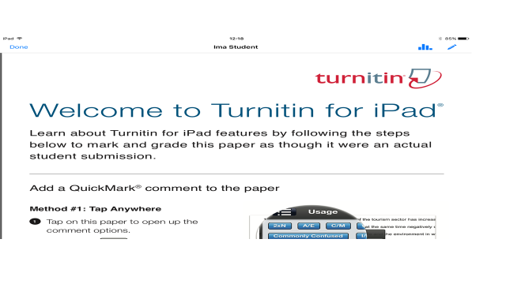

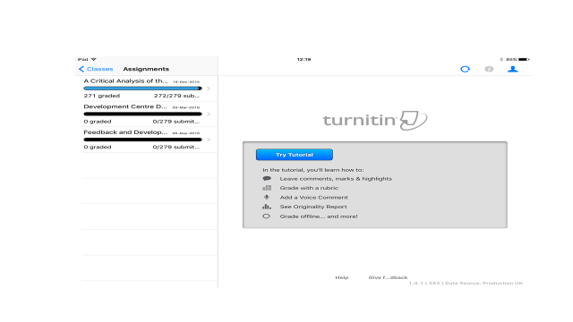

1. **Rubric design**

All scoring Rubric need to have a top score that equals the overall total, so if marking out of a 100 the top score needs to be 100. Having marked the papers though you can’t now edit the Rubric being used without losing all associated marks. What you could do is change the amount the paper is being marked out of to 95. Or do as you suggest in your email, ie. duplicate the Rubric and add the top score to it but then you will need any marked papers to be marked again.

1. **Managing multiple markers – Managing submission points**

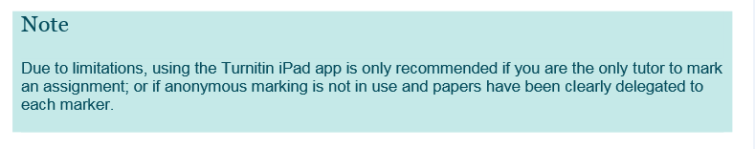

1. **Downloading assessments**
2. **Marking offline – Why do it this way?**

* Rubric ticks

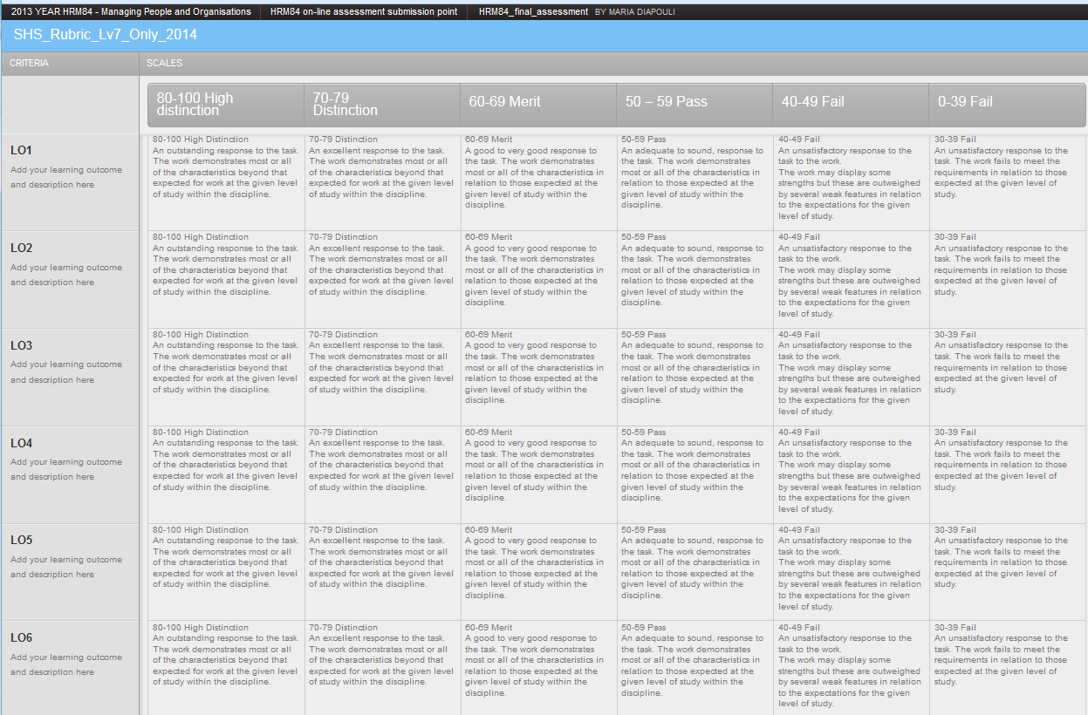

* In text comments
* Library of comments
* Summative comments

1. **Syncing - *Danger**

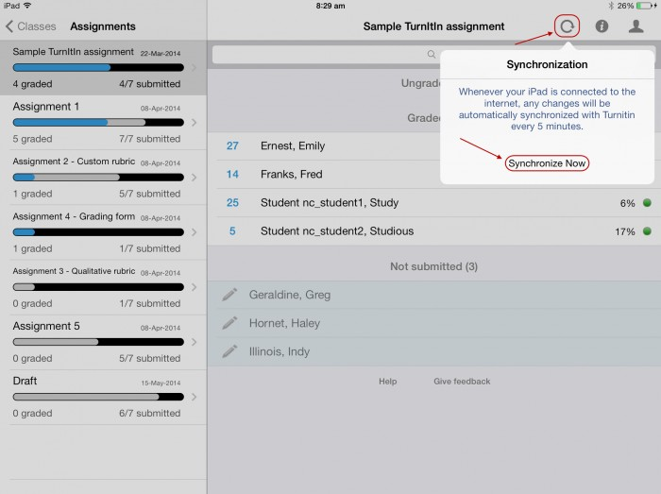

The sync function is for the ipad only as when you get the papers you are essentially downloading them from the server as a copy to enable the offline marking function. If sync from your ipad you should see the other examiners’ comments on the papers. They do not need to sync unless working from an ipad too. If simply using a computer and browser other examiners will automatically be adding comments directly to the papers held on the server.

There is a danger of overwriting comments which is why you need to manage the marking. If another examiner has completed their marking and you sync from your iPad and you can see the others’ comments on the paper then all is well.

1. **Support**

Marion Curdy, Learning Technologist @ Moulsecoomb

Tel:                      01273 642660

Mobile:                07540 668614

Website:              <http://blogs.brighton.ac.uk/elearning/>

Twitter:                @mecurdy

Jason Bailey, Learning Technologies Adviser (Moulsecoomb)

Tel: 01273 641279

Mobile: 07964 422986

Website: <http://blogs.brighton.ac.uk/elearning>

Twitter: @jason_lta

**If you are marking or about to start marking in Turnitin please do the following:**

1. On the module Control Panel select **Gradecentre>Full Gradecentre**
2. Look for the column that matches the Turnitin Submission you are about to mark (you may need to scroll to the right) and check that the column is hidden 9see screen shot below). If it isn’t hidden you can manually hide it (again see screen shot below for details of how to do this).

_________________________________________________

